Change animal data

Open form „Animal“ via Menu „Edit“
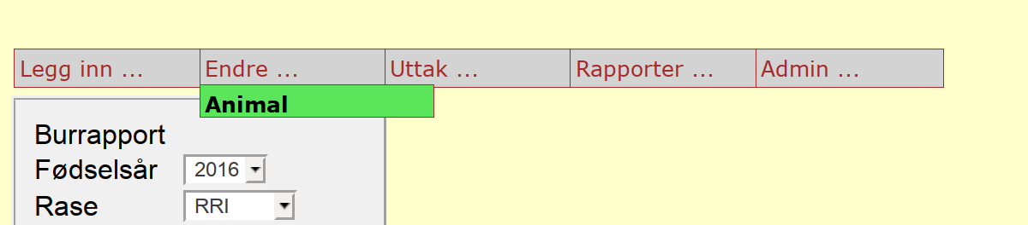

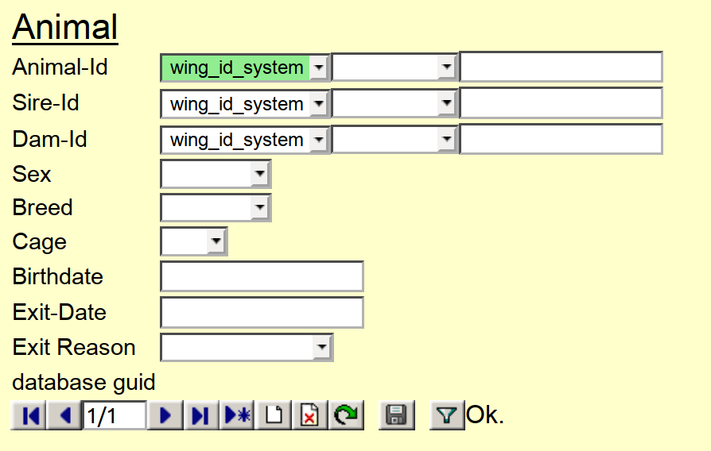

enter Animal-ID and press filter-button to load data from database
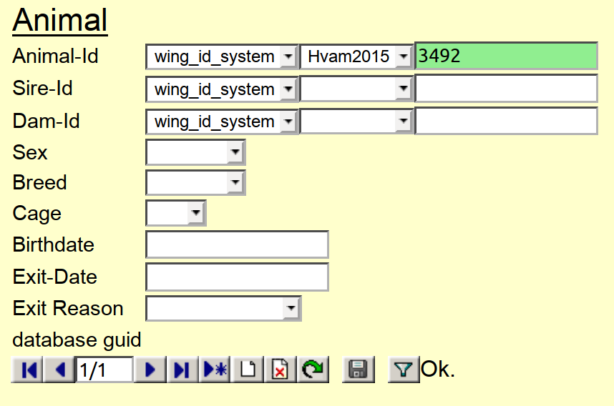

change something and press disc-button to store it in the database
