Problem 1)
A Researcher is interested to know whether the performance in a public examination by students of schools from Tsunami Affected area compared with other students is poor or not. A random sample of 10 students from coastal area schools is selected whose marks are given below. 68, 72 64,65,56,72,64,56,60,73. Another sample of 10 students from non- coastal area schools has the following marks 76,78,68,72,83,85,88,78. 80,81 (Level of significance at 5%)
Q1. Set the hypothesis of above problem.
Q2. Which parametric statistical tools is appropriate on the above data set.
Q3. Which hypothesis is accepted, If significance value is less than level of significance.
Q4. Write Down interpretation of above data set on the basis of hypothesis.
Solution: Check https://nattabiochem.files.wordpress.com/2009/08/selected-statistical-tests.pdf (Page 51)
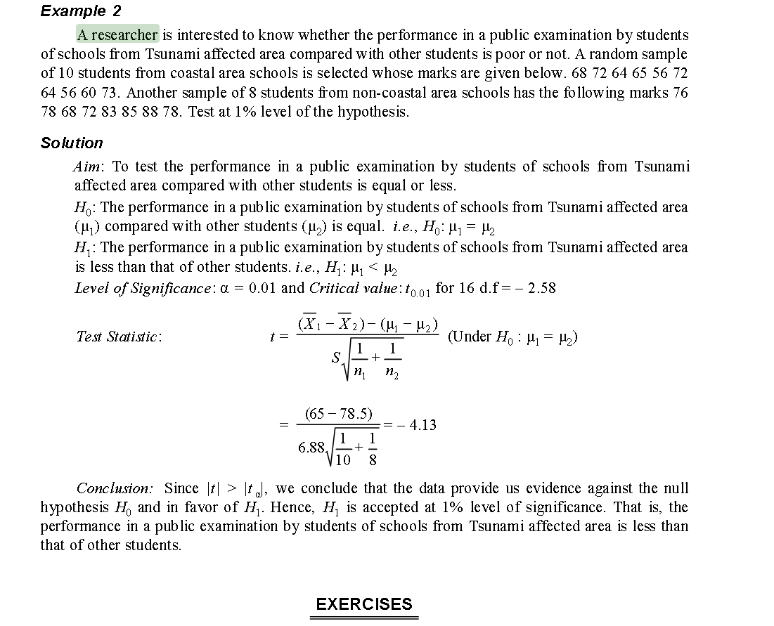

Problem2)
When to use non- parametric test? Explain Wilcoxon sign test with assumptions.
Solution:
A non parametric test does not assume anything about the underlying distribution, also that compared to parametric test, which makes assumptions about a population’s parameters (for example, the mean or standard deviation).
Non parametric tests are used when your data isn’t normal. Therefore the key is to figure out if you have normally distributed data.
- One or more assumptions of a parametric test have been violated.
- Your sample size is too small to run a parametric test.
- Your data has outliers that cannot be removed.
When the word “non parametric” is used in stats, it doesn’t quite mean that you know nothing about the population.
It usually means that you know the population data does not have a normal distribution.

The Wilcoxon signed rank test is a non-parametric test to compare data. The Wilcoxon signed rank test should be used if the differences between pairs of data are non-normally distributed.
The Wilcoxon signed rank test compares your sample median against a hypothetical median.
The Wilcoxon Sign Test requires two repeated measurements on a commensurate scale, that is, that the values of both observations can be compared. If the variable is interval or ratio scale, the differences between both samples need to be ordered and ranked before conducting the Wilcoxon sign test.
The Wilcoxon Sign test makes four important assumptions:
1. Dependent samples – the two samples need to be dependent observations of the cases. The Wilcoxon sign test assess for differences between a before and after measurement, while accounting for individual differences in the baseline.
2. Independence – The Wilcoxon sign test assumes independence, meaning that the paired observations are randomly and independently drawn.
3. Continuous dependent variable – Although the Wilcoxon signed rank test ranks the differences according to their size and is therefore a non-parametric test, it assumes that the measurements are continuous in theoretical nature. To account for the fact that in most cases the dependent variable is binominal distributed, a continuity correction is applied.
4. Ordinal level of measurement – The Wilcoxon sign test needs both dependent measurements to be at least of ordinal scale. This is necessary to ensure that the two values can be compared, and for each pair, it can be said if one value is greater, equal, or less than the other.

Problem3)
What do you understood by SPSS Software? Explain its following terms.
a) Variable view window and data view window
b) Sort cases
c) Select cases
d) Creating graphs
Solution:
- SPSS stands for “Statistical Package for the Social Sciences”
- This package is mainly used for statistical analysis of the data.
- SPSS is mainly used in educational research, healthcare, marketing, market researchers, health researchers, survey companies, education researchers, government, marketing organizations, data miners.
a) Variable view window and data view window
Variable view: Variable View is a view in which we find information about our data -dictionary information. It allows us to customize the data type as required for analyzing it. To analyze the data one needs to populate the different column headings like Name, Label, Type, Width, Decimals, Values, Missing, Columns, Align, and Measures.
Data view: The data view is structured as rows and columns. By importing file or adding data manually we can work with SPSS. Data View is where we inspect our actual data
b) Sort cases
Sort Cases: Sorting cases will rearrange the rows based on a given variable (or variables). The values for the selected variables can be sorted in ascending (smallest to largest, or alphabetical) or descending order (largest to smallest, or reverse alphabetical).
c) Select cases
Select cases: Sorting cases will rearrange the rows based on a given variable (or variables). The values for the selected variables can be sorted in ascending (smallest to largest, or alphabetical) or descending order (largest to smallest, or reverse alphabetical).
d) Creating graphs
Creating Graphs: SPSS allows to create Pie Charts, Histograms, Bar Charts and various other graph that enable data visualizations.

Problem4)
Why we use sampling? A sample of 50 students is to be drawn from a population consisting of 500 students belonging to two institutions A and B. The number of students in the institution A is 200 and the institution B is 300.
Q1) How will you draw the sample using proportional allocation?
Q2) In above problem which sampling method we will use for selection of samples?
Solution:
There are two strata in this case with sizes N1 = 200 and N2 = 300 and the total population
N = N1 + N2 = 500
The sample size is 50.
If n1 and n2 are the sample sizes,
n1 = 𝑛/𝑁 × N1 =50/500×200=20
n2 = 𝑛/𝑁 × N2 =50/500×300=30
The sample sizes are 20 from A and 30 from B.
Then the units from each institution are to be selected by simple random sampling.

