LAB- Spring Security Basics

Step 1 -- Securing an App using Spring boot with Basic and Form Based Authentication

In this step you will be working on 01-security-basics-start project.

Open HelloController.java and observe it.

Open WebSecurityConfiguration.java and observe that it is empty now.

This application is not yet secured.

Now start this application and make a request to http://localhost:8080/hello?name=Siva

Observe that you get the response as expected.

Now we want to secure this application.

Open pom.xml and complete TODO-1 in it.

Now restart the application. You should observe that there is a password logged into the console.

Now make a request to http://localhost:8080/hello?name=Siva

You should be redirected to login page at http://localhost:8080/login

Give username as user and password which is printed on the console as credentials and login

You should be shown the the response from the controller.

We don’t want the default username as user. We want to configure our own username and password. Open application.yml and configure the below:

spring:
security:
user:
name: siva
password: secret

Now restart the application, restart the browser and make a request http://localhost:8080/hello?name=Siva

You should be able to login using siva/secret

We want more than one user details to be configured in memory.

Open WebSecurityConfiguration.java and complete TODO-2

Observe how we are encoding passwords using Password encoders.

Now restart the application, restart the browser and make a request http://localhost:8080/hello?name=Siva

You should be able to login using the user details configured in InMemoryUserdetailsManager bean.

we want to store userdetails using h2 as embedded database.

Open pom.xml and observe that we have already added h2 as a dependency using below xml

<dependency>
<groupId>com.h2database</groupId>
<artifactId>h2</artifactId>

</dependency>

To enable h2 console, add the below in application.yml

spring:
h2:
console:
path: /h2-console
enabled: true

datasource:
url: jdbc:h2:mem:mydb
username: siva
password: siva

Open WebSecurityConfiguration.java and modify complete TODO-3

Open data.sql and schema.sql in src/main/resources and obsere the tables DDL and inserts
These sql files will be automatically executed by spring boot on embedded database.

That’s it. We have now configured our security configuration to use jdbc authentication.

Now give a request to http://localhost:8080/hello?name=Siva and use the credentials from data.sql

You should be successfully logged in using credentials from database

We have used form based authentication till now which is the default.
Why is form based authentication the default?

How did my application get security just by adding security Starter Dependency?

Open SecurityAutoConfiguration.java and observe that it is importing SpringBootWebSecurityConfiguration.java

Open SpringBootWebSecurityConfiguration.java
It has below code which is configuring a bean SecurityFilterChain

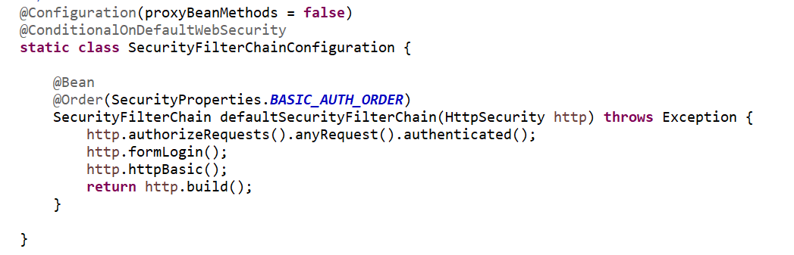

Above SecurityFilterChain bean is configured for both form based and basic Authentication.

Now we want to enable Basic Authentication.

If we define our own SecurityFilterChain with lesser order, our filter chain will be given precedence.

Open WebSecurityConfiguration.java under com.way2learnonline package and complete the TODO-4

Now restart the application and give a request to http://localhost:8080/hello?name=Siva

Your browser should ask for username/password in a pop up window.

Step 2 -- Securing an App using Spring boot with Digest Authentication

Now We want to configure 2 SecurityFilterChains. One for Digest and other for Basic Authentication.

Open WebSecurityConfiguration.java and complete TODO-5 to TODO-7 Make sure that you complete TODOs in order.

Observe that we have configured Order as 1 for myAdminSecurityFilterChain and 2 for mySecurityFilterChain. Can you tell why?

Now run the application in debug mode.

Open DelegatingFilterProxy.java and keep a break point at keep a break point at the last line of doFilter() method.

Now give a request to http://localhost:8080/admin/hello?name=Siva

Observe that there will be 2 Filter chains as shown below:

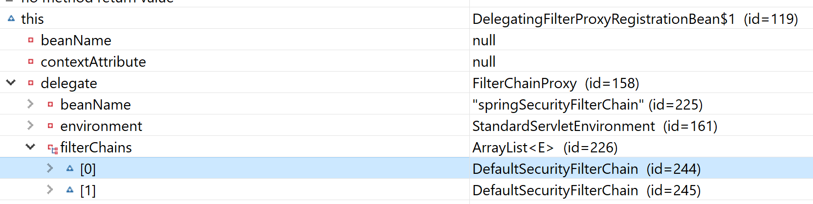

Observe that First filter chain I mapped to /admin/**

Observe that there is DigestAuthenticationFilter in the first chain.

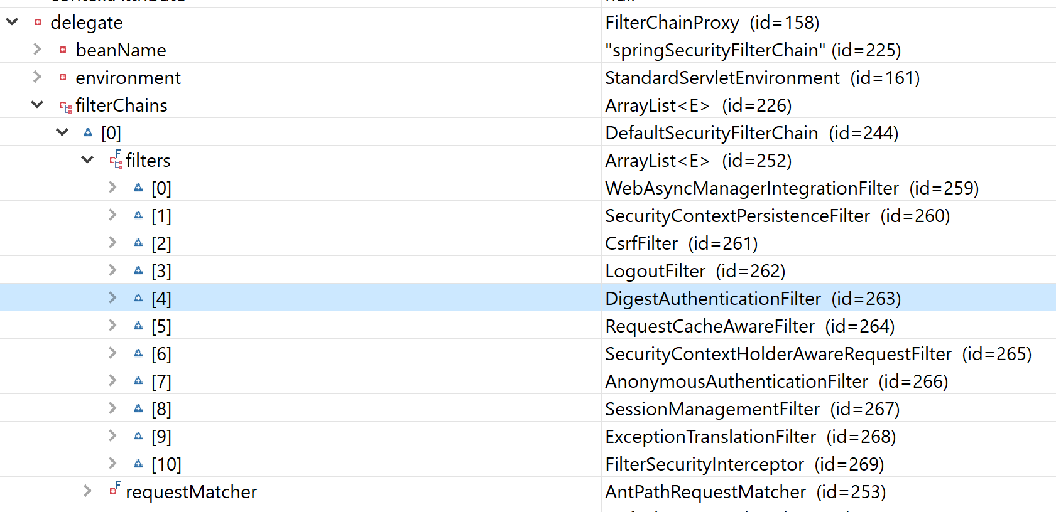

Given admin credentials as admin/adminsecret . You should be able to see the response successfully.

Restart your browser now.

Right click on Firefox and open “Inspect Element” and click on network.

Now give a request to http://localhost:8080/admin/hello?name=Siva
It should ask for username/password. Click on cancel and observe the network tab

You should observe WWW-Authenticate header as shown below in the response headers

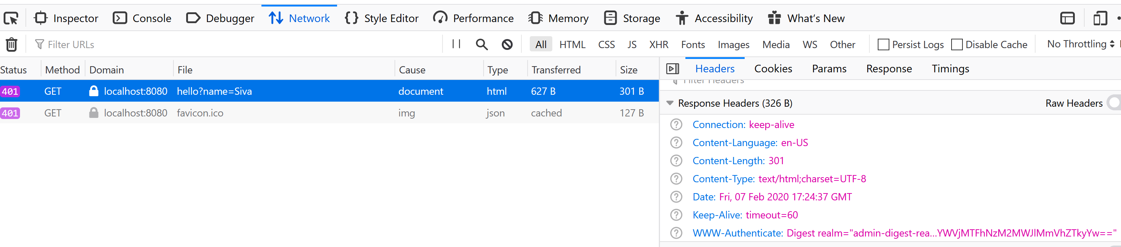

This proves that the server is requesting for digest authentication

.

Step 3– Configuring Custom Form login

We want to enable Form login for any url other than /admin/**

Open WebSecurityConfiguration.java and modify the mySecurityFilterChain method as shown below:

@Bean
@Order(2)
SecurityFilterChain mySecurityFilterChain(HttpSecurity http) throws Exception {
/*

http.authorizeRequests().anyRequest().authenticated();
http.httpBasic();

return http.build();
*/

http
.authorizeRequests()
.antMatchers("/h2-console/**","/mylogin").permitAll()
.anyRequest().authenticated()
.and()
.formLogin().loginPage("/mylogin")
.and().csrf().disable();

http.headers().disable();

return http.build();

}

Observe that we have disabled csrf.

Open MvcConfiguration.java and fully uncomment it. Observe how we have configured viewcontroller for /mylogin

Open mylogin.html in src/main/resources/templates and observe it.

Restart the application now .
Give a request to http://localhost:8080/hello?name=Siva. You should be redirected to /mylogin and you should see that the custom login page is dispayed

But css is not displayed properly.
We don’t want security for static files like css

So, Open WebsecurityConfiguration.java and the configure a bean as shown below:

@Bean
public WebSecurityCustomizer webSecurityCustomizer() {
return (web) -> web.ignoring().antMatchers("/css/**", "/webjars/**");
}
Restart the application now .
Give a request to http://localhost:8080/hello?name=Siva. You should be redirected to /mylogin and you should see that the custom login page is dispayed properly with css.

You should be able to login successfully.

Step 4 – Remember me

We want to enable remember me functionality for my app.
Open login.html and uncomment the check box code for remember me check box

Open WebSecurityConfiguration.java and enable rememberme filter as shown below:

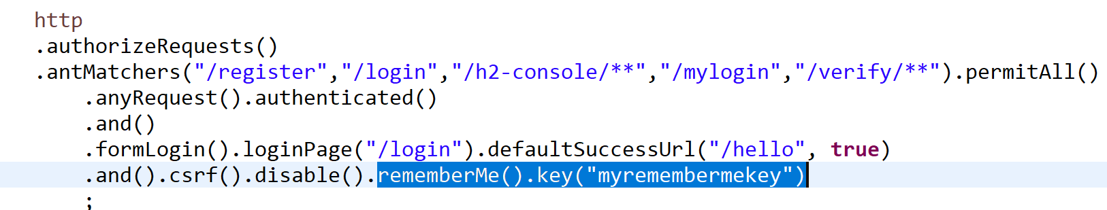

Now, give a request to http://localhost:8080/hello?name=Siva

You should be redirected to login page and now you should see remember me check box.

Press F12 on your firefox browser and click on storage tab to see cookies. You should see only jsessionid cookie.

Now submit your credentials and login.
After logging in, you should see remember-me cookie also.

Now just delete the jsessionid cookie and refresh the browser. You will not be prompted for login again. You will be automatically authenticated using remember me cookie

I have explained you how

In WebSecurityConfiguration.java, configure logout such that remember-me cookie is deleted once logout is successful as shown below:

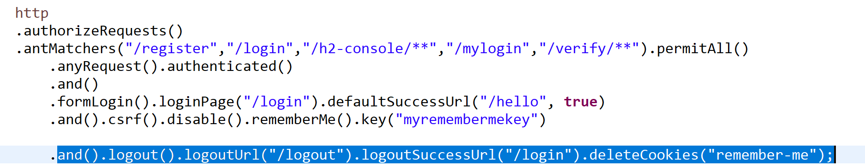

Step 4– Enabling Https for Spring Boot Application

Create your own keystore using the below command

keytool -genkey -alias tomcat -storetype PKCS12 -keyalg RSA -keysize 2048 -keystore mykeystore.p12

Create Give the keystore password as tomcat

Copy the created mystore.p12 into src/main/resources.

Configure below in application.yml

server:
port: 8443
ssl:
key-store-password: tomcat
key-store: classpath:mykeystore.p12
key-store-type: PKCS12
key-alias: tomcat

Now give a request to https://localhost:8443/hello?name=Siva
You should be able to login and see the page

What if some one gives a request to http://localhost:8080/hello?name=Siva
We want the redirect to https://localhost:8443/hello?name=Siva

Open Application.java and complete TODO-13

Now restart the application and give a request to http://localhost:8080/hello?name=Siva

You should be redirected to login page which uses https and port 8443

Step 5– Externalizing secrets to Vault

In this step, we will be storing our sensitive information in vault.

We will be using HashiCorp’s Vault.

It can be downloaded from https://www.vaultproject.io/downloads/

But I have given you the downloaded zip file to you in micro-lab-docs folder. Extract it.

Copy vault.hcl given to you under the extracted folder.
Open vault.hcl and observe the configuration . It is configured to listen at 8200 and tls is disabled

Use the below command to start vault

Vault server –config ./vault.hcl

Our Vault server now is running, but since this is its first run, we need to initialize it.

Set VAULT_ADDR=http://localhost:8200
vault operator init

After issuing the above command, we should see a message like this:

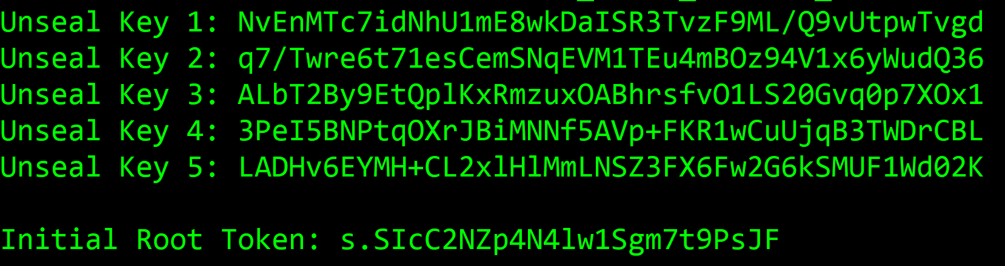

The five first lines are the master key shares that we will later use to unseal Vault's storage. Please note that Vault only displays the master key shares will during initialization – and never more. Take note and store them safely or we'll lose access to our secrets upon server restart!

Now execute the below command:

Set VAULT_TOKEN= <root token value>

Let's see our server status now that we have initialized it, with the following command:

Execute the following command:

vault status

you should see as shown below:

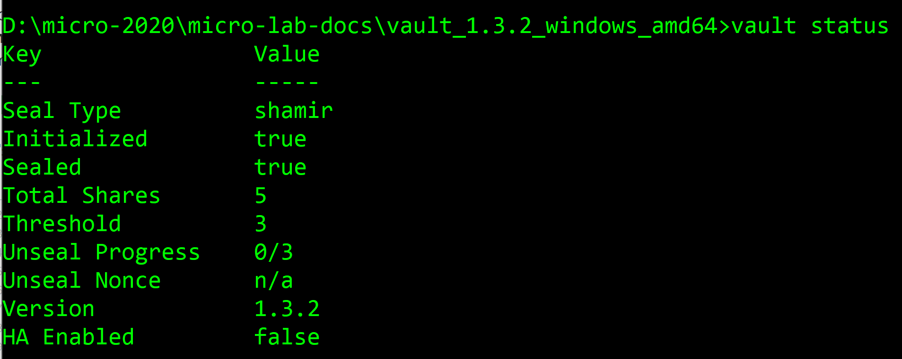

Observe that the vault is sealed

Observe the unseal progress: “0/3” means that Vault needs three shares, but got none so far. Let's move ahead and provide it with our shares.

We now unseal Vault so we can start using its secret services. We need to provide any three of the five key shares in order to complete the unseal process:

vault operator unseal <key share 1 value>
vault operator unseal <key share 2 value>
vault operator unseal <key share 3 value>

After executing all the 3 commands, value should be unsealed

Now You need to enable the KV secrets engine at path secret

Execute the following commands

vault secrets enable -path=secret/ kv

Now put a key value pair into vault using below command:

vault kv put secret/myapp keystorepassword=tomcat

Till now, we have started valut and stored keystorepassword=tomcat in vault

Now we want out spring boot app to read secrets from valut.

Open pom.xml and complete TODO-14

Now create a file with name bootstrap.yml under src/main/resources and configure it will following:

spring:
application:
name: myapp
cloud:
vault:
host: localhost
port: 8200
scheme: http
# authentication: token
token: s.yZPi3ogu1BI585ZHw9Dqh2EZ

Now Replace the key token in bootstrap.yml with the root token which you got when you initialized vault

In application.yml replace the value of server.ssl.key-store-password with ${keystorepassword}

Now start your application and give a request to http://localhost:8080/hello?name=siva

Everything should work fine and you should be redirected to login page which uses https

This means that the keystore password is retrieved from the vault successfully.

Good Blog to refer:
https://spring.io/blog/2022/02/21/spring-security-without-the-websecurityconfigureradapter

CONGRATULATIONS YOU KNOW HOW TO SECURE YOUR APPLICATION USING SPRING BOOT

