LAB- Securing using oAuth2

Step 1 – Creating a Custom Authorization Server

In this step you will be working on 01-oauth2-server-start project.

Open pom.xml and observe that we have added
<dependency>
<groupId>org.springframework.security</groupId>
<artifactId>spring-security-oauth2-authorization-server</artifactId>
<version>0.3.0</version>
</dependency>

Authorization Server exposes endpoints for
requesting access token,checking the access token,Authorizing the client,etc

All those beans are registered by AutoConfiguration classes related to oAuth server.

Open AuthorizarionServerConfiguration.java and complete TODO-1 and TODO-2

Observe how we have configured other beans in AuthorizarionServerConfiguration.java

Start this application from boot dashboard and use postman to make a POST request to http://localhost:8000 /oauth2/token

Select Authorization tab in postman, select Basic Auth in the drop down and give client1/myClientSecretValue as username/password

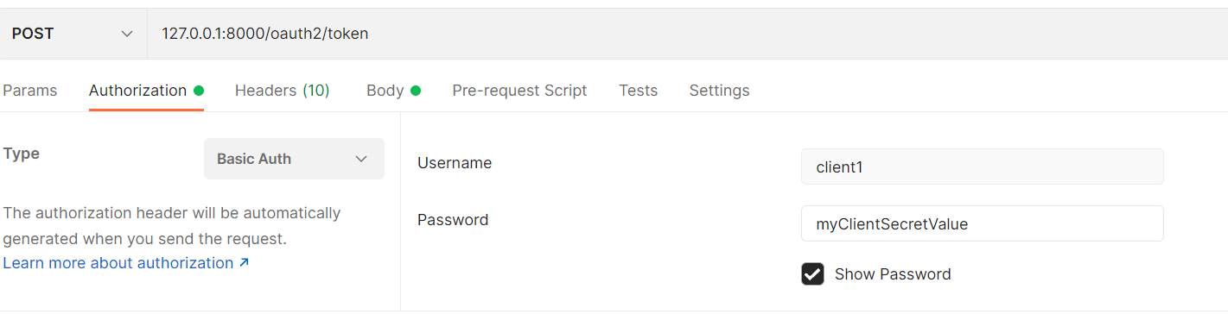
Observe that Authorization header will be added in post man.

Select Body and select x-www.form-url-encoded and give grant_type as client_credentials as shown below:

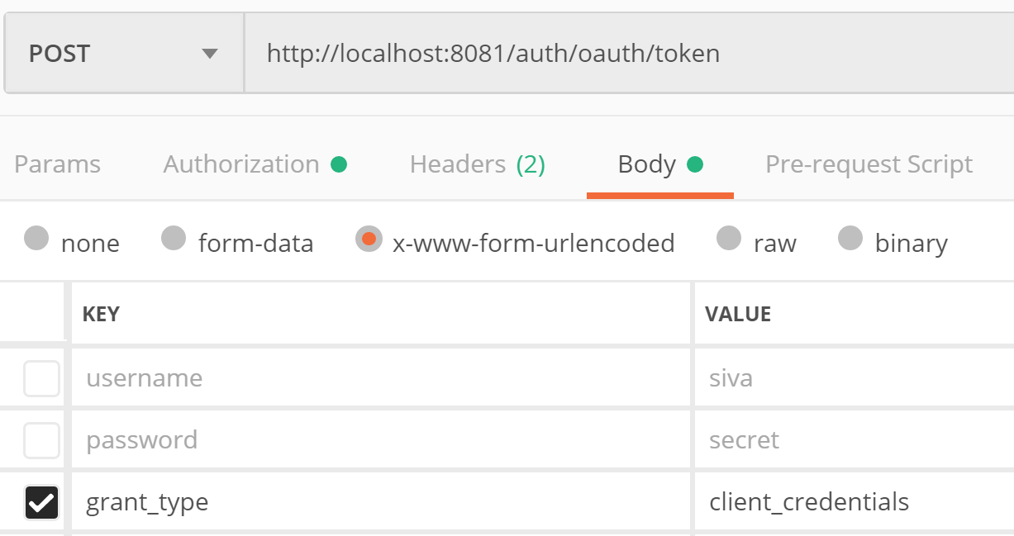

Now click on send in post man to make a request.

You should get the access token.

Congratulations!! U understood how to get access token using client_credentials grant type

Now we want to use authorization code grant for obtaining access token.

Open AuthorizationServerConfiguration.java and configure RegisteredClient to use AuthorizationCode grant instead of ClientCredentials by changing the following

.authorizationGrantType(AuthorizationGrantType.AUTHORIZATION_CODE)

/oauth2/authorize is the authorization endpoint of authorization server. If authorization has to be done, user needs to login and then only user can authorize the client. So, /oauth2/authorize endpoint has to be secured.

Open SpringSecurityConfiguration.java and complete TODO-3 and TODO-4

First we need to get authorization code and then using authorization code we can get access token.

Do the following to get authorization code:

Open browser and make a GET request to http://localhost:8000/oauth2/authorize?response_type=code&client_id=client1&redirect_uri=http://127.0.0.1:9001/authorized&scope=openid read mywrite

U will be redirected to login page of authorization server. Once u login using credentials siva/password, u will be redirected to the consent page. Once u provide consent, u will be redirected to given redirect_uri http://127.0.0.1:8080/authorized with code as query parameter

Once we get auth code, we can exchange it to get access token

Open postman and make a POST request to http://localhost:8000/oauth2/token

Select Authorization tab in postman, select Basic Auth in the drop down and give client1/myClientSecretValue as username/password

Observe that Authorization header will be added in post man.

Select Body and select x-www.form-url-encoded and give grant_type as authorization_code, code and redirect_uri as shown below:

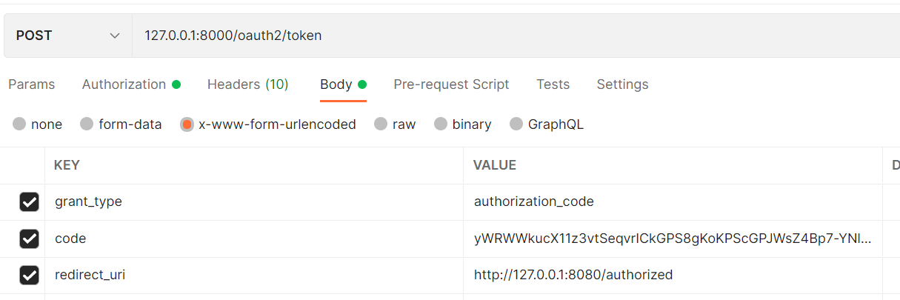

Now, make a request and observe that u get access token

Congratulations!! U understood how to get access token using authorization code grant type

Step 2 – Securing a Resource Server

In this step you will be working on 02-resource-server-start project.

Open pom.xml and observe that we have added below dependency

<dependency>
<groupId>org.springframework.boot</groupId>
<artifactId>spring-boot-starter-oauth2-resource-server</artifactId>
</dependency>

As we have added resource server dependency, the auto configuration will configure all the beans required for securing all URLs in this application.

To access any URL, access token is required.

When access token is received in the request, it need to be validated. To Validate the JWT token, u need the key. So, u need to tell to this resource server where it can obtain keys.

Open application.properties and the following

spring.security.oauth2.resourceserver.jwt.issuer-uri=http://auth-server:8000

Start the application.

Make a request to http://auth-server:8000/.well-known/oauth-authorization-server and observe the response. Did u get what is the authorization endpoint url , token endpoint url ,etc ?

Open OrderController.java and observe the code.

Try to give a GET request to http://127.0.0.1:8091/orders from PostMan and observe that u get 401 status code in response.

So, get the access token by following the step1 as described above.

Now using postman, make a GET request to http://127.0.0.1:8091/orders . Make sure u add Authorization header with value “Bearer <<accesstoken>>” as shown below

Now You should get success response

Congratulations!! U understood how to Secure Resource Server

Step 3 – Securing a web application client with authorization grant flow

In this step you will be working on 03-oauth2-web-client-start project.

Open pom.xml and observe that we have added below dependency

<dependency>
<groupId>org.springframework.boot</groupId>
<artifactId>spring-boot-starter-oauth2-client</artifactId>
</dependency>

Open application.properties and observe that we have configured the following

spring.security.oauth2.client.registration.mywebclient.client-id=client1
spring.security.oauth2.client.registration.mywebclient.client-secret=myClientSecretValue
spring.security.oauth2.client.registration.mywebclient.scope=openid
spring.security.oauth2.client.registration.mywebclient.authorization-grant-type=authorization_code
spring.security.oauth2.client.registration.mywebclient.redirect-uri=http://127.0.0.1:8080/login/oauth2/code/mywebclient

spring.security.oauth2.client.provider.mywebclient.issuer-uri=http://auth-server:8000

spring.security.oauth2.client.provider.mywebclient.authorization-uri = http://auth-server:8000/oauth2/authorize
spring.security.oauth2.client.provider.mywebclient.token-uri = http://auth-server:8000/oauth2/token
spring.security.oauth2.client.provider.mywebclient.jwk-set-uri=http://auth-server:8000/oauth2/jwks

Observe that all the properties are following pattern spring.security.oauth2.client.registration.<<clientregistrationid>>

Observe that clientregistrationid is mywebclient in all the properties

Observe that mywebclient is the registrationid used while configuring RegisteredClient

Open OrderController.java and observe the code.

As we have added the OAuth2 client dependency, autoconfiguration will configure all the beans required for securing this application

If you try to give a request to /orders (Don’t make request now, just read to understand) , u will be redirected to authorization endpoint of authorization server. U already configured below property which tell the authorization endpoint

spring.security.oauth2.client.provider.mywebclient.authorization-uri = http://auth-server:8000/oauth2/authorize

As this end point is secured at authorization server, u will be redirected to login page of authorization server. Once you login using the credentials, you will be redirected to the redirect url specified in the property

spring.security.oauth2.client.registration.mywebclient.redirect-uri=http://127.0.0.1:8080/login/oauth2/code/mywebclient

While redirecting, authorization server will send the authorization code in the URL

At this URL, there will be a security filter which will take authorization code and obtain access token from the authorization server. Using this token, Oauth2AuthorizedClient will be populated and SecurityContext Will also be populated.

So, when ever required, we can access the access token from SecurityContext or Oauth2AuthorizedClient

Open OrderController.java and observe how we are injecting OAuth2AuthorizedClient into getOrders method.

Complete TODO-1 in OrderController.java and understand how we are getting accesstoken and using that token to make a rest api call to resource server

Now start the application and make a request to http://localhost:8080/orders using the browser

You will be redirected to login page of authorization server. Once u login, u can see the orders page with orders.

Observe that access token is logged on the console.

We can use WebClient to make requests instead of RestTemplate.

Open Application.java and observe how we have configured WebClient bean

Complete TODO-2 in OrderController.java to use webclient.

Congratulations!! U understood how to Secure a web application client using authorization CodeGrant Flow

Step 4 – Securing a web application client with using google

In this step you will be working on 04-oauth2-google-login project.

Open pom.xml and observe that we have added

<dependency>
<groupId>org.springframework.boot</groupId>
<artifactId>spring-boot-starter-oauth2-client</artifactId>
</dependency>

Go to https://console.developers.google.com/

Click on Credentials link in the left menu
Click on Create credentials ,select “Oauth Client Id”

Select Application type as “Web Application”

Give Some Name , and redirect uri as http://localhost:8080/myapp/login/oauth2/code/google and create.

Note down the client-id and client-secret shown

Now configure following in application.yml

spring.security.oauth2.client.registration.google.client-id=<<client id obtained from google>>
spring.security.oauth2.client.registration.google.client-secret==<<client secret id obtained from google>>
spring.security.oauth2.client.registration.google.redirect-uri=http://127.0.0.1:8080/login/oauth2/code/google

Open Oauth2AuthenticationSuccessHandler.java given to you in com.way2learnonline package and observe that it is extracting user details from OAuth2AuthenticationToken
And saving MyAppUser into database if user is not existing.

Open WebSecurityConfiguration.java and observe that we have configured SecurityFilterChain as shown below:

@Bean
@Order(2)
SecurityFilterChain mySecurityFilterChain(HttpSecurity http) throws Exception {

http
.authorizeRequests()
.antMatchers("/h2-console/**","/mylogin","/login/**").permitAll()
.anyRequest().authenticated()
.and()
.oauth2Login().loginPage("/mylogin")
.successHandler(oauth2authSuccessHandler)
.and().csrf().disable();

;

http.headers().disable();

return http.build();

}

Open login.html under templates folder and observe how we have added link for Google Login

That’s all !!
Now give a request to http://localhost:8080/orders so that you will be redirected to login page.

In the login page choose to login using google.

You should be successfully logged in.

Congratulations!! U understood how to Secure a web application client using Google Login!!

https://cloud.spring.io/spring-cloud-static/spring-cloud-security/2.1.3.RELEASE/single/spring-cloud-security.html#_client_token_relay_in_spring_cloud_gateway

