Network Diagram: App_Code_I3SQL

Generated: 2025-10-22 17:19:15

# Server Classification Summary

Server Classification Summary:  
  
 • Web: 1 server(s)  
 - server-not-found (Unknown)

# Architecture Diagram

*Note: This diagram shows the network architecture with server classification. For best quality, SVG files are available for manual import (infinite zoom capability).*

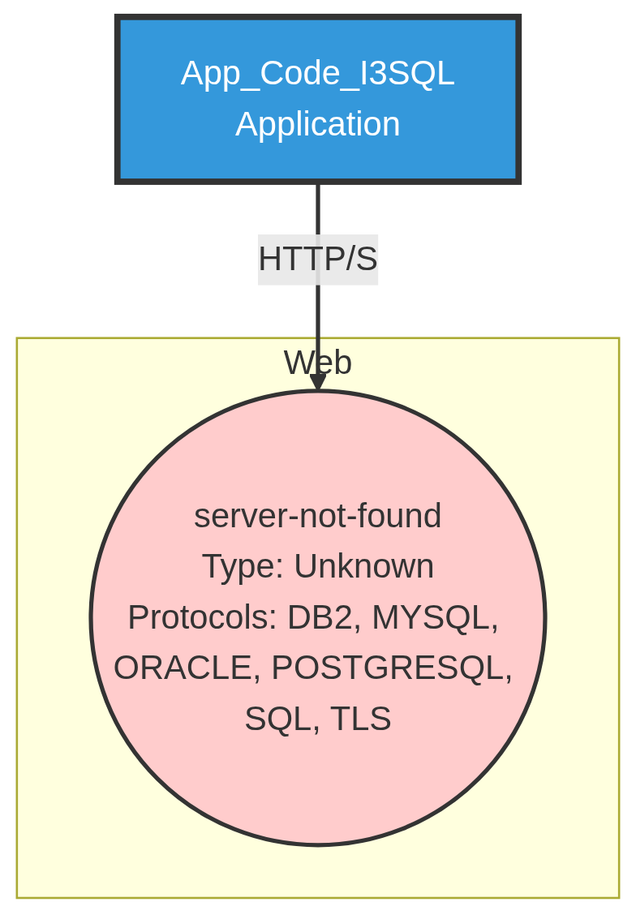

# For Best Diagram Quality

## Automated (Good Quality)

* Word documents automatically include high-resolution PNG diagrams (4800px width).
* This provides excellent quality for most use cases.

## Manual (Perfect Quality - Recommended for Presentations)

For infinite zoom capability:

* 1. Locate SVG file: App_Code_I3SQL_enhanced.svg
* 2. In Word: Insert → Pictures → Select SVG file
* 3. Replace existing PNG diagram
* 4. Result: Perfect quality at any zoom level

## Use HTML Diagrams

* Open: App_Code_I3SQL_enhanced.html
* - Perfect zoom in web browser
* - Interactive pan/zoom controls
* - Ideal for presentations via browser