Online Appendix

**Additional notes on overview**

In the previous studies, the individuals in exposed phase were often defined as infected but not contagious (Perez & Dragicevic, 2009). This rule is largely aligned with the types of diseases like influenza. However, in the case of COVID-19, the presymptomatic individuals are able to infect susceptible people (citation?). Therefore, we modified the exposed phase rules in the SEIR model to simulate the disease spreading through the presymptomatic and asymptomatic contacts, i.e., the infected individuals without showing symptoms. Then we add a module of tracing and quarantine to examine the effects of full and partial quarantine on the disease spreading.

**Additional notes on contact network**

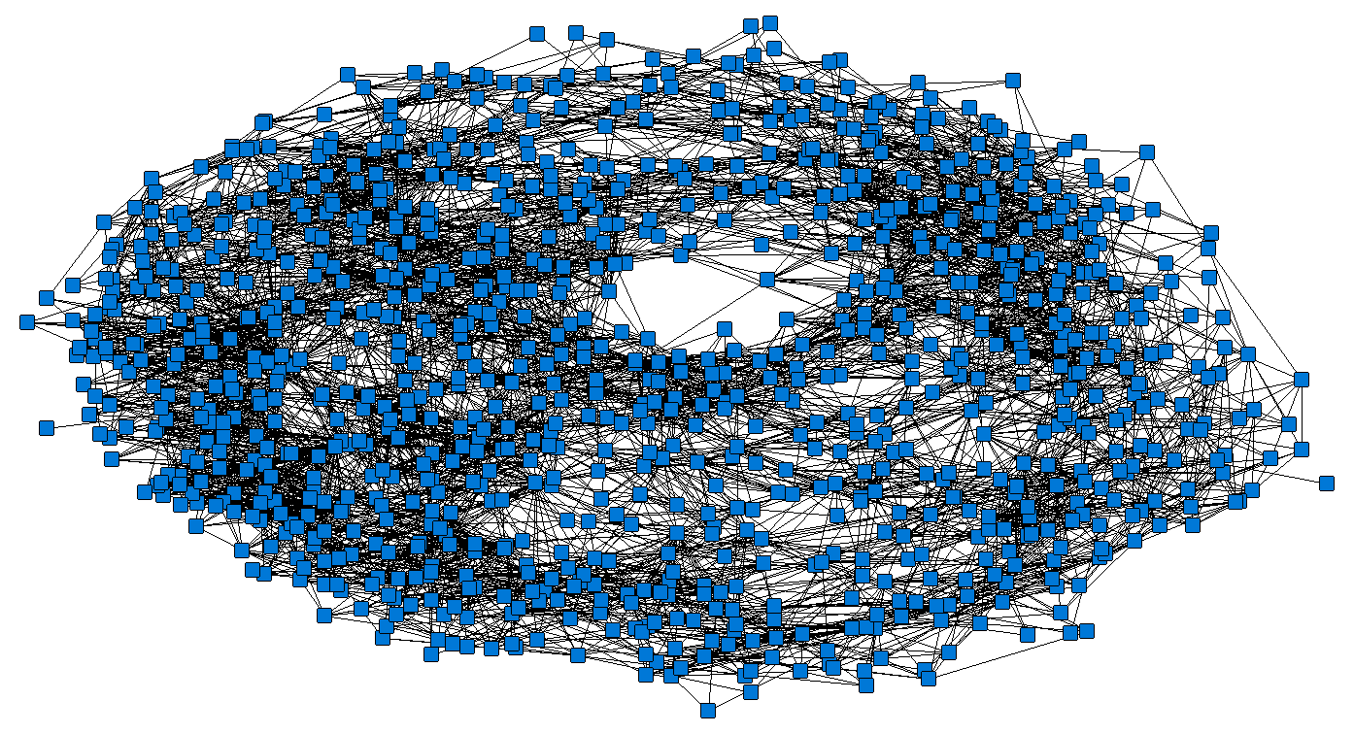

|  |  |
| --- | --- |
| **Whole-network metric** | **Value** |
| Nodes | 1000 |
| Ties | 13002 |
| Density | .013 |
| Clustering coefficient | .33 |
| Average path-length | 4.59 |
| Average degree | 13.00 |

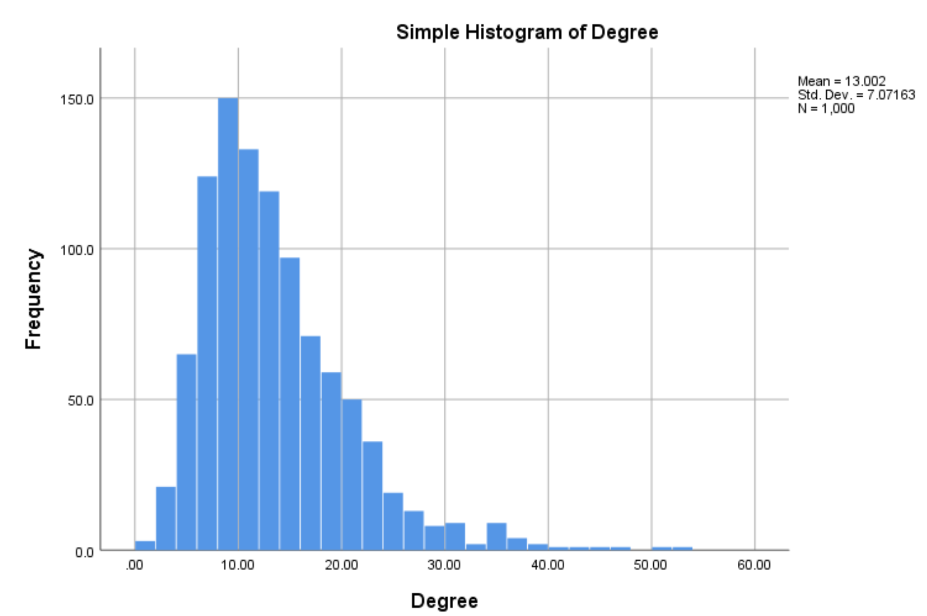

**Additional notes on model verification**

These parameters are emerging as they result from the interaction of multiple settings that are directly set in the model. Each parameter combination was run at least 30 time to gain the sufficient data point for statistical analyses.

**Number of possible contacts*.*** In this model, the number of possible contacts is determined by the infection radius, the population size and the simulation world resolution. The relationship among the three settings can be represented as:

For example, in a 30x30 world resolution with a population size of 1000, an agent with an infection radius of 4 may have 13~14 contacts, which somewhat reflect the average contacts in the USA and European countries reported by social network and tracing studies (e.g., Del Valle et al., 2007; Mossong et al., 2008; Rothwell, 2020). The OFAT test results confirmed the number and showed that the resulting number of possible contacts was relatively stable holding the infection radius and population density constant (see Table 2).

Table 2.

*OFAT test results on estimation of R0 and number of contacts per person, with a mobility of 2, infection radius of 4, incubation period of 8, and a transmission rate of 45%*

|  |  |  |  |  |  |  |
| --- | --- | --- | --- | --- | --- | --- |
| Population-size | World resolution | Population Density | Estimated R0 | | Contacts per person | |
|  |  |  | Mean | SD | Mean | SD |
| 1000 | 61 x 61 | 0.269 | 2.42 | 0.30 | 13.54 | 0.13 |
| 2000 | 87 x 87 | 0.264 | 2.43 | 0.31 | 13.29 | 0.11 |
| 3000 | 105 x 107 | 0.267 | 2.42 | 0.32 | 13.43 | 0.10 |
| 4000 | 121 x 123 | 0.269 | 2.51 | 0.30 | 13.50 | 0.07 |
| 5000 | 137 x 137 | 0.266 | 2.54 | 0.36 | 13.39 | 0.10 |
| 6000 | 149 x 151 | 0.267 | 2.54 | 0.48 | 13.42 | 0.07 |
| 7000 | 161 x 163 | 0.267 | 2.42 | 0.45 | 13.40 | 0.06 |
| 8000 | 173 x 173 | 0.267 | 2.47 | 0.48 | 13.44 | 0.06 |

**The basic reproduction number (R0).** R0 is defined as the average secondary cases generated by a primary case in a completely susceptible population. In this model, we estimate the R0 using the average number of secondary cases per patient from the first day to the day that is right before the first recovered individual is present, introducing immunity into the system. With a constant number of contacts, the R0 may be affected by mobility, incubation period, and transmission rate. The OFAT test results suggested that incubation period and transmission rate more significantly affected the R0 than mobility. Disease spreading does not take place when incubation period is shorter than 3 days, or transmission rate is 10% or below.

The tests also revealed that estimation of R0 was not linearly related to transmission rate or incubation period. The simulation dynamic showed that, to certain extent, the increase of incubation period or transmission rate may lead to a quick decrease in the susceptible people, which in turn leads to a decreased R0. Different R0 numbers have been reported in the past few months for COVID-19, ranging from 1.5 to 6 (Liu et al., 2020). In the results section, we will report our testing results for two situations in which R0 falling into the 2 and 3, which is the current estimate of the R0 according to John Hopkins University (Eisenberg, 2020). In situation 1, we proceed with settings that produce an R0 range of 2.00 ~ 2.20. This can be thought of the low-end R0 context. In situation two, we proceed with setting that produce an R0 range of 2.40-2.60. In this situation, we can interpret these setting as the high-end R0 context (see Table 3).

*Model settings*

|  |  |  |
| --- | --- | --- |
| Parameter | Settings | |
| Low-end context  Observed R0 = 2~2.2 | High-end context  Observed R0 = 2.4~2.6 |
| Population-Size | 1000 | 1000 |
| World Resolution | 61 * 61 | 61 * 61 |
| Infection Radius | 4 | 4 |
| Mobility | 2 | 2 |
| Incubation period | 7 days | 8 days |
| Transmission rate | 40% | 45% |
| Disease period | 10 days | 10 days |
| Quarantine period | 14 days | 14 days |
| Fatality rate | 2% | 2% |
| %-contacts-quarantined | 5%~100% | 5%~100% |
| %-Asymptomatic-carriers | 0% | 0% |
| Quarantine-time-lags | 0 day | 0 day |

**Additional notes on prevalence**

Although there are debates around what level of prevalence would be needed for herd immunity to develop, traditional herd immunity thresholds can be used as a rough guide to determine if any of the contact tracing interventions succeed in containment. Fine, Eames, and Heymann (2011), for example, define critical level of infection prevalence for herd immunity to develop (Hc) as a function of the R0 value of the infection:

Based on this equation, the critical prevalence level (Hc) for the low-context spread condition (R0 = 2.17) would be 53.91%. Likewise, the crucial prevalence level for the high-context spread condition (R0 = 2.62) would be 61.83%. For interpretation, we might be interested to see if manipulating network accuracy and level would produce results that would fall below those critical prevalence levels.

**Sensitivity analysis**

**High Group: 1st-level**

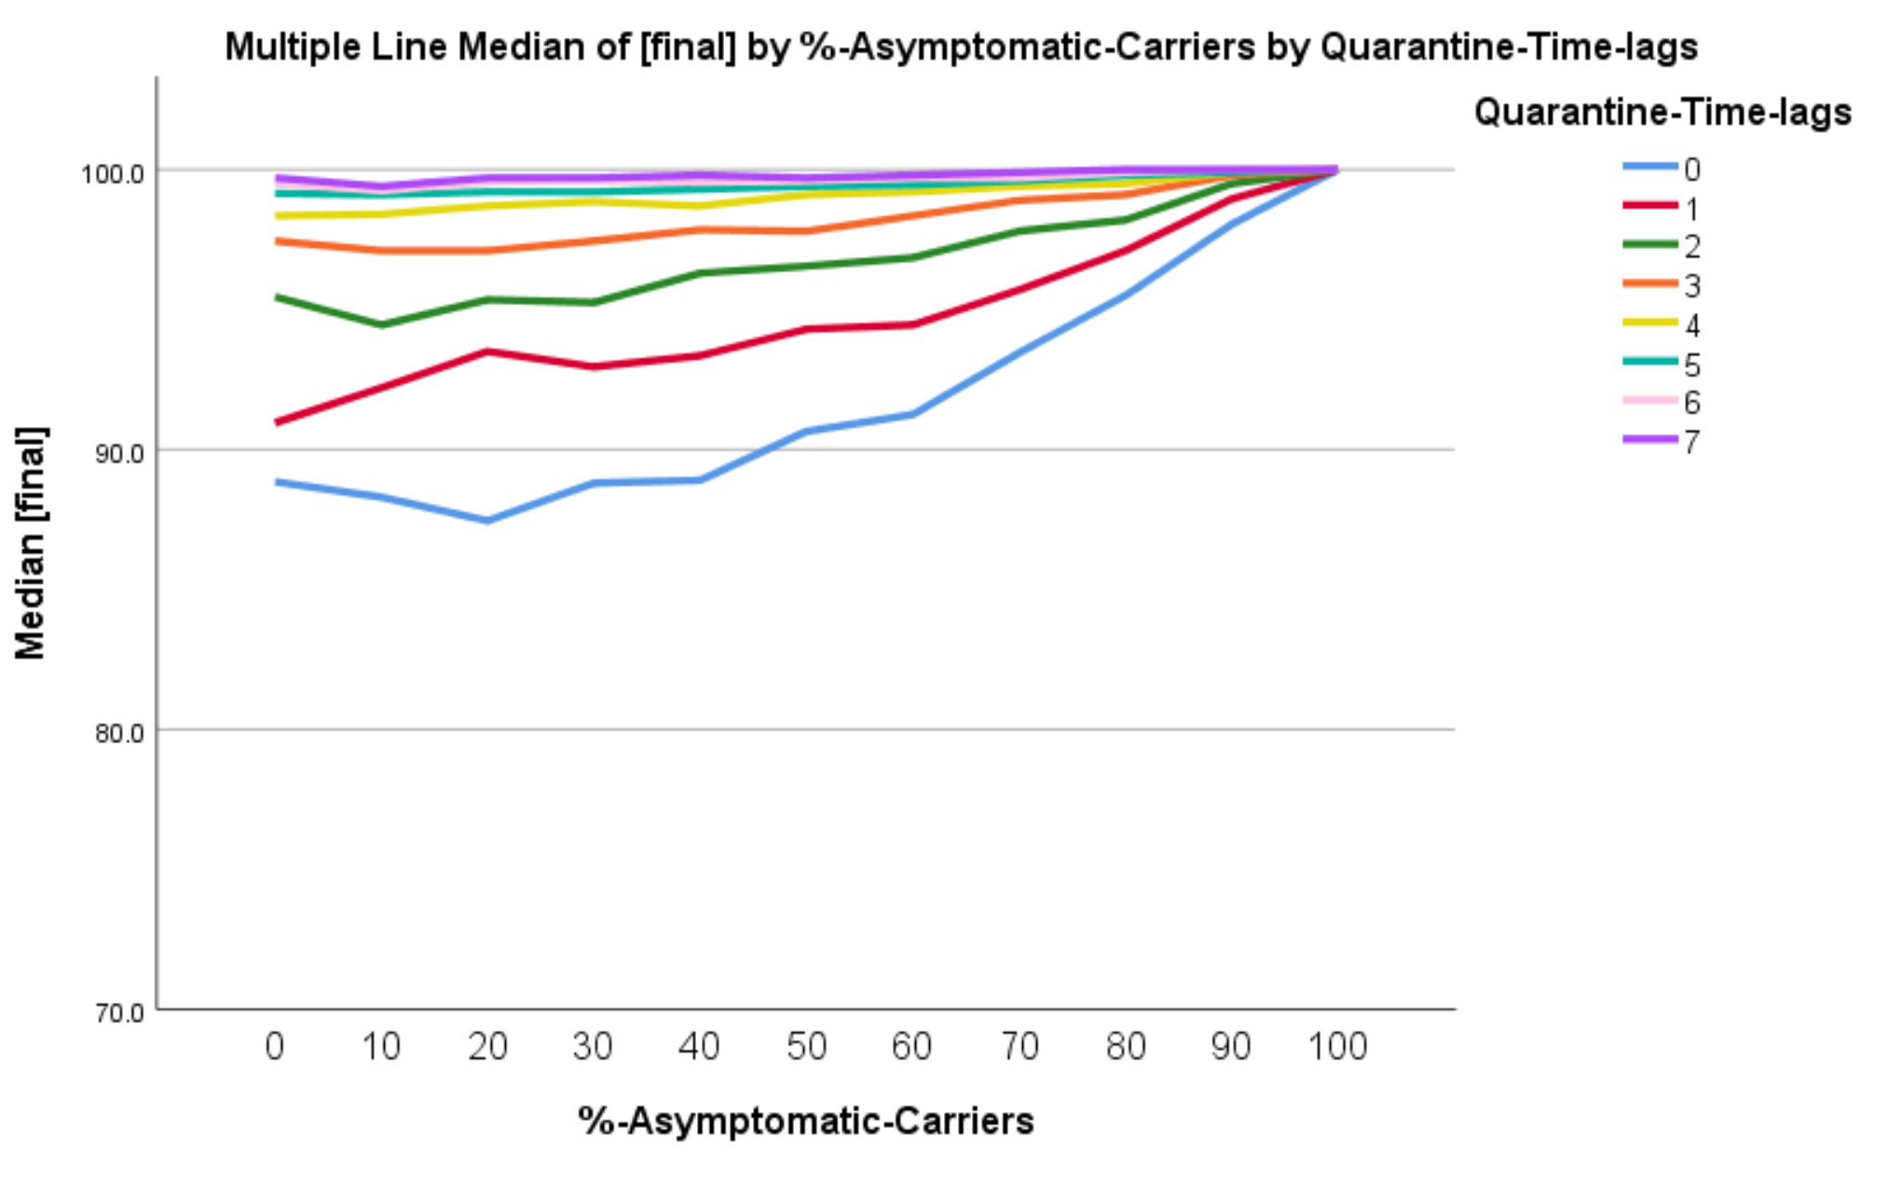

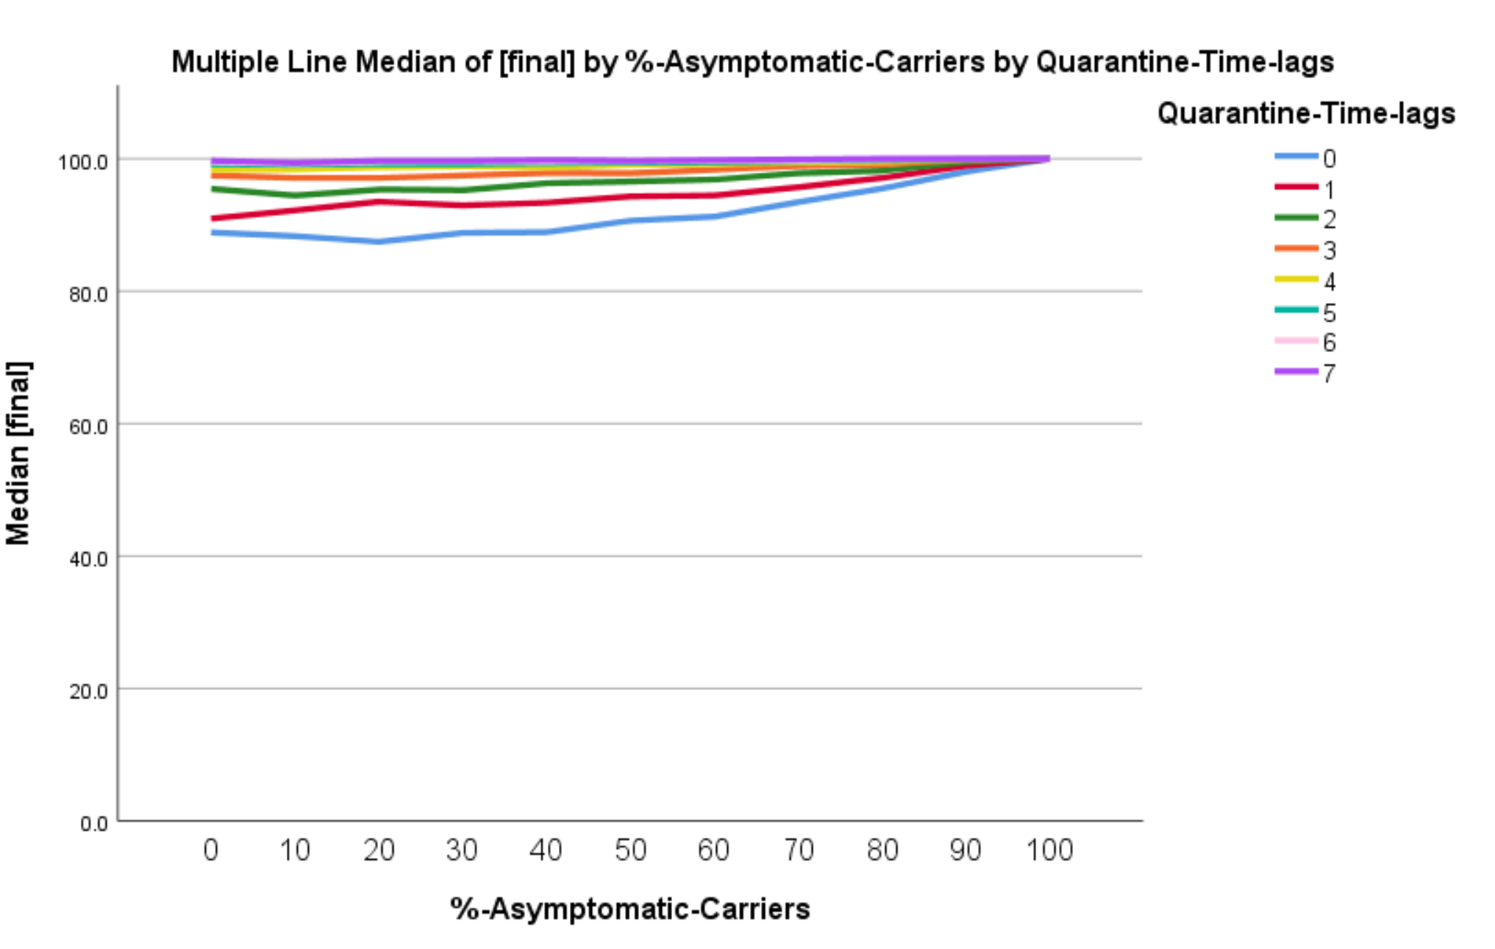

**Low Group: 1st-level**

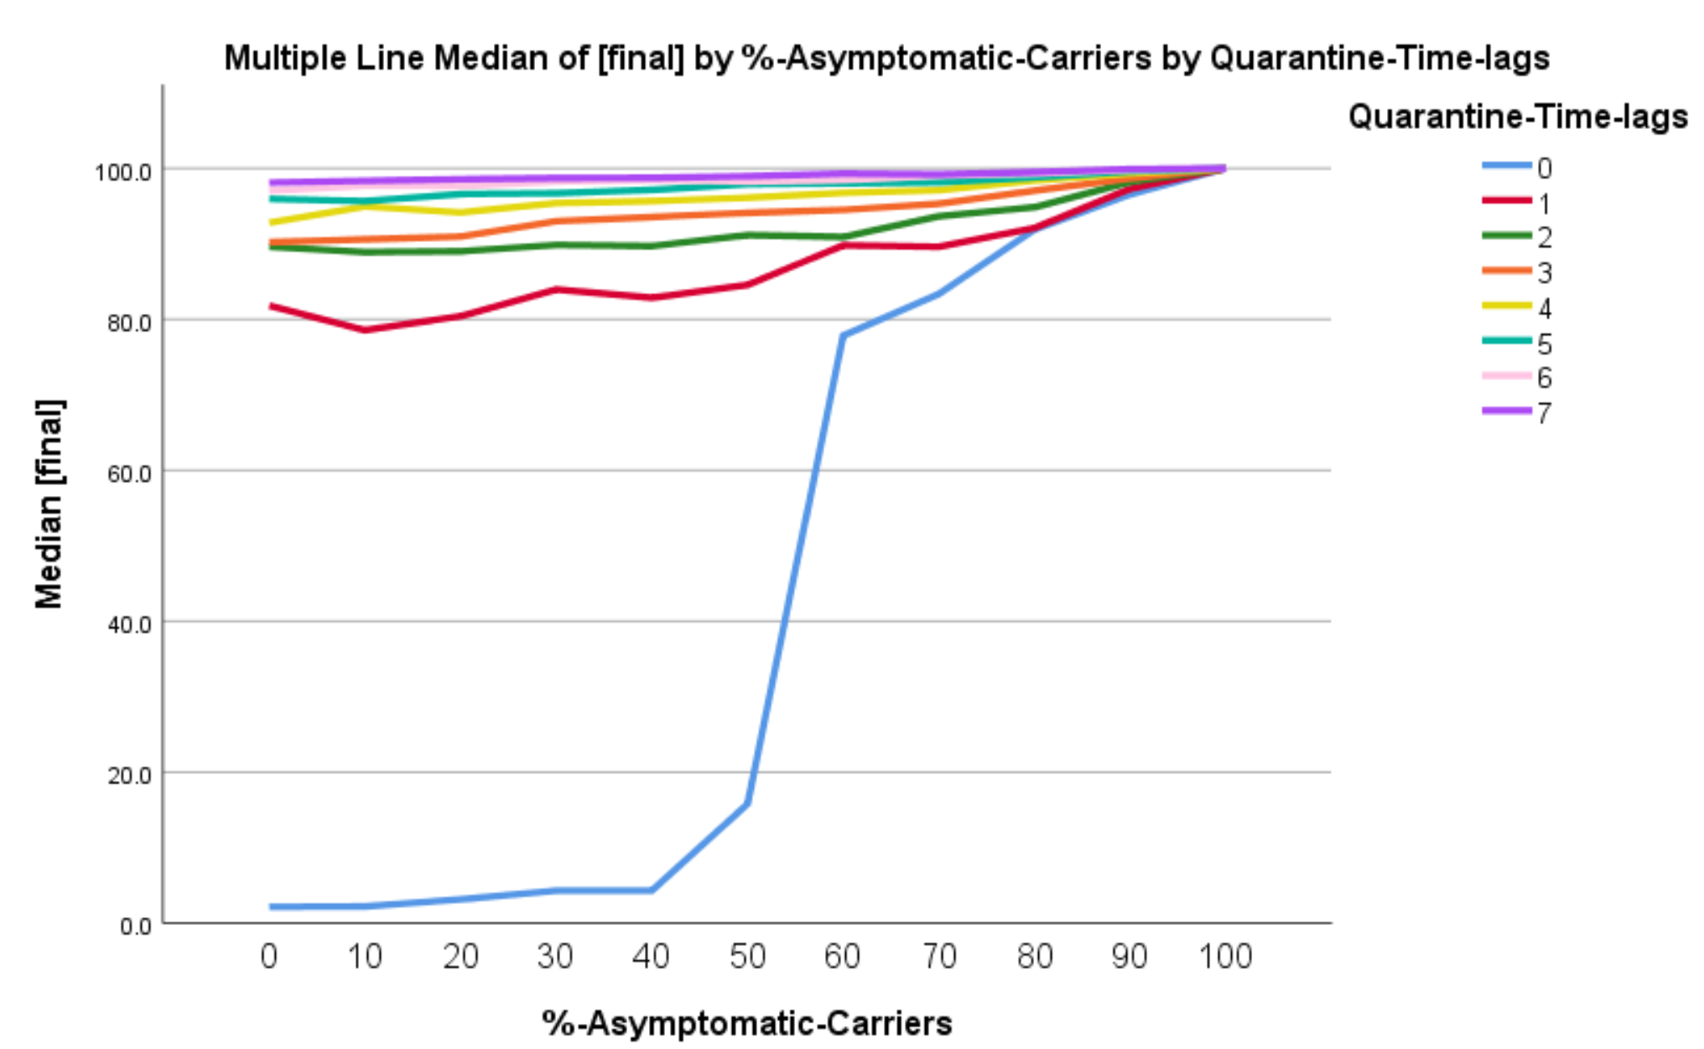

**Low Group: 2nd-level**

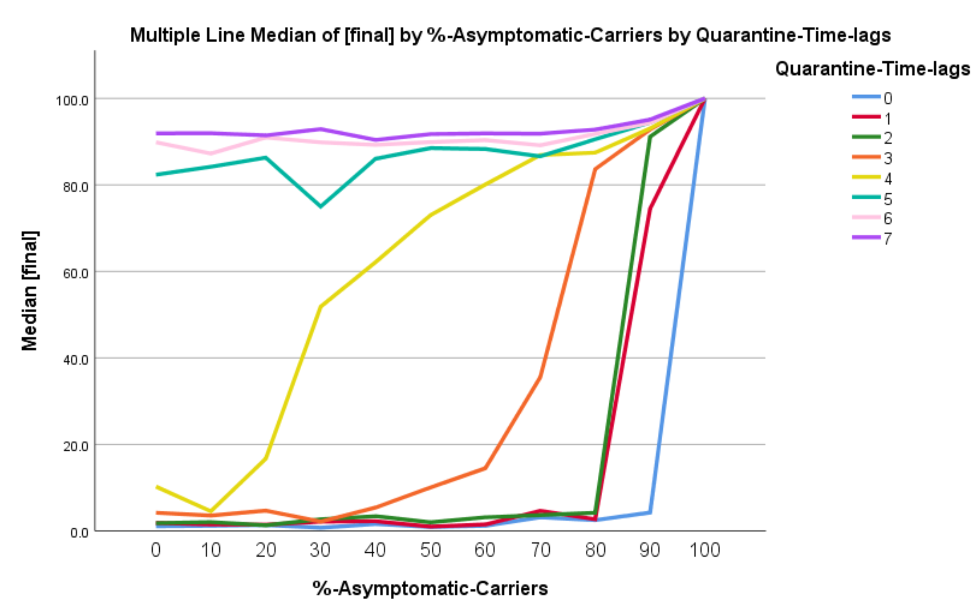

**High Group: 2nd-level**

