Memory virtualization

Type of memory

<https://www.tutorialspoint.com/cprogramming/c_storage_classes.htm>

code: เก็บตัว executable instructions (ชุดคำสั่งของโปรแกรมที่นำไป execute ได้) โดยทั่วไปแล้วจะเป็นแบบ read-only และไม่สามารถปรับขนาดได้

stack: <https://2bedev.com/365days-of-program-day-13/>

**non – contiguous memory allocation:** allows a process to acquire the several memory blocks at the different location in the memory according to its requirement

**Why? -** to solve a lot of unused space (External fragmentation) from contiguous memory allocation

**How?**

1. Segmentation scheme: divided into segment of unequal size.

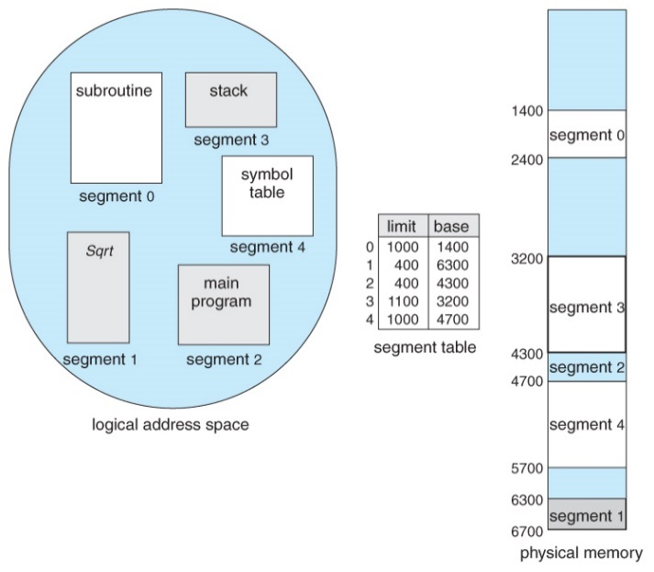- Address translation: allow each segment to be placed in a different part of physical memory. (logical memory -> physical memory)

Segment number

- **memory management**: similar to contiguous allocation. How to make multiple program   
execute at the same time and best efficient. Use 3 allocation strategy which are   
1. First-fit: advantage of speed  
2. Best-fit: tries to reduce wasted space  
3. Worst-fit strategy: tried to avoid leaving small holes that can arise with the Best-fit

2. Paging scheme: the physical memory divided into a number of parts (page frames) in equal size.

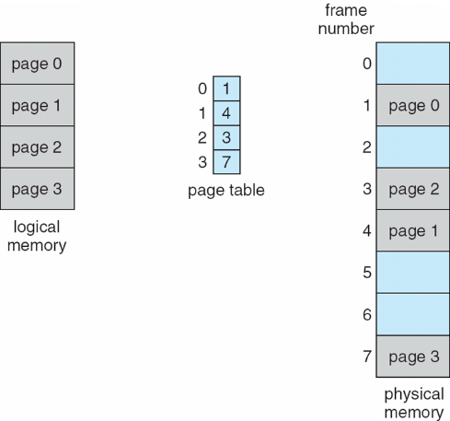 Page size = Frame size  
 (Logical) (Physical)

Advantage: Flexible – (support การใส่ข้อมูลโดยไม่คิดถึง  
 ข้อมูลทีใช้อยู่)  
 Simplicity of free space management - (จัดการง่ายเพราะ   
 ขนาดพื้นที่เท่ากันหมด)