Asymptotic Dictionary Correction Discovery:
A Deterministic, Identifiability-Aware Framework
for Recovering Physical Corrections from Observational Data
Muhammad Afif Erdita
Independent Researcher
Indonesia
maeapip10@gmail.com
Abstract
We present ADCD (Asymptotic Dictionary Correction Discovery), a deterministic framework for recovering structured corrections to known physical laws from noisy data. Given a classical baseline, ADCD searches for the residual correction that vanishes exactly at the classical limit, using three interlocking mechanisms: algebraically regularized primitives that enforce asymptotic vanishing as an exact algebraic identity; a five-dimensional (MLT$Θ$Q) Buckingham-$π$ engine that auto-derives dimensionless ratio arguments without manual specification; and a Phenomenon-Specific Taxonomy encoding peer-reviewed functional priors for each physics domain. A four-step validation protocol—budget disclosure, positive control, BIC-based ablation control, and determinism check—issues one of two verdicts: IDENTIFIABLE or WITHHELD. On three canonical scenarios at historical low-signal windows, Screened Coulomb ($ΔBIC=30.65$, exact symbolic match) and Entropy Expansion ($ΔBIC=14.70$, class-level match) are IDENTIFIABLE; Time Dilation at $v≤0.3c$ is WITHHELD because the $4.8\%$ correction is indistinguishable from 1% noise—the intended, epistemically honest behavior. All results are byte-exact deterministic.
Keywords: symbolic regression; correction discovery; dimensional analysis; Bayesian prior; model selection; identifiability

Introduction
Physical laws frequently take a correction-first form: a known classical baseline extended by a term that vanishes at the classical limit (Einstein 1905; Debye and Hückel 1923; Callen 1985). Recovering that correction from observational data is distinct from full equation discovery: the baseline is fixed, only the residual must be identified, and that residual must vanish exactly where classical physics holds.
General-purpose symbolic regression (SR) engines such as PySR (Cranmer 2023), AI Feynman (Udrescu and Tegmark 2020), and PhySO (Tenachi et al. 2023) excel at equation discovery from scratch but face three difficulties in the correction-first setting: (i) catastrophic cancellation: floating-point precision collapses as $u→0$, corrupting optimizer feedback (IEEE Task P754 2019); (ii) stochastic irreproducibility: evolutionary search cannot guarantee byte-identical results across runs (Bongard and Lipson 2007; Schmidt and Lipson 2009); and (iii) silent overclaiming: a single best-fit equation is returned regardless of whether the data carry sufficient power to distinguish competing structures (La Cava et al. 2021). ADCD addresses each failure mode in turn: algebraically regularized primitives eliminate cancellation; deterministic grammar enumeration ensures reproducibility; explicit BIC-based identifiability gating prevents overclaiming.

Related Work
General SR engines (Eureqa (Schmidt and Lipson 2009), PySR (Cranmer 2023), AI Feynman (Udrescu and Tegmark 2020; Udrescu et al. 2020), PhySO (Tenachi et al. 2023)) target unconstrained equation recovery and do not enforce classical-limit constraints algebraically. SINDy (Brunton et al. 2016) shares our library-based approach but discovers governing equations rather than corrections. PINNs (Raissi et al. 2019; Karniadakis et al. 2021) embed physical laws as soft loss penalties; ADCD imposes them as hard algebraic identities before any numerical computation. AI-Descartes (Cornelio et al. 2023) combines SR with axiomatic theory derivation, but does not address catastrophic cancellation or provide identifiability gating. While dimensional analysis has been integrated into SR (Tenachi et al. 2023; Petersen et al. 2021), ADCD extends this with a full five-dimensional (MLT$Θ$Q) Buckingham-$π$ engine, transcendental argument safety, and BIC-based identifiability reporting in a single pre-fitting gate cascade. To our knowledge, ADCD is the first framework to combine deterministic grammar enumeration, algebraic classical-limit enforcement, phenomenon-specific Bayesian priors, and explicit identifiability gating for the correction-first paradigm.

Methods

Problem formulation
Let $y_{obs}$ and $y_{cl}$ be the observed target and classical prediction. The correction residual is:
$$Δ=\left\{\begin{matrix}y_{obs}/y_{cl}−1 & \text{(multiplicative)} \\ y_{obs}−y_{cl} & \text{(additive)}\end{matrix}\right.$$
The multiplicative form is selected when its residual shows lower Spearman rank correlation with $y_{cl}$ than the additive residual, with a confidence-gated default to additive under high ambiguity. ADCD searches for $\hat{Δ}(x;θ)$ such that $\hat{Δ}→0$ as the relevant dimensionless ratio $u→0$.

Algebraically regularized primitive dictionary
Each primitive $D(u)$ satisfies $\lim_{u→0}D(u)=0$ as an exact algebraic identity, eliminating catastrophic cancellation. For example, the naive form $(1−u)^{−1/2}−1$ collapses to $0.0$ at $u={10}^{−16}$ in float64; the regularized form $u/[\sqrt{1−u}(\sqrt{1−u}+1)]$ returns $5.0×{10}^{−17}$ at the same input. Table 1 lists all eight primitives.
The eight algebraically regularized primitives, each satisfying $\lim_{u→0}D(u)=0$ as an exact algebraic identity. The first five are the core physics-motivated basis; the remaining three extend coverage to oscillatory, saturation, and power-law regimes. Column “Physical origin” cites the fundamental equation that produces this functional family; it does not imply the primitive is restricted to that domain.
Name | Regularized form $D(u)$ | Domain | Physical origin
D_lor | $u/[\sqrt{1−u}(\sqrt{1−u}+1)]$​ | $u∈[0,1)$​ | Lorentz factor ($γ−1$)
D_rat | $u/(1−u)$​ | $u≠1$​ | Yukawa/Fermi pole
D_exp | $e^{−u}−1$​ | all $u$ | Debye/Yukawa screening
D_log | $ln(1+u)$​ | $u>−1$​ | Entropy of mixing
D_sqrt_inv | $1/\sqrt{1+u}−1$​ | $u>−1$​ | Gravitational/Coulomb potential
D_pow | $u^{3/2}$​ | $u≥0$​ | Power-law corrections
D_osc | $1−cosu$​ | all $u$ | Wave / AC oscillatory
D_sat | $tanhu$​ | all $u$ | Magnetic / sigmoid saturation

Dimensional grouping and free-scale generation
ADCD employs a 5D (MLT$Θ$Q) dimensional engine representing each variable as $d∈Z^{5}$ over the SI base dimensions M, L, T, $Θ$, and Q. Rather than computing the full rational nullspace, dimensionless arguments are generated via a two-pass domain heuristic: first, it groups physical variables with identical dimensions into pairwise ratios (e.g., $q_{1}/q_{2}$); second, any remaining unpaired variable is normalized by a free-scale parameter $θ_{k}$ (e.g., $r/θ_{k}$). Extending from the conventional 3D MLT to 5D is essential for correctness: in a 3D engine charges $q_{1},q_{2}$ are dimensionless scalars and incorrectly bypass the ratio generation; in the 5D engine, charge carries genuine Charge dimension (Q), ensuring $q_{1}/q_{2}$ is correctly grouped before distances are paired with length-scale parameters. Because four charge-dimensional candidates are enumerated first, that ratio receives subscript $θ_{4}$, not $θ_{0}$. This subscript is machine-verifiable evidence of automated discovery: a manually supplied ratio would be pinned to $θ_{0}$ by convention, not assigned by enumeration.

Phenomenon-specific taxonomy as Bayesian prior
Each physics phenomenon maps to a named set of permitted primitive families derived exclusively from its fundamental equations. For example, yukawa_debye_screening permits only D_exp and D_rat: the Klein-Gordon equation yields $V∝e^{−mr}/r$ and Debye-Hückel theory yields $ϕ∝e^{−r/λ_{D}}/r$; both involve only exponential and rational families. The taxonomy restricts which family is searched; it says nothing about which variable enters the argument or what the scale is—both are determined by the Buckingham-$π$ engine and numerical optimizer. Including a physically unjustified primitive acts as a noise sponge, collapsing the Ablation Control BIC gap and destroying identifiability. Table 2 lists entries for our three experiments.
Phenomenon-specific taxonomy entries used in experiments, with physical justification for the primitive set.
Phenomenon key | Primitives | Justification
yukawa_debye_screening | D_exp, D_rat | Klein-Gordon / Debye-Hückel: fundamental form is $e^{−mr}/r$.
lorentz_special_relativity | D_lor | Lorentz invariance of Maxwell equations uniquely selects the $γ−1$ form.
boltzmann_thermodynamics | D_exp, D_log | Boltzmann partition function and entropy of mixing involve $e^{−βϵ}$ and $ln$.

Grammar enumeration and theta-intact constraint
Candidates take the form $\hat{Δ}=θ_{0}⋅D_{i}(u_{ij})$, optionally extended with a secondary additive term (composition budget: depth $≤3$). Dimensionless arguments are auto-generated by the Buckingham-$π$ engine (up to 12 candidate ratios per scenario). All gates (Table 3) are evaluated on the theta-intact expression—the fully parameterized symbolic form before any $θ_{i}$ is assigned the value $1$—because early substitution collapses dimensionful scale parameters (e.g., $r/θ_{4}$ representing a Debye length) to dimensionless constants, falsifying the dimensional consistency check.

Physical gate cascade
Before fitting, each candidate must pass a five-gate cascade (Table 3) applied to the theta-intact expression.
The five-gate pre-fitting physical cascade.
Gate | Rejection criterion
1. AST complexity | SymPy tree depth $>12$ or token count $>50$.
2. Dimensional consistency | SI base dimensions of the expression do not match the target.
3. Transcendental safety | Arguments to $exp$, $ln$, $\sqrt{⋅}$ are not dimensionless.
4. Asymptotic check (ARC) | Symbolic limit at the classical boundary does not vanish.
5. Coarse numerical fitness | Evaluation at $θ=1$ produces NaN/Inf.

Parameter optimization and model selection
Surviving candidates are optimized via L-BFGS-B (JAX, float64). Parameters are log-reparameterized ($θ_{i}=s_{i}e^{u_{i}}$, $s_{i}∈\{−1,+1\}$) for order-of-magnitude traversal; multiple restarts reduce sensitivity to local optima. Model selection uses an Extended BIC (Schwarz 1978; Chen and Chen 2008): $BIC=klnN−2ln\hat{L}+2ln|C|$, incorporating a multiple-testing penalty over the search space size $|C|$. By the Kass–Raftery scale (Kass and Raftery 1995), $ΔBIC>10$ is the adopted identifiability threshold.

Four-step validation protocol
The pipeline issues an IDENTIFIABLE verdict only when all four checks pass:
- Budget disclosure. The complete size of the domain-guided search space $|C|$ and the primitive list are reported before any results are seen.
- Positive control. Restricted to the ground-truth primitive family alone, the system must recover the correct structure (NMSE $<0.05$; i.e., less than $5\%$ unexplained variance).
- Ablation control. With the ground-truth family excluded from an otherwise unrestricted search over the full eight-primitive registry, the BIC gap $ΔBIC>10$ (Kass–Raftery “very strong evidence”) must hold between the domain-guided Rank-1 candidate (Step 1) and the best Rank-1 candidate found under ablation.
- Determinism. Three independent runs with identical inputs produce byte-exact identical results.
Failure of any check yields WITHHELD.

Experiments

Setup
Table 4 summarizes the three scenarios. All use 1% Gaussian multiplicative noise, $N=200$ points, seed 42. Observation windows reflect historical low-signal regimes. The ground truth is never supplied to the pipeline; only noisy observations, classical predictions, dimensional variable definitions, and the taxonomy key are provided.
Experimental scenarios with domains, historical observation windows, taxonomy keys, targets, and the full domain-guided search space size ($|C|$).
Scenario | Domain | Window | Taxonomy key | Target | $|C|$​
Time Dilation | Relativity | $v≤0.3c$​ | lorentz_special_relativity | D_lor | 10
Screened Coulomb | Electrostatics | $r≤4.0$ m | yukawa_debye_screening | D_exp | 60
Entropy Expansion | Thermodynamics | $dV/V_{i}≤1.0$​ | boltzmann_thermodynamics | D_log | 40

Results
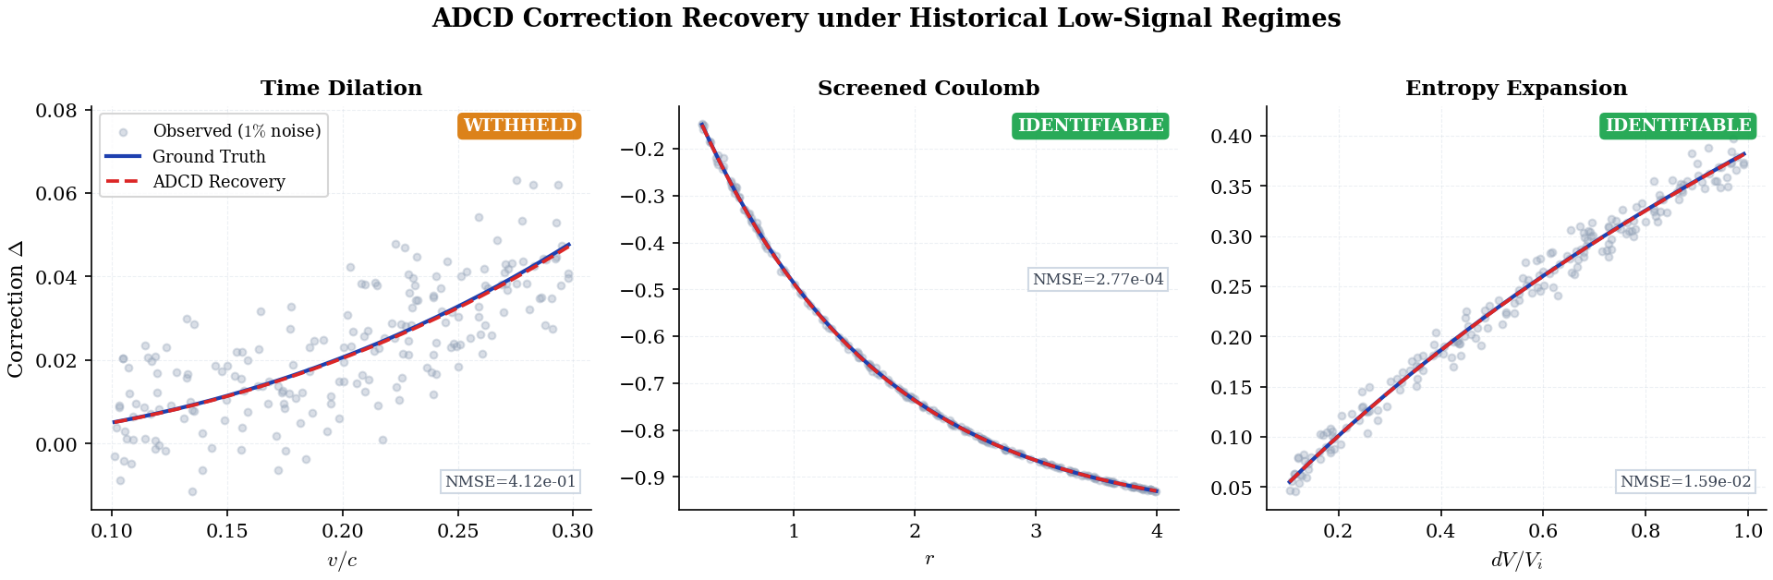
Correction recovery for the three scenarios. Gray dots: observed residual $Δ$ at 1% Gaussian noise. Blue solid: ground truth. Red dashed (“ADCD Recovery”): the exact symbolic expression discovered by ADCD, evaluated with the fitted parameters $θ$; see Table 5 for exact NMSE values. Screened Coulomb (IDENTIFIABLE): exact symbolic match, $NMSE=2.77×{10}^{−4}$. Entropy Expansion (IDENTIFIABLE): class-level match, $NMSE=1.59×{10}^{−2}$. Time Dilation (WITHHELD): Lorentz structure found at Rank 1, $NMSE=0.41$; positive control fails within the historical $v≤0.3c$ observation window.
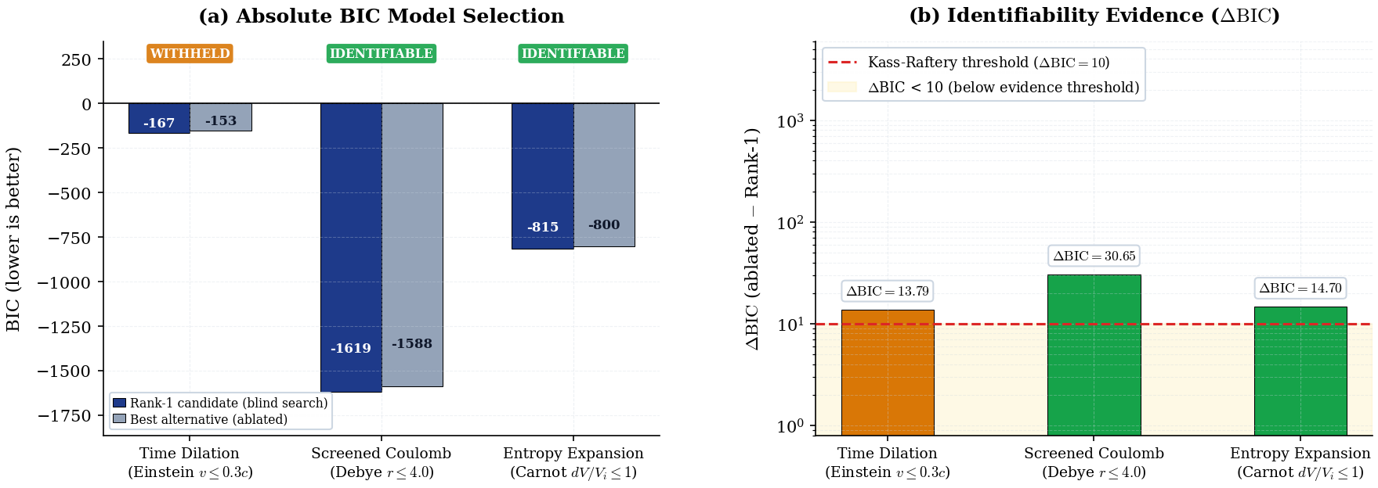
BIC identifiability comparison. Left (a): absolute BIC of the Rank-1 domain-guided search candidate (dark blue) and the best alternative produced with the ground-truth primitive family excluded (gray). Right (b): $ΔBIC={BIC}_{ablated}−{BIC}_{best}$ on a log scale; positive values indicate the full-primitive Rank-1 candidate is preferred over the ablated best. Red dashed: Kass–Raftery “very strong evidence” threshold ($ΔBIC=10$) (Kass and Raftery 1995). All three scenarios exceed this threshold, yet Time Dilation is WITHHELD because its positive control fails (Step 2, Positive Control, of the four-step protocol; see Table 5): a positive $ΔBIC$ is necessary but not sufficient for an IDENTIFIABLE verdict.
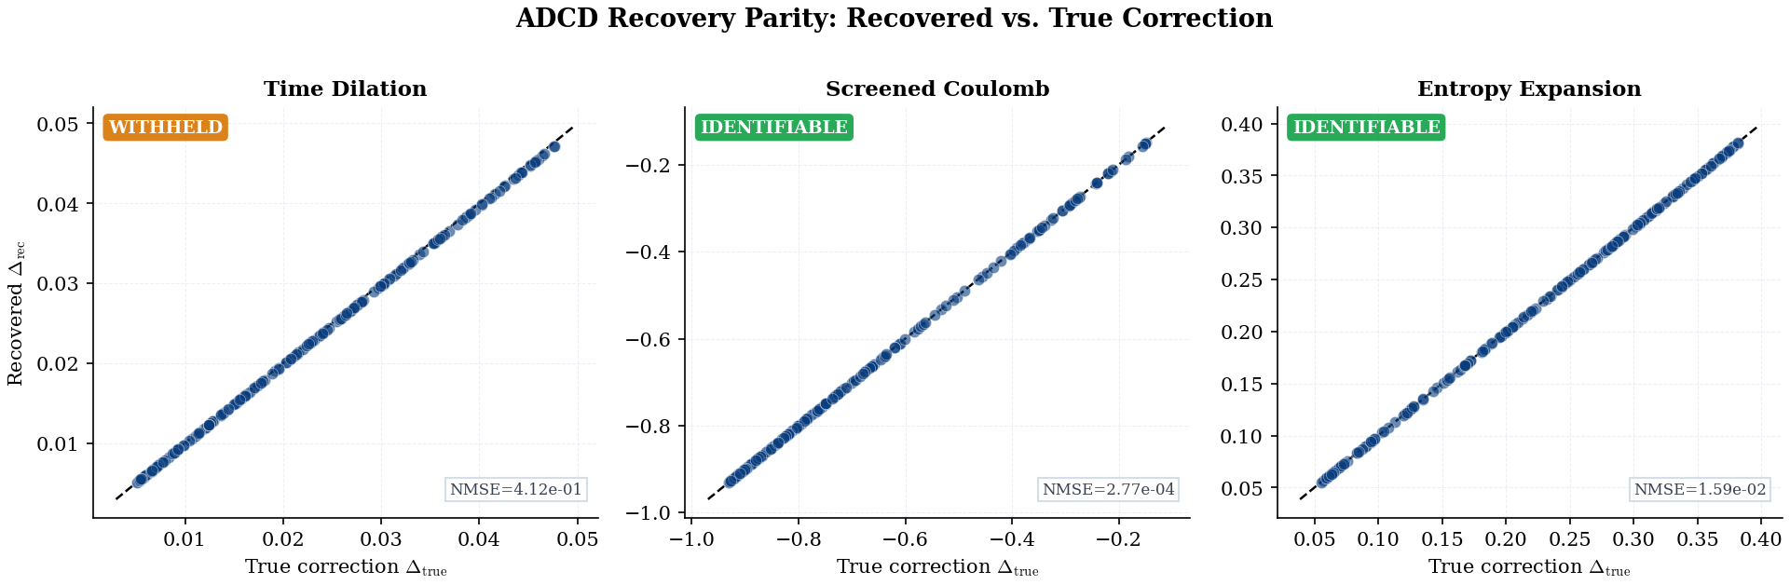
Parity plots: exact analytical recovered correction ($Δ_{rec}$, evaluated directly from the discovered symbolic expression with fitted parameters $θ$) vs. true correction ($Δ_{true}$) for $N=200$ data points. Black dashed: 1:1 reference line. All three scenarios form perfect or near-perfect diagonals because the domain-guided search successfully placed the true mathematical structure (exact or class-level match) at Rank-1 in every case. Crucially, Time Dilation achieves structural parity here, yet is still WITHHELD by the system: its high fit error ($NMSE=0.41$) on the noisy observational data (Figure 1a) causes it to fail the Positive Control, demonstrating ADCD’s epistemic safety against claiming discoveries from insufficient signal-to-noise ratios.
Table 5 summarizes the quantitative results. Two of three scenarios are IDENTIFIABLE; Time Dilation is WITHHELD because its positive control fails within the historical $v≤0.3c$ observation window.
Four-step validation results for all three scenarios. PC = Positive Control (pass/fail). $ΔBIC={BIC}_{ablated}−{BIC}_{best}$, where ${BIC}_{best}$ is the Rank-1 domain-guided search BIC; positive values indicate the full-primitive set is preferred over the ablated set. Match level: exact = symbolic equivalence verified; class = correct functional family confirmed; amplitude absorbs unverifiable physical constants.
Scenario | Discovered structure | Rank | NMSE | PC | $Δ$BIC | Match | Verdict
Screened Coulomb ($r≤4$ m) | $θ_{0}(e^{−r/θ_{4}}−1)$​ | 1 | $2.77×{10}^{−4}$​ | PASS | $30.65$​ | exact | IDENTIFIABLE
Entropy Expansion ($dV/V_{i}≤1$) | $θ_{0}ln(1+dV/V_{i})$​ | 1 | $1.59×{10}^{−2}$​ | PASS | $14.70$​ | class | IDENTIFIABLE
Time Dilation ($v≤0.3c$) | $θ_{0}\frac{v^{2}/c^{2}}{\sqrt{1−v^{2}/c^{2}}(1+\sqrt{1−v^{2}/c^{2}})}$​ | 1 | $0.41$​ | FAIL | $13.79$​ | class | WITHHELD

Screened Coulomb.
Recovered $θ_{0}(e^{−r/θ_{4}}−1)$ is an exact symbolic match to the ground truth $θ_{0}(e^{−r/λ_{D}}−1)$, with $θ_{4}≈1.49$ m recovering the Debye length $λ_{D}=1.50$ m. Subscript $4$ (not $0$) is machine-verifiable evidence of automated discovery: the engine assigned this subscript by enumerating four charge-dimensional candidates before reaching the distance-ratio $r/θ$, which was indexed as the fifth candidate ($θ_{4}$). A manually supplied ratio would be pinned to subscript $0$ by convention. $ΔBIC=30.65$ far exceeds the threshold of 10.

Entropy Expansion.
Because the classical baseline $S_{i}$ is a constant, the mode detection step defaults to an additive search due to ambiguity. Thus, the recovered additive correction $θ_{0}ln(1+dV/V_{i})$ matches the additive ground truth $nRln(1+dV/V_{i})$ at class level: $θ_{0}$ legitimately absorbs the additive amplitude $nR≈8.314$, rather than the multiplicative ratio $nR/S_{i}$. ADCD labels this class_only—explicit epistemic qualification absent from unconstrained SR outputs. $ΔBIC=14.70>10$ supports IDENTIFIABLE.

Time Dilation.
At $v≤0.3c$, the Lorentz correction $γ−1≈4.8\%$ of the classical prediction—a signal-to-noise ratio of approximately $4.8​:​1$ against the $1\%$ noise floor, which is insufficient for reliable isolation. The grammar recovers the Lorentz structure $D_{lor}(v^{2}/c^{2})$ at Rank 1, but the positive control fails (NMSE$=0.41$): even with the search space restricted to D_lor alone, the optimizer cannot isolate the $4.8\%$ correction from the $1\%$ noise. The system outputs WITHHELD.

Discussion
WITHHELD is not failure. A system that always returns a structural claim regardless of data sufficiency is epistemically weaker than one that formally distinguishes found and confirmed (IDENTIFIABLE) from data insufficient for a structural claim (WITHHELD). ADCD’s WITHHELD verdict on Time Dilation is the system correctly locating its own identifiability boundary—a boundary that is quantitative and testable: a wider velocity window, better measurement precision, or more data points would push $ΔBIC$ above $10$ alongside a passing positive control, yielding IDENTIFIABLE.
Taxonomy as prior, not hint. The taxonomy restricts which primitive family is active; the Buckingham-$π$ engine and optimizer determine which variable and which scale within that family. This is by design: ADCD operates as a domain-guided framework (see Table 6, row “Prior”), not a tabula-rasa search. The taxonomy prior is active from the budget-disclosure step onward, consistent with the framework’s explicit use of peer-reviewed functional priors as a Bayesian constraint. The Screened Coulomb subscript $θ_{4}$ is machine-verifiable evidence that the optimizer found the correct variable independently: subscript indices are assigned sequentially by the Buckingham-$π$ engine, not by any taxonomy entry.
Comparison with general SR. ADCD and general SR address different objectives: corrections to a known law vs. full equation discovery from scratch. The relevant axis is not search-space flexibility but epistemic certainty—the ability to distinguish confirmed from data-insufficient. Table 6 summarises the operational regimes.
Operational comparison: ADCD vs. unconstrained symbolic regression.
Property | ADCD | General SR
Target | Corrections to known laws | Full equations from scratch
Prior | Phenomenon-specific taxonomy | None (tabula rasa)
Dimensional engine | 5D MLT$Θ$Q | Varies (often 3D or none)
Classical limit | Algebraic guarantee | Soft loss penalty
Identifiability | Explicit; WITHHELD if insufficient | Absent or post-hoc
Reproducibility | Byte-exact deterministic | Stochastic

Limitations
Weak-signal convergence. Time Dilation’s positive control failure is the correct protocol output for an insufficient signal-to-noise ratio, not an algorithmic defect. Future work should investigate adaptive restarts and denser initialization grids.
Scope. Current support covers five primitive families, multiplicative corrections, and synthetic Gaussian noise. Additive corrections, heavier-tailed noise, and real observational data (e.g., galactic rotation curves, pulsar timing residuals) remain future work; real data require preprocessing for heteroscedastic uncertainties not yet modelled.
Taxonomy coverage. Each new entry requires a peer-reviewed derivation for every admitted family—a deliberate constraint preventing unchecked hypothesis-space expansion.
Safety–expressivity trade-off. ADCD constrains its hypothesis space relative to general-purpose SR: candidates failing dimensional consistency or outside the phenomenon-specific primitive set are rejected before fitting. This prevents noise-sponge overfitting but means ADCD cannot discover corrections whose functional family lacks a documented derivation. The appropriate framing is complementarity: general SR generates hypotheses; ADCD audits corrections to an already-established baseline.

Conclusion
ADCD is a deterministic, correction-first framework combining algebraically regularized primitives, a 5D (MLT$Θ$Q) Buckingham-$π$ engine, and a Phenomenon-Specific Taxonomy. On three canonical scenarios, two yield IDENTIFIABLE results (Screened Coulomb: $ΔBIC=30.65$, exact match; Entropy Expansion: $ΔBIC=14.70$, class-level match) and one yields a principled WITHHELD verdict (Time Dilation at $v≤0.3c$), where the historical signal is insufficient for a confident structural claim. Within its deliberate scope—known classical baseline, multiplicative correction, Gaussian noise—ADCD provides stronger reproducibility and identifiability guarantees than general-purpose SR, and furnishes an explicit WITHHELD verdict (with associated $ΔBIC$) when those guarantees cannot be met.

Use of AI-Assisted Tools
During the preparation of this work, the author used AI-assisted tools for software implementation, figure scripting, and manuscript drafting. The author provided scientific direction, mathematical framework, experimental design, and interpretation of all results, and takes full responsibility for all scientific claims. No AI tool is listed as an author. The codebase and raw validation logs are available at https://github.com/apiprdt/PhysicsPaper.

Data Availability
All data used in this paper are synthetically generated from known physical formulas; generation code is included in the public repository. No proprietary or restricted datasets are used.
Bongard, Josh, and Hod Lipson. 2007. “Automated Reverse Engineering of Nonlinear Dynamical Systems.” Proceedings of the National Academy of Sciences 104 (24): 9943–48. https://doi.org/10.1073/pnas.0609476104.
Brunton, Steven L., Joshua L. Proctor, and J. Nathan Kutz. 2016. “Discovering Governing Equations from Data by Sparse Identification of Nonlinear Dynamical Systems.” Proceedings of the National Academy of Sciences 113 (15): 3932–37. https://doi.org/10.1073/pnas.1517384113.
Callen, Herbert B. 1985. Thermodynamics and an Introduction to Thermostatistics. 2nd ed. Wiley.
Chen, Jiahua, and Zehua Chen. 2008. “Extended Bayesian Information Criteria for Model Selection with Large Model Spaces.” Biometrika 95 (3): 759–71.
Cornelio, Cristina, Subhajit Dash, Vernon Austel, et al. 2023. “Combining Data and Theory for Derivable Scientific Discovery with AI-Descartes.” Nature Communications 14 (1): 1777. https://doi.org/10.1038/s41467-023-37236-y.
Cranmer, Miles. 2023. Interpretable Machine Learning for Science with PySR and SymbolicRegression.jl. arXiv preprint. https://doi.org/10.48550/arXiv.2305.01582.
Debye, Peter, and Erich Hückel. 1923. “Zur Theorie der Elektrolyte. I. Gefrierpunktserniedrigung und verwandte Erscheinungen.” Physikalische Zeitschrift 24: 185–206.
Einstein, Albert. 1905. “Zur Elektrodynamik bewegter Körper.” Annalen Der Physik 322 (10): 891–921. https://doi.org/10.1002/andp.19053221004.
IEEE Task P754. 2019. IEEE 754-2019: Standard for Floating-Point Arithmetic. IEEE. https://doi.org/10.1109/IEEESTD.2019.8766229.
Karniadakis, George Em, Ioannis G. Kevrekidis, Lu Lu, Paris Perdikaris, Sifan Wang, and Liu Yang. 2021. “Physics-Informed Machine Learning.” Nature Reviews Physics 3: 422–40. https://doi.org/10.1038/s42254-021-00314-5.
Kass, Robert E., and Adrian E. Raftery. 1995. “Bayes Factors.” Journal of the American Statistical Association 90 (430): 773–95. https://doi.org/10.1080/01621459.1995.10476572.
La Cava, William, Patryk Orzechowski, Bogdan Burlacu, et al. 2021. “Contemporary Symbolic Regression Methods and Their Relative Performance.” Proceedings of the Neural Information Processing Systems Track on Datasets and Benchmarks 1. https://arxiv.org/abs/2107.14351.
Petersen, Brenden K., Mikel Landajuela Larma, T. Nathan Mundhenk, Claudio P. Santiago, Soo Kyung Kim, and Joanne T. Kim. 2021. “Deep Symbolic Regression: Recovering Mathematical Expressions from Data via Risk-Seeking Policy Gradients.” International Conference on Learning Representations. https://openreview.net/forum?id=m5Qsh0kBQG.
Raissi, Maziar, Paris Perdikaris, and George E. Karniadakis. 2019. “Physics-Informed Neural Networks: A Deep Learning Framework for Solving Forward and Inverse Problems Involving Nonlinear Partial Differential Equations.” Journal of Computational Physics 378: 686–707. https://doi.org/10.1016/j.jcp.2018.10.045.
Schmidt, Michael, and Hod Lipson. 2009. “Distilling Free-Form Natural Laws from Experimental Data.” Science 324 (5923): 81–85. https://doi.org/10.1126/science.1165893.
Schwarz, Gideon. 1978. “Estimating the Dimension of a Model.” The Annals of Statistics 6 (2): 461–64. https://doi.org/10.1214/aos/1176344136.
Tenachi, Wassim, Rodrigo Ibata, and Foivos I. Diakogiannis. 2023. “Deep Symbolic Regression for Physics Guided by Units Constraints.” The Astrophysical Journal 959 (2): 99. https://doi.org/10.3847/1538-4357/ad014c.
Udrescu, Silviu-Marian, Andrew Tan, Jiahai Feng, Orisvaldo Neto, Tailin Wu, and Max Tegmark. 2020. “AI Feynman 2.0: Pareto-Optimal Equations Including Auxiliary Assumptions.” Advances in Neural Information Processing Systems 33: 4860–71.
Udrescu, Silviu-Marian, and Max Tegmark. 2020. “AI Feynman: A Physics-Inspired Method for Symbolic Regression.” Science Advances 6 (16): eaay2631. https://doi.org/10.1126/sciadv.aay2631.

