A Working Group Draft of the Joint Committee on the ATC
Ballot Copy for Joint Adoption by AASHTO, ITE, and NEMA

ATC v01.00

Advanced Transportation Controller (ATC)
Software Design Document (SDD)
Field I/O Application Programming Interface (FIO API)

This is a draft document, which is distributed for review and ballot purposes only. You may reproduce and distribute this document within your organization, but only for the purposes of and only to the extent necessary to facilitate review and ballot to AASHTO, ITE, or NEMA. Please ensure that all copies reproduced or distributed bear this legend. This document contains recommended information which is subject to approval.
Published by

American Association of State Highway and Transportation Officials (AASHTO)
444 North Capitol St., N.W., Suite 249
Washington, DC, 20001

Institute of Transportation Engineers (ITE)
1099 14th St. N.W., Suite 300 West
Washington, DC, 20005-3438

National Electrical Manufacturers Association (NEMA)
1300 N. 17th Street, Suite 1847
Rosslyn, Virginia 22209-3801

Copyright 2006 AASHTO/ ITE/NEMA. All rights reserved.
NOTICE

Joint NEMA, AASHTO, and ITE Copyright and
Advanced Transportation Controller (ATC)
Application Programming Interface (API) Working Group

These materials are delivered "AS IS" without any warranties as to their use or performance.

AASHTO/ITE/NEMA AND THEIR SUPPLIERS DO NOT WARRANT THE PERFORMANCE OR RESULTS YOU MAY OBTAIN BY USING THESE MATERIALS. AASHTO/ITE/NEMA AND THEIR SUPPLIERS MAKE NO WARRANTIES, EXPRESSED OR IMPLIED, AS TO NON-INFRINGEMENT OF THIRD PARTY RIGHTS, MERCHANTABILITY, OR FITNESS FOR ANY PARTICULAR PURPOSE. IN NO EVENT WILL AASHTO, ITE, NEMA OR THEIR SUPPLIERS BE LIABLE TO YOU OR ANY THIRD PART FOR ANY CLAIM OR FOR ANY CONSEQUENTIAL, INCIDENTAL, OR SPECIAL DAMAGES, INCLUDING ANY LOST PROFITS OR LOST SAVINGS, ARISING FROM YOUR REPRODUCTION OR USE OF THESE MATERIALS, EVEN IF AN AASHTO, ITE, OR NEMA REPRESENTATIVE HAS BEEN ADVISED OF THE POSSIBILITY OF SUCH DAMAGES. Some states or jurisdictions do not allow the exclusion or limitation of incidental, consequential, or special damages, or exclusion of implied warranties, so the above limitations may not apply to you.

Use of these materials does not constitute an endorsement or affiliation by or between AASHTO, ITE, or NEMA and you, your company, or your products and services.

If you are not willing to accept the foregoing restrictions, you should immediately return these materials.

ATC is a trademark of NEMA/AASHTO/ITE

Table of Contents
Table of Contents 1
Approvals 3
Revision History 4
Authorship 5
Contributors 6
1. Introduction 2
1.1 Purpose 2
1.2 Scope 2
1.3 Intended Audience 2
1.4 Definitions, Acronyms, and Abbreviations 2
1.5 Conventions 3
1.6 Supporting Documentation 3
2. General Considerations 4
2.1 Design Goals 4
2.2 Tools and Environment 4
2.3 Coding Standards 4
2.4 Error Handling 4
2.5 Memory Management 4
2.6 Thread Synchronization 4
2.7 Localization 4
2.8 Testing Support 5
3. High Level Design 6
3.1 FIO Sub-System Architecture 6
3.2 FIOAPI Architecture 7
3.3 FIO Driver LKM Architecture 8
3.3.1 FIOMAN Architecture 9
3.3.2 FIOMSG Architecture 10
3.4 Linux SDLC Device Driver Architecture 11
4. Detailed Design 12
4.1 Field I/O Driver Internals 12
4.1.1 General Application Interface 13
4.1.2 Field I/O API (FIOAPI) 13
4.1.3 Field I/O Manager (FIOMAN) 14
4.1.4 Field I/O Message Scheduler (FIOMSG) 15
4.2 Kernel Interface 17
4.3 FIO Driver LKM API 18
5. Process Decomposition 20
5.1 FIO Driver Initialization 20
5.2 Application Processing 20
5.2.1 Traffic Control Example 20
6. Requirements Traceability Matrix 22
Appendix A - SDLC Kernel Driver Interface 35

Approvals
___________________________________________________________ ____________
[name], [title] Date
___________________________________________________________ ____________
[name], [title] Date
___________________________________________________________ ____________
[name], [title] Date
___________________________________________________________ ____________
[name], [title] Date

Revision History
Revision | Date | Author | Description
1.1 | 10/10/06 | Thomas E. Gauger, Vanteon | Updates following further SRS changes and feedback.
1.0 | 08/18/06 | Thomas E. Gauger, Vanteon | Initial Release

Authorship
Vanteon
255 Woodcliff Drive
Fairport, NY 14450
Voice: (585) 419-9555
FAX: (585) 248-0537
http://www.vanteon.com
Written under contract with the ITE

Contributors
- Thomas E. Gauger, Vanteon Corp., tgauger@vanteon.com
- Ralph Boaz, Pillar Consulting, rboaz@pillarinc.com
- Larry Hartzell, Vanteon Corp., lhartzell@vanteon.com
- Greg Huber, Vanteon Corp., ghuber@vanteon.com

Advanced Transportation Controller
Field I/O Application Programming Interface
Software Design Description

Introduction

Purpose
This document is a description of the software design for the Field I/O Sub-System (FIOS) within the Advanced Transportation Controller (ATC). It is intended to describe how the software design satisfies the requirements, and as a guide to implementation of the software.

Scope
This document is intended to provide the basic information necessary for an application implementer to access and interact with Field I/O Devices (FIOD).

Intended Audience
This document is of a technical nature. It is intended for members of the cross-functional project team involved in the design, implementation, maintenance, and testing of the FIOS.

Definitions, Acronyms, and Abbreviations
- ANSI - American National Standards Institute
- API - Application Programming Interface
- ATC - Advanced Transportation Controller
- AUX - Auxiliary Switch
- FIO – Field I/O
- FIOAPI – Field I/O Application Programming Interface
- FIOD – Field I/O Device
- FIOMAN - Field I/O Manager
- FIOS - Field I/O Sub-System
- FIOMSG - Field I/O Message Scheduler
- FPD - Front Panel Driver
- FPM - Front Panel Manager
- FPS - Front Panel System
- IOCTL - I/O Control
- ITE - Institute of Transportation Engineers
- LKM – Loadable Kernel Module
- POSIX - Portable Operating System Interface
- SRS - Software Requirements Specification
- TP - Test Plan
- TUI - Text User Interface
- UTD - Unit Test Driver
- VFS - Virtual File System

Conventions
- Square brackets ( [ ] ) indicate to-be-determined information which will be resolved before this document is finalized. For example, “The minimum hard disk space is [TBD]MB.”
- Mono-spaced type indicates functions, variables, parameters, statements, commands, and other operating system or programming language constructs. For example, “Use the ls command to list the files and directories.”
- Italicized text (substitution) indicates a substitution parameter. For example, “Use the ls path command to list the files and directories in the given path.”
- Bold type indicates user interface elements (windows, dialog boxes, menus, and controls). For example, “Press the OK button.”
- Vertical bars (|) are used to indicate a path through a hierarchical user interface. For example, “Select File | Open… to open a file."
- Function, structure and variable declarations and definitions are expressed in the C programming language.

Supporting Documentation
- “Advanced Transportation Controller (ATC) Standard”, Version v5.2a, January 24, 2006
- “Advanced Transportation Controller (ATC) Standard for the Type 2070 Controller”, v02.03, March 12, 2004
- “Advanced Transportation Controller (ATC) Application Programming Interface (API) Software Requirements Specification (SRS)”, v02.05, August 11, 2006
- “Intelligent Transportation System (ITS) Standard Specification for Roadside Cabinets v01.02.17a”, ATC JC, March 24, 2006
- ISO/IEC 9899:1999 Programming Language C”, Available from the International Organization for Standardization (ISO)
- “NEMA Standards Publication TS 2-2003 v02.06 Traffic Controller Assemblies with NTCIP Requirements”, Available from the National Electrical Manufacturers Association
- “Application Programming Interface (API) Standard for the Advanced Transportation Controller (ATC)”, Working Group Draft Version 99.09.14, Institute of Transportation Engineers (ITE), September 14, 1999.
- “Advanced Transportation Controller (ATC) Standard for the Type 2070 Controller”, Version 02.03, Institute of Transportation Engineers (ITE), March 12, 2004
- “Field I/O Sub-System Test Plan”, FIO-TP-005, August 11, 2006

General Considerations

Design Goals
It is the intention of this project to provide a robust, standardized interface providing management between multiple applications and the Field I/O Devices (FIOD) physically located on the ATC device. To achieve this, as much of the Embedded Linux Operating Environment as possible will be leveraged. Additional drivers and managers will be provided as required. Deliverables of this project include, but are not limited to, API, drivers, daemons, and applications. Source code, loadable objects and any supporting documentation required will be provided.

Tools and Environment
All source code to be released as part of this project will be written using the ISO C99 'C' language standard. Other tools such as simulators or test benches may be released in Java to negate any dependency on a particular development or test platform. Since the product is based on an Embedded Linux Kernel, it is recommended that development take place on a Linux platform, or at least in an emulated Linux environment.

Coding Standards
The code herein will be developed using the standards defined by the “GNU Coding Standards” documents, publicly available at http://www.gnu.org/prep/standards/ .

Error Handling
Since this project is in support of an embedded environment, an absolute minimum of user interaction is expected. All error conditions must be accounted for. System provided routines describe their individual error handling within the limits of the system. All routines return an error code indicating the error condition. These error codes are documented in the MAN pages. Developed applications must handle all errors.

Memory Management
The Embedded Linux Kernel provides a robust memory management system. There are no requirements at this time to extend this system or implement another system. Due to the limited memory size, care must be taken when assigning or allocating buffers. In general, buffers that are used frequently are allocated at load time. Large or infrequently used buffers are allocated as required during execution.

Thread Synchronization
The Embedded Linux Kernel provides the POSIX Standard thread utilities, scheduling and synchronization. There is no requirement to extend this.

Localization
There are no localization requirements for the FIOS.

Testing Support
During the development process, UTDs written in ‘C’ will be developed and utilized to debug as much of the FIO API code as possible; prior to loading on to a real ATC system. Test benches with various FIODs will be created and tested; as indicated by the published Test Plan (TP), for integration and verification test purposes. A series of test applications will be written to run in this environment. Please refer to the FIO Test Plan for further detail.

High Level Design

FIO Sub-System Architecture
It is the design intention of the FIOAPI to provide each application what appears to be shared read access to all FIODs and exclusive write access to registered and reserved output points of all FIODs. The application does not need to have any knowledge of the physical hardware of the ATC. An application will access all FIODs through the FIOAPI library. In addition, the FIOAPI provides Application Registration and other features. The FIOAPI provides all drivers and management utilities necessary to achieve this requirement. Figure 1 shows the functional architecture of the FIOAPI. Applications have access to other system drivers and resources as required; the FIOAPI manages access to the physical FIODs.
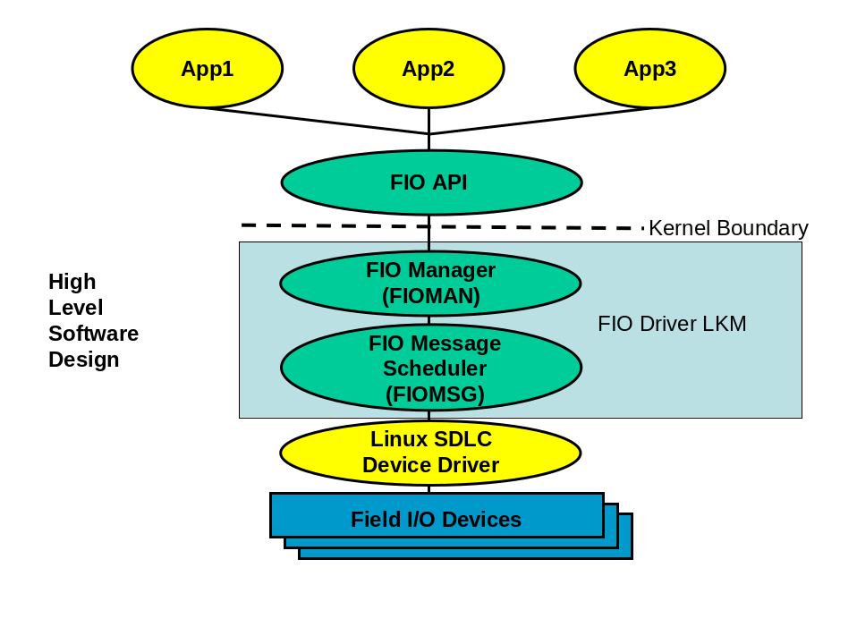
Figure 1
The Field I/O Sub-System (FIOS) consists of 4 layers of software: Field I/O API (FIOAPI), Field I/O Manager (FIOMAN), Field I/O Message Scheduler (FIOMSG) and the Linux SDLC Device Driver. The Linux SDLC Device Driver is manufacturer supplied. A section is provided below to aid in the development of the Linux SDLC Device Driver for usage with the FIOS.
The FIOAPI is a user level library that provides a consistent and orthogonal interface to the FIOS. The FIOMAN and FIOMSG Software exist as part of the FIO Driver. The FIO Driver is provided as a Loadable Kernel Module (LKM). The FIOMAN is executed as an extension of a user process. The FIOMSG layer is a collection of Kernel Timer based tasks. One task is used for transmission (TX) of FIOD request frames. A second task is utilized for the polling and reception (RX) of FIOD response frames.
FIOAPI provides:
- Abstraction for Applications to access FIO API Services
- Consistent / Orthogonal Application Interface to FIODs
- Interface to FIOS Kernel Tasks
- Functions to Support all SRS Requirements
- Easy extensibility
FIOMAN provides:
- Synchronicity of requests and responses with applications
- Control of access to FIODs; FIOMAN knows what applications have reserved and how to access a FIOD
- Health Monitor Functionality
- Watch Dog Functionality
- Manages API responses
- Manages view of application data to a FIOD
- Manages view of FIOD data to applications
- Transition Buffer handling
FIOMSG provides:
- Control of sending and receiving of request and response frames
- Handles multiple ports
- Merges the 3 ports into 1 application stream from the FIOMAN point of view
- Manages a list of the last response frame of each type for each FIOD
- Manages queues of request frames to be sent in timed frequency output order; by port
- Response frames are matched with request frames.

FIOAPI Architecture
The FIOAPI is a user level library that provides a consistent and orthogonal interface to the FIOS. This library must be linked into user level applications wishing to utilize services provided by the FIOS. This library is libfioapi.a. A complete list of and MAN pages for functions provided by the FIOAPI is listed in the SRS.
The FIOAPI provides a user level interface to the FIO Driver LKM. All access to this LKM is via the FIOAPI.
Design ideas utilized in the FIOAPI include:
- All functions begin with fio_;
- All functions are named in an orthogonal way, such that;
  - _register() and _deregister() functions are used to access and dismiss service usage;
  - _enable() and _disable() functions are used to turn services on and off;
  - _fiod_ functions indicate interaction with an FIOD;
  - _cmu_ functions interact with a CMU FIOD;
  - _mmu_ functions interact with a MMU FIOD;
  - _ts?_ functions interact with a TS 1 and / or TS 2 FIOD;
  - _get() and _set() functions indicate interaction with software controlled services and are used to access and update data;
  - _inputs_ and _outputs_ functions indicate operations on input and output data;
  - _reservation_ functions allow operations of output reservations;
  - _frame_ functions indication operations on request and response frames;
  - _write() and _read() functions are used for writing and reading frames to and from a FIOD;
  - _trans_ functions deal with transition buffers;
  - _wd_ functions deal with the Watch Dog Service
  - _hm_ functions deal with the Health Monitor Service
- Such a naming convention allows the user of the API to determine the usage of a function simply from its name
Examples of FIOAPI naming convention used
- fio_register() – Register for FIO services
- fio_deregister() - Deregister FIO services
- fio_fiod_register() – Register for FIOD services
- fio_fiod_deregister() – Deregister FIOD services
- fio_fiod_outputs_reservation_set() – Reserve output points
- fio_fiod_frame_schedule_set() – Schedule a request frame
- fio_fiod_inputs_get() – Access input points
- fio_fiod_outputs_set() – Update output points
- fio_fiod_inputs_filter_set() – Set input filter values
- fio_fiod_wd_heartbeat() – Watch Dog task alive
- fio_hm_heartbeat() – Health Monitor task alive
A complete list of functions supplied by the FIOAPI can be found in the SRS.

FIO Driver LKM Architecture
The FIO Driver consists of the FIOMAN and the FIOMSG layers. This kernel level module is a standard Linux compatible driver. The FIO Driver is provided as a Loadable Kernel Module (LKM) fiodriver.ko. This LKM must be loaded prior to any access to the FIOS. Two scripts are provided to facilitate the loading and unloading of this LKM: fio_load and fio_unload, respectively.
The FIO Driver LKM, when first loaded, generates a dynamic major device number for the FIOS. This major device number is utilized by fio_load to generate a device node in the /dev directory. This device node is named /dev/fio. The minor device for the FIOS is always 0. The major and minor device numbers are utilized by the Linux Kernel to map a request for service on /dev/fio to fiodriver.ko.
The fio_unload script is run when it is desired to remove the FIO Driver LKM from service. The FIO Driver LKM will only unload if there are no applications currently utilizing its services.
These scripts must be updated by each individual manufacturer for their specific environment.

FIOMAN Architecture
The FIOMAN is provided as a part of the FIO Driver LKM and exists in Kernel Space. The FIOMAN is executed as an extension of a user application. Access to the FIOMAN is through the standard Linux device interface open(), close(), read(), write() and ioctl(). However, the specifics of this interface are simplified and handled by the FIOAPI; the user for the FIOS need only interface to the FIOAPI.
Registering with the FIOAPI results in an open() call to the /dev/fio device. Deregistering results in calling close() on this device. Most other services are provided through ioctl() calls; the FIOAPI provides a simplistic way to set up and perform these calls.
The interface between the FIOAPI, the FIOMAN and FIOMSG is illustrated in figure #2.
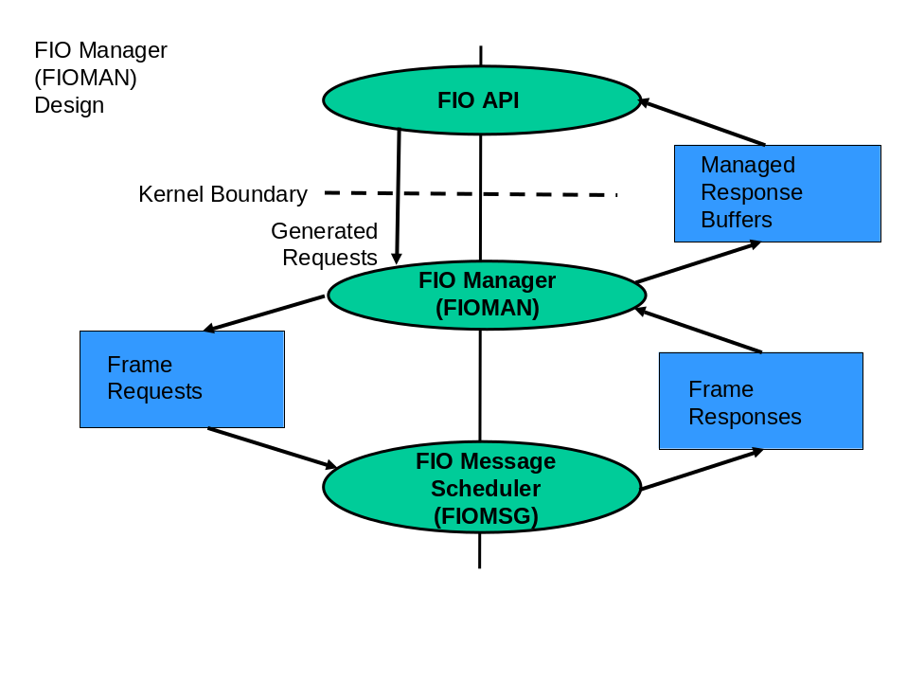
Figure #2
An application utilizes the FIOAPI to generate requests to the FIOS. Many requests can be satisfied by the FIOMAN itself. In this case, the FIOMAN responds with information already stored in its cache. Some requests require interaction with a FIOD. In this case, the FIOMAN generates a request frame and requests the FIOMSG to send this frame to the indicated FIOD. When the corresponding response frame is received (if a response frame is expected), the FIOMSG notifies the FIOMAN. The FIOMAN then logs appropriate information and gives a managed response buffer back to the application.
The FIOMAN manages two cache buffers. The first is an application specific view (myopic view). The second is a system view (all applications). An application can request information corresponding to either view; in most cases. For instance, an application (via the FIOAPI) can request a list of reserved output points for an FIOD from the applications point of view or a list of reserved output points for an FIOD from a system point of view.

FIOMSG Architecture
The FIOMSG layer is provided as a part of the FIO Driver LKM and exists in Kernel Space. FIOMSG consists of 2 Kernel Timer based tasks. One Task is used for transmission (TX) of FIOD request frames. A second Task is utilized for the polling and reception (RX) of FIOD response frames. There are two Kernel Timer Tasks per port; a total of 6 Tasks can be active at any given time.
The interface between the FIOMAN, FIOMSG and Linux SDLC Device Driver is illustrated in figure #3.
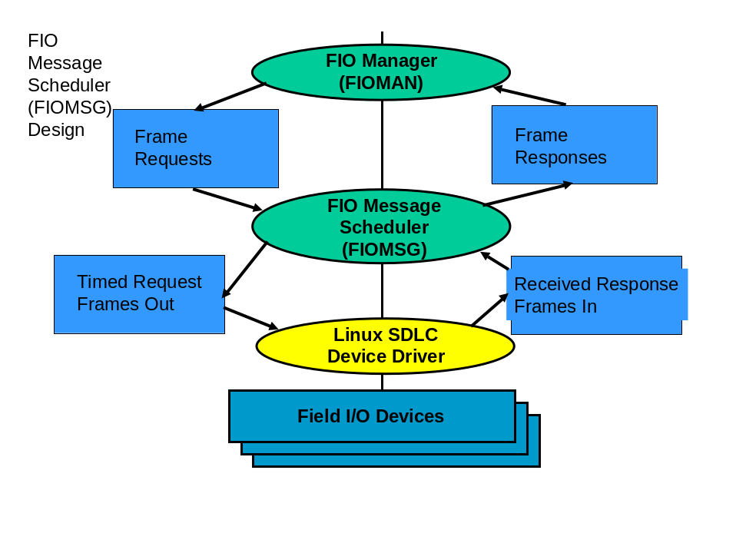
Figure #3
When the FIOMAN requires additional information from a FIOD, the FIOMAN will generate a frame request to the FIOMSG Kernel Timer Transmission (TX) Task. The FIOMSG TX Task manages queues of Request Frames, in send time order. These queues (one per port) are utilized by the FIOMSG TX Task to send the next Request Frame during its appropriate time slice.
Once a frame is sent (if a response frame is expected) the FIOMSG TX Task sets up a Kernel Timer RX Task to poll for the response frame. When the response frame is received the information is passed to the FIOMAN.
The FIOMSG RX Task maintains a FIOD specific last response frame type list, as illustrated in figure #4.
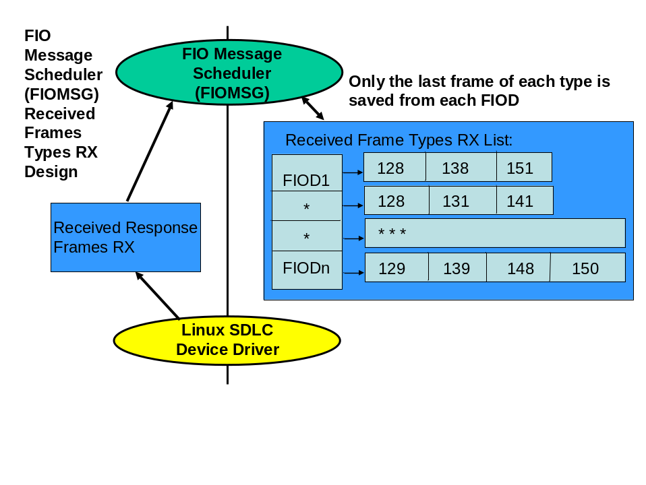
Figure #4
In this way, the last response frame of a given type for each FIOD is always available. There is one such list per port.
The FIOMSG RX Task also handles response timeouts and FIOD status logging.

Linux SDLC Device Driver Architecture
The FIOS architecture is a Kernel Space based solution. As such, it requires the ability to access the manufacturer supplied Linux SDLC Device Driver directly from Kernel Space. Appendix A supplies the interface requirements to which a manufacturer must adhere, to allow the FIOS to operate correctly.

Detailed Design

Field I/O Driver Internals
This kernel level module is a standard Linux compatible driver, except that it does not attach to any specific hardware component – it is considered a “pseudo-driver”. It supports the standard Linux calls open(), close(), read(), write() and ioctl(). The FIOAPI library is used to abstract the specifics of this interface away from an application.
The FIO Driver consists of the FIOMAN and the FIOMSG layers. The FIO Driver is provided as a Loadable Kernel Module (LKM), fiodriver.ko. This LKM must be loaded prior to any access to the FIOS. Two scripts are provided to facilitate the loading and unloading of this LKM: fio_load and fio_unload, respectively.
The FIO Driver LKM, when first loaded, generates a dynamic major device number for the FIOS. This major device number is utilized by fio_load to generate a device node in the /dev directory. This device node is named /dev/fio. The minor device for the FIOS is always 0. The major and minor device numbers are utilized by the Linux Kernel to map a request for service on /dev/fio to fiodriver.ko.
The fio_unload script is run when it is desired to remove the FIO Driver LKM from service. The FIO Driver LKM will only unload if there are no applications currently utilizing its services; this is a Linux feature.
These scripts must be updated by each individual manufacturer for their specific environment.
Each open() passes a file descriptor structure to the FIO Driver LKM; as managed by Linux. This same structure is also passed in for read(), write(), ioctl() and release() (close) FIO Driver LKM calls. The private_data reference field of this structure is used to hold a reference to the interface description structure associated with the application performing the open(). This provides all the necessary information required to ensure the applications view of the FIOAPI.
Figure #5 illustrates the detailed design of the FIOS.
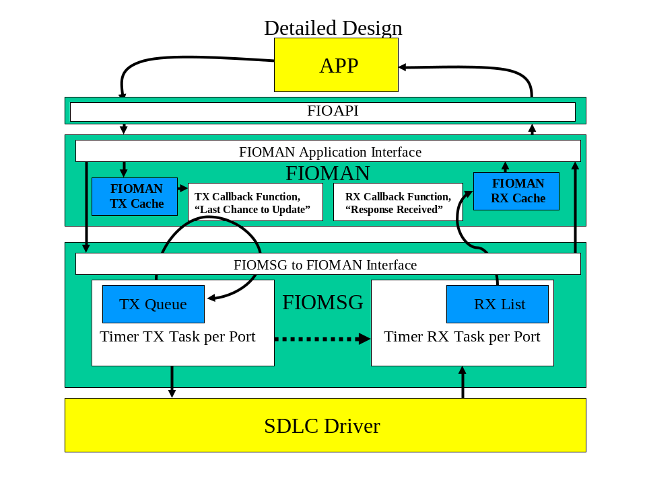
Figure #5
The sections below describe figure #5 in detail. Yellow boxes are used to indicate vendor supplied functionality; blue boxes are used for buffers; green boxes indicate layers of FIOS software; white boxes are software operations of a layer; bold arrows are used to indicate data flow; and dotted arrows are used to indicate flow control.

General Application Interface
All applications interface to the FIOS through the FIOAPI library. This user space library, libfioapi.a, is linked in by an application and provides all required functions to support the FIOAPI requirements.
DEFINITION: An application is a single Linux Process, as defined by a unique process id. If output points need to be shared between processes, this sharing must be done at a higher level. Writing of an output point is exclusive to a Linux Process. If 2 or more Linux Processes want to write to the same output point; this sharing must be solved by the user of the FIOAPI. The FIOAPI does not directly support this.

Field I/O API (FIOAPI)
All applications interface to the FIOS through the FIOAPI library. This user space library, libfioapi.a, is linked in by an application and provides all required functions to support the FIOAPI requirements. The SRS contains MAN Pages for all FIOAPI functions. The traceability matrix maps the SRS requirements to FIOAPI functions.
The FIOAPI layer is a thin layer of software that removes the need for application developers to know how to interface to the FIOS. There are 5 system level functions supported by the FIO Driver LKM: open(), close(), read(), write() and ioctl(). All FIOAPI functions map to one or more of these system level function calls. In general, most FIOS operations are supported by an ioctl() command.
The FIOAPI interfaces through these system level function calls to the FIOMAN. The FIOAPI generates requests through a system level function to the FIOMAN and receives responses from the FIOMAN through alternate system level function calls.
The list of functions supported by the FIOAPI is:
fio_register(), fio_deregister(), fio_fiod_register(), fio_fiod_deregister(), fio_fiod_enable(), fio_fiod_disable(), fio_fiod_inputs_get(), fio_fiod_outputs_set(), fio_fiod_outputs_get(), fio_fiod_outputs_reservation_set(), fio_fiod_outputs_reservation_get(), fio_query_fiod(), fio_fiod_channel_reservation_set(), fio_fiod_channel_reservation_get(), fio_fiod_channel_map_set(), fio_fiod_channel_map_count(), fio_fiod_channel_map_get(), fio_fiod_inputs_filter_set(), fio_fiod_inputs_filter_get(), fio_hm_register(), fio_hm_deregister(), fio_hm_heartbeat(), fio_hm_fault_reset(), fio_fiod_frame_schedule_set(), fio_fiod_frame_schedule_get(), fio_fiod_frame_size(3FIO), fio_fiod_frame_read(), fio_fiod_frame_notify_register(), fio_fiod_frame_notify_deregister(), fio_query_frame_notify_status(), fio_fiod_inputs_trans_set(), fio_fiod_inputs_trans_get(), fio_fiod_inputs_trans_read(), fio_fiod_wd_register(), fio_fiod_wd_deregister(), fio_fiod_wd_reservation_set(), fio_fiod_wd_reservation_get(), fio_fiod_wd_heartbeat(), fio_fiod_cmu_fault_set(), fio_fiod_cmu_fault_get(), fio_fiod_cmu_dark_channel_set(), fio_fiod_cmu_dark_channel_get(), fio_fiod_mmu_flash_bit_set(), fio_fiod_mmu_flash_bit_get(), fio_fiod_status_get(), fio_fiod_status_reset(), fio_fiod_ts_fault_monitor_set(), fio_fiod_ts_fault_monitor_get(), fio_fiod_ts1_volt_monitor_set(), fio_fiod_ts1_volt_monitor_get(), fio_apiver()
MAN pages for these functions can be found in the SRS.

Field I/O Manager (FIOMAN)
FIOMAN is the top layer of software of the FIO Driver LKM. This layer manages all access to and activity of the FIO Driver LKM. The FIOMAN layer executes as an extension of a user application process in Kernel Space.
FIOMAN, upon application request for action, either sets information into its internal cache, performs house keeping activities (such as health monitoring), or interacts with the FIOMSG layer to cause a Request Frame to be sent to a FIOD.
FIOMAN upon application request for response information either queries its internal cache for the required response information, or requests FIOMSG for the appropriate Response Frame.
FIOMAN maintains two separate views of information: what the application (APP view) currently knows about, has enabled, has set, or has reserved, etc.; and a view of what all applications (SYSTEM view) currently know about, have enabled, have set, have reserved, etc. An application can request either view.
Finally, to support the connection of what the system wants sent to a FIOD (system to FIOD) and providing feedback to the system as to the current state of a FIOD (FIOD to system), the FIOMAN supports two call back routines. These routines are called by the FIOMSG TX and RX Timer Tasks at appropriate times.
The FIOMSG TX Timer Task invokes a “Last Chance to Update” call back routine when a particular Request Frame is about to be transmitted. There is one call back routine for each unique Request Frame. The function of this call back routine is to update information in the request frame to be sent with the “latest and greatest” information from the system’s point of view. For instance, the need to set the current state of output points is handled via a call back. This call back routine first checks to see if any thing has changed (“change flag”) since the last time the routine has been called (did an application update output points); if the current state has changed, the new array of output points is copied into the Request Frame. Upon return from this routine, the FIOMSG layer is now free to send this frame to the FIOD. The “change flag” checking is done to ensure costly operations, such as the copying of memory, is not performed unless absolutely needed.
Mapping of Data / Control to Plus / Minus is performed by the FIOMAN TX Callback routine. This mapping is performed as follows (based upon cabinet):
ITS & Caltrans  Data / Control | TS2  Plus / Minus
00 | 00
01 | 01
11 | 10
10 | 11
Table #1
Data / Control to Plus / Minus Mapping
The FIOMSG RX Timer Task supports a “response received” call back routine. This unique routine, per Response Frame type, is called to allow the FIOMAN to update its RX cache as needed; with current information received from a FIOD. It is also used to allow asynchronous notification of the reception or error of a response frame, to an application.

Field I/O Message Scheduler (FIOMSG)
The FIOMSG layer of software is charged with communicating to the actual FIODs. It does so at an applications request, via the FIOMAN. The FIOMSG supports 3 functional layers of software: a FIOMAN interface layer, a TX Timer Task and a RX Timer Task. There are logically 3 FIOMSGs; one for each active port. The FIOMSG only initiates and communicates with a FIOD when commanded to do so by an application, via the FIOMAN.
The FIOMAN interface layer is used to allow commands and queries by the FIOMAN to be initiated.
All communication to a FIOD is via a Kernel Level Interface to a manufacturer supplied SDLC Device Driver. The manufacturer must export symbols, as noted in Appendix A, to allow the FIO Driver LKM to link, at LKM load time, with the manufacturer supplied SDLC Device Driver and work properly.
The FIOMSG TX Timer Task is a Kernel Timer based Task. This Task manages a queue of Request Frames to be sent on a specific port, at a specific time. There is one TX Queue and one TX Timer Task per port. When the FIOMAN is commanded by an application to communicate to a FIOD, it does so by sending Request Frames to the TX Queue. A single port is a full-duplex connection that can have one to many FIODs daisy chained on it. At any given point in time, there can only be one outstanding Request Frame and one outstanding Response Frame on the physical wire associated with the port. The FIOMSG TX Timer Task manages sending the next scheduled Request Frame on the port, when that frame is scheduled to be sent. The last thing the TX Timer Task does is set the TX Timer for the next Request Frame to be sent.
The sending of Request Frames and receiving of Response Frames is completely timer based. The NEMA TS2 specification goes into detail about the timing of these frames. Even though the NEMA TS2 specification only deals with NEMA TS2 cabinets; the specification of Request and Response Frame timing has been utilized for this implementation (NEMA TS2 frame timing is the most definitive specification). Manufacturers are encouraged to modify the table found in the FIO Driver LKM dealing with Request and Response Frame timing to suit their implementation needs. The NEMA TS2 table is table 3-4 “Service, Response, and Command Values”; found in the NEMA TS2 specification. Equations 3-2 and 3-3 found in the NEMA TS2 specification are implemented by the solution described herein.
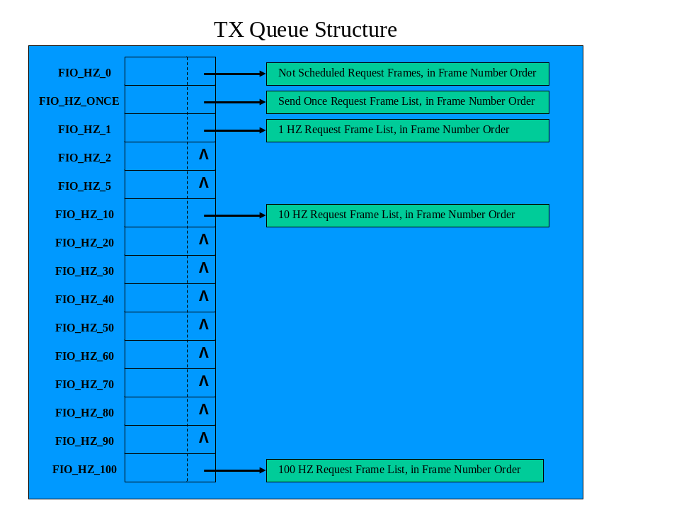
Figure #6
The TX Queue, described above, is sorted in the following manner:
- There is a table of frame TX structures indexed by TX frequency;
- Each TX structure contains a pointer to a list of Request Frames to be TX’ed at this frequency. A NULL pointer indicates there are no Request Frames scheduled at this frequency;
- Each list of Request Frames is sorted by Frame Number (type) order;
- Each TX structure contains information as to when (jiffies) the first frame in the pointed to list is to be TX’ed next;
- The FIO_HZ_0 list (non-scheduled Request Frames) contains a complete list of all possible Request Frames;
- When the FIOMAN requires communications with an FIOD, a list of Request Frames to be queued is generated (from the FIO_HZ_0 list);
- All Request Frames in this list are sorted into the appropriate frequency list, in the correct sort order;
- The TX Timer Task sends all Request Frames of a given Frequency as a group;
- The TX Timer Task sends Request Frames in lowest frequency to highest frequency order. In so doing, this ensures that Date / Time frames whose frequency is typically 1 Hz, are sent before a group of frames whose frequency is 10 Hz.
When the FIOMSG TX Timer Task fires, the next Request Frame in the TX Queue (as mentioned above) is sent on the indicated port to the indicated FIOD. Before the actual TX occurs, however, the FIOMSG TX Timer Task invokes the FIOMAN “Last Chance to Update” call back routine; as described above. This allows the FIOMAN to ensure the correct information is conveyed to the FIOD.
When a Request Frame is sent from the TX Queue, the next TX time is established. This is done to make sure TX time drift does not occur. The new TX time is the current time (jiffies) plus the Request Frame transmission frequency HZ.
If the Request Frame being TX’ed is expecting a Response Frame, a RX Timer Task is set up; based upon the expected full Response Time from the NEMA TS2 Table. When the RX Timer Task fires; the Response Frame is expected to be fully received by the manufacture supplied SDLC Device Driver. A read is performed to the manufacture supplied SDLC Device Driver. If no data is available, the response is marked in error (no response). If a Response Frame is found, error checking is performed it ensure that the expected Response Frame is what was received. If the correct Response Frame was received, it is added to the RX List and the correct FIOMAN RX call back routine is invoked to allow the FIOMAN to cache information as needed.
The RX List is a table sorted by FIOD. For each FIOD, the last Response Frame per frame type is maintained in frame number (type) order. There is one RX List per port.

Kernel Interface
In reality, the application does not communicate directly with the FIO Driver, but rather indirectly through a system library which provides a standard interface and some checking using the file descriptor. The application developer does not need to make any special considerations for this; it is a function of the kernel. The following details the operations and routines required to properly load the FIO Driver LKM into the kernel. These routines are not directly exposed to the application developer; some are executed indirectly through the system library.
int __init fio_init( void )
This is the routine that actually registers the driver with the VFS. It is performed once, at system startup, when the driver is loaded; using fio_load. In addition, the storage reserved for device descriptors and other information is initialized.
void __exit fio_exit( void )
This routine unregisters the driver from the VFS. Should the driver be forced to unload, using fio_unload, any allocated storage is freed and the device descriptor storage is re-initialized.
int fio_open( struct inode *inode, struct file *filp )
The open function provides a control point for all processes requesting the use of this device driver. The inode structure contains information about the specific device that is being opened; the filp structure contains a unique file descriptor structure. If all checks on this request are successful, the open is granted. At this point a reference to the file operations (f_ops) structure is loaded into the file descriptor structure. This structure correlates application calls, such as read() or write() with the driver routines that perform the actual operation.
int fio_release( struct inode *inode, struct file *filp )
This routine is called when close() is called, or anytime the application exits without explicitly calling close(). It releases resources held for the calling application, and performs any other cleanup as required. The process requesting a release must have a valid file descriptor (from a previous open() request) and sufficient privilege to execute the release.
ssize_t fio_read( struct file *filp, char __user *buf, size_t count, loff_t *ppos )
In general, this routine returns a Response Frame to an application.
ssize_t fio_write( struct file *filp, const char __user *buf, size_t count, loff_t *ppos )
In general, this routine is used to write a Request Frame to the FIOS..
int fio_ioctl( struct inode *inode, struct file *filp, unsigned int cmd, unsigned long arg )
I/O Control's (IOCTL's) are a way of getting non-standard information into and out of the driver. These pseudo-operations are used to perform advanced operations supported by the driver. Supported IOCTL commands are included in the “fio.h” file.

FIO Driver LKM API
From the application developer’s point of view, it has full access to what appears to be a list of FIODs using standard library calls. These functions can be found in the MAN pages for the Embedded Operating Environment and are standard across all UNIX based systems. In all cases, the functions return a status code to the caller. If this value is less than zero (< 0) an error has occurred and the global variable errno must be checked to determine the specific nature of the error. Values equal to or greater than zero are “call” specific as described below. The functions listed below are utilized by the FIOAPI library. The FIOAPI library is present to remove the specifics of this iunterface from an application.
int open( char *pathname, int flags )
This call must be the first call made to the FIOS. The pathname must be /dev/fio.
int close( int fd );
This call must be the last call to the FIOS. It invalidates the file descriptor and destroys the APP view associated with this descriptor.
int read( int fd, void *buf, size_t count )
This function, in general, returns a Response Frame. Data is transferred into the specified buffer buf. At most count bytes are transferred. In some cases, less then count bytes or even zero bytes can be returned. The call returns the actual number of bytes read unless an error occurred.
int write( int fd, const void *buf, size_t count )
This function writes count bytes of a Request Frame to the FIOS. The call returns the actual number of bytes written, which in this case should always be count, unless an error has occurred.
int ioctl( int fd, int cmd, ... )
This function allows the application to make non-standard requests to the FIO Driver. Depending on the request, there may be an additional data argument to the call.

Process Decomposition

FIO Driver Initialization
The FIO Driver LKM is loaded by the kernel during system initialization. The FIO Driver LKM performs the following steps:
- Allocate and initialize any memory necessary for general FIO Driver usage;
- Initialize the FIOMAN Layer – Allocate and initialize all FIOMAN System buffers
- Initialize the FIOMSG Layer – Allocate and initialize all FIOMSG System buffers
- Upon unloading of the FIO Driver LKM, the FIOMSG Layer and FIOMAN Layer cleanup routines are called to release all memory associated with these layers. Finally, any global FIO Driver memory is released.
No communications are commenced until the FIOS is commanded to do so by an application.

Application Processing
Below are code snippets of a simple application program utilizing the FIOAPI.

Traffic Control Example
C’ Code: (no error handling shown)
#include “fio.h”
{
/* Allocate Buffers to control inputs & outputs */
unsigned char inputs_list[ FIO_INPUT_POINTS_BYTES ];
unsigned char outputs_list[ FIO_OUTPUT_POINTS_BYTES ];
unsigned char reserve_list[ FIO_OUTPUT_POINTS_BYTES ];

/* Register with FIO API */
FIO_APP_HANDLE fh = fio_register();

/* Register DEV 1 */
FIO_DEV_HANDLE dev = fio_fiod_register( fh, FIO_SP3, FIO332 );

/* Reserve Output Points */
FIO_BITS_CLEAR( reserve_list, sizeof( reserve_list ) );
FIO_BIT_SET( reserve_list, OUTPUT_BIT_0 ); /* Reserve only output point 0 */
err = fio_fiod_outputs_reservation_set( fh, dev, reserve_list );

/* Enable Communications with the FIOD */
err = fio_fiod_enable( fh, dev ); /* Turn on I/O to DEV 1 * /

/* Start processing */
FIO_BITS_CLEAR( outputs_list, sizeof( outputs_list ) );
do
{
sleep(1); /* Wait for a while */
err = fio_fiod_inputs_get( fh, dev, FIO_INPUTS_FILTERED, inputs_list ); /* Get Inputs */
if ( FIO_BIT_TEST( inputs_list, INPUT_BIT_2 ) ) /* If something happened */
{
FIO_BIT_SET( outputs_list, OUTPUT_BIT_0 ); /* Turn on light */
}
else
{
FIO_BIT_CLEAR( outputs_list, OUTPUT_BIT_0 ); /* Turn off light */
}
err = fio_fiod_outputs_set( fh, dev, outputs_list ); /* Set the light to the state indicated */
}
while( 1 ); /* Do forever */

endloop:
fio_deregister( fh ); /* cleanup all services */
}

Requirements Traceability Matrix
Requirement in SRS | Summary of Requirement in SRS | FIOAPI Function Supporting Requirement
SRS3.1.2[1] | The API shall assume it has exclusive access to the serial communications ports of the ATC Engine Board that are designated for Field I/O Devices. | Supported by fio_register()
SRS3.1.2[2] | The supported Field I/O serial communications ports shall be SP3, SP5 and SP8. | Supported by fio_fiod_register() FIO_PORT parameter.
SRS3.1.2[3] | The supported communication modes on those ports shall be 153.6 Kbps and 614.4 Kbps SDLC. | Supported by fio_fiod_register()
SRS3.1.2[4] | The API shall not open any serial communications port or initiate communications to any Field I/O Device unless explicitly commanded to do so by an application program. | Supported by fio_fiod_enable()  The application calls this function to enable communications.
SRS3.1.2[5] | The API shall support all cabinet architectures and associated Field I/O Device types as listed in the ATC Controller Standard Section 8. | Supported by fio_register()
SRS3.1.2[6] | The API shall support the Field I/O Device types shown in Table 2. | Supported by fio_fiod_register()  FIO_DEVICE_TYPE parameter
SRS3.1.2[7] | The API shall assume that BIU and MMU Field I/O Devices operate at 153.6 Kbps and all other Field I/O Device types operate at 614.4 Kbps. | Supported by fio_fiod_register()
SRS3.1.2[8] | The API shall support communication to multiple Field I/O Devices on a single communications port provided the Field I/O Devices have compatible physical communication attributes. | Supported by fio_fiod_register()
SRS3.1.2[9] | The API shall support a maximum of one Field I/O Device of each type per communications port except in the case of BIUs and SIUs. | Supported by fio_fiod_register() and FIO_DEVICE_TYPE parameter
SRS3.1.2[10] | The API shall support up to 8 Detector BIU and 8 Terminal & Facilities BIU Field I/O Devices per communications port. | Supported by fio_fiod_register() and FIO_DEVICE_TYPE parameter
SRS3.1.2[11] | The API shall support up to 5 Input SIU, 2 14-Pack Output SIU, and 4 6-Pack Output SIU Field I/O Devices per communications port. | Supported by fio_fiod_register() and FIO_DEVICE_TYPE parameter
SRS3.1.2[12] | The API shall only support valid Output SIU combinations as defined in the ITS Cabinet Standard, Section 4.7. | Supported by fio_fiod_register() and FIO_DEVICE_TYPE parameter
SRS3.1.2[13] | The API shall identify specific Field I/O Devices using the API Field I/O Device Names in Table 2. | Supported by FIO_DEVICE_TYPE enum
SRS3.1.2[14] | The API shall provide a method for application programs to register and deregister with the API for access to the API Field I/O services. | Supported by fio_register() and fio_deregister()
SRS3.1.2[15] | The process of application program registration shall not cause the API to perform any communications with the Field I/O Device. | Supported by fio_register()
SRS3.1.2[16] | When an application program deregisters for access to Field I/O services, the API shall deregister (as defined in Item “e”) all Field I/O devices registered by that application program. | Supported by fio_deregister()
SRS3.1.2[17] | The API shall provide a method to allow application programs to register and deregister for access to specific Field I/O Devices by specifying the communications port, device type, and where applicable, the Field I/O Device number. | Supported by fio_fiod_register() and fio_fiod_deregister()
SRS3.1.2[18] | Once a device has been registered on a communications port, the API shall permit the registration of additional compatible Field I/O Devices on the same communications port and prohibit the registration of incompatible Field I/O Devices on the same communications port. | Supported by fio_fiod_register()
SRS3.1.2[19] | The Field I/O Device registration process shall not cause the API to perform any device communications. | Supported by fio_fiod_register()
SRS3.1.2[20] | When an application program deregisters for access to a Field I/O Device, the API shall disable (as defined in Item “g”) the Field I/O Device, relinquish all output points for that device, and sets all application program settable states to their default values. | Supported by fio_fiod_deregister()
SRS3.1.2[21] | The API shall provide a method for application programs to query for the presence of a Field I/O Device using the communications port, device type, and where applicable, the Field I/O Device number. | Supported by fio_query_fiod()
SRS3.1.2[22] | If the API does not have the communications port open at the time of the query and it is necessary for the API to open the communications port to determine the Field I/O Device, the API shall close the communications port after the query is completed. | Supported by fio_query_fiod()
SRS3.1.2[23] | If the API has the communications port open at the time of the query and the communications attributes for the Field I/O Device used in the query are not compatible with the current settings on the communications port, the API shall assume that the Field I/O Device is not present. | Supported by fio_query_fiod()
SRS3.1.2[24] | If the API has the communications port open at the time of the query and API is already successfully completing scheduled communications to the Field I/O Device, the API shall indicate that the Field I/O Device is present without sending any additional frames to the device.  Guidance: It is not required for an application program to be registered with a Field I/O Device to perform a query. | Supported by fio_query_fiod()
SRS3.1.2[25] | The API shall provide a method which allows an application program to enable and disable communications to a Field I/O Device for which the application program has registered. | Supported by fio_fiod_enable() and fio_fiod_disable().
SRS3.1.2[26] | When the communications enable method is called, the API shall initiate scheduled communications between the API and the specified Field I/O Device if not already active. | Supported by fio_fiod_enable()
SRS3.1.2[27] | When the disable communications method is called, the API shall cease scheduled communications between the API and the specified Field I/O Device if the device is no longer enabled by any application program. | Supported by fio_fiod_disable()
SRS3.1.2[28] | When a Field I/O Device is disabled, any output points which have been reserved by that application program shall be set to Off. | Supported by fio_fiod_disable()
SRS3.1.2[29] | The API shall provide a method for application programs to read the states of the input and output points on registered Field I/O Devices, including both filtered and non-filtered states for the input points (depending on which input frames are scheduled). | Supported by fio_fiod_inputs_get() and fio_fiod_outputs_get().  It was universally decided by the QRG that input and output points will be represented by bit map arrays of type unsigned char *.
SRS3.1.2[30] | If multiple application programs have registered for the same Field I/O Device, the API shall provide shared read access to the input and output point states for all application programs which have registered that device. | Supported by fio_fiod_inputs_get() and fio_fiod_outputs_get().
SRS3.1.2[31] | When the state of an output point is read, the API shall return the current state of that output point within the API.  Guidance: When a read is requested, the API does not attempt to query the actual states of the output points on the Field I/O Device. | Supported by fio_fiod_outputs_get()
SRS3.1.2[32] | The API shall provide a method for application programs to reserve/relinquish exclusive “write access” to individual output points of a Field I/O Device. | fio_fiod_outputs_reservation_set()  Provides both reserve and relinquish functionality
SRS3.1.2[33] | If an application program reserves a point that has already been reserved by that application program, it shall not be considered an error. | Supported by fio_fiod_outputs_reservation_set()
SRS3.1.2[34] | If an application program relinquishes a point that is already in the relinquished state for that application program, it shall not be considered an error. | Supported by fio_fiod_outputs_reservation_set()
SRS3.1.2[35] | If a point in a group of points cannot be reserved, the reservation attempt shall fail for all of them. | Supported by fio_fiod_outputs_reservation_set()
SRS3.1.2[36] | The API shall allow only one application program to reserve write access to any individual output point. | Supported by fio_fiod_outputs_reservation_set()
SRS3.1.2[37] | The API shall allow multiple application programs to reserve different output points on a single Field I/O Device. | Supported by fio_fiod_outputs_reservation_set()
SRS3.1.2[38] | Exclusive reservation of an output point for write access by one application program shall not preclude other application programs from reading the state of the output point. | Supported by fio_fiod_outputs_get()
SRS3.1.2[39] | The API shall provide error codes so that the application program can determine if the reservation action was successful or if there was a conflict with another application program. | Supported by fio_fiod_outputs_reservation_set()
SRS3.1.2[40] | The API shall make output point reservations on a “first come first served basis”. | Supported by fio_fiod_outputs_reservation_set()
SRS3.1.2[41] | An application program shall be able to set the state of an output point if it has registered the associated Field I/O Device and reserved exclusive write access to the output point.  Guidance: Non-NEMA devices set their outputs using arrays of Control and Data instead of Load Switch +/-. The API needs to make the translation accordingly | Supported by fio_fiod_outputs_set(0
SRS3.1.2[42] | To set the state of an output point and control dimming, the API shall use separate arrays for control of the Load Switch + and Load Switch – (see Section 3.3.1.4.1.5 of the TS 2 Standard). | Supported by fio_fiod_outputs_set()
SRS3.1.2[43] | The API shall provide a method for application programs to query the reservation status of output points on registered Field I/O Devices. | Supported by fio_fiod_outputs_reservation_get()
SRS3.1.2[44] | The API shall provide a method for application programs to map/unmap reserved output points to reserved channels and colors on a registered FIOMMU or FIOCMU device. | Supported by fio_fiod_channel_map_set()  Provides both map and unmap functionality  Supported by fio_fiod_channel_map_count() and fio_fiod_channel_map_get()
SRS3.1.2[45] | The API shall use this mapping to set the contents of FIOMMU Frame 0 and FIOCMU Frames 61 and 67. | Supported by fio_fiod_channel_map_set() and fio_fiod_outputs_set()
SRS3.1.2[46] | Any channel and color not mapped to an output point shall be set to Off. | Supported by fio_fiod_channel_map_set()
SRS3.1.2[47] | The API shall provide a method for application programs to reserve/relinquish exclusive control of individual monitored channels on the FIOMMU or FIOCMU device. | Supported by fio_fiod_channel_reservation_set()  Provides both reserve and relinquish functionality  Supported by fio_fiod_channel_reservation_get()
SRS3.1.2[48] | If an application program reserves a channel that has already been reserved by that application program, it shall not be considered an error. | Supported by fio_fiod_channel_reservation_set()
SRS3.1.2[49] | If an application program relinquishes a channel that is already in the relinquished state for that application program, it shall not be considered an error. | Supported by fio_fiod_channel_reservation_set()
SRS3.1.2[50] | If a channel in a group of channels cannot be reserved, the reservation attempt shall fail for all of them. | Supported by fio_fiod_channel_reservation_set()
SRS3.1.2[51] | The API shall allow multiple applications to reserve different channels on a single FIOMMU or FIOCMU device. | Supported by fio_fiod_channel_reservation_set()
SRS3.1.2[52] | The API shall provide error codes so that the application program can determine if the reservation action was successful or if there was a conflict with another application. | Supported by fio_fiod_channel_reservation_set()
SRS3.1.2[53] | The API shall make channel reservations on a “first come first served basis”. | Supported by fio_fiod_channel_reservation_set()
SRS3.1.2[54] | The API shall provide a method for applications to query the reservation status of channels on registered FIOMMU or FIOCMU devices. | Supported by fio_fiod_channel_reservation_get()
SRS3.1.2[55] | Relinquishing a reserved output point or channel shall clear the associated assignments. | Supported by fio_fiod_outputs_reservation_set(), fio_fiod_channel_reservation_set(). fio_fiod_channel_map_set() and fio_fiod_channel_map_count()
SRS3.1.2[56] | The API shall provide functions which allow application programs to set and get the leading and trailing edge filter values on a per input basis for all Field I/O Devices that support configurable filtered inputs. | Supported by fio_fiod_inputs_filter_set() and  fio_fiod_inputs_filter_get()
SRS3.1.2[57] | If multiple application programs set the filter values of an input, the shortest filter values shall be used. | Supported by fio_fiod_inputs_filter_set()
SRS3.1.2[58] | The API shall provide a return code containing the status and the value used for the set filter operation. | The fio_fiod_inputs_filter_set() function returns current filter values in the input filter list.
SRS3.1.2[59] | The default leading and trailing edge filter values shall be 5 consecutive samples.  Guidance: Any application program can read and set the filter value on any input. Future versions of the API may want to restrict this in some fashion. | This will be a #define constant that an application may choose to utilize.  #define FIO_FILTER_DEFAULT 5  Supported by fio_fiod_inputs_filter_set()
SRS3.1.2[60] | The API shall have the ability to collect and buffer the transition buffer information for each registered Field I/O Device used for input. | Supported by fio_fiod_inputs_trans_set() and fio_fiod_inputs_trans_read()
SRS3.1.2[61] | When the API reads the transition buffer of a Field I/O Device, it shall read the entire transition buffer. | Supported by fio_fiod_inputs_trans_read()
SRS3.1.2[62] | The API shall buffer the transition data on a per application program basis with the capability of storing 1024 transition entries in a FIFO fashion. | Supported by fio_fiod_inputs_trans_read()
SRS3.1.2[63] | The API shall provide a function which allows application programs to enable or disable transition monitoring of selected input points. | Supported by fio_fiod_inputs_trans_set() and  fio_fiod_inputs_trans_get()
SRS3.1.2[64] | By default, transition monitoring for all input points shall be disabled. | Supported by fio_fiod_inputs_trans_set()
SRS3.1.2[65] | If an application program enables an input point for transition monitoring and that input point is already in the enabled state, it shall not be considered an error. | Supported by fio_fiod_inputs_trans_set()
SRS3.1.2[66] | If an application program disables an input point for transition monitoring and that input point is already in the disabled state, it shall not be considered an error. | Supported by fio_fiod_inputs_trans_set()
SRS3.1.2[67] | The API shall provide functions that allow application programs to access the API transition buffer information asynchronously (i.e. read the transition entries from the API buffer independent of any Field I/O Device communications). | Supported by fio_fiod_inputs_trans_read()
SRS3.1.2[68] | When an application program reads a transition entry from an API transition buffer, that transition entry shall be cleared for that application program only, without affecting the API transition buffers for other application programs. | Supported by fio_fiod_inputs_trans_read()
SRS3.1.2[69] | If the transition buffer in the Field I/O Device overruns before information can be copied to the API transition buffer information, the API shall indicate that a device overrun condition has occurred in the transition buffer for that Field I/O Device. | Supported by fio_fiod_inputs_trans_read()  The return value is success (count of entries), FIOD Overrun or FIO API overrun
SRS3.1.2[70] | If the transition buffer of the API overruns before the information is retrieved by the application program, the API shall indicate that an API overrun condition has occurred.  Guidance: The purpose of the two overrun conditions discussed in the preceding paragraph is to alert application programs that they are missing data. | Supported by fio_fiod_inputs_trans_read()  The return value is success (count of entries), FIOD Overrun or FIO API overrun
SRS3.1.2[71] | The ATC Controller Standard, Section 8, specifies the frames for communication with Field I/O Devices for Model 332 Cabinets, NEMA TS 1 and TS 2 Type 2 Cabinets, and ITS Cabinets. The API shall support a subset of these frames at the scheduled frame frequencies as shown in Table 3. | Supported by fio_fiod_frame_schedule_set()
SRS3.1.2[72] | The NEMA TS 2 Standard, Section 3.3, specifies the frames for communication with Field I/O Devices for NEMA TS 2 Type 1 Cabinets. The API shall support a subset of these frames at the scheduled frame frequencies as shown in Table 4. | Supported by fio_fiod_frame_schedule_set()
SRS3.1.2[73] | The timing for the command/response cycle of the frames shall be defined by the “Handshaking” algorithm in Section 3.3.1.5.3 of the NEMA TS 2 Standard.  Guidance: Although the timing for the command/response cycle of the frames is defined for the API by the NEMA TS 2 Standard, it applies to all frame types regardless of the cabinet standard. | Supported by fio_fiod_frame_schedule_set()
SRS3.1.2[74] | The API shall provide a method for application programs to set the scheduled frame frequencies for a registered Field I/O Device.  Guidance: If an application program deregisters with a Field I/O Device, the frame frequency for all frames associated with that application program is set to 0 and the next highest frequencies for those frames are used by the API. | Supported by fio_fiod_frame_schedule_set() and fio_fiod_frame_schedule_get()
SRS3.1.2[75] | The frame frequency used by the API shall be the highest frequency requested by all application programs registered for that Field I/O Device.  Guidance: For a frame to be disabled to a Field I/O Device, all registered application programs must set the frequency of the frame to 0. | Supported by fio_fiod_frame_schedule_set()
SRS3.1.2[76] | The API shall provide a method to send a frame one time (non-scheduled).  Guidance: A frame intended to be sent one time should be sent after the next set of scheduled frames has complete. Generally, the API should order the frames sent to a Field I/O Device based on their frame type. | Supported by fio_fiod_frame_schedule_set() frequency of FIO_HZ_ONCE
 | The API provides methods to set and clear application-initiated “fault” conditions. The management of the fault condition varies by Field I/O Device type as follows: | No requirements, lead in to items below.
SRS3.1.2[77] | The API shall provide a method to set/get the Failed State Action of a FIOCMU Field I/O Device. | Supported by fio_fiod_cmu_fault_set()  This uses frame 62.  Supported by fio_fiod_cmu_fault_get()
SRS3.1.2[78] | The Failed State Action shall be settable to None (LFSA=0, NFSA=0), Latched (LFSA=1, NFSA=0), or Non Latched (LFSA=0, NFSA=1). | Supported by fio_fiod_cmu_fault_set()
SRS3.1.2[79] | The default Failed State Action shall be None. | Supported by fio_fiod_cmu_fault_set()
SRS3.1.2[80] | If any application program sets the state to Latched, the API shall set the Failed State Action to Latched. | Supported by fio_fiod_cmu_fault_set()
SRS3.1.2[81] | If no application program has set the Failed State Action to Latched, then if any application program sets the state to Non Latched, the API shall set the Failed State Action to Non Latched. | Supported by fio_fiod_cmu_fault_set()
SRS3.1.2[82] | If all application programs have a state of None, then the API shall set the Failed State Action to None. | Supported by fio_fiod_cmu_fault_set()
SRS3.1.2[83] | The API shall provide a method to set/get the state of the Fault Monitor output point of FIOTS1 and FIOTS2 Field I/O Devices. | Supported by fio_fiod_ts_fault_monitor_set() and fio_fiod_ts_fault_monitor_get()
SRS3.1.2[84] | The API shall retain ownership of the Fault Monitor output point and not allow application programs to reserve this output point. | Supported by fio_fiod_ts_fault_monitor_set()
SRS3.1.2[85] | If any application program sets the Fault Monitor state to Off, the API shall turn Off the Fault Monitor output point on that device. | Supported by fio_fiod_ts_fault_monitor_set()
SRS3.1.2[86] | If all application programs have a Fault Monitor state of On for a FIOTS1 or FIOTS2 Device, then the API shall turn On the Fault Monitor output point on that device. | Supported by fio_fiod_ts_fault_monitor_set()
SRS3.1.2[87] | The default state of the Fault Monitor output point shall be On. | Supported by fio_fiod_ts_fault_monitor_set()
SRS3.1.2[88] | The API shall provide a method to set/get the state of the Voltage Monitor output point of a FIOTS1 Field I/O Device. | Supported by fio_fiod_ts1_volt_monitor_set() and fio_fiod_ts1_volt_monitor_get()
SRS3.1.2[89] | The API shall retain ownership of the Voltage Monitor output point and not allow application programs to reserve this output point. | Supported by fio_fiod_ts1_volt_monitor_set()
SRS3.1.2[90] | If any application program sets the Voltage Monitor state to Off, the API shall turn Off the Voltage Monitor output point on that device. | Supported by fio_fiod_ts1_volt_monitor_set()
SRS3.1.2[91] | If all application programs have a Voltage Monitor state of On for a FIOTS1 Device, then the API shall turn On the Voltage Monitor output point on that device. | Supported by fio_fiod_ts1_volt_monitor_set()
SRS3.1.2[92] | The default state of the Voltage Monitor output point shall be On. | Supported by fio_fiod_ts1_volt_monitor_set()
SRS3.1.2[93] | The API shall provide a method which allows application programs to assign the output point used for the Watchdog output of any registered Field I/O Device. | Supported by fio_fiod_wd_reservation_set() and fio_fiod_wd_reservation_get()
SRS3.1.2[94] | The API shall restrict the ability to assign the Watchdog output point to the first application program to call the assignment method. | Supported by fio_fiod_wd_reservation_set() and fio_fiod_wd_register()
SRS3.1.2[95] | The API shall retain ownership of the Watchdog output point and not allow application programs to reserve that output point directly. | Supported by fio_fiod_outputs_reservation_set(), fio_fiod_wd_reservation_set() and fio_fiod_wd_register()
SRS3.1.2[96] | The API shall provide a method for application programs to register for shared control of the Watchdog output point. | Supported by fio_fiod_wd_register() and fio_fiod_wd_deregister
SRS3.1.2[97] | The API shall provide a method for Watchdog registered application programs to “request” that the API toggle the state of the Watchdog output point. | Supported by fio_fiod_wd_heartbeat()
SRS3.1.2[98] | The API shall only toggle the Watchdog output point if all Watchdog registered application programs have made the toggle request (Watchdog Triggered Condition). | Supported by fio_fiod_wd_heartbeat()
SRS3.1.2[99] | Upon a Watchdog Triggered Condition, the API shall toggle the state of the Watchdog output point within the API. | All registered applications have called fio_fiod_wd_heartbeat().
SRS3.1.2[100] | When the API updates the output states of the Field I/O Device (see Item “n”), the API shall clear all previous toggle requests and the Watchdog Triggered Condition so that a new Watchdog Triggered Condition can be generated. | Supported by fio_fiod_wd_heartbeat()
SRS3.1.2[101] | The API shall not toggle the Watchdog output point more than once per update of the output states on the Field I/O Device. | Supported by fio_fiod_wd_heartbeat()
SRS3.1.2[102] | The API shall provide functions which allow application programs to obtain status information of a registered Field I/O Device. | Supported by fio_fiod_status_get()
SRS3.1.2[103] | All counters contained in the Field I/O Device status information shall be four byte unsigned values each with a maximum value of 4,294,967,295. | Supported by fio_fiod_status_get()
SRS3.1.2[104] | The counters shall be frozen when they reach the maximum value to prevent rollover. | Supported by fio_fiod_status_get()
SRS3.1.2[105] | The API shall provide the following communication status information for each registered Field I/O Device:  - Communications Enabled/Disabled;  - Cumulative successful response count for all frames to this device;  - Cumulative error count for all frames to this device; and  - Command frames sent to this device with the following information for each frame type: current scheduled frequency, cumulative successful response count, cumulative error count, numbers of errors in the last 10 frames, a response frame sequence number and the raw data from the most recent response frame.  Guidance: Although the response frame time period is defined for the API by the NEMA TS 2 Standard, it applies to all frame types regardless of the cabinet standard. | Supported by fio_fiod_status_get().  Frame access supported by  fio_fiod_frame_read().  Frame size and sequence number are supported by fio_fiod_frame_size().  A sequence number will be provided on all returned frames for frame aging.
SRS3.1.2[106] | The response frame sequence number shall be a four byte unsigned value and rollover after the maximum value. | Supported by fio_fiod_frame_size(), fio_fiod_frame_read() and fio_query_frame_notify_status()
SRS3.1.2[107] | The API shall provide a method for application programs to reset the communications status counters to 0 (zero) for a registered Field I/O Device. | Supported by fio_fiod_status_reset()
SRS3.1.2[108] | A response frame shall only be considered successful if it is fully received within the time period defined by the “Handshaking” algorithm in Section 3.3.1.5.3 of the NEMA TS 2 Standard. | Supported by fio_fiod_status_get()
SRS3.1.2[109] | The API shall provide an API Health Monitor Function which registered application programs use to indicate to the API that they are operational. | Supported by fio_hm_heartbeat()
SRS3.1.2[110] | The API shall provide a method to set an API Health Monitor Timeout for each application program (each application program has its own unique API Health Monitor Timeout). | Supported by fio_hm_register() and fio_hm_deregister().
SRS3.1.2[111] | This API Health Monitor Timeout shall indicate the maximum allowable time between calls to the API Health Monitor Function. | Supported by fio_hm_register()
SRS3.1.2[112] | The API Health Monitor Timeout shall be specified in tenths of a second. | Supported by fio_hm_register()
SRS3.1.2[113] | If the API Health Monitor Timeout expires for an application program, the API shall disable (as defined previously in Item “g”) all Field I/O Devices registered by that application program. | General _hm_ functionality, supported indirectly by fio_hm_register() fio_hm_heartbeat().
SRS3.1.2[114] | The API shall provide a method for an application program to disable the API Health Monitor feature for itself. | Supported by fio_hm_register() and fio_hm_deregister()
SRS3.1.2[115] | The API shall provide a method for an application program to reset an API Health Monitor fault condition and allow the API to resume Field I/O Device communications. | Supported by fio_hm_fault_reset() and fio_hm_heartbeat()
SRS3.1.2[116] | An application program shall only be able to reset its own API Health Monitor fault condition and not that of any other application program. | Supported by fio_hm_fault_reset()
SRS3.1.2[117] | If an application program resets the API Health Monitor fault condition, then any devices that were disabled due to that condition shall be re-enabled. | Supported by fio_hm_fault_reset()
SRS3.1.2[118] | If an application program attempts to enable a device (as defined in Item “g”) that has been disabled due to an API Health Monitor fault condition, then the enable operation shall return an error and the Field I/O Device remain disabled. | Supported by fio_hm_fault_reset() and fio_fiod_enable()
SRS3.1.2[119] | A call to the API Health Monitor Function after a Health Monitor fault has occurred shall not reset the Health Monitor fault condition. | General Health Monitor functionality. Supported by fio_hm_fault_reset() and fio_hm_heartbeat().
SRS3.1.2[120] | The API Health Monitor Function shall return whether an API Health Monitor fault condition exists. | Supported by fio_hm_heartbeat()
SRS3.1.2[121] | The API shall provide a method for an application program to send the Get CMU Configuration frame to a registered FIOCMU device. | This requirement is satisfied by:  - Set frame notification for response frame 193 using fio_fiod_frame_notify_register()  - Send frame 65 one time using fio_fiod_frame_schedule_set()  - Received response frame notification: SIGIO and fio_query_frame_notify_status()  - Read response frame 193 using fio_fiod_frame_read()
SRS3.1.2[122] | The API shall reset all Module Status bits using the Request Module Status frame when a FIO332, FIOTS1, FIOTS2 or SIU device is first Enabled (as defined in Item “g”). | Supported by fio_fiod_enable() and fio_fiod_frame_schedule_set()  Uses frame 49.
SRS3.1.2[123] | Anytime a response to a Request Module Status frame has Module Status bits indicating hardware reset, comm loss or watchdog reset, then the API shall clear those bits, reset the input point filter values (Item “k”), and reconfigure transition reporting (Item “l”). | Supported by fio_fiod_enable() and fio_fiod_frame_schedule_set()  Uses frame 49.
SRS3.1.2[124] | The API shall provide a method to notify an application program when a command frame is acknowledged (response frame received by the API) or when an error occurs. | fio_fiod_frame_notify_register() Allows application to say I want to be notified when this frame is received.  fio_fiod_frame_notify_deregister() Allows application to dismiss the notification service.  fio_query_frame_notify_status()  For retrieving information on frame status after notify – what frame is being notified and why (received, error, other ). This function has to returns the FIO_DEV_HANDLE that represents the FIOD that responded.
SRS3.1.2[125] | The command frame shall be identified by the frame type, and a registered Field I/O Device. | Supported by fio_fiod_frame_notify_register() and fio_fiod_frame_notify_deregister()
SRS3.1.2[126] | The response frame notification shall include the Field I/O Device, response frame type, response frame sequence number, response frame size in bytes, and an indication as to why the notification occurred (response received or error detected). | Supported by fio_query_frame_notify_status()
SRS3.1.2[127] | The notification shall be able to be set for a one time occurrence or continuous occurrence. | Supported by fio_fiod_frame_notify_register() and fio_fiod_frame_notify_deregister()
SRS3.1.2[128] | The API shall provide a method to set and get the Dark Channel Map selection for a registered FIOCMU device. | Supported by fio_fiod_cmu_dark_channel_set() and fio_fiod_cmu_dark_channel_get()
SRS3.1.2[129] | If multiple application programs attempt to set the Dark Channel Map selection, the API shall use the most recent selection. | Supported by fio_fiod_cmu_dark_channel_set()
SRS3.1.2[130] | The default value of the Dark Channel Map Select bits shall be 0 (Mask #1). | Supported by fio_fiod_cmu_dark_channel_set()
SRS3.1.2[131] | The API shall provide a method to set and get the state of the Load Switch Flash bit of a registered FIOMMU device. | Supported by fio_fiod_mmu_flash_bit_set() and fio_fiod_mmu_flash_bit_get().  Bit 112 of MMU frame 0. Default to value 0.
SRS3.1.2[132] | If multiple application programs attempt to set the state of the Load Switch Flash bit, the API shall use the most recent state. | Supported by fio_fiod_mmu_flash_bit_set()
SRS3.1.2[133] | The default value of the Load Switch Flash bit shall be 0. | Supported by fio_fiod_mmu_flash_bit_set()
SRS3.1.2[134] | When an application program exits or terminates for any reason, the API shall deregister the application program from the API (as defined in Item “d”). | Supported by fio_deregister()
SRS3.2[1] | The API shall provide a method to determine the version number(s) of the API software [1]. | Supported by fio_apiver()  1 = API Version, 2 = Driver Version
- Table 1: Requirements Traceability Matrix

Appendix A - SDLC Kernel Driver Interface
A.1 ATC SPxs Synchronous Driver Kernel Level Interface
Overview
This section defines a generalized synchronous driver Kernel Level interface for the serial ports of the ATC Controller Engine Board. The action and meaning of the functions and parameters selected by this standard shall follow those defined by the Open Group Base Specifications Issue 6 IEEE STD 1003.1, 2004 Edition. However, only those flags and commands defined here require implementation to ensure conformance.
An additional Kernel Level interface is required to allow Kernel Level programming usage of the SPxs Synchronous Driver. The symbols mentioned herein must be exported to the Kernel so that Loadable Kernel Modules (LKM) may link to these functions.
A.1.1 Channel Numbers
Each synchronous serial port shall have a special channel number associated with it. Channel numbers shall be defined as follows:
Device | Channel Number
SP1 | 1
SP2 | 2
SP3 | 3
SP5 | 5
SP8 | 8
A.1.2 SPxs Functions
All function symbols listed herein must be exported to the Kernel environment to allow Linking by Loadable Kernel Modules (LKM).
sdlc_kernel_open( )
This function allows kernel code to request exclusive ownership of a serial port, for read and write access. Upon opening, the port is made ready to be configured via an sdlc_kernel_ioctl( ) function call and then accessed via the sdlc_kernel_read( ), sdlc_kernel_write( ) and sdlc_kernel_close( ) functions.

Prototype
void * sdlc_kernel_open( int channel );
Argument | Description
channel | This is the channel number to open.

Return Value | Description
IS_ERR() | An error occurred, or the channel could not be opened.
Pointer to driver block | A pointer to a device driver data block, specific to this driver and channel. This pointer will be passed in subsequent sdlc_kernel_ calls.

Errors | Description
ENODEV | Incorrect device specified or device cannot be found.
EBUSY | The device is already open or the device is busy
EINTR | The open system call was interrupted by a signal.

Example
void *context;
context = sdlc_kernel_open( ATC_SP5 ); /* Get the file context for sp5s */
if ( IS_ERR( context ) )
{
printk( KERN_ALERT "sdlc_kernel_open() failure on sp5s, errno = %d\n", PTR_ERR( context ) );
}
else
The returned context is the ownership “handle” passed by kernel code to the sdlc_kernel_close( ), sdlc_kernel_read( ), sdlc_kernel_write( ) and sdlc_kernel_ioctl( ) functions.
sdlc_kernel_close( )
This function allows kernel code to release ownership of the serial port pointed to by context. This function should only be called after a successful sdlc_kernel_open( ) of the respective port. Upon closing the port, all settings and configurations are put in a reset state.
Prototype
int sdlc_kernel_close( void *context );
Argument | Description
context | This is the context of the port to be closed.

Return Value | Description
-1 | An error occurred. The negative error code is returned.
0 | The operation succeeded.

Errors | Description
EBADF | Incorrect file descriptor specified.
ENODEV | Incorrect device specified or device cannot be found.
EBUSY | The device is busy
EINTR | The close system call was interrupted by a signal.

Example
int status;
status = sdlc_kernel_close( context );
if ( 0 != status )
printk( KERN_ALERT "sdlc_kernel_close() failure, error = %d\n", status);
return(status);
sdlc_kernel_read( )
This function allows kernel code to read data from the open serial port pointed to by context. This function should only be called after a successful sdlc_kernel_open( ) of the respective port. The function reads up to count bytes from the receive FIFO. This is a non-blocking operation. Up to count bytes is returned. 0 is returned if there is no data waiting. The function places the requested data in the memory location pointed to by *buf.

Prototype
size_t sdlc_kernel_read( void *context, void *buf, size_t count);
Argument | Description
context | This is the context of the port to access.
buf | The data sdlc_kernel_read will be put here.
count | This is the desired number of bytes to read.

Return Value | Description
< 0 | An error occurred. The negative error code is returned.
0 to count | The operation succeeded. The number of bytes actual read is returned.

Errors | Description
EBADF | Incorrect file descriptor specified.
EFAULT | There was a problem copying data into the user specified buffer.
EINTR | The call was interrupted by a signal before any data was read.

Example
size_t status;

status = sdlc_kernel_read( context, &buf, count );
if ( 0 > status )
printk( KERN_ALERT "sdlc_kernel_read() failure, error = %d\n", status );
else
sdlc_kernel_write( )
This function allows kernel code to write data to the open serial port pointed to by context. This function should only be called after a successful sdlc_kernel_open( ) of the respective port. The function writes up to count bytes to the transmit FIFO. This is a non-blocking call. The function takes the data from the memory location pointed to by *buf.

Prototype
size_t write( void *context, const void *buf, size_t count);
Argument | Description
context | This is the context of the port to access.
buf | The data written comes from here.
count | This is the desired number of bytes to write.

Return Value | Description
< 0 | An error occurred. The negative error code is returned.
0 to count | The operation succeeded. If less than count is returned, all of the data was not written.

Errors | Description
EBADF | Incorrect file descriptor specified.
ENODEV | Incorrect device specified or device cannot be found.
EFAULT | There was a problem copying data from the user specified buffer.
EINTR | The call was interrupted by a signal before any data was written
EINVAL | The maximum number of bytes to be written has been exceeded.

Example
int status;
status = sdlc_kernel_write( context, &buf, count );
if ( 0 > status )
printk( KERN_ALERT "sdlc_kernel_write() failure, error = %d\n", status );
sdlc_kernel_ioctl( )
This function allows kernel code to configure, control and monitor status of the serial port pointed to by context. This function should only be called after a successful sdlc_kernel_open( ) of the respective port. The operation performed by the sdlc_kernel_ioctl( ) function depends on the command argument. The command argument determines the interpretation of any additional arguments. The supported IOCTL services are defined below.

Prototype
int sdlc_kernel_ioctl( void *context, int command, parameters );
Argument | Description
context | This is the context of the port to access.
command | This specifies the desired operation to be performed.
parameters | This argument is an integer or a pointer to a source structure containing port configuration data or an integer or a destination structure where status  Information is placed by the sdlc_kernel_ioctl( ) function call.

Return Value | Description
< 0 | An error occurred. The negative error code is returned
0 | The operation succeeded.

Errors | Description
EBADF | Invalid file descriptor specified.
EFAULT | There was a problem accessing data from the user specified buffer.
ENOTTY | An invalid command parameter was specified
EINVAL | An invalid command parameter was specified.

Valid SPxs IOCTL Commands
ATC_SPXS_WRITE_CONFIG
This command passes the atc_spxs_config structure to the serial port pointed to by context. This command is used to set the baud rate, protocol and clocking options of a port.
ioctl( ) Argument | Description
context | This is the context of the device to access.
command | ATC_SPXS_WRITE_CONFIG
parameter | * struct atc_spxs_config

Example
int status;

status = sdlc_kernel_ioctl( context, ATC_SPXS_WRITE_CONFIG, &atc_sp1s_configure);
if ( 0 > status )
printk( KERN_ALERT "sdlc_kernel_ioctl() failure, error = %d\n", status);
ATC_SPXS_READ_CONFIG
This command copies the data from the port’s atc_spxs_config structure to the buffer pointed to by parameter. This command is used to check the state of the baud rate, protocol and clocking options of a port.
ioctl( ) Argument | Description
context | This is the context of the device to access.
command | ATC_SPXS_READ_CONFIG
parameter | Pointer to kernel space destination

Example
int status;

status = sdlc_kernel_ioctl( context, ATC_SPXS_READ_CONFIG, &port_configuration );
if ( 0 > status )
printk( KERN_ALERT "sdlc_kernel_ioctl() failure, error = %d\n", status );
A.1.3 ATC SPxs Data Structures
Structure members that are not applicable to a port’s selected protocol shall be ignored by the driver. Upon receipt of an invalid, as compared to not applicable, argument, the sdlc_kernel_ioctl( ) function shall generate an EINVAL error.
The driver shall maintain one atc_spxs_config structure for each SPxs port.
typedef struct atc_spxs_config
{
u8 protocol; // Set the port protocol (ATC_ SDLC,
// ATC_ SYNC, ATC_HDLC)
u8 baud; // Set the port baud rate (ATC_B1200,
// ATC_B4800, ATC_B9600, ATC_B19200,
// ATC_B38400, ATC_B57600, ATC_B76800,
// ATC_ B115200,,ATC_B153600, ATC_B614400)
u8 transmit_clock_source; // (ATC_CLK_INTERNAL, ATC_CLK_EXTERNAL)
u8 transmit_clock_mode; // Sets whether the sync transmit clock is on
// continuously or bursts with the data frame
// (ATC_CONTINUOUS, ATC_BURST)
};
A.1.4 Constants Defined by this Standard for SPxs Synchronous Drivers
These constants shall reside in a file named atc_spxs.h. IOCTL commands are defined according to Linux conventions. See include/asm/ioctl.h.
#include <asm/ioctl.h>

#ifndef _ATC_SPXS_H_
#define _ATC_SPXS_H_

#define ATC_SPXS_MAX 5
#define ATC_SP1 1
#define ATC_SP2 2
#define ATC_SP3 3
#define ATC_SP5 5
#define ATC_SP* 8

// ‘ioctl’ commands
// Note these commands ARE NOT, as listed, standard IOTCL commands
// But this is the way the ATC spec had them listed.
#define ATC_SPXS_WRITE_CONFIG 0
#define ATC_SPXS_READ_CONFIG 1

// Available communications protocols
#define ATC_SDLC 0 // Default
#define ATC_SYNC 1
#define ATC_HDLC 2

// Available baud rates
#define ATC_B1200 1200
#define ATC_B2400 2400
#define ATC_B4800 4800
#define ATC_B9600 9600
#define ATC_B19200 19200
#define ATC_B38400 38400
#define ATC_B57600 57600
#define ATC_B76800 76800
#define ATC_B115200 115200
#define ATC_B153600 153600 // NEMA default
#define ATC_B614400 614400 // ITS Cabinet default

// Available clock sources
#define ATC_CLK_INTERNAL 0 // Default
#define ATC_CLK_EXTERNAL 1

// Available transmit clock modes
#define ATC_GATED 0 // Default
#define ATC_CONTINUOUS 1

#endif /* _ATC_SPXS_H_ */

