WEEK 1 LAB
From Better Question to Reviewable Engineering Trail
Lab 01: GitHub Desktop + the CampusConnect lifecycle artifacts
MODE | IN CLASS | TOOLS | FINISH LINE
Individual | About 45 minutes | GitHub Desktop + VS Code | 11 Markdown files + 3 commits

THE IDEA
Turn the lecture's six stages - Plan, Design, Build, Test, Deploy, and Maintain - into a small chain of reviewable Markdown files. You are documenting an engineering trail, not building the chatbot today. No command line, pull request, or project board is required.

What you will understand by the end
• Repository = the project's versioned home. GitHub.com holds the remote copy; your computer holds the local copy.
• README.md = the front door: what the project is, why it exists, and how another person should understand it.
• Markdown (.md) = plain-text documentation that humans and AI tools can both read easily.
• Commit = a named checkpoint in project history. Push = send that checkpoint to GitHub.com.
• Artifact trail = written evidence showing how intent became a spec, plan, verification record, release gate, and maintenance request.
• GitHub Project = a planning board for issues and pull requests. Useful later, but not required today.

Today's CampusConnect story
The sponsor says: "Students ask the same questions. Build us an AI chatbot." Your first job is not to code. Your job is to clarify the human problem, expose design risks, plan the smallest slice, define proof, set a review gate, and learn from one realistic failure.

Minutes | Part | Finish line
5 | 1 | GitHub Desktop is signed in; you can explain local vs. remote.
7 | 2 | A local CampusConnect repository is created and published privately.
28 | 3 | All lecture-aligned Markdown artifacts are created across six stages.
3 | 4 | Three meaningful commits appear in History and on GitHub.com.
2 | 5 | The file tree is checked and the repository URL is submitted.

Part 1 - GitHub Desktop mini tutorial (about 5 minutes)
THINK OF IT THIS WAY
GitHub.com is the online history. GitHub Desktop is the friendly control panel on your computer. VS Code is where you edit the files. You do not need Terminal commands for this lab.

A. Install or verify the three tools
- GitHub account: https://github.com/
- GitHub Desktop download: https://desktop.github.com/
  - Official GitHub Desktop install help: https://docs.github.com/en/desktop/installing-and-authenticating-to-github-desktop/installing-github-desktop
  - Official GitHub Desktop sign-in help: https://docs.github.com/en/desktop/installing-and-authenticating-to-github-desktop/authenticating-to-github-in-github-desktop
- Visual Studio Code download: https://code.visualstudio.com/download

B. Five words that matter
Word | Plain-English meaning | CampusConnect example
Repository | A versioned project folder with history. | comp7431-campusconnect
Local | The working copy on your computer. | The folder opened in VS Code.
Remote | The copy published on GitHub.com. | The private online repository.
Commit | A named checkpoint of selected changes. | docs: capture CampusConnect intent and spec
Push | Send local commits to GitHub.com. | The online History now shows the checkpoint.

Repository vs. GitHub Project - easy to mix up
A repository stores versioned files and history. A GitHub Project is a planning board for work items such as issues and pull requests. We will use Projects later; today the repository is enough.
GitHub Projects overview: https://docs.github.com/en/issues/planning-and-tracking-with-projects/learning-about-projects/about-projects

Part 2 - Create and publish your CampusConnect repository

Step 1 - Create the repository on your computer
1. Open GitHub Desktop and sign in to GitHub.com if prompted.
2. If you see the first-use screen, click Create a New Repository on your Hard Drive. If another repository is already open, use File > New Repository.
3. For Name, enter comp7431-campusconnect-<your-github-username>.
4. For Description, enter Week 1 engineering trail for CampusConnect.
5. Review Local Path. Documents/GitHub is a sensible location, but another easy-to-find folder is fine.
6. Select Initialize this repository with a README. Leave Git ignore as None and License as None for this lab.
7. Click Create repository. GitHub Desktop creates the local folder and an Initial commit.
SMALL BUT IMPORTANT
A private repository is not a secure vault. Do not place real student records, passwords, API keys, private email, or unapproved campus data in the repository.

Step 2 - Publish the local repository to GitHub.com
1. Look at the top repository bar. Click Publish repository.
2. In the Publish Repository window, confirm the repository Name and Description.
3. Make sure Keep this code private is selected. If an Owner or Organization menu appears, use your personal GitHub account unless your instructor tells you otherwise.
4. Click Publish Repository. When publishing finishes, the top action becomes Fetch origin because the local and remote copies match.
5. To confirm the remote copy, use Repository > View on GitHub. You should see README.md and the Initial commit.
Official create-and-publish walkthrough: https://docs.github.com/en/desktop/overview/creating-your-first-repository-using-github-desktop
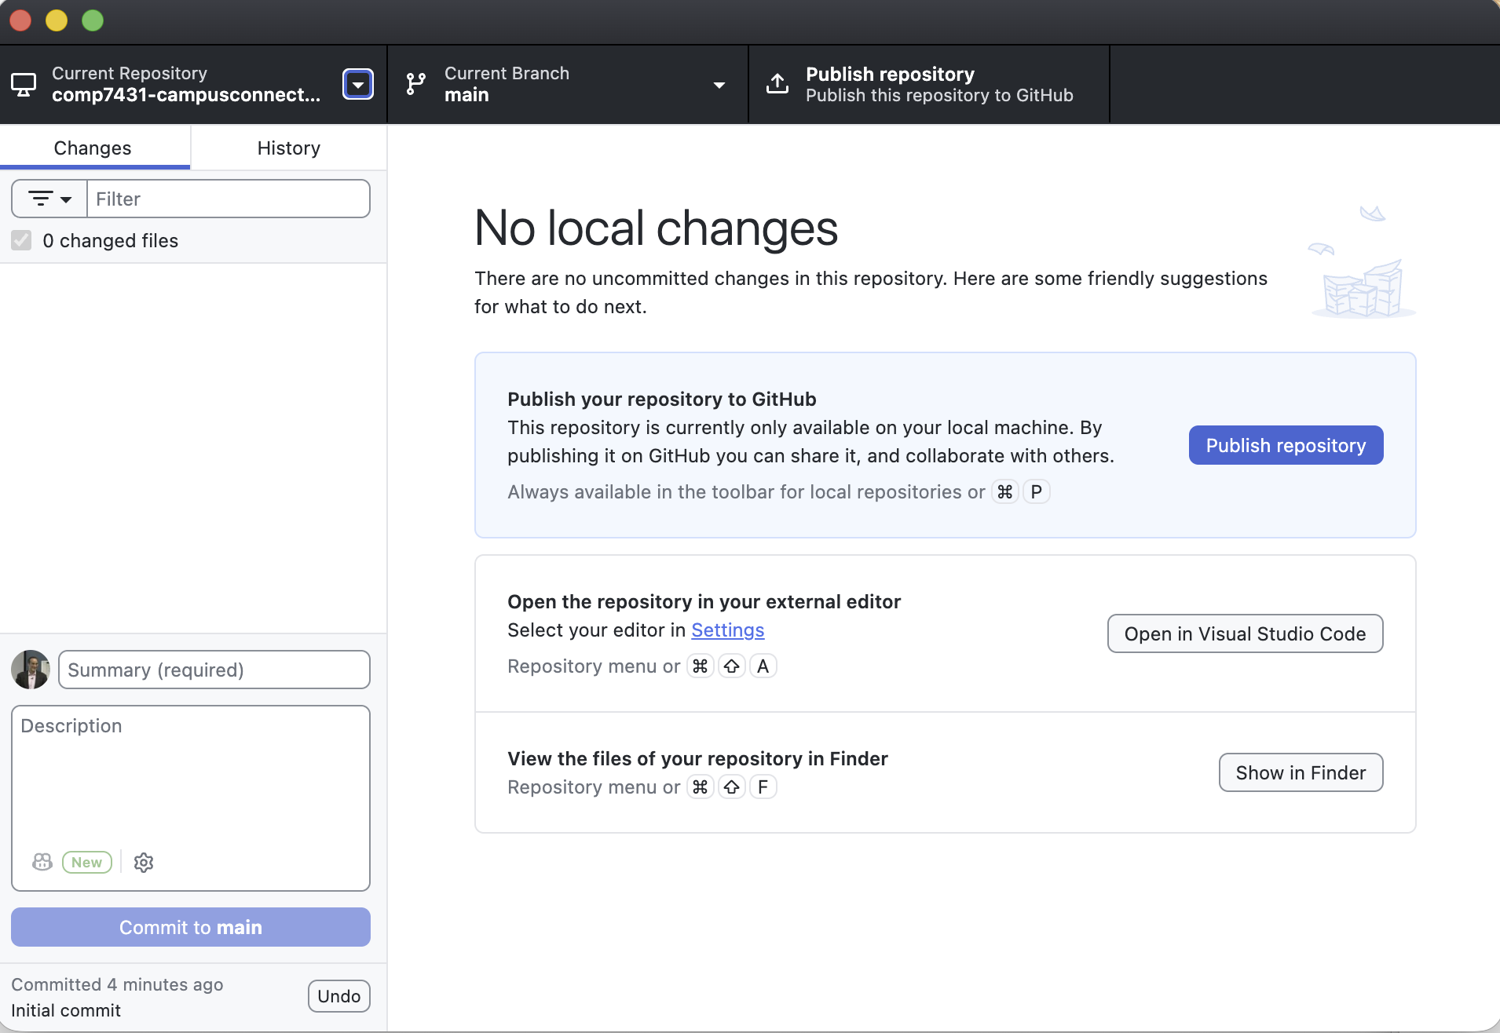
What you may see after creating the local repository: Publish repository is blue; Commit to main stays inactive until you save a file change.
TWO COPIES, ONE PROJECT
Before Publish repository, the project exists only on your computer. After publishing, GitHub.com holds the remote copy and GitHub Desktop manages the local copy. VS Code edits the local files; Commit records a checkpoint; Push origin sends that checkpoint online.

Part 3 - Build the six-stage Markdown trail
The lecture's slides 28 through 33 use one reviewable artifact at each engineering stage. Follow the same order here. Keep filenames and capitalization exactly as shown so another student - or an AI coding assistant - can follow the trail.

Step 3 - Open the repository in VS Code
1. In GitHub Desktop, click Open in Visual Studio Code in the center panel, or use Repository > Open in Visual Studio Code.
2. If VS Code is not offered, click the Settings link in GitHub Desktop and select Visual Studio Code as the external editor. You can also use Repository > Show in Finder, then open that exact folder from VS Code.
3. Confirm README.md is visible in the Explorer panel. From now on, create every file inside this repository folder.

Stage 1 Plan - capture intent before features
First, make README.md useful. Replace its contents with the starter below.
# CampusConnect
## Purpose
This repository is my COMP-7431 engineering trail for CampusConnect.
## Week 1 question
How can we help a student find trustworthy campus guidance and reach the right person without repeating the whole story?
## Working rule
Start with the human problem. Build only after the need and evidence are clear.
Create a folder named docs. Inside it, create intent.md. Paste the starter below, then change at least one line so the artifact reflects your own thinking.
# Intent: CampusConnect
Author: <your name>
Status: draft
## Problem
Students can encounter conflicting or outdated campus guidance and may not know which office owns the answer.
## Proposed outcome
Help a student identify a trustworthy next step, see the source, and reach a human when confidence is low.
## Affected users
Students, advisors, service-office staff, and content owners.
## Constraints
Use approved or synthetic information only. Do not store private student data.
## Open questions
- Which student questions create the most confusion?
- Which sources are authoritative?
- When should the system stop and hand off to a person?
Inside docs, create design-thinking-notes.md. This file preserves the human-centered questioning that happened before the spec.
# Design Thinking Notes
## Requested solution
"Build us an AI chatbot."
## Better human-centered question
How can we help a student find trustworthy guidance and reach the right person without repeating the whole story?
## Three possible solution directions
1. Better search and navigation.
2. RAG assistant that always shows approved sources.
3. Guided handoff workflow that carries only necessary context.
## What I would investigate next
Write one question you would ask a real student before choosing a solution.

Stage 2 Design - turn intent into docs/spec.md
Create docs/spec.md. Use docs/intent.md as the source. The spec should expose contradictions and risks, not merely polish the prose.
# Spec: CampusConnect guidance
## User story
As Maya, I want a trustworthy next step so I can act before a deadline.
## Acceptance criteria
- Shows source and owner
- Flags conflicting guidance
- Offers handoff when confidence is low
## Design concerns
- Accessibility
- Privacy
- Outdated content
- Human escalation
## Human confirmation needed
- Which offices own each source?
- How often must each source be reviewed?
CHECKPOINT 1
Save the listed files in VS Code: README.md, docs/intent.md, docs/design-thinking-notes.md, and docs/spec.md. Return to GitHub Desktop, keep those files checked, type 'docs: capture CampusConnect intent and spec' in Summary, click Commit to main, and then click Push origin in the top toolbar.

Stage 3 Build - plan before changing implementation
Create docs/plan.md. The lecture names future Python files so the plan is concrete; do not create app.py or tests/test_routes.py today.
# Plan: CampusConnect first slice
## Files that change
- README.md
- data/sample_pages.md
- app.py
- tests/test_routes.py
## Order of work
1. Load approved sample pages
2. Add search route
3. Show source and owner
4. Add fallback handoff text
## Proof
All test questions return a source or safe fallback.
## Week 1 boundary
Plan only. No application code is required in this lab.
At the repository root, create CLAUDE.md. Although the filename comes from an AI coding-tool convention, its job here is broader: give any new human or AI collaborator the project rules, commands, and traps.
# CampusConnect Working Guide
## Read first
- README.md
- docs/intent.md
- docs/spec.md
- docs/plan.md
## Working rules
- Use approved or synthetic information only.
- Plan before proposing code.
- Show the source and content owner.
- Use a safe human handoff when confidence is low.
## Planned commands
- Run: python app.py
- Test: pytest
## Known traps
- Do not invent office ownership.
- Do not place private student data or secrets in this repository.
- Do not change a test merely to hide a product failure.
CHECKPOINT 2
Save the listed files in VS Code: docs/plan.md and CLAUDE.md. Return to GitHub Desktop, keep those files checked, type 'docs: plan CampusConnect first slice' in Summary, click Commit to main, and then click Push origin in the top toolbar.
Now create a folder named data. Inside it, create sample_pages.md. This is a tiny, synthetic content source - not real university policy.
# Approved Sample Pages
Status: synthetic classroom data
## Page 1: Registration questions
Owner: Registrar example
Reviewed: 2026-09-01
Guidance: Confirm deadlines in the official academic calendar. If dates conflict, hand off to the Registrar.
## Page 2: Financial account questions
Owner: Student Accounts example
Reviewed: 2026-09-01
Guidance: Do not request private account details. Direct the student to the approved secure portal or a human staff member.
## Rule
Never present these examples as real university policy.

Stage 4 Test - create docs/verification.md
The lecture permits verification.md or test.md. To keep the class consistent, use docs/verification.md; you do not need a second test.md. The commands are planned for a later coded prototype, while the Week 1 checks can be completed now.
# Verification
## Planned commands
- Run: python app.py
- Test: pytest
## Required evidence for the later prototype
- [ ] 5 expected questions pass
- [ ] 2 confusing questions get a safe fallback
- [ ] Source and owner display correctly
- [ ] No private data is required
## Week 1 evidence
- [ ] Every Markdown file opens in VS Code
- [ ] sample_pages.md says the content is synthetic
- [ ] No password, token, API key, or student record appears
## Rule
Fix the app, not the test, unless the expected result is wrong.

Stage 5 Deploy - add REVIEW.md and release_checklist.md
At the repository root, create REVIEW.md. Keep the uppercase filename shown in the lecture.
# REVIEW.md
## Review passes
- Requirements: matches docs/spec.md
- Bugs: edge cases and broken flows
- Security: secrets, authentication, and data leakage
- Human factors: accessibility and handoff
## Important means
Would mislead a student, expose data, or break the core journey.
## Do not report
Style nits unless they affect clarity.
Also at the repository root, create release_checklist.md. This is the lightweight human release gate paired with REVIEW.md on the lecture slide.
# Release Checklist
## Before release
- [ ] Intent and spec still agree
- [ ] Source owner is visible
- [ ] Conflicting guidance triggers a safe handoff
- [ ] Accessibility has been reviewed
- [ ] No secret or private student data is present
- [ ] Verification evidence is attached
- [ ] A human reviewer approves release
## Decision
- [ ] Ready to release
- [ ] Blocked - return to the appropriate earlier stage

Stage 6 Maintain - add docs/incident.md and restart intent
Inside docs, create incident.md using the lecture's outdated-deadline example.
# Incident: outdated deadline answer
## Signal
A student reported an answer that cited an old page.
## Evidence
Source page last reviewed 2024; newer office PDF says 2026.
## Impact
Student may miss the correct form deadline.
## Proposed outcome
Retire the stale source and add owner review dates.
## Next artifact
Update docs/intent.md with a content-freshness improvement request.
The lecture's arrow incident.md -> new intent.md means that maintenance evidence starts the next cycle. Reopen docs/intent.md and append this final section; do not create a confusing duplicate intent file.
## Next intent: content freshness controls
### New problem
Approved sources can become stale even when the application still works.
### Proposed outcome
Record a content owner and review date for every source, and route conflicts to a human.
### Evidence that triggered this change
See docs/incident.md.
CHECKPOINT 3
Save the listed files in VS Code: data/sample_pages.md, docs/verification.md, REVIEW.md, release_checklist.md, docs/incident.md, and the updated docs/intent.md. Return to GitHub Desktop, keep those files checked, type 'docs: add verification review and maintenance trail' in Summary, click Commit to main, and then click Push origin in the top toolbar.

Optional 3-minute vibe exercise - let AI challenge the trail
If you are moving quickly, use ChatGPT, Claude, Gemini, or another approved AI assistant. Keep the request small and do not paste private or unapproved university information.
Read the following CampusConnect files as a skeptical software engineer:
- docs/intent.md
- docs/spec.md
- docs/plan.md
- docs/verification.md
- REVIEW.md
- release_checklist.md
Find exactly 3 contradictions, missing decisions, or weak tests.
For each, name the file that should change and explain why.
Keep the response under 180 words.
Choose one useful suggestion. Add it to the appropriate Markdown file in your own words, then commit and push that small correction with a precise summary.

Part 4 - Verify the commits and remote copy (about 3 minutes)
1. In GitHub Desktop, open the History tab. You should see the Initial commit plus the three checkpoint commits.
2. Select each commit and confirm the intended files appear. A commit is a selected checkpoint, not merely everything you happened to save.
3. If the top toolbar says Push origin, click it. If it says Fetch origin, your local and remote copies are already synchronized.
4. Use Repository > View on GitHub. Refresh the browser and open two or three Markdown files to confirm they render correctly.
GitHub Desktop committing and reviewing changes: https://docs.github.com/en/desktop/making-changes-in-a-branch/committing-and-reviewing-changes-to-your-project-in-github-desktop
GitHub Flow - the fuller workflow we will grow into: https://docs.github.com/en/get-started/using-github/github-flow
THREE DIFFERENT SAVES
Save writes the file on your computer. Commit records a named checkpoint in Git history. Push origin sends committed checkpoints to GitHub.com. GitHub Desktop's top action changes with the state of your repository, so read its label rather than looking for one permanent button color.

Part 5 - Verify, submit, and celebrate (about 2 minutes)

Your repository should now contain
comp7431-campusconnect-<username>/
|-- README.md
|-- CLAUDE.md
|-- REVIEW.md
|-- release_checklist.md
|-- data/
| `-- sample_pages.md
`-- docs/
|-- design-thinking-notes.md
|-- incident.md
|-- intent.md
|-- plan.md
|-- spec.md
`-- verification.md

What to submit
1. Your private repository URL. Grant the instructor access if requested.
2. One screenshot of the GitHub.com file tree showing the root files plus the docs and data folders.
3. One screenshot of the GitHub Desktop History tab showing the three named checkpoint commits.
YOU ARE DONE
You have practiced the lecture's full engineering loop: intent -> spec -> plan -> verification -> review gate -> incident -> renewed intent. The files are small, but the trail is visible, reviewable, and ready for the next engineer or AI assistant.

Quick fixes
What you see | What it means | Try this
No blue Publish repository action | The repository may already be published. | Look for Fetch origin or Push origin. Use Repository > View on GitHub to confirm.
Commit to main is inactive | No saved, selected changes are available. | Save in VS Code, return to Changes, and keep at least one changed file checked.
VS Code is not offered | An external editor is not configured. | Use the Settings link in the center panel and choose Visual Studio Code.
GitHub.com lacks new files | The latest commit may still be local. | Click Push origin, wait for Fetch origin, and refresh the browser.
I pasted a secret | Treat it as exposed even if the repo is private. | Tell the instructor and rotate the secret. Deleting the visible line is not enough once committed.

Useful references for later
Creating your first repository with GitHub Desktop: https://docs.github.com/en/desktop/overview/creating-your-first-repository-using-github-desktop
GitHub Markdown basics: https://docs.github.com/en/get-started/writing-on-github/getting-started-with-writing-and-formatting-on-github/basic-writing-and-formatting-syntax
About README files: https://docs.github.com/en/repositories/managing-your-repositorys-settings-and-features/customizing-your-repository/about-readmes
About GitHub Projects: https://docs.github.com/en/issues/planning-and-tracking-with-projects/learning-about-projects/about-projects

