Hashing & Hash Search

By: Christopher Kim

11-22-2016

Headerfile.h

1. Introduction()

2. Purpose()

3. HashingProcess()

4. HashSearch()

5. HashSearch().fixError()

**1. Introduction()**

What do you already know about hash/hashing?

If false

where might have you heard the term hashing?

Then

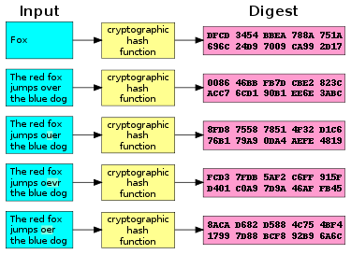Guess;

2. **Purpose()**

Mostly used for encryption/security.

Have you seen this before? 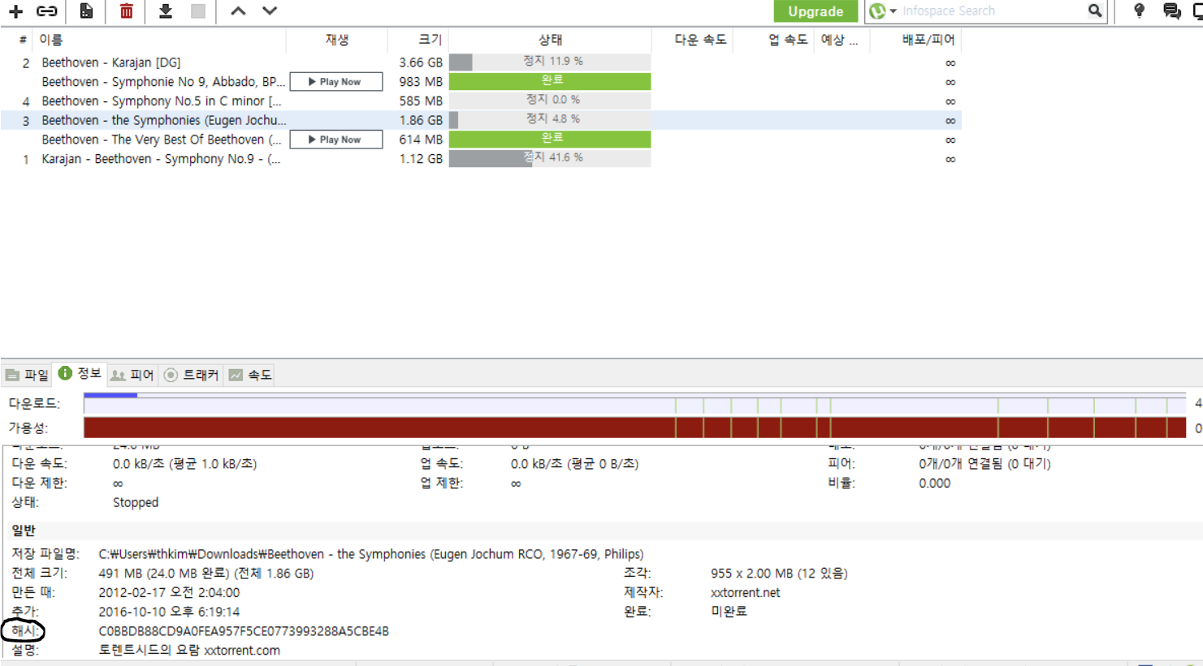

Or

Hash: de5d8fc0a0c8f3709d84c2aea9e7e464400891af Wham Last Christmas torrent.

Or

MD5?

SHA-224? SHA-226? SHA-512?

Those are all type of hashing / variations of hashing that is used for encryption.

The picture attached are hashing methods to check the authenticity of the file, and or to check if the files are not corrupted and downloaded in its original form.

3. Process()

Important Vocabularies

|  |  |
| --- | --- |
| Key | The Object that is inputted from user, or Object generated by program. Key is going to be processed by a Hash function |
|  |  |
|  |  |
|  |  |
|  |  |