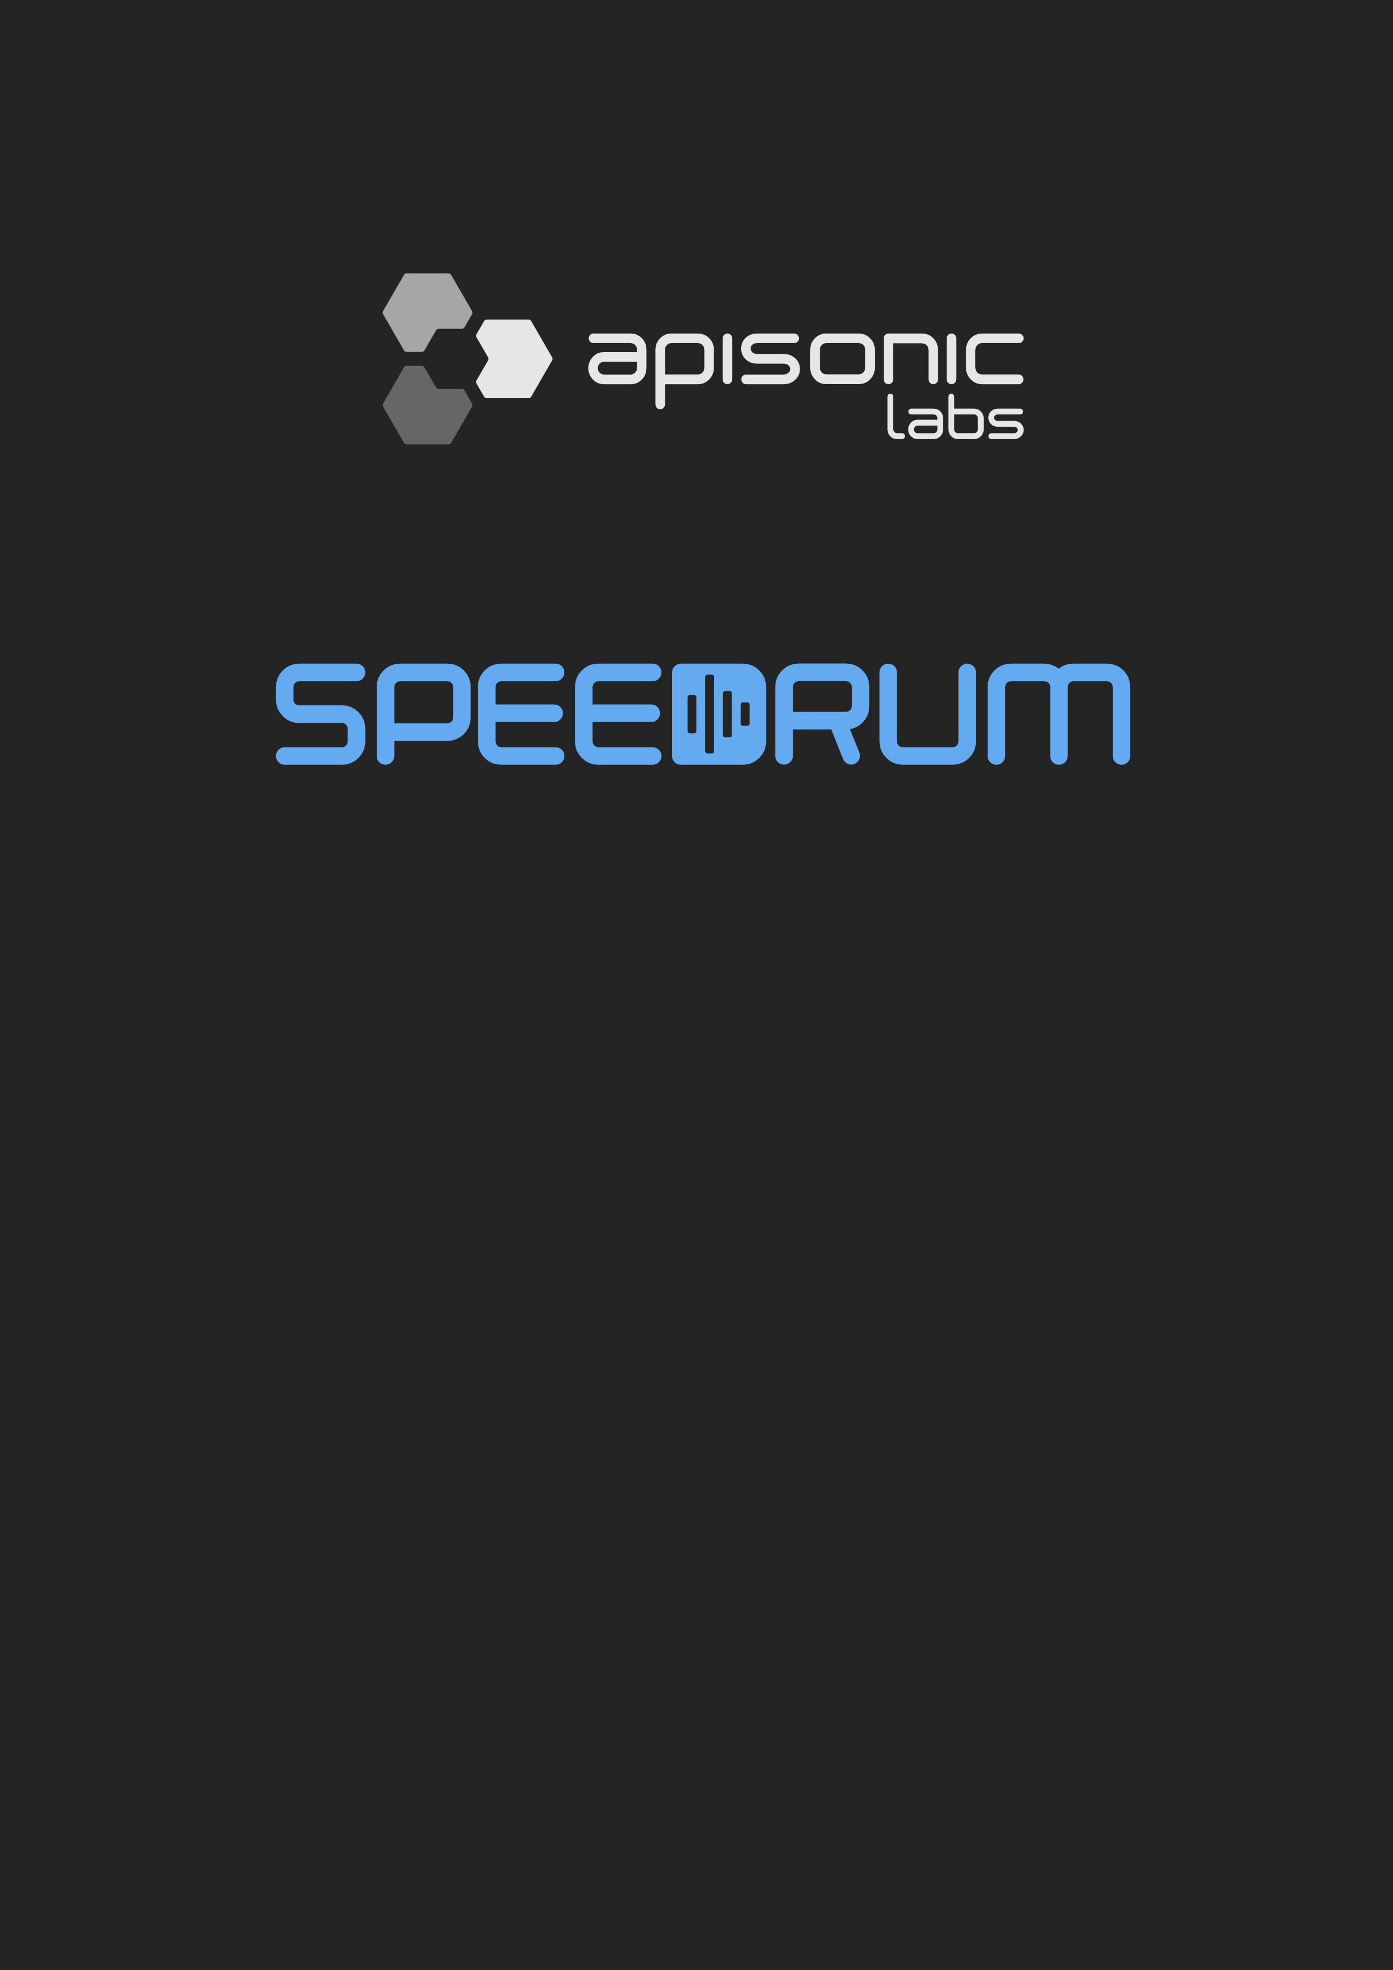

User Guide

version 1.0

Table of Contents
Quick Start 3
Header 4
Preferences 5
Browser 6
The Drum Pads 7
Main Controls 8
Modulation Controls 9
FX Section 10
Layers 11
Setup 13
System Requirements 14

Quick Start

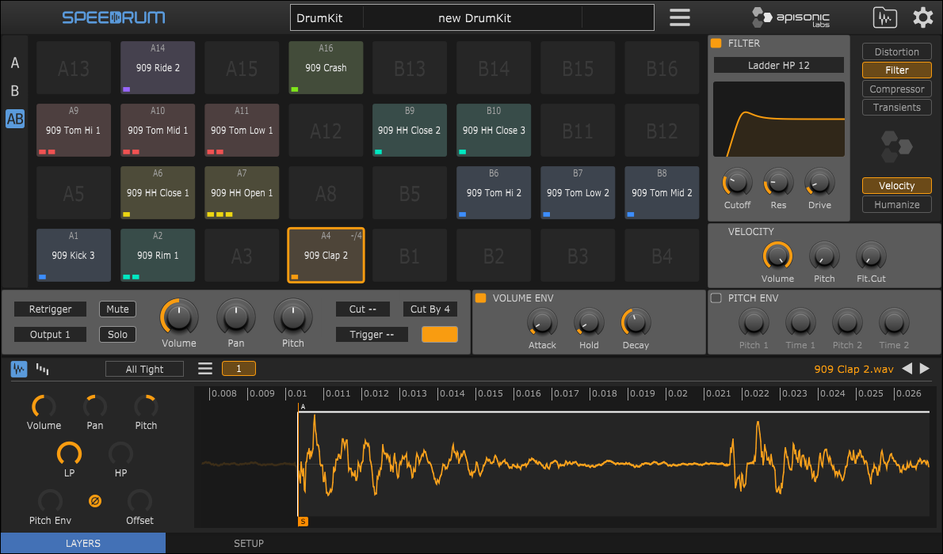

To quickly start load Speedrum into your preferred plugin host / DAW, and then just drag and drop audio sample(s) from a plugin host sample browser or a system file manager to a Pad or Layer editor. Layer editor will show waveform of a loaded sample and layer controls will be available for adjusting. Left-click on a Pad to play it, or use your midi controller.

TIP - if you plugin host support it Pad name will be visible in a plugin host Piano Roll (only for VST/VST3 version of a Speedrum)

Header

Speedrum logo - open About page on mouse click

Central label - displays all relevant information

Main menu:
- New DrumKit
- Load DrumKit
- Import - Lite kit - will import kit saved with Lite version (only Sample AHD Hold parameter will not be imported, because in a Speedrum it is automatic on a sample level)
- Import - Poise kit - will partially import Poise (by One Small Clue) drumkit, some of non-compatible parameters will be skipped
- Save Drumkit
- Save DrumKit + Samples - will save drumkit file and all samples in a sub-folder named like a drumkit file
- Set Outputs - shortcuts to set all pads to main (first) stereo channel or every pad on separated stereo channel
- Size - set plugin window size for this instance of a plugin
- Check for Updates - check latest stable version

Browser - toggle sample/kit browser

Preferences - toggle Preferences page

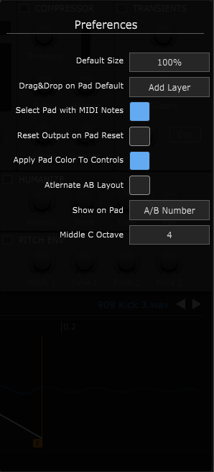
Preferences

- Default Size - plugin window size for new instances
- Drag&Drop on Pad Default - default behavior for sample drop on a Pad - alt/option key will override this and do the opposite
- Select Pad with MIDI Notes - when plugin host not playing
- Reset Output on Pad Reset - option to reset also Output channel when a Pad is reset
- Apply Pad Color to Controls - apply active Pad color to all active Pad controls, otherwise controls will have default plugin color
- Alternate AB Layout - put B set of pads on top of A set of pads in a 32 pads layout (default is B right of an A)
- Show on Pad - change what is displayed on a Pad
- Middle C Octave - according to what middle C octave to display the notes numbers

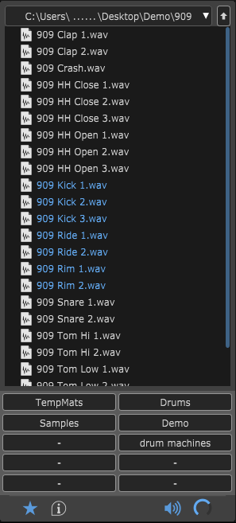
Browser

Browser will show drumkits and samples for supported formats.

The arrow keys can be used to navigate the browser, if it doesn't work check that your plugin host send keystrokes to the plugin (some hosts may not support sending key press info to a plugin).

Audio preview can be toggled clicking on a small speaker icon and preview volume can be set with a knob.

Section on the right will show basic info (sample rate, channels, etc.) for the selected sample, or name and cover art for the selected drumkit.

There are 10 slots for a folder fast access.
Left click on a slot will set browser to that location, right click on a slot will set a slot shortcut for currently opened location, and alt/option + right click will empty slot.
First slot is a default location for new instances.

Double clicking on a drumkit will load it.
Select one or multiple samples and drag & drop to Pad, Layer buttons or Layer waveform.

The arrow keys can be used to navigate the browser, and Return key to preview selected sample.
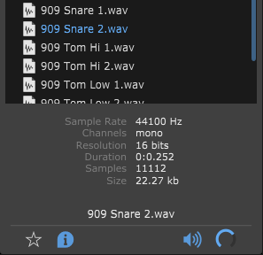

TIP - set the drumkit cover art by putting a .png or .jpg file (200x200 pixels) of the same name as the drumkit file in the folder next to the drumkit file

TIP - If it doesn't work, check hot keys are
enabled in the Options dialog.

The Drum Pads
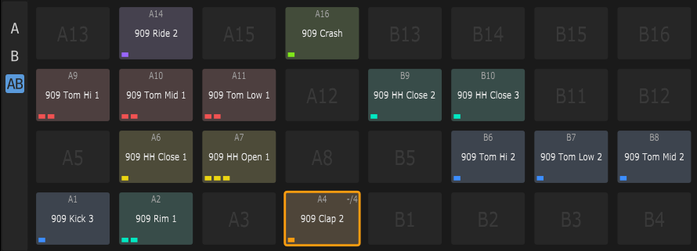
Speedrum has 32 Drum Pads. Each Pad can have up to 8 layers, and each layer can load one sample. Each Pad is triggered by one MIDI note.

Drum pads can be swapped by drag & drop, and copied by alt/option + drag & drop.
Standard Cut, Copy, Paste shortcuts can also be used, as well as Delete.
AWSD keys and Arrow Keys can be used to change the selected drum pad.
(If browser is open, Arrow Keys are used to navigate the browser)

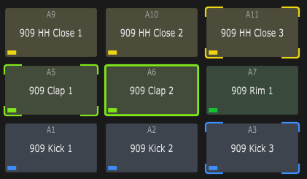
Multiple Pads can be selected at once for a multi-edit functionality.
ctrl/command + mouse click on a Pad will add/remove it from multi-selection.

When in multi-edit mode any change to active Pad will be applied to all other Pads in a multi-selection (volume, out channel, color...).

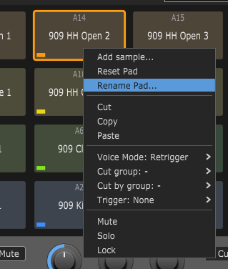
Pad context menu:
- Add sample... - open system file manager to load sample
- Reset Pad(s) - Clear Pad (Pads if multi-edit) data
- Rename Pad
- Standard Cut, Copy, Paste
- Voice Mode - see Main Controls
- Cut group - see Main Controls
- Cut by group - see Main Controls
- Trigger - on note on trigger selected Pad 1-32
- Mute - mute the Pad
- Solo - solo the Pad
- Lock - locked drum pads will be skipped when loading drum kits

Main Controls

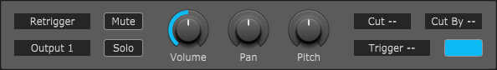

Main Controls of a Pad:

- Voice Mode - Retrigger - active sample layers will be silenced, sound will not overlap
- Poly - active sample layers will continue to play, sounds will overlap
- Output - Each Pad can be set to one of 16 individual stereo outputs
- Mute / Solo
- Volume - Pad volume - 0 to 200 %
- Pan - Pad pan/balance
- Pitch - Pad pitch +/-12 semitones
- Cut / Cut By - There are 8 Cut groups. When a pad assigned to a 'Cut' group is
triggered, any pads assigned to the corresponding 'Cut By' group will be silenced
- Trigger - on note on trigger selected Pad 1-32
- Color - there are 12 colors that can be assigned to each Pad for better recognition, White is the default

TIP - some knobs snap to specific values (like Pitch), with an alt/option key moving knob will ignore snapping

TIP - double clicking the knob will reset its value to default

TIP - for fine control, hold down a SHIFT key on your computer keyboard before adjusting
the knob

TIP - there are toggle in Preferences to apply Pad color to all controls

TIP - right click a knob to show the MIDI Learn context menu - MIDI Learn is parameter based

Modulation Controls

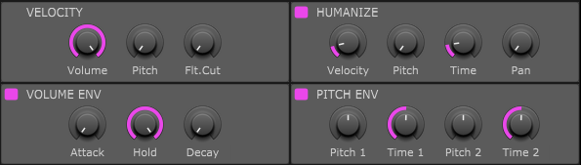

Volume Envelope:
AHD (Attack, Hold, Decay) type Pad envelope with 0 - 15 seconds for every segment

Pitch Envelope:
Pitch envelope is Pad based, but the amount it will affect the Pad Layer is controlled on a Layer with a “Pitch Env” knob
Pitch 1 - the initial sample pitch shift amount
Time 1 - time taken to travel to the second envelope point
Pitch 2 - the second sample pitch shift amount
Time 2 - time taken for the pitch envelope to finish

Velocity:
- to Pad Volume (0 - 100 %)
- to Pad Pitch (0 - 12 semitones)
- to Filter Cutoff in a FX Section (0 - 100 %)

Humanize:
- Velocity (+/- 40 %) maximum amount to randomize the trigger velocity
- Pitch (+/- 2 semitones) maximum amount to randomize sample pitch
- Time (0 - 50 ms) maximum time to delay the sample start
- Pan (+/- 40 %) maximum amount to randomize sample pan

FX Section

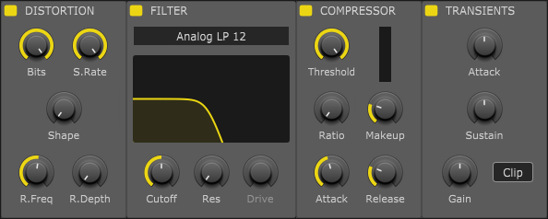

Each drum Pad has a dedicated FX Section with four essential effect.
The effects section changes its layout depending on the layout of the Pads.
All effects has a Power button so can be activated/deactivated.

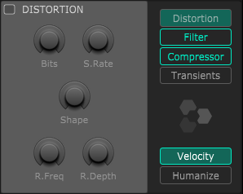
Distortion includes controls for:
Bits - bitcrusher
S. Rate - sample rate reduction
Shape - waveshaping
R. Freq - ring modulation frequency
R. Depth - ring modulation depth

Filter has 2 type, Analog and Ladder
with 3 mode lowpass, bandpass and highpass all with 12 / 24 dB slopes
Cutoff and Resonance controls can be controlled simultaneously dragging on the filter
response curve.
Ladder type has additional Drive parameter.

Compressor is classic VCA type with all essential controls.
It is used for adding punch and to control dynamics.
Ratio knob snaps to specific values but can be fine tuned with alt/option key modifier.
Simple reduction meter show gain reduction.

Transients is a simple transient shaper with two parameters, Attack and Sustain.
It also include an overall Gain parameter and a Hard Clipper.

Layers
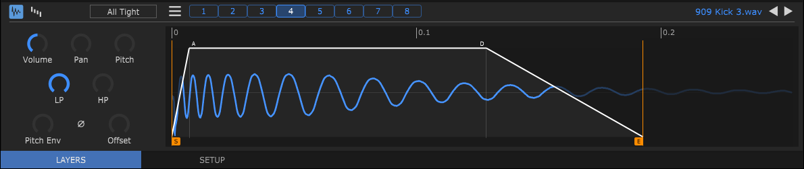

Lower pane of a plugin window contains LAYERS and SETUP tabs.
LAYERS tab shows all the Layers (with a loaded sample) of an active Pad. Every Pad can have up to 8 Layers, and every Layer can load one sample.
Clicking on a Layer number will make that layer active, and consecutive click on the active layer will preview audio of the layer. Multiple sample layers can be selected at once for quick editing with ctrl/command + click. Layers can be swapped, or can be moved to a different Pad (copied with alt/option) by drag and drop.

Layer menu (hamburger icon):
- Delete - unload sample and reset the layer
- Duplicate - add a duplicate of an active layer at the end of a layers if not all 8 layers used already
- Normalize - normalize a sample to 0dB, it is non-destructive and can be undone
- Reverse - reverse the sample
- Show file... - shows the sample using system default file manager

Each Pad has a Layer Mode parameter. It determines which layers are played when a drum pad is triggered.

Pad Layer Modes:
- Single - when a Pad is triggered, only the active (selected) layer will play
- Velocity - a layer is triggered according to the MIDI note velocity (layer velocity range can be edited)
- Round Robin - the next layer will be played each time the Pad is triggered
- Random - a random layer will be played each time the Pad is triggered
- All Tight - default mode - all layers will be played, the humanization is calculated once and used for all layers

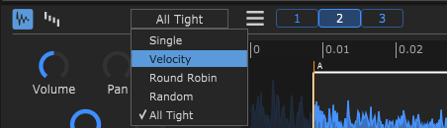

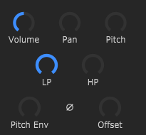
Every layer has a set of dedicated controls:
- Volume - layer volume
- Pan - layer pan
- Pitch - adjusts the pitch of the sample layer. (+/- 12 semitones)
- LP, HP - Low-pass and High-pass filter
- Pitch Env - amount of Pad Pitch envelope applied to a Layer
- Phase - invert the phase of a sample
- Offset - the offset control delays the start of a sample when the pad is triggered

There are two views in a Layer editor (can be switched with first two buttons on the editor header):

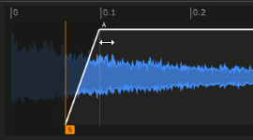
Waveform view - default view - sample waveform view of the selected Layer

With a simple mouse drag you can set a Start / End of a sample and also an Attack / Decay of a sample AHD envelope.

You can also zoom waveform view horizontally to get a closer look:
- ruler drag up/down and left/right to zoom and move
- double click on a ruler resets view to full
- mouse wheel up/down to zoom in/out on a mouse pointer
- mouse wheel click+drag to move zoomed area left/right
- ctrl/command + left/right click sets start/end marker to mouse pointer

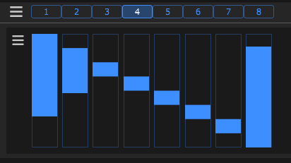
Velocity ranges view - velocity ranges of all Layers
The velocity ranges work in conjunction with Velocity Mode and can be used to program velocity splits.
(selecting Velocity from a Layer Mode will automatically switch to this view)

Setup

Setup tab includes Pads MIDI Map (trigger map). A trigger map contains 'region' information for each drum pad. In other words it controls what MIDI notes trigger which drum pad. Every pad respond to a single MIDI note.
For pad to learn a trigger note just click on a pad note/number you want to learn in the Setup tab and then press a key or pad on your MIDI controller or a DAW Piano Roll. It will change the pad text according to the newly learned note.

Saving and loading of trigger maps is supported from a Pads MIDI Map menu

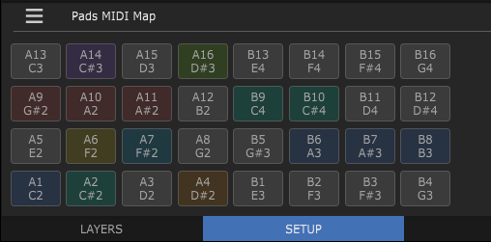

System Requirements

Windows 7 or above - 64 & 32 bit host
macOS 10.7 or above - 64 bit host
Linux Ubuntu 18 or above - 64 bit host (experimental)

Demo restrictions:
Disabled drumkit loading and plug-in state re-loading.

