

User Guide

version 2.1.1

Table of Contents
Introduction 3
Header 4
Preferences 5
Browser 7
The Drum Pads 8
Main Controls 10
Pad Modulation Controls 11
FX Section 12
Pad Layers 13
Pad Seq 17
Mixer 18
Slicer 19
Sends / Master 21
Sequencer 22

Introduction

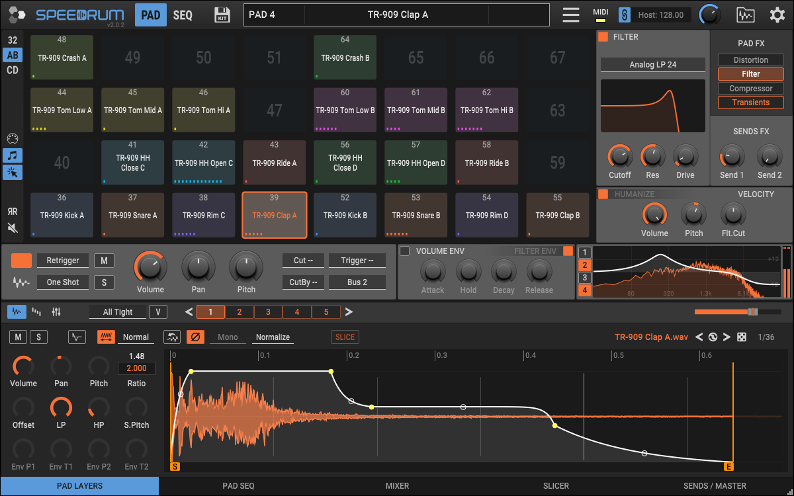

Speedrum is a sample-based MPC style virtual drum machine with dedicated step-sequencer and the addition of the loop slicer. It is designed for easy startup and fast workflow, but with powerful features if you need them.

It runs as a plug-in within a host application, which is usually a sequencer or DAW (Digital Audio Workstation) application such as Reaper, FL Studio, Ableton Live or Cubase. Host application will handle audio and MIDI streaming.

Mayor new features in version 2:

64 Pads (from 32) and 16 Layers (from 8)
Pads mixer and Layers mixer
Layer special MSEG envelope
Buses system with mixer and bus FX
Pad 4 band EQ and Pad Filter envelope
Note Sequencer with patterns, randomization, recording...
Hugely improved browser with unlimited favorites, file filter...

Header

Apisonic Logo - manage plugin window size
Speedrum logo - shows About page
Pad - shows Pads page
Seq - shows Sequencer page
Save drumkit - save drumkit ( enabled if kit was changed )
Central label - displays all relevant information
Main menu:
- New DrumKit
- Load/Import DrumKit...
- Save Drumkit As - opens a save customization dialog box, where you specify what you want to save
  - samples will be saved in a sub-folder named like a drumkit file
  - kit info consists of text and an image that can be easily loaded
- Download User Guide - open Speedrum web page
- Check for Updates - check latest stable version
- About - some info about the plugin and the system
- Reset All Settings - resets Preferences to default values
- Activate/Deactivate license
MIDI - MIDI-IN LED indicator
Sync - toggle the synchronization of the sequencer with the host tempo
BPM - manual tempo setting when synchronization is not enabled
Play - manual play/stop when synchronization is not enabled
Global Volume - global volume of the instrument
Browser - toggle sample/kit/pattern browser
Preferences - toggle Preferences page

Preferences
The user can adjust some things according to his preference.

UI
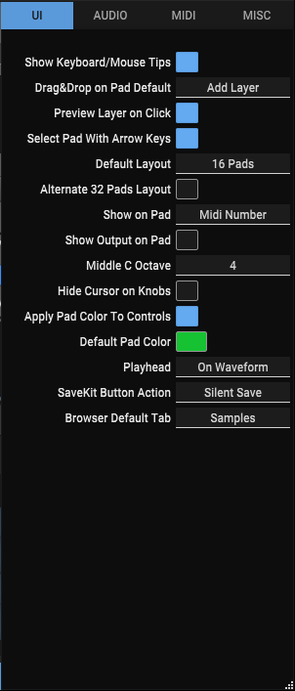
- Show Keyboard/Mouse Tips - a toggle to show tip on the bottom of the window
- Drag&Drop on Pad Default - default behavior for sample drop on a Pad - Alt/Option key will override this and do the opposite
- Preview Layer on Click - whether a mouse left-click on the layer will preview that layer or just select it
- Select Pad with Arrow Keys - navigate throu pads whit keyboard arrow keys
- Default Pads View - set 16 or 32 pads layout for new instances
- Alternate 32 Pads Layout - put B/D set of pads on top of A/C set of pads in a 32 pads layout (default is B/D right of an A/C)
- Show on Pad - change what is displayed on a Pad
- Show Output on Pad - display pad output channel
- Middle C Octave - according to what middle C octave to display the notes numbers
- Hide Cursor on Knobs - hide mouse pointer when dragging knobs
- Apply Pad Color to Controls - apply active Pad color to all Pad controls, otherwise controls will have default plugin color
- Default Pad Color - default color for pads on new drumkit
- Playhead - playhead gui position
- Save Kit Button Action - action of the Save Kit Button (silent or dialog)
- Browser Default Tab - tab shown at the start

AUDIO
- Reset Output on Pad Reset - option to reset also output channel when a Pad is reset
- Layer Start Smoothing (ms) - smooth start of layer playback in milliseconds (eliminate clicks and pops due to sudden transitions)
- Layer End Smoothing (ms) - smooth end of layer playback in milliseconds
- Default Layers Play Mode - layers mode when adding samples to empty pad

MIDI
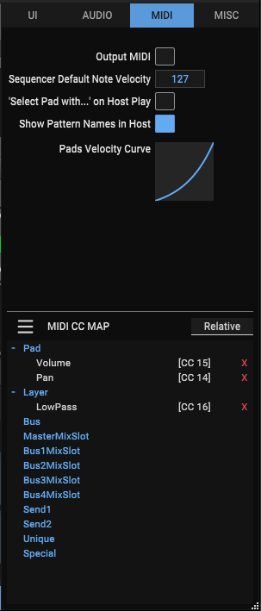
- Output MIDI - a toggle for outputting MIDI notes from the Speedrum
- Sequencer Default Note Velocity - starting velocity for sequencer note
- ‘Select Pad with...’ on Host Play - the effect of the "Select Pad with MIDI Notes" option also when playing
- Show Pattern Names in Host - to display the pattern in the host's pianoroll
- Pads Velocity Curve - map incoming velocity values to different output values via an adjustable curve
- MIDI CC Map - contains GUI control links to midi cc parameters. There are two operating modes for receiving cc messages, so it can be set to correctly recognize the mode from the sender: Absolute - received messages are interpreted as 0 to 127, Relative - received messages are interpreted +1/-1 (most often come from the endless encoder). The currently mapped controls are visible in the list. A control can be "unlearned" by clicking on the red "X" in its row.

MISC
- Default Sample/Kit Folder - when saving/loading
- Drag&Drop Render Folder - will be used to save drag&drop rendering to Pad or DAW, unless overriden with Current Project Folder
- Current Project Folder - overrides Drag&Drop Render Folder but only for this instance of the plugin, useful for storing rendered samples directly in the host project folder
- SFZ Import <group> as Layers - recognize <group> as one Pad and import first 8 samples <region> as Layers
- Autocheck for new Versions - automatically checking for a new version of a plugin
- External Audio Editor - browse to binary of an audio editor on your system

Browser

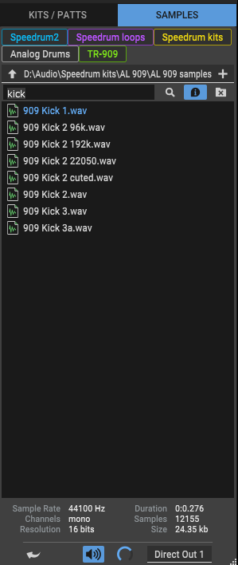
The Browser is the main method of loading sounds into Speedrum. Supported audio file formats are WAV, AIFF, FLAC, MP3 and OGG. Drumkits and patterns are also loaded through the browser. In addition to the native drumkit format, it is also possible to import drumkits from several other formats (with certain concessions), such as SFZ, Poise and Geist.

The arrow keys can be used to navigate the browser, while RightArrow will also preview selected sample. Return key will load selected drumkit, sample in the visible tab (LAYERS or SLICER), or pattern file in active pattern.
If it doesn't work, check that your plugin host send keystrokes to the plugin (some hosts may not support sending key press info to a plugin).
Samples are also loaded using the drag&drop to pad/layer/seq row/slicer or from the context menu of a file/folder.

Middle-click on any folder will add that folder to the favorites. Middle-click on a favorite will delete it. Coloring favorites can be done via the favorite Right-click menu.

Filtering files in the current folder is done by entering the desired phrase in the Filter entry. To the right of it there are switches for showing info and hiding folders.
The search button will be enabled if at least 3 characters are entered in the filter. The search is done through the current folder and all subfolders.

At the bottom of the Kits/Patts tab, it is possible to toggle loading the sequencer state and pad trigger map with the kit.
While on the Samples tab there are controls for sample auto-load, auto preview, preview volume and preview output. If auto-load toggle is on, the selected sample will be automatically loaded into active editor (layer/slicer).

The Drum Pads
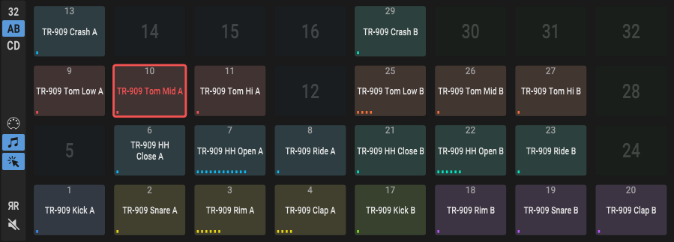
Speedrum has 64 Drum Pads and each Pad can have up to 16 layers (with one sample per layer). Each Pad is triggered by one MIDI note.

There are two pad views, for 16 and 32 pads, it can be changed clicking on a 16(32) number. View of the group buttons (A/B/C/D/AB/CD) also change according to the view. A shows pads 1-16, B shows pads 17-32, etc.

Drum pads can be swapped by drag & drop, and copied by Alt/Option + drag & drop.
Delete key or middle-click will reset the pad.
Arrow Keys can be used to change the selected drum pad (option in Preferences).
(If browser is open, Arrow Keys are used to navigate the browser).

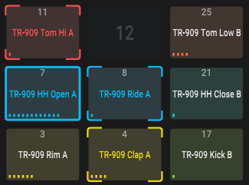
Multiple Pads can be selected at once for a multi-edit functionality.
Ctrl/Command + left-click on a Pad will add/remove it from multi-selection.
Multi-selection can also be achieved by mouse right-button drag, or adding to selection while holding Ctrl/Command.

Ctrl/Command + left-click on a layout button selects all pads from that layout.

When in multi-edit mode, any change to an active Pad will be applied to all other Pads in a multi-selection (volume, out channel, color...).

Pad context menu:

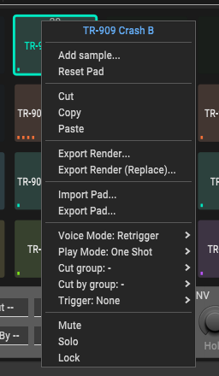
- Pad name - left-click to edit
- Add sample... - open system file manager to load sample
- Reset Pad(s) - Clear Pad (Pads if multi-edit) data
- Standard Cut, Copy, Paste
- Export Render... - to file (with maximum velocity, ignore Humanization)
- Export Render (Replace)... - same as above but replaces Layers with rendered sample after exporting the render
- Import Pad... - import saved Pad from a file
- Export Pad... - save single Pad settings to a file
- Voice Mode - see Main Controls
- Play Mode - see Main Controls
- Cut group - see Main Controls
- Cut by group - see Main Controls
- Trigger - on note on trigger selected Pad 1-32
- Mute - mute the Pad
- Solo - solo the Pad
- Lock - locked drum pads will be skipped when loading drum kits, loading new drum kits, delete/reset pads

Tip - if you plugin host support it Pad name will be visible in a plugin host Piano Roll (only for VST/VST3)

Pads MIDI Map (trigger map)

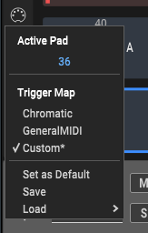
A trigger map controls what MIDI notes trigger which drum pad. Every pad respond to a single MIDI note.

For pad to learn a trigger note just left-click on a midi-connector button and all selected pad will be in trigger learn mode.
To change the Pad’s midi note manually, left-click on the number below the “Active Pad” menu item and enter the desired midi note number.

Trigger maps can be saved and loaded. Also, it is possible to set the current trigger map to be the default map for all new instances.

Main Controls

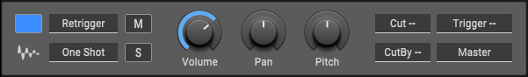
Main Controls of a Pad:

- Color - there are 12 predefined colors that can be assigned to each Pad for better recognition, it is also possible to set the color to any value with the provided color picker, default pad color can be set in the Preferences.
- Waveform-button - drag&drop to export rendering of the Pad (Rendering Folder or Project Folder if specified will be used for saving files). On Windows and MacOS - can be droped to other Pad or outside Speedrum (DAW or folder), on Linux - can be droped to other Pad.
- Voice Mode - in Retrigger mode active sample layers will be silenced, sound will not overlap. In Poly mode active sample layers will continue to play, sounds will overlap.
- Play Mode - the play mode option controls how a drum pad responds to MIDI note-off events. In One Shot mode pad will play all the way through, ignoring any MIDI note-off events and release knob will be disabled. In Note On mode pad will play until it receives a MIDI note-off event. If the amplitude envelope is off, the pad will be silenced immediately, if the amplitude envelope is on it will begin the release stage.
- Mute / Solo
- Volume - Pad volume - after the sum of all layers, and before FX processing
- Pan - Pad pan/balance
- Pitch - Pad pitch +/-12 semitones
- Cut / Cut By - There are 8 Cut groups. When a pad assigned to a 'Cut' group is
triggered, any pads assigned to the corresponding 'Cut By' group will be silenced
- Trigger - on note on trigger selected Pad 1-64
- Output - each Pad output can be set to Master (first stereo output), to four Buses or to one of 16 individual stereo outputs.

Pad Modulation Controls
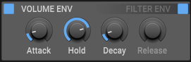
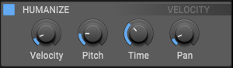
Volume/Filter Envelope:
Clicking on the name of the envelope will display its controls, while switching on is possible without changing the view. AHD(R) (Attack, Hold, Decay, Release) type Pad envelope with 0 - 15 seconds for every segment, Release will be enabled only in a “Note On” Play Mode, the Filter envelope affects the filter cut parameter and have a Amount parameter (+/- 100%)

Velocity:
- to Pad Volume
- to Pad Pitch (-12 to +12 semitones)
- to Filter Cutoff in a FX Section (-100% to +100 %)

Humanize:
- Velocity (+/- 40 %) maximum amount to randomize the trigger velocity
- Pitch (+/- 2 semitones) maximum amount to randomize sample pitch
- Time (0 - 50 ms) maximum time to delay the sample start
- Pan (+/- 40 %) maximum amount to randomize sample pan

Some tips for knobs/sliders:

- double-clicking or Ctrl/Command + click on the knob will reset its value to default
- for fine control, hold down a Shift key on your computer keyboard before adjusting the knob
- some knobs snap to specific values (like Pitch), with an Alt/Option key moving knob will ignore snapping
- knob contextual menu (right-click on a knob):
  - click on the blue value to enter the value manually
  - MIDI Learn - based on selected Pad/Layer (follows the active Pad/Layer) (also for buttons)
- there are option in the Preferences to apply Pad color to knobs/slider

FX Section

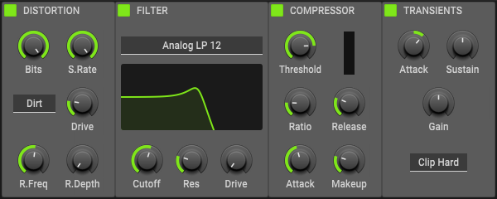

Each drum Pad has a dedicated FX Section with four essential effect.
The effect’s section changes its layout depending on the layout of the Pads.
All effects have a Power button, so can be activated/deactivated.

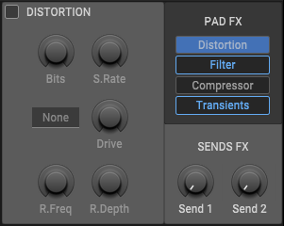
Distortion includes controls for:
Bits - bitcrusher
S. Rate - sample rate reduction
Shaper - waveshaping
Drive - shaper amount
R. Freq - ring modulation frequency
R. Depth - ring modulation depth

Filter has 2 type, Analog and Ladder
with 3 mode lowpass, bandpass and highpass all with 12 / 24 dB slopes and drive,
Cutoff and Resonance controls can be controlled simultaneously, dragging on the filter response curve.

Compressor is classic VCA type with all essential controls.
It is used for adding punch and to control dynamics.
Ratio knob snaps to specific values but can be fine-tuned with Alt/Option key modifier.
Simple reduction meter show gain reduction.

Transients is a simple transient shaper with two parameters, Attack and Sustain.
It also includes an overall Gain parameter and a Soft/Hard Clipper.

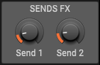
Sends/Output:
- Send 1 - the amount of pads output to be sent to Send 1
- Send 2 - the amount of pads output to be sent to Send 2

Pad Layers

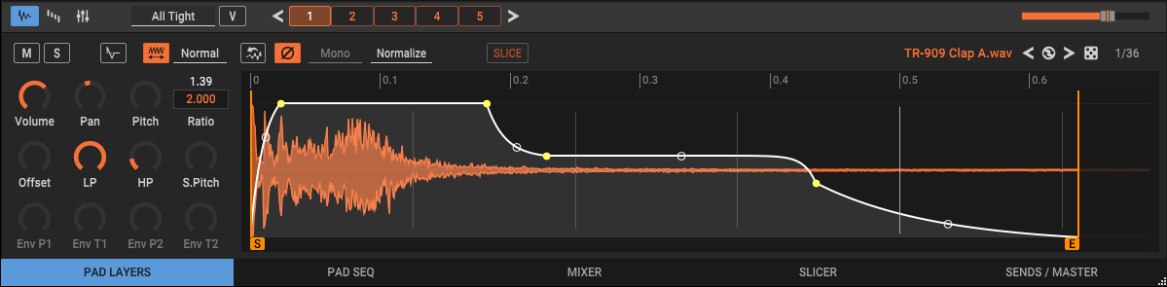
Layers are the basic 'slots' for loading samples. There are 16 layers on each pad. Pad layers can be accesed on the first tab of the lower pane “PAD LAYERS”. It shows all the Layers (with a loaded sample) of an active Pad. Every Layer can load one sample.
Left-click on a Layer number or the waveform will make that layer active, and preview the audio of the layer if host not playing. You can scroll through the layers using the < > buttons.
Multiple sample layers can be selected at once for quick editing with Ctrl/Command + left-click, or Ctrl/Command + right-click on any layer button will select all layers.
Layers can be swapped, or can be moved to a different Pad (copied with Alt/Option) by drag and drop. Delete layer(s) with middle-click on a layer number.
Shift + left (right) click on a Layer will mute (solo) selected layers (same behavior as on Pads).

Right-click on a Layer will open layer menu:
- Delete - unload sample and reset the layer
- Duplicate - add a duplicate of an active layer at the end of layers if not all 8 layers used already
- Render - to file (ignore Pad params)
- Render (Replace) - to file (ignore Pad params), and reload rendered afterwards
- Load in Slicer - load the sample file in the Slicer tab
- Show file... - shows the sample using system default file manager
- Edit with (editor) - open sample file in a selected (in Preferences) audio editor (WARNING if sample file is edited (premanent change) but was loaded in mutiple layers/pads it will not load on that other layers/pads next time when loading state/kit, because it is now a diferent sample file)

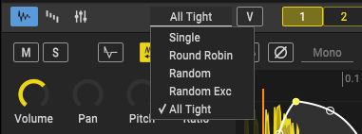
Each Pad has a Layers Mode parameter. It determines which layers are played when a drum pad is triggered.

Pad Layers Modes:
- Single - when a Pad is triggered, only the active (selected) layer will play
- Round Robin - the next layer will be played each time the Pad is triggered
- Random - a random layer will be played each time the Pad is triggered
- Random Exc - (random exclusive) same as Random, but does not repeat the last played
- All Tight - default mode - all layers will be played, the humanization is calculated once and used for all layers

All mods can additionally respect velocity ranges (“V” button) - triggering according to the MIDI note velocity, and layers velocity ranges can be edited (see Velocity ranges view)

Every layer has a set of dedicated controls:

- Mute/Solo
- Pitch Env - layer Pitch envelope
- Stretch - stretching on/off
- Stretch Mode - Normal, Smooth, Crisp
- Reverse - reverse the sample, non-destructive
- Phase - invert the phase of a sample
- Channels Mode - for stereo samples selectable Stereo, Mono (L + R), Left and Right
- Normalize - normalize a sample to 0dB, -3dB, -6dB, it is non-destructive
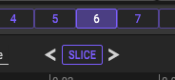
- Slice - trim (indefinitely, non-destructive) to use only part of the sample. It will be disabled when Stretch or Reverse is active, but it can be applied before those actions. The colored button emphasizes that it is a slice. Layer created from Slicer will automatically be Slice, and temporarily (until the reload) you will be able to change the slice on the layer itself using the < > buttons around the Slice button.

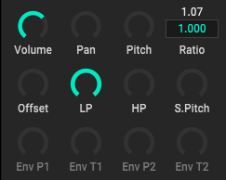
- Volume - layer volume
- Pan - layer pan
- Pitch - adjusts the pitch of the sample layer. (+/- 12 semitones)
- LP, HP - Low-pass and High-pass filter
- Phase - invert the phase of a sample
- Offset - the offset control delays the start of a sample when the pad is triggered
- Stretch Sample Length Beats - left/right arrow will stretch to next whole beat if possible, it is also possible to manually enter a value with a mouse click
- Stretch Ratio - ratio knob, it is also possible to manually enter a value with a mouse click
- Stretch Pitch - pitch that use stretching - sample will not change the length
- Pitch Envelope controls:
    - Pitch 1 - the initial sample pitch shift amount
    - Time 1 - time taken to travel to the second envelope point
    - Pitch 2 - the second sample pitch shift amount
    - Time 2 - time taken for the pitch envelope to finish

There are three views in a Layer editor (can be switched with first three buttons on the editor header):

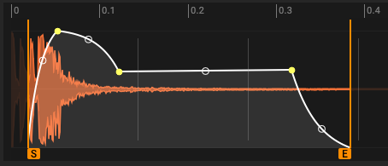
Waveform view - default view - sample waveform view of the selected Layer

With a simple mouse drag you can set a Start / End of a sample.
Selection can be moved left right with Alt/Option + drag.

You can also zoom waveform view horizontally to get a closer look:
- ruler drag up/down and left/right to zoom and move
- double-click on a ruler resets view to full
- Alt/Option + double-click on a ruler zoom to selected area (Start-End sliders)
- mouse wheel up/down to zoom in/out on a mouse pointer
- mouse middle-click + drag to move zoomed area left/right
- Ctrl/Command + left/right-click sets start/end marker to mouse pointer
- MIDI Learn for start/end slider - (right-click) based on selected Pad/Layer and actual zoom

Layer volume envelope is a special MSEG. It is Ssecial because the first segment plays the role of attack and the last one plays the role of decay, and they have a sticky property in relation to Start/End sliders, and are more important than other segments. Right-clicking on points (both vertices and curves) opens a menu. Apart from using the menu to create/remove a segment, you can also shift-click anywhere within the Start-End slider. Shift-clicking on a curve point resets (straightens) the curve.

Top right corner contains the name of the loaded sample with the number of samples in a current folder, and the Slice mode toggle button. Double-click on a sample/loop name will open a Browser and select that sample file.
There are also some buttons for fast loading sample from current folder, with the autoplay:
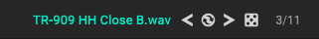
- previous sample
- reload current sample
- next sample
- random sample

The far right is the ordinal number of the sample file in the total number of files in the current folder.

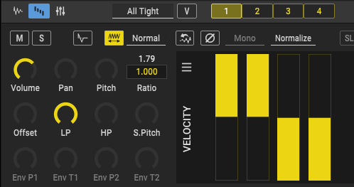
Velocity ranges view - velocity ranges of all Layers

The velocity ranges work in conjunction with all Play Modes and can be used to program velocity splits.

The velocity menu contains commands for spliting, inverting, reseting and moving overlaps.

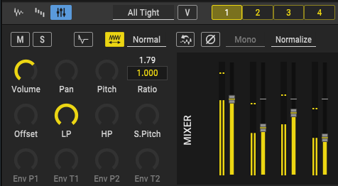
Layers mixer view

Here you can control the volume of all layers on the pad in one place.

Pad Seq

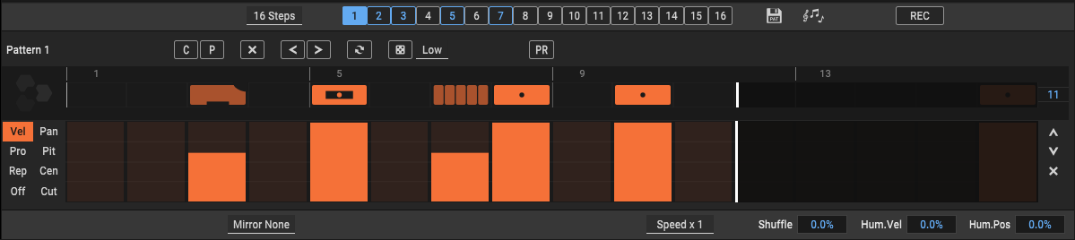
The Pad Seq tab is a view of the Sequencer in which only the line of notes associated with the active Pad is visible. This view serves so that we do not have to switch to the Sequencer page if we want to edit the notes only for the active Pad. All other controls are the same as on the Sequencer page, so all explanations are on the "Sequencer" section.

Tip - if you plugin host support it, Pattern name (number) will be visible in a plugin host Piano Roll (only for VST/VST3)

Mixer

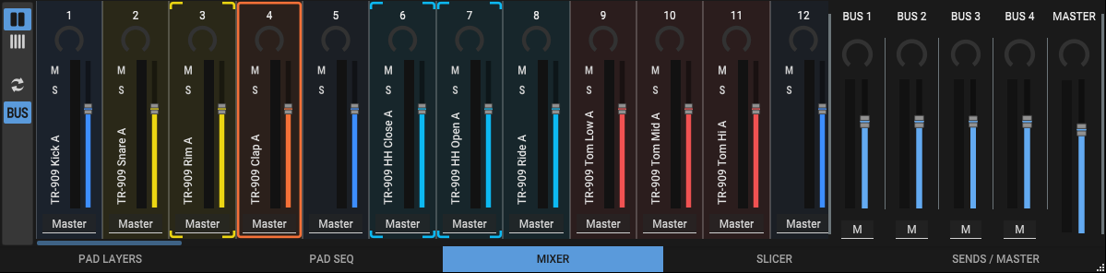
The Mixer tab displays mixer slots for every pad (64). There are two views, wide and narrow. The buss mixer view can also be turned on. In addition, it is possible to turn on synchronization with pad groups, so that the active slot is almost always visible when changing the active pad. Multi-selection is supported just like on Pads.

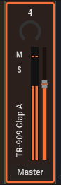
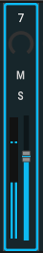
The mixer slot contains display-dependent controls. The narrow display has: Pan, Volume, Mute, Solo and meter. The wide display has everything the same as the narrow one plus the name of the pad and the output selector.

Slicer

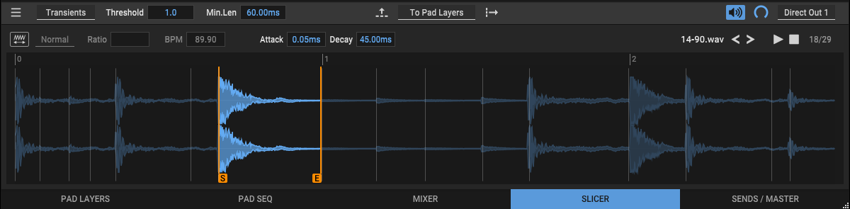
With Slicer, the drum loop can be cut into individual drum hits which can then be loaded into the Pads as normal samples.
There are two slicing modes:
In Transients mode, slicing will look at transients/onsets.
- Threshold - the Threshold knob will set the sensitivity when looking for transients/onsets
- Length - the Length knob will set the minimum length of a slice

In BPM mode, slicing will be processed with the beats per minute base.
- Sync - sync slicing bpm to free/host/stretch bpm
- BPM - set the desired beats per minute
- Division - additional divisions of a beat

Stretching controls:
- Stretch - stretching on/off
- Stretch Mode - Normal, Smooth, Crisp
- Stretch Ratio - ratio knob, it is also possible to manually enter a value with a mouse click
- BPM - right mouse click will set stretching bpm to host bpm, with left mouse click you can manually enter a bpm value

A slice can be selected with the left mouse button. When selected, start and end of a slice can be changed with the Start/End slider. Moving a transient/onset marker over the other will delete that marker. Additional transient/onset markers can be created with the Shift + left-click on the loop.
The slices can be dragged and dropped onto the pads to populate pads or layers on a specific pad. Ctrl/Command + drag will take selected slice plus all the slices to the right of the selected, so for example, to drag all slices at once hold Ctrl/Command while start dragging first slice.
When dropping on pads, “Drag&drop on Pad Defaul” from preferences is respected, which can be temporarily switched with holding Alt/Option key.
Pads can be filled with Slices also via the button in the middle of the header, and next to the button is a menu for setting the way the pads will be filled.
In Slice Thru Mode, when adding to Pad, each slice will be the size from the beginning of the slice to the end of the loop.
There are controls for auto play loaded loop, preview volume and preview output.

Sends / Master

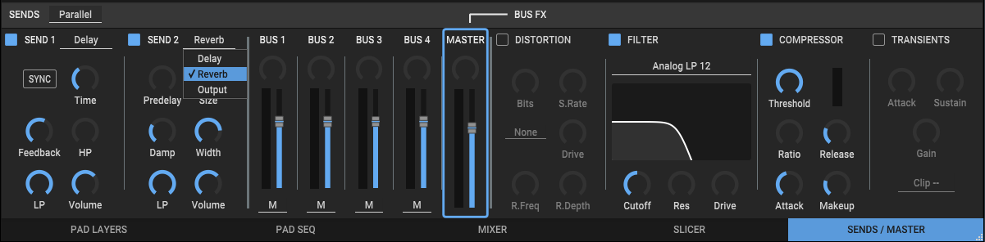
Sends / Master tab provides two Send fx/out slots, buses mixer and buses fxs. Send can be Delay, Reverb or direct output to send signal to external effect. If it is Delay or Reverb, then the signal is forwarded to the Master channel. In the case of the direct output the signal is not returning to the master channel. Sends can be processed in parallel or serial.
Delay includes controls for:
Sync - sync the delay to your host's tempo with the selected note value
Time - Sync is on, it will give a note values - right-click menu to choose from
- Sync is off, it will control the delay in seconds (milliseconds)
Feedback - amount of repeating echoes, a value of 0 produces only one echo
LP / HP - lowpass and highpass filter
Volume - output volume of the delay

Reverb includes controls for:
Predelay - a short amount of delay (0-500ms) before the reverb takes effect
Size - sets the room size, affecting how long the reverberation lasts
Damp - amount of absorption in the room from the environment
LP - lowpass filter
Width - higher values increase the stereo effect
Volume - output volume of the reverb

Output - send can be set to any of the available direct output channels, so it can be used to easily send the amount of the output of an individual pad to an external effect

Bus Mixer - to edit bus FX section click on a bus in a bus mixer to select it.
For effects on a Bus FX see “FX Section”.

Sequencer

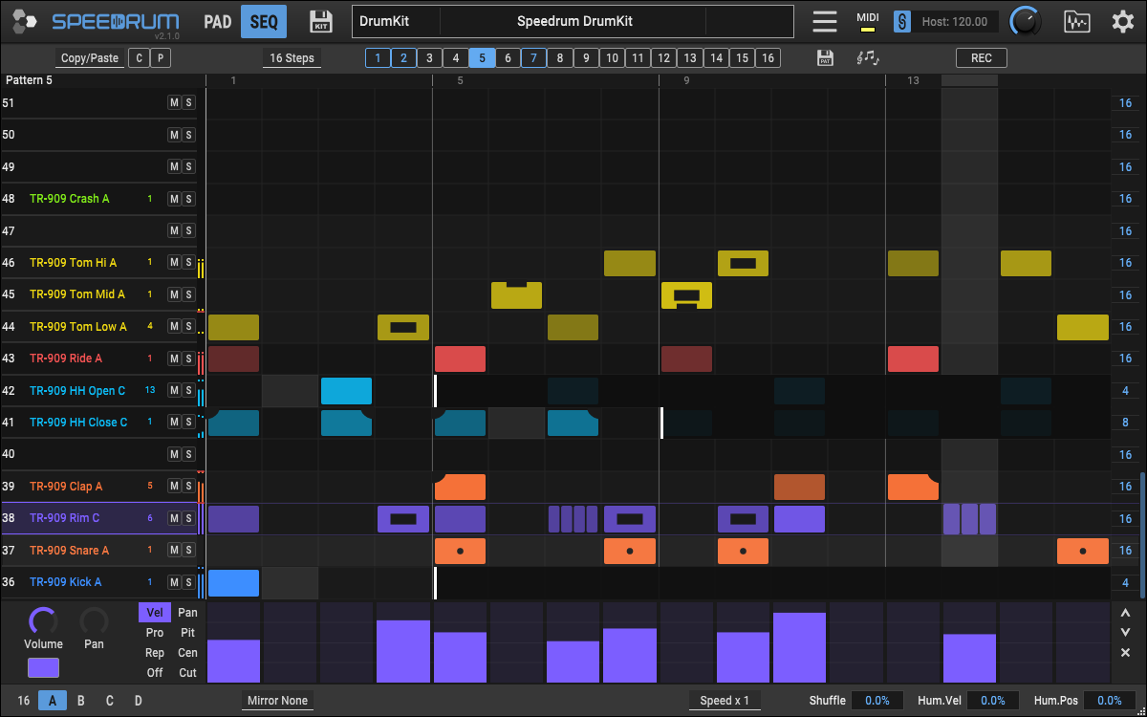
Sequencer has 16 patterns. Each pattern has 64 tracks, one for each pad.

There are two views of the sequencer, the "Seq" page and the "Pad Seq", and in both the header and footer contain the same controls (with the exception of the action buttons, and View buttons), while the middle shows the pattern editor.

Header

Action buttons - for the active pattern and they can be changed by selecting from the drop-down menu next to them. The action buttons on the bars will be the same as these. Only visible in the full sequencer, i.e. the Seq page.
Steps - the number of steps i.e. the number of notes in the row of the pattern.
Pattern buttons - used to select the active pattern. When the pattern is not empty, i.e. it contains at least one note, its button will be colored. Various actions on the pattern are possible from the button context menu.
Save pattern - saving active pattern. Saved patterns can later be loaded through the Browser.
Export midi - exporting the state of the active pattern to midi file on Windows and macOS by drag and drop, to the host's midi sequencer, to some other application that accepts midi files, or simply to a midi file on the hard disk.
Record midi - recording the input midi signal into the active pattern.

Footer

The footer contains humanization controls that apply to the entire sequencer.
View buttons - row views are synchronized with pad views, and buttons behave the same
Mirror mode - duplicating note/step input mode
Speed - modifier of the current tempo.
Shuffle - the amount of shuffle (also known as swing or syncopation)
Humanize Velocity - the amount of random deviation from the velocity value of the note
Humanize Position - the amount of random deviation from the note position on the grid

Pattern editor

The full pattern editor shows all tracks for all pads, and each track has a label and the name of the pad it belongs to. It also has mute and solo buttons, as well as action buttons whose display follows the mentioned menu in the header. Depending on what is selected from the menu, it can be copy/paste, clear, random or shift (left/right). Although these track actions can be reached from the contextual menu of the track, but also with the shortcuts.

Left-click on the grid to add a note. Click and drag a note up or down to adjust its velocity value, and that value will than be a base velocity for new notes. Right-click to delete a note. Left/Right-click and drag to insert/remove a series of notes.
On the right at the end of the row there is a slider for adjusting the number of steps - polymeter. Dragging up/down changes the number of steps for the row from 1 to the current number of steps for the pattern.

Pad Seq only displays the track for the active pad, while the track action buttons are all available above the bar itself.

In both views, at the bottom is the expanded note state editor - graph.
Each note has a velocity, probability, repeats and offset state.
Additionally, the Pan, Pitch (coarse), Cents (fine pitch) and Filter Cut for the Pad located on that Row can be modulated at the step level.
Values are adjusted for each note by clicking and dragging up and down or for several notes by dragging to the side. Ctrl/Command + left-click on graph to reset value. In the case of Velocity, holding down the Shift key will automatically turn On notes that are Off.

In addition to using the mouse, the active pattern can also be changed using notes. Midi note 12 will activate pattern 1, note 13 pattern 2 and so on.
Also, the Sequencer can be muted using midi note 11.
The row context menu contains various actions that can be performed on the notes.

