Traktor Editor
User manual

Rev. 0

Contents
General 4
Database 4
Properties 4
Targets 4
Log 5
Settings 5
Deploy 5
Colors 6
General 6
Modules 6
Shortcuts 7
Renderer 7
Pipeline 7
Scene 7
Audio 7
Standard dialogs 8
Type browser 8
Object browser 8
Standard object editor 9
Color dialog 9
Manage external resources 10
Create a mesh asset 10
Create a texture asset 10
Manually create asset 11
Shader graph editor 12
Create new shader graph 12
Add nodes and connect edges 12
Disconnect edge 12
Use fragments 13
Tips and tricks 13
Scene editor 14
Toolbar 14
Entities pane 15
Dependencies 15
Navigate 15
Camera navigation 15
Transform entities 15
Scene controller 15
Create ”prefab” entities 16
Particle effect editor 17
Sound editor 18
Script editor 19
Flash editor 19
Skeleton editor 19
Animation editor 20
Animation state graph editor 20
Localization editor 20
Video editor 20
Assets 21
traktor.animation.AnimationAsset 21
traktor.animation.SkeletonAsset 21
traktor.flash.FlashMovieAsset 21
traktor.mesh.MeshAsset 21
Runtime mesh types 21
traktor.physics.HeightfieldAsset 22
traktor.physics.MeshAsset 22
traktor.render.TextureAsset 23
traktor.scene.SceneAsset 23
traktor.sound.BankAsset 23
traktor.sound.SoundAsset 24
traktor.spray.PointSetAsset 24
traktor.terrain.HeightfieldAsset 24
traktor.terrain.MaterialMaskAsset 24
traktor.weather.CloudMaskAsset 24
traktor.video.VideoAsset 24
Use case 1 – Create a scene with a single lit mesh 25

General

Database
The database view show all the objects available in the source database. In order for an object to be accessible from the editor and also the game it must be in the database.
Each object in the database is a serialized C++ object with an unique ID attached. Those Ids are used so each object are able to reference each other.
Instances in the database can also have lumps of data attached to them in order to store, for example, textures and sounds etc.

Objects in the database are edited by double-clicking on selected object. When double-clicking on an object an associated editor is opened to handle the specific type of the object.
Objects can be renamed and moved in the database view as seem fit without risking loosing references between instances as they are always reachable by the unique ID.

Properties
The properties view is common UI element which is used by many of the specialized editor components in order to modify object properties, or members.
Values can be edited simply by clicking on the value column on the desired row.
Values are verified to attributes specified by each member of the objects in order to prevent invalid entries.

Targets
Targets view contains a list of all the game-projects defined in the database. There is also a drop-down containing all of the supporting platforms.

So in order to launch a desired project on a specified platform you simply do the following:
- Select platform in the drop-down.
- Press the play button on the desired project.
- The project is now built specifically for the platform and automatically launched if the content is built successfully.
In order to propagate changes made in the editor while the project is running you simply press the play button again while holding the Shift key.
Information about running projects are stacked below each project row. This contains information about frame-rate, how much memory, how many objects etc the project is currently using.

Log
The log view shows information and possible error messages from all of the active systems in the editor. This view is particularly interesting while building content through the pipeline as it will show which content failed.
Different log-levels have different background colors and icons in order to make it easy to spot critical errors.

Settings
By selecting the menu option Edit/Settings... you will reach the settings dialog. This dialog contain settings for various aspects of the editor.

Deploy
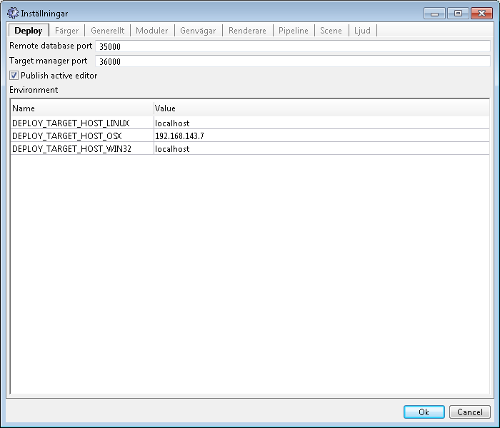
On the “Deploy” tab there are settings on how to deploy and launch game projects from the editor.
There are also a list of environment variables which are used by the deploy tools to specify the target hosts for different platforms.

Remote database port | Port used by games to access content through the editor.
Target manager port | Port used by games to communicate with editor, such as runtime information etc.
Publish active editor | Add ID of object currently opened for edit into game's configuration file.

Colors
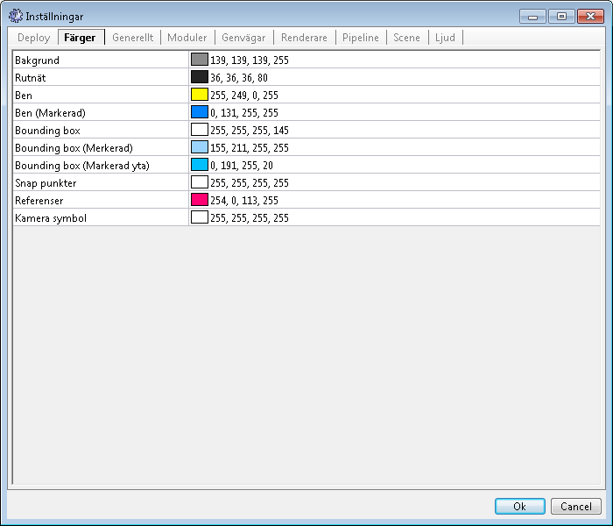
In the “Colors” tab you are able to change colors used for previewing in the editor.
Modify a color by double-click on the desired row.

General
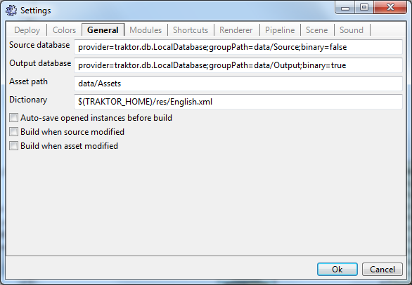
The “General” tab contains probably the most important settings. On this tab there are settings for the database connections, language, automatic build etc.

Source database | Connection string to source database.
Output database | Connection string to output database.
Asset path | Common path to source assets.
Dictionary | Language dictionary used for editor.
Auto-save opened instances before build | Save all opened instances before building content.
Build when source modified | Automatically build content when a source object has been modified and saved.
Build when asset modified | Automatically build content when a source asset has been modified externally.

Modules
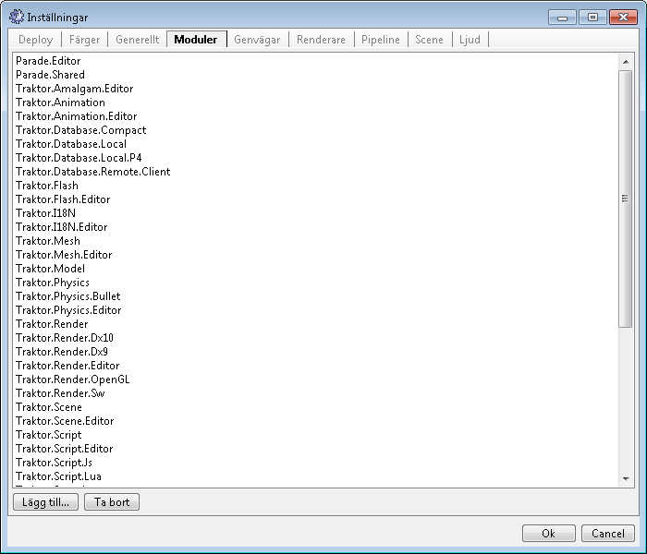
As the editor rely on modules to implement functionality it's important to be able to add new modules.
On the modules tab lists all of the modules currently loaded by the editor.

Shortcuts
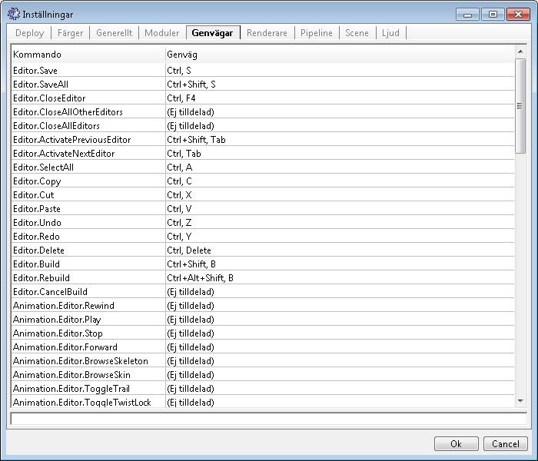
On the shortcuts tab you can modify current keyboard shortcut bindings to almost all operations in the editor and it's modules.
- Select shortcut you wish to modify.
- Put focus in the input field below the list of shortcuts, it will become green when it receives focus.
- Press desired shortcut on your keyboard.

Renderer
This tab specify which renderer API to use for previewing in the editor. Also settings for texture filtering and MSAA are found here.

Pipeline
Settings for the caching mechanism used by the pipeline in order to reduce build times. The pipeline either use memcached which is a cache server backed up by lots of RAM or it can use a simple file based cache. Either way, the configuration for those are found in this tab.

Scene
A couple of settings for the scene editor is found on this tab.

Audio
Audio preview settings.

Standard dialogs

Type browser
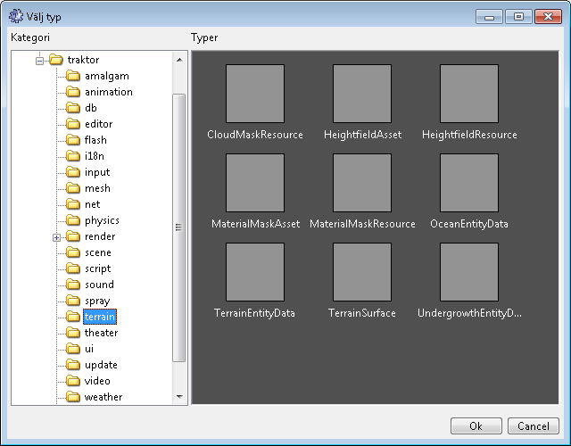
The type browser is used when the user needs to a concrete type.
The tree view is a representation of the namespaces in which the types, in the left view, are defined.

Object browser
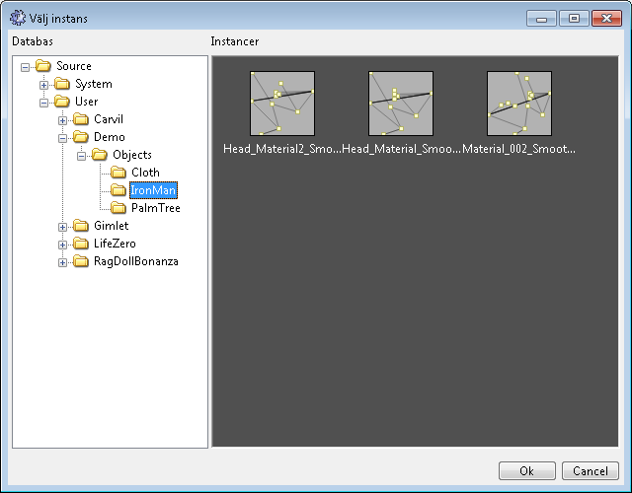Browsing shadergraphs
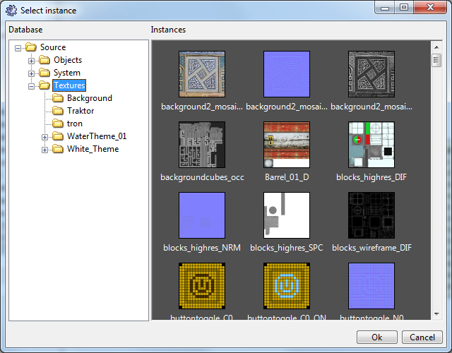Browsing textures
The object browser is used to browse for objects in the database. This dialog is often filtered on a specific type which reduces the amount of selectable objects.
There are also automatic preview generation for the icons in order to make the objects more distinguishable. For instance, when selecting a texture a thumbnail image is generated for each texture making it simple to select the right texture.

Standard object editor
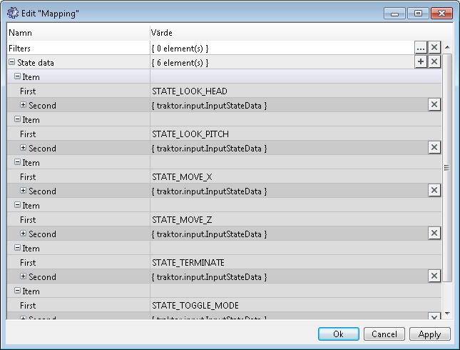
Objects which doesn't have a specialized editing tool the editor will open the standard object editor dialog. This dialog only contains a property list which simply reflects the object and all it's properties. This will allow for editing all objects without the necessity to implement custom editing tools for all types.
The dialog works in similar fashion as the properties view panel. All changes are performed by simply selecting the value field for a desired row.

Color dialog
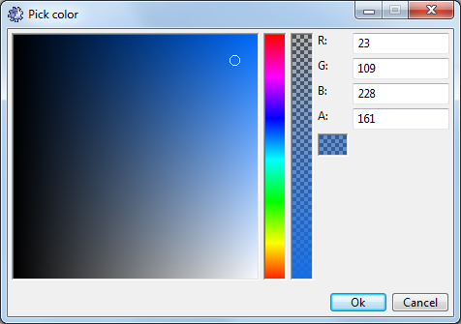
Color picking dialog used whenever editing colors. The color dialog tries to mimic behavior of the color dialog found in Adobe Photoshop.

Manage external resources
External resources, such as textures, sounds, 3D models, animations etc, are references through a concept called an Asset. An asset is an object in the database and contains a file path to the physical asset and additional properties of how this asset should be built by the pipeline.

Create a mesh asset
- Select a group node in the database view and right click on it.
- Select “Create mesh asset...” wizard in the pop-up menu.
- Select the source model (Collada, FBX, LWO or OBJ file).
- A new instance is now created in the database with the same name as the source model.
- Double click on the instance in the database view to open the Mesh asset editor dialog.
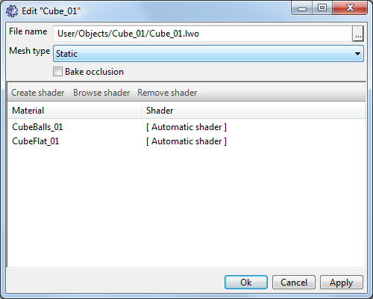
- This dialog now contains the path to the model but also the runtime specifications such as mesh type (static, instancing etc) and a mapping table between materials found in the source model and the shaders which will be used.

Create a texture asset
- Select a group node in the database view and right click on it.
- Select “Import texture batch...” wizard in the pop-up menu.
- The “Import texture batch” dialog will now appear.
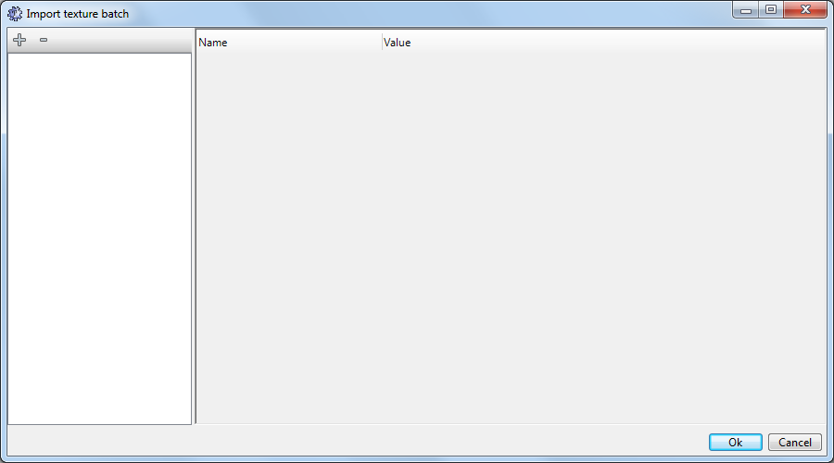
- Click on the '+' sign in the toolbar to the left to add a source texture.
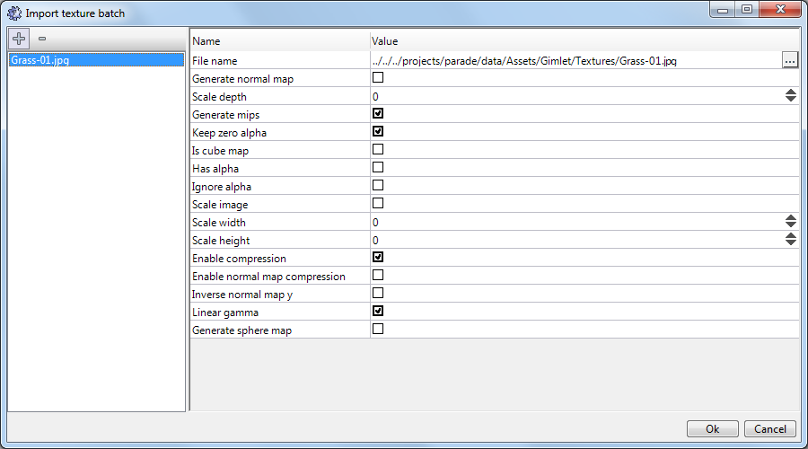
- Now a texture is added to the list and also a set of usage properties of the texture is shown.
- Repeat above steps for all the textures you wish to add.
- Click Ok when finished and texture asset instances will be created in the database for each texture imported. The texture asset properties can be modified later by double-clicking on the instance in the database view.

Manually create asset
Many types of assets doesn't have a custom wizard implemented so in order to create those we do it manually. For instance when creating a sound asset we do the following:
- Select a group node in the database view and right click on it.
- Select “New instance...”
- Browse and select the SoundAsset type in the traktor/sound namespace.
- Change the name from “Unnamed” to something useful and click Ok.
- A new blank sound asset is now created in the database with the name given. Double-click on the instance in the database view.
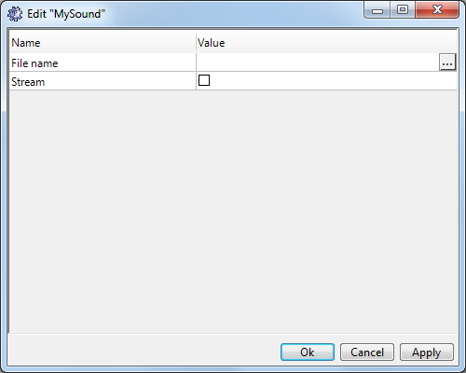
- In this dialog, which are the default object editor dialog, you're now able to browse the source asset and also specify the build properties.

Shader graph editor
The shader graph editor enables the user to visually create and modify shaders for all platforms in one unified way.

Create new shader graph
- Select a group node in the database view and right click on it.
- Select “New instance...”
- Browse and select the ShaderGraph type in the traktor/render namespace.
- Change the name from “Unnamed” to something useful and click Ok.
- A new empty shader graph instance have now been created in the database.

Add nodes and connect edges
- Open the shader graph created in the previous chapter. The shader graph editor will now open with a blank canvas.
- Add a new node by right-click in the canvas and select “Create node...” and then select category and node.
- Create another node at some different location.
- Click and hold left mouse button on the output of the first node, in the little circle which represent a connectable pin.
- Move, while holding left button, the mouse onto an input pin of the second node and release. The edge will now connect between output and input of the nodes.

Disconnect edge
- Press left mouse button in the input of a node you wish to disconnect and while holding move the “floating” edge and release into the void.

Use fragments
- Navigate in the database view to the object /System/Shaders/Fragments/Truncate and select it.
- Drag and drop the Truncate fragment object from the database view onto the shader graph editor.
- A new, yellow, node have now been created which is a reference to the selected fragment. Each input/output port defined in the fragment is represented as a input/output pin on the node.

Tips and tricks
- Double click on a fragment node will open the fragment in another editor tab.
- Select multiple nodes with selection box; press and hold left mouse button and drag a selection box.
- Textures are drag and dropped from the database view similar to fragments.
- No need to disconnect and edge before replacing with another edge, just release new edge onto an already connected input will replace the edge.
- Nodes are highlighted with a red overlay if something is incorrectly setup, such as names, unconnected required inputs etc. The error is reported in the log view.
- In the mesh asset dialog it's possible to create shader graphs which are prepared to reflect the settings from the source model material.

Scene editor
This is used to place and modify entities in a scene. Entities can be of varying types such as meshes, physics, paths, logic etc. The editor have only two distinctions which are spatial and non-spatial where the spatial is the only ones able to be transformed.
The scene editor also supports multiple view ports by splitting the editor into 1, 2 or 4 views. Each view port can have either orthogonal (aligned with x, y or z axis) or perspective projection. There is also a special view for debugging various internals of the scene rendered such as shadow buffers etc.
The scene editor supports both magnetic snapping or grid-based snapping.
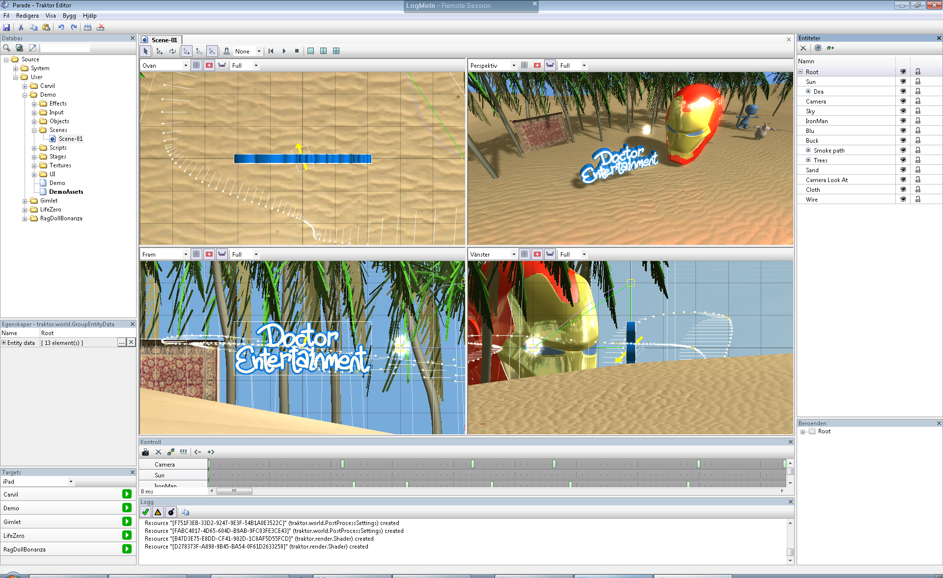Scene editor with four views.

Toolbar
Enable selection through the 3D views.
Activate translation modifier.
Activate rotation modifier.
Enable X, Y or Z axises.
Enable magnetic snapping.
Select grid snapping distance.
Playback controls for animation etc.
View port configuration.

Entities pane
On the right hand side is a panel which outlines the entity hierarchy. Through this pane you're able to add or remove entities, hide entities or lock further modification of entities.
There are also a toolbar with some special tools in order to have the camera either follow or track the transform of selected entities.

Dependencies
Lower right hand side is a panel which details the dependencies of the selected entity. This allows a shortcut in order to find out which meshes, textures etc. an entity is dependent upon and also by double-clicking on a dependency it's associated editor will be opened.

Navigate

Camera navigation
Activate camera navigation by holding the Ctrl key and then use left mouse button to translate the camera's position or the right mouse button to rotate.

Transform entities
Hold left mouse button and drag in order to apply chosen modifier on the selected entities. Current modifier is selected on the toolbar.

Scene controller
Beside entities, a scene can also have an associated controller. These controllers can be used for cut-scenes or animating the scene globally without the game needs to have any special knowledge about it.

Create ”prefab” entities
Prefabricated entities are ready-made entities which is stored as separate objects in the database and can be instantiated in multiple scenes, or multiple times within the same scene. Those entities are called “external entities” and are replaced during loading with the concrete entity.
There are no constraints as to what an prefabricated entity can be thus it's possible to create very complicated entities which is simply placed by another user.
Prefabricated entities can also contain references to other external entities.

Particle effect editor

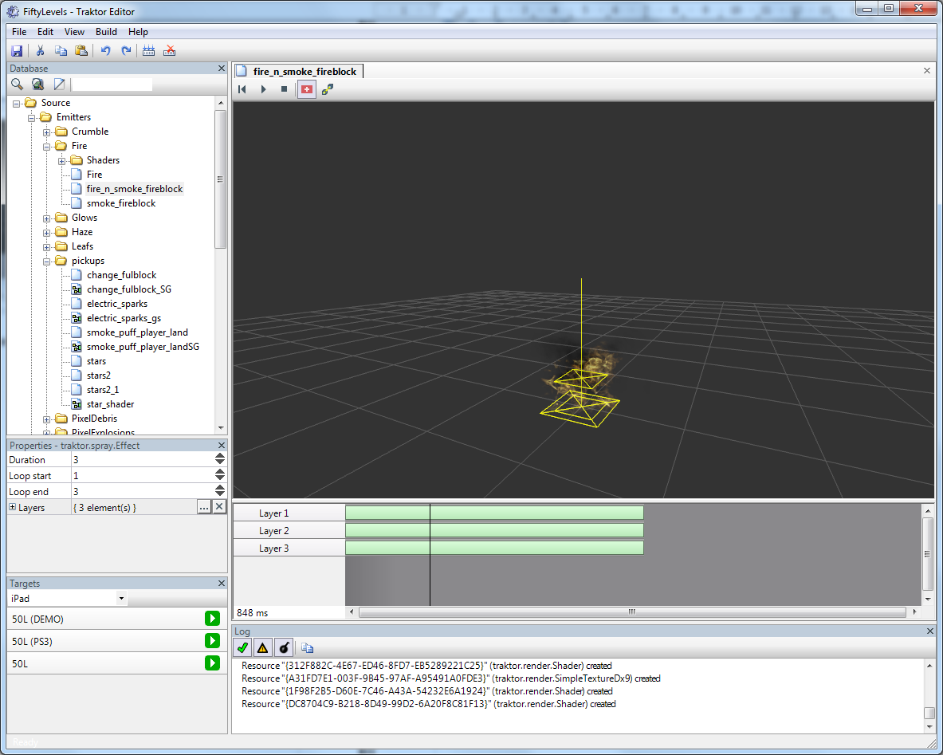
The particle editor is a slim editor used to design layers of particle effects.
TBD

Sound editor
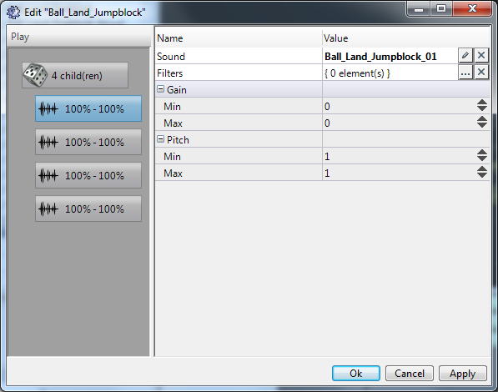
The sound system supports a mechanism called “sound banks” which is a collection of sounds, groups and filters combined into what the game perceives as a single sound.
A sound bank is composed of “grains”, a grain can either be a randomizing group, simple playback grain etc.
These sound banks are edited through a dedicated sound bank editor dialog. The dialog is split into a tree like view of all the grains and a property view of the selected grain.

The sound engine supports the following grains:
Mute | Mute sound for a given number of milliseconds.
Play | Play a sound; either a sound asset or another bank. The play grain also supports tweaking the gain or pitch in order to create slight differences.
Random | Randomly play a child grain. Able to humanize to prevent repeating same grain multiple times consequentially.
Repeat | Repeat a child grain a number of times.
Sequence | Play trough child grains in sequence.

Grains are created by right-click in the tree like view and select “Add grain...” option. If a grain which can have children is selected then the new grain will be added as a child.
Each grain in the sound bank can be preview by selecting the grain and pressing the “Play” button in the toolbar.

Script editor
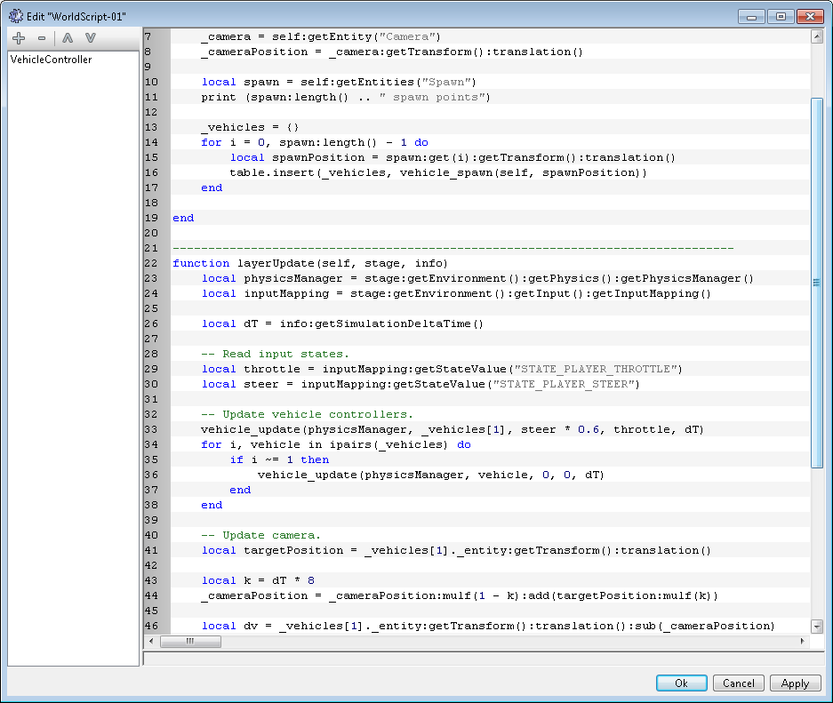
The script editor is used to edit scripts written either in LUA or JavaScript. The editor supports syntax highlighting of both those languages.
In order to resolve script dependencies there is a special list on the left which includes all of the references to other scripts. The referenced scripts are automatically included in the “global scope” of the current script.

Flash editor
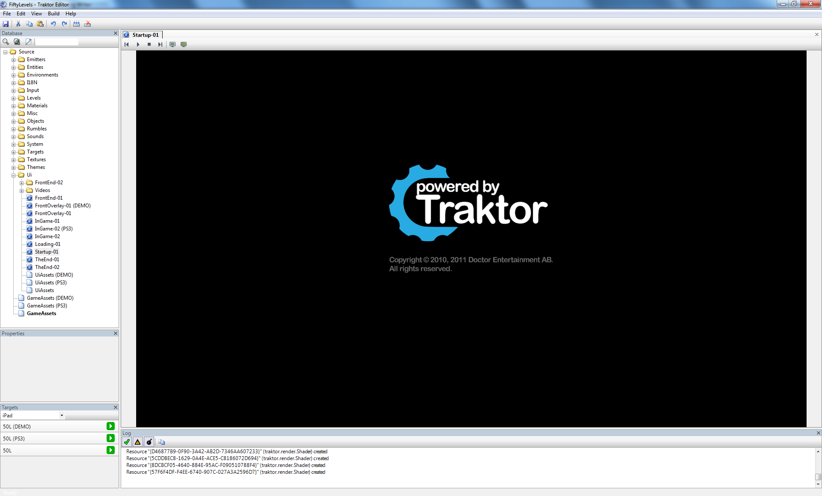
The Flash editor is only used to preview Flash movies through the engine's Flash player.

Skeleton editor
TBD

Animation editor
TBD

Animation state graph editor
TBD

Localization editor
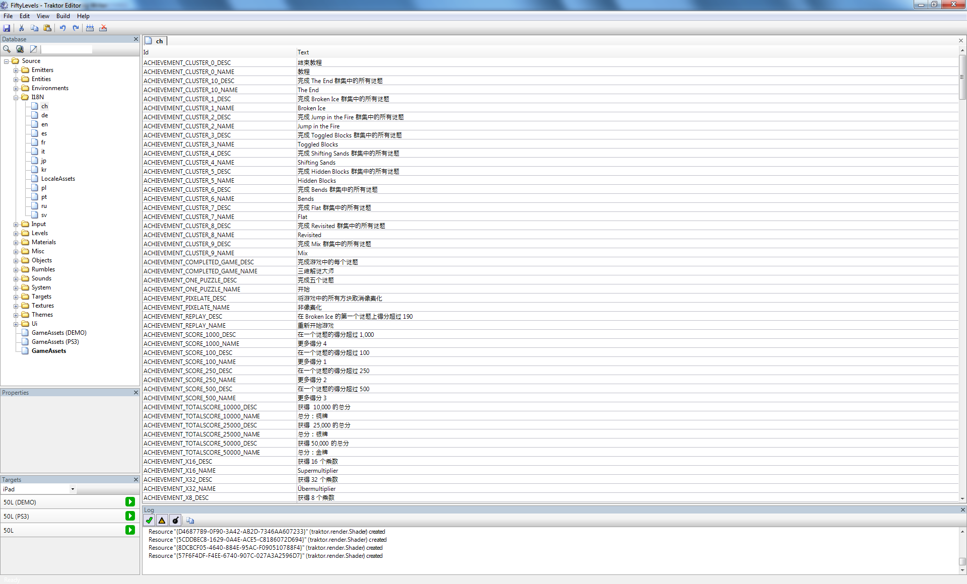
The internationalization editor, or I18N for short, is used to create string tables for different languages. As the editor have full unicode support it's able to correctly show all different languages.

Video editor
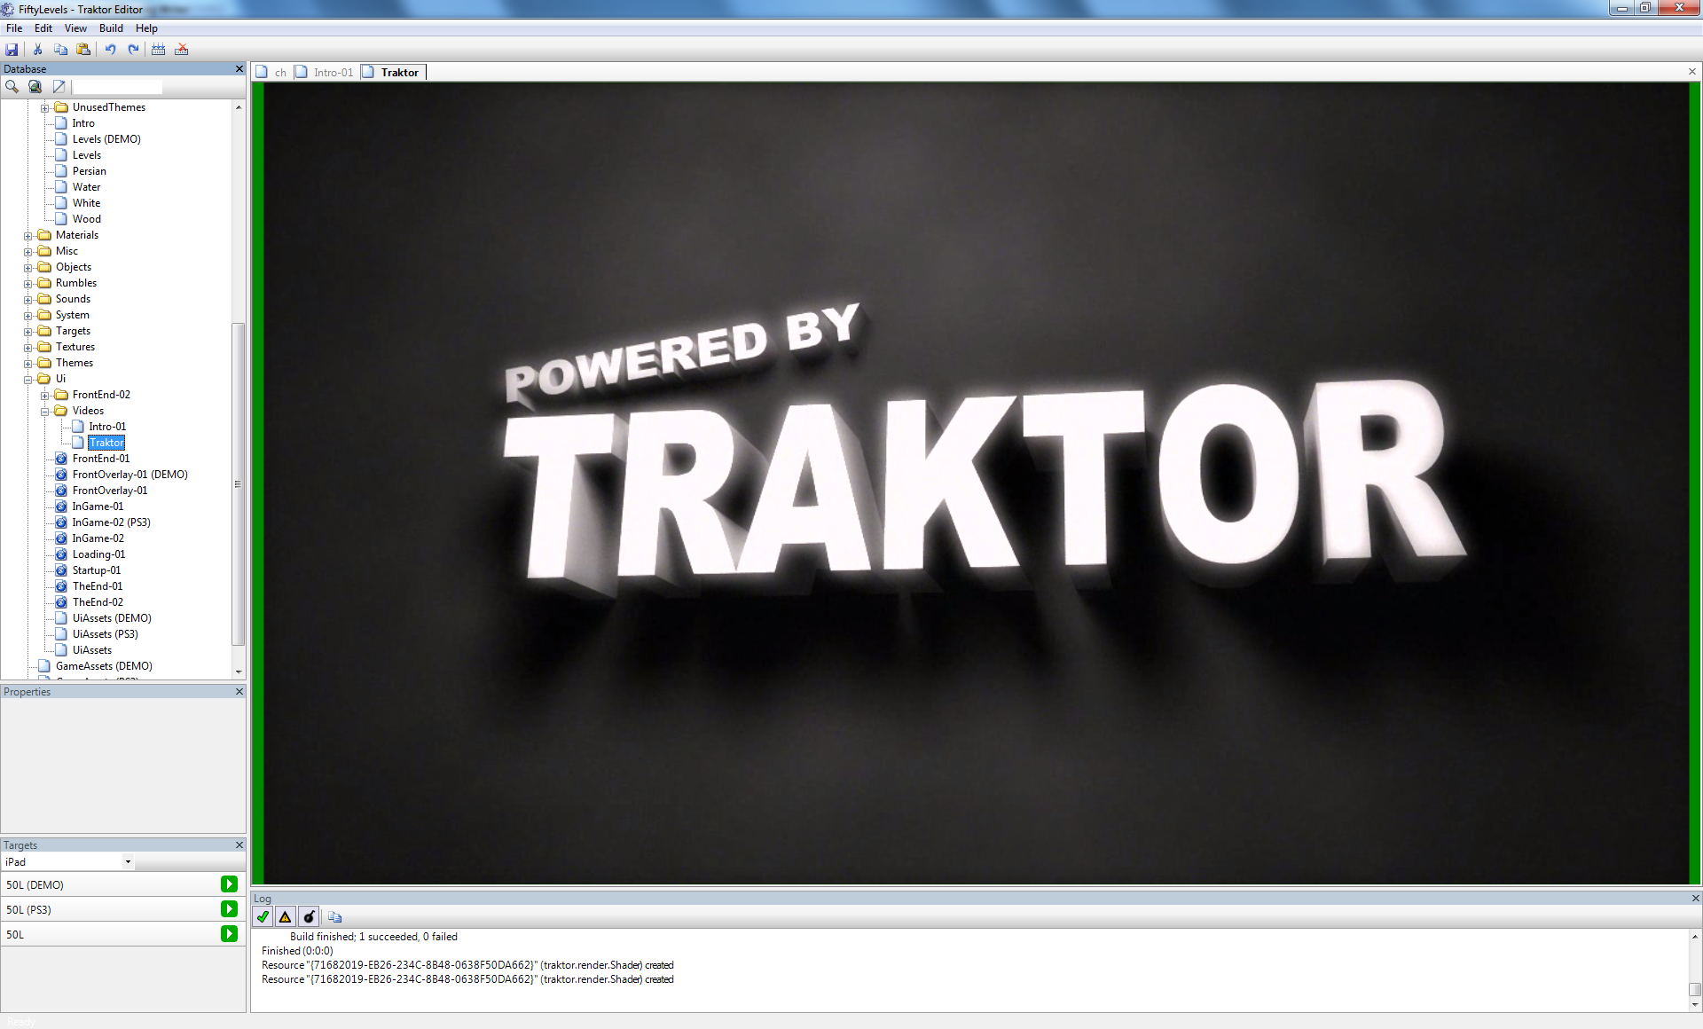
The Video editor is only used to preview video streams through the engine's video player.

Assets
External content, or assets, are accessed from the editor and the pipeline through instances of following types in the database. As each instance is built through the pipeline the source asset is loaded into the pipeline and converted into a representation best suited for the target platform.
Some of these assets are created through wizards but some has to be made explicitly by creating instances in the database through the “New instance...” method in the database view.
Here we go through the available assets and also which properties each of those assets expose to the user:

traktor.animation.AnimationAsset
This asset is used to reference animation data from tools such as MotionBuilder or similar which are able to export BVH data. Also animation data from motion capture equipment should be referenced through this type.
fileName | Path to physical source file; supporting BVH.

traktor.animation.SkeletonAsset
TBD
fileName | Path to physical source file; supporting BVH.

traktor.flash.FlashMovieAsset
This asset is used for Flash movie references.
fileName | Path to physical source file; supporting SWF.

traktor.mesh.MeshAsset
This asset is used to reference source 3D models. The mesh asset also dictates which type of renderable mesh should be produced, such as static or skinned geometry.
fileName | Path to physical source file; supporting Collada, FBX, LWO or OBJ.
meshType | Type of runtime mesh. See table XXX for further information.
materialShaders | Table of model material to runtime shader mapping.
bakeOcclusion | Automatically bake vertex occlusion in pipeline step.
cullDistantFaces | Cull backfacing faces as if the viewer was “almost” placed in the center of the mesh. Useful for static environment meshes.

Runtime mesh types
As each mesh have different requirements in runtime is necessary to be able to specify the runtime intent of the mesh in the asset.
MtBlend | Blend meshes have multiple blend shapes, ie multiple sets of vertices which can be blended inbetween by a weights from the game.
MtIndoor | Indoor meshes are a very special type in the sense it expects meta geometry in the model to specify sectors of the world. These sectors are then automatically joined into a very efficient culling scheme suitable for indoor environments.
MtInstance | Instance meshes are meshes which are repeated many times in a scene, such as bushes, litter or such. By instancing the geometry the hardware is able to draw many copies of the mesh with a single call to the hardware, thus increasing the efficiency a lot.
MtPartition | Partition meshes are similar to indoor meshes but differ in how they are partitioned. An oct-tree is built in the pipeline from the geometry in order to render only visible pieces of the mesh during runtime. This reduce the number of vertex operations required to render the mesh thus increasing efficiency. Meshes suitable for being a partition mesh must be quite complex and large, probably span the entire viewport.
MtSkinned | Skinned meshes use a per-vertex weight factor in order to “follow” an animated skeleton.
MtStatic | Static meshes are untouched meshes which have reasonable complexity and is not very frequent.
MtStream | Streaming meshes is actually made up from many meshes in sequence which are streamed in during runtime in order to perform really complex animations. There are no restrictions as same vertex count or weights as each frame of the animation can be a unique source model.

traktor.physics.HeightfieldAsset
Heightfield asset which are used for static collision in the physics simulation.
fileName | Path to physical source file; supporting any image format and also 16-bit RAW.
worldExtent | Size of the heightfield in world coordinates.

traktor.physics.MeshAsset
Mesh asset which are used for collision in the physics simulation.
fileName | Path to physical source file; supporting Collada, FBX, LWO or OBJ.
calculateConvexHull | Calculate the convex hull of the mesh in the pipeline. As this is quite a time consuming task and only required for dynamic colliders this can be turned off for static only colliders.

traktor.render.TextureAsset
Texture assets are references to image data stored as TGA, PNG, JPEG or GIFs. The asset also has properties to perform special operations during pipeline step such as compression, normal map generation etc.
fileName | Path to physical source file; supporting TGA, PNG, JPEG or GIFs.
generateNormalMap | Assume the source image represents heights and converts those into a normal map.
scaleDepth | Depth scaling factor used when transforming image into a normal map.
generateMips | Generate a complete mipmap chain when building runtime representation.
keepZeroAlpha | Always keep zero alpha when generating the mipmap chain.
isCubeMap | The texture should be used as a cube map; thus the image is expected to have 6:1 ratio.
hasAlpha | Force the pipeline to assume the image has an alpha channel.
ignoreAlpha | Force the pipeline to disregard alpha channel even if source image has alpha.
scaleImage | Scale image prior to convert it in the pipeline.
scaleWidth | Scaled width of image.
scaleHeight | Scaled height of image.
enableCompression | Enable use of DXT class compression of texture.
enableNormalMapCompression | Enable special compression scheme used for normal maps.
inverseNormalMapY | Inverse normal map Y element.
linearGamma | If checked the source image is assumed to be in linear gamma, thus no preparation is needed in order to be useful in shading.
generateSphereMap | Generate a 2D sphere map projection of a cube map. Note this assumes the source image to be a cube map.

traktor.scene.SceneAsset
TBD

traktor.sound.BankAsset
TBD

traktor.sound.SoundAsset
SoundAsset is the asset type for sound source content.
fileName | Path to physical source file; supporting WAV, FLAC, MP3 or OGG.
stream | If sound should be streamed from disc or fully loaded into memory during playback.

traktor.spray.PointSetAsset
TBD

traktor.terrain.HeightfieldAsset
TBD

traktor.terrain.MaterialMaskAsset
TBD

traktor.weather.CloudMaskAsset
TBD

traktor.video.VideoAsset
TBD

Use case 1 – Create a scene with a single lit mesh
1. Create a source model
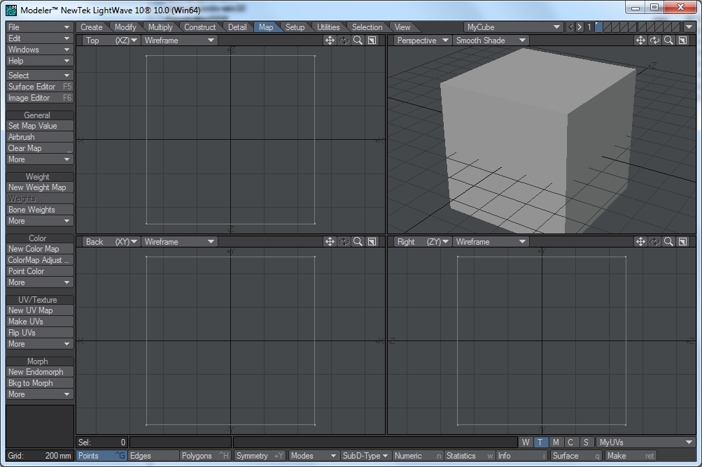
2. Launch Traktor editor. Ensure both “Build when source modified” and “Build when asset modified” are checked in the General tab in the settings dialog.
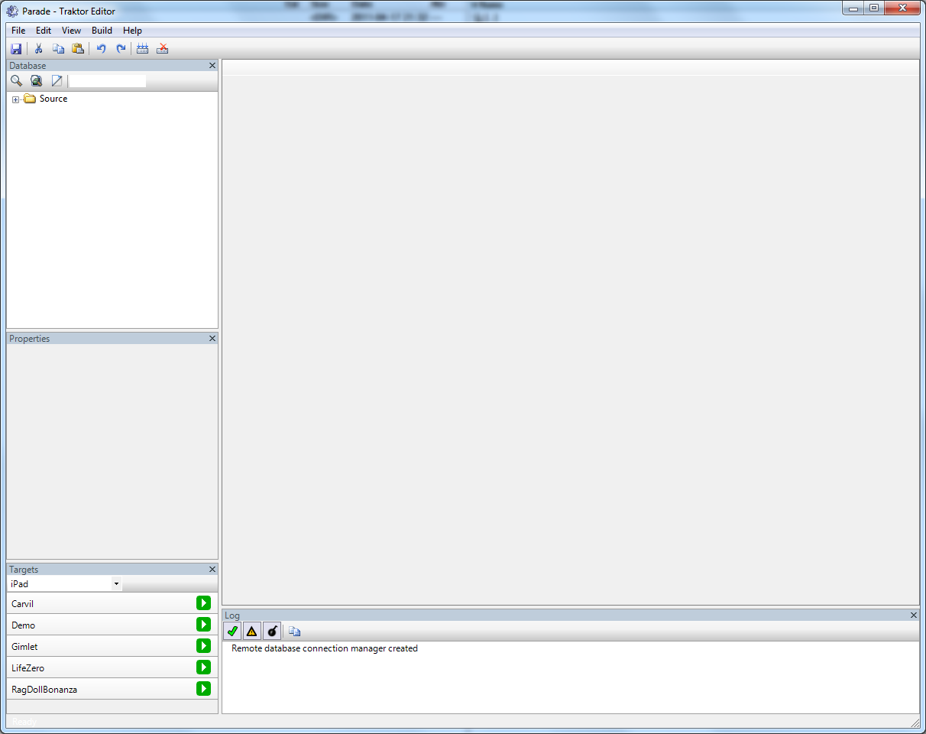
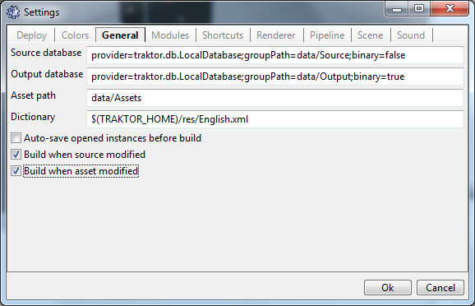
3. Right-click in database view and choose wizard “Create mesh asset...”. Select your source model and click Ok.
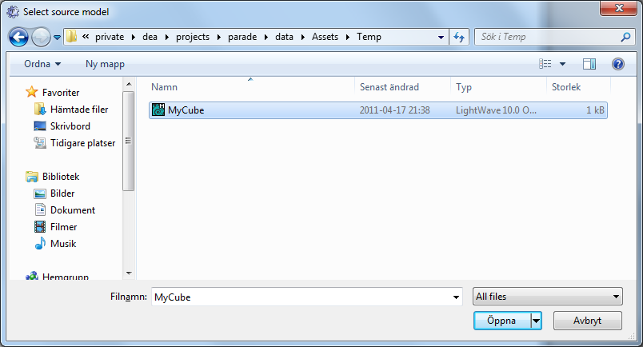
4. Right-click in database view and choose “New instance...”
5. Select traktor/scene/SceneAsset in the browser dialog; name it “MyScene” or similar.
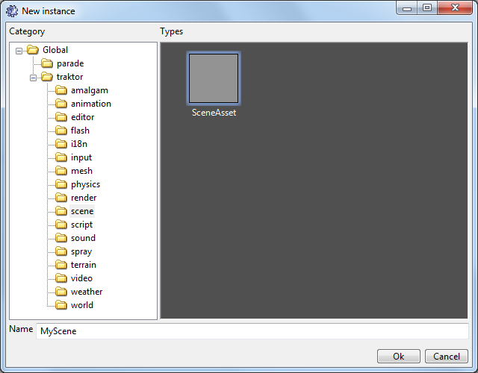
6. Double-click on “MyScene” instance in database view to open the scene editor.
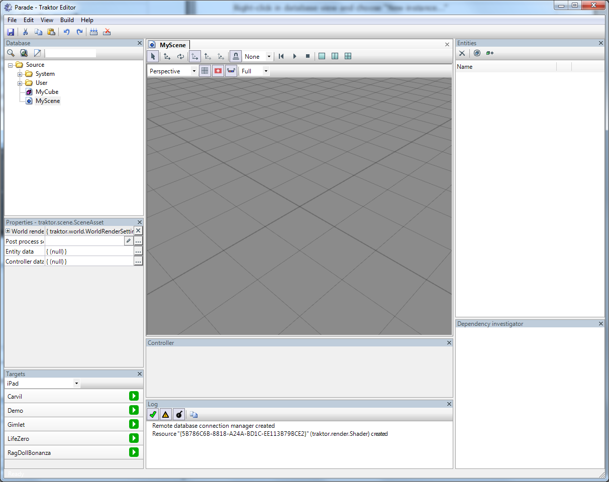

7. Right-click in the Entities pane and choose “Add entity...” in the pop-up menu.
8. Select traktor/world/GroupEntityData in the browser dialog.
9. Select the new blank row in the Entities pane, note that the new entity's properties are exposed in the properties view.
10. Click on the name value field in the properties view and enter “Root” or similar.
11. Right-click on “Root” entity in the Entities pane and once again choose “Add entity...”.
12. This time choose traktor/world/DirectionalLightEntityData in the browser dialog.
13. Keep selection on the “Root” entity and yet again choose “Add entity...”.
14. Select traktor/mesh/MeshEntityData in the browser dialog.
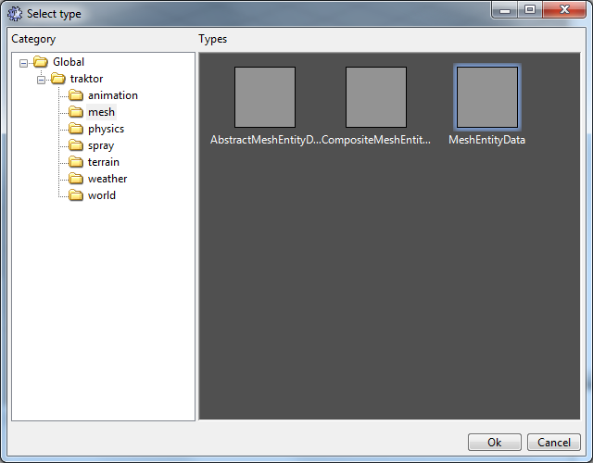
15. Select the new mesh entity in the Entities pane.
16. Click on the “...” button next to the Mesh entry in the properties view.
17. Browse for your mesh asset, it's named similar to your source model, and click Ok.
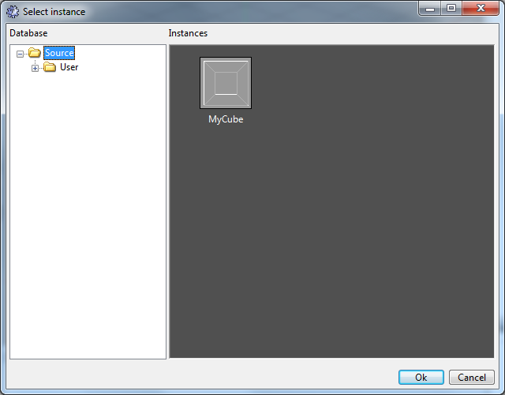

18. The mesh will now appear in the scene, lit from straight up.
