Caprica units 1 through 8 placed on Taraval Rooftop March 1st, 2016 along with Apogee SP-212 Pyranometer. Units were placed facing south in a line from east to west in order:

East – Cap 8 – Cap 7 – Cap 6 – Cap 5 – Cap 4 – Cap 3 – Cap 2 – Cap 1 – AG (Apogee) – West

With Apogee output connected to Cap 1 soil port. At around 1:00PM PST, units were moved to different positions and reset. New order was,

East – Cap 2 – Cap 3 – Cap 4 – Cap 5 – Cap 6 – Cap 7 – Cap 8 – Cap 1 – AG (Apogee) – West

Notice Cap 5, Cap 1 and AG were not moved.

The results of this days tests are shown below:

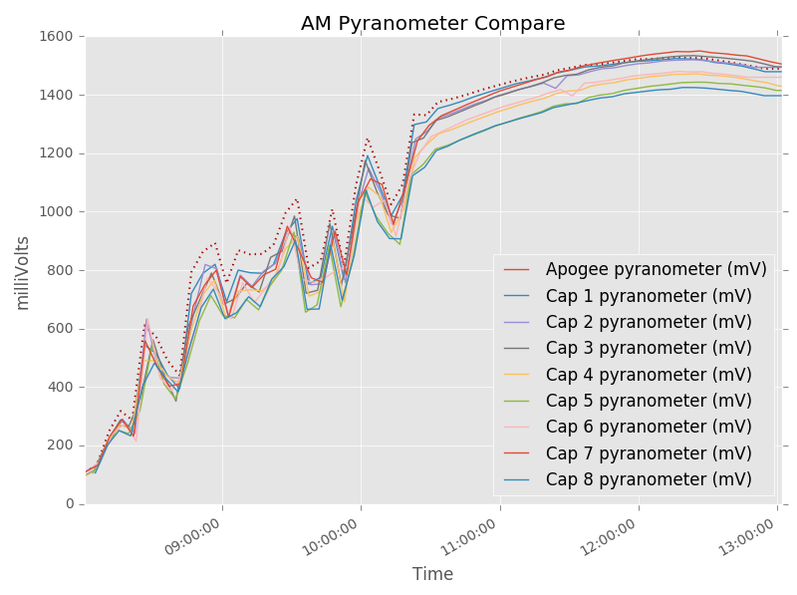

Figure . AM Pyranometer Comparison - AG is dotted red line. Actual Solar Radiation is ½ mV Output

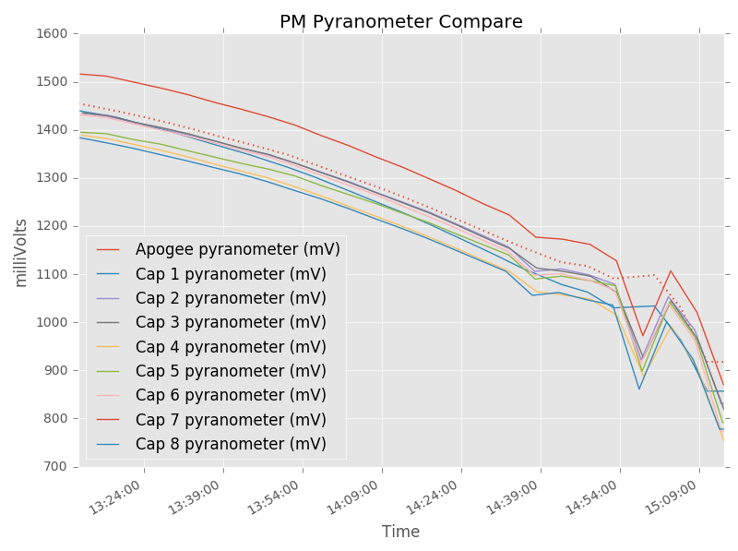

Figure . PM Pyranometer Comparison - AG is dotted red line. Actual Solar Radiation is ½ mV Output

For the error calculations, stable slices of AM and PM datasets were used – ignoring the remainder.

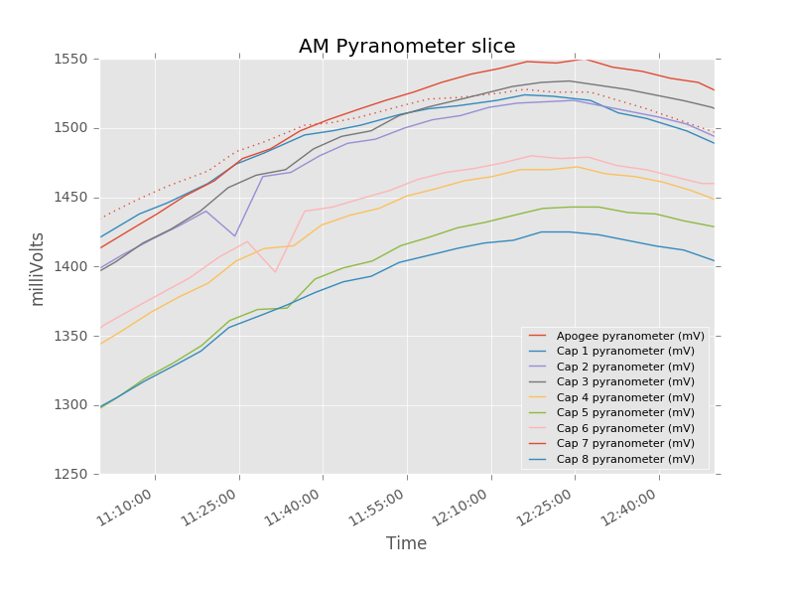

Figure . Pyranometer data used in calculations. AG is dotted red line

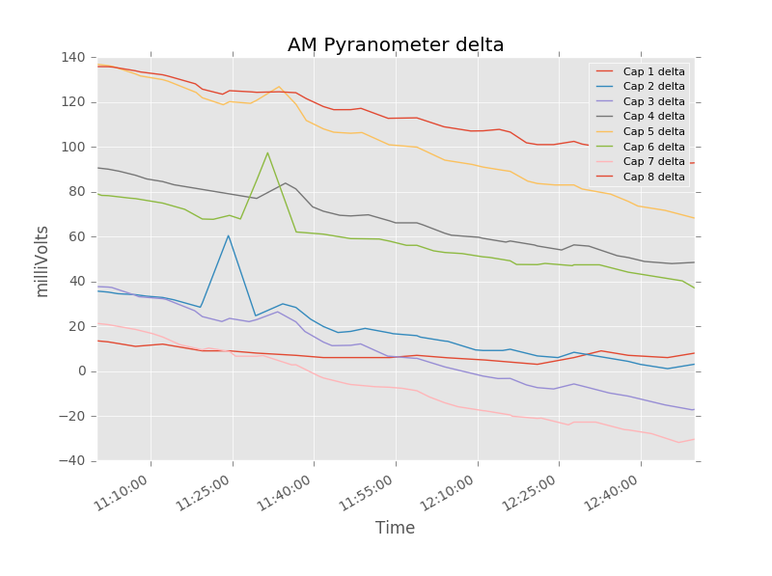

Figure . Delta between Pyranometers and Apogee. Negative values reflect outputs greater than Apogee. High red line is Cap 8

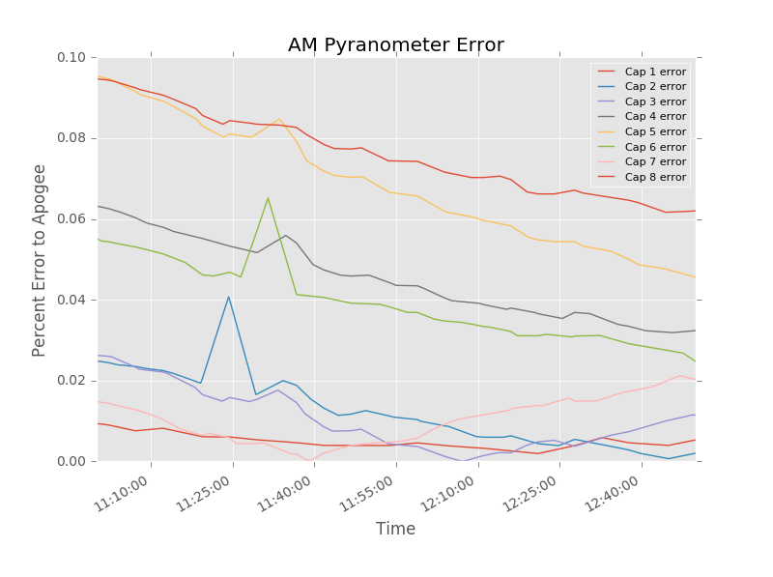

Figure . AM Error to Apogee (abs). High red line is Cap 8 Error

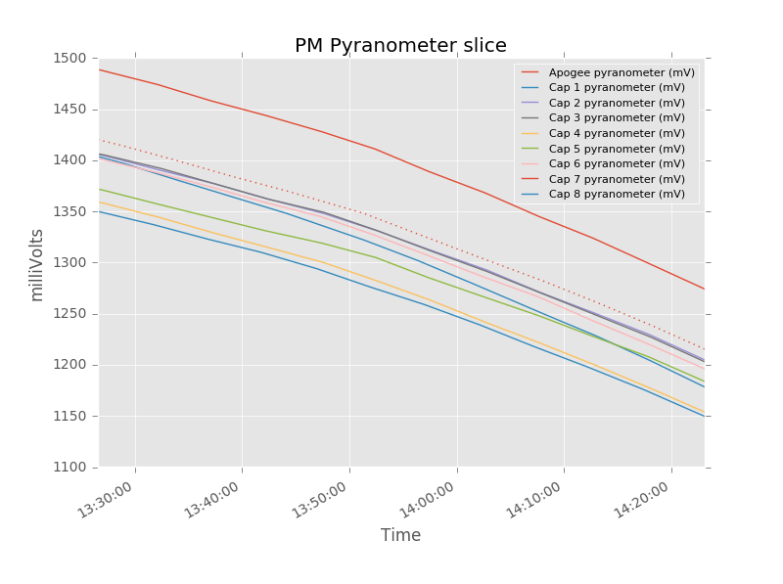

Figure . Pyranometer data used in calculations. AG is dotted red line

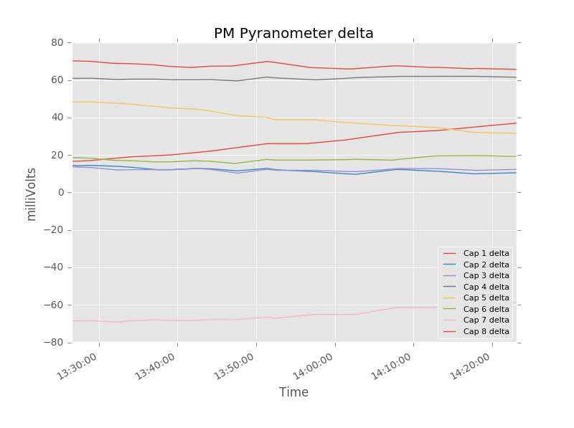

Figure . Delta between Pyranometers and Apogee. Negative values reflect outputs greater than Apogee. High red line is Cap 8

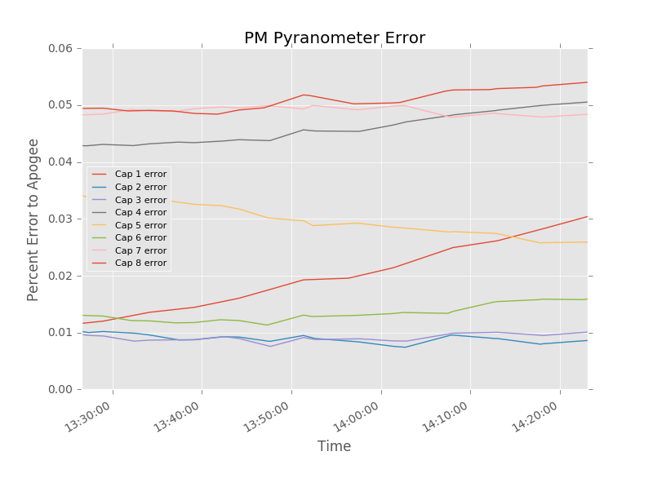

Figure . PM Error to Apogee (abs). High red line is Cap 8 Error

Summary of the uncalibrated results:

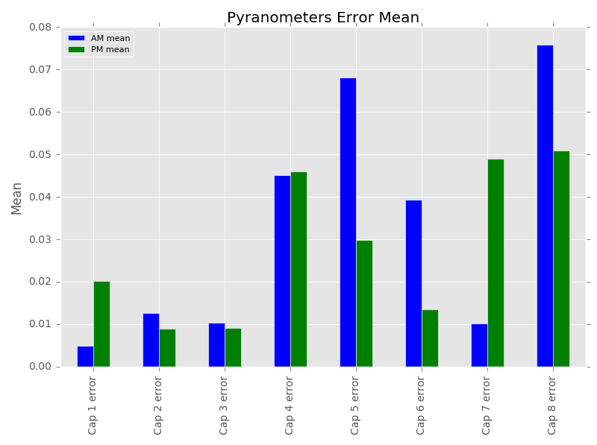

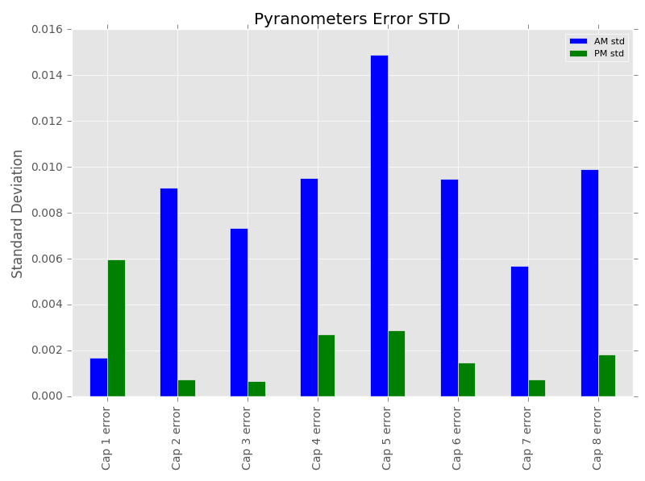

Other Plots:

