**Bitwise Operators**



**Objective**

This challenge will let you learn about bitwise operators in C.

Inside the CPU, mathematical operations like addition, subtraction, multiplication and division are done in bit-level. To perform bit-level operations in C programming, bitwise operators are used which are explained below.

Bitwise AND operator & The output of bitwise AND is 1 if the corresponding bits of two operands is 1.

If either bit of an operand is 0, the result of corresponding bit is evaluated to 0. It is denoted by &.

Bitwise OR operator | The output of bitwise OR is 1 if at least one corresponding bit of two operands is 1. It is denoted by |.

Bitwise XOR (exclusive OR) operator ^ The result of bitwise XOR operator is 1 if the corresponding bits of two operands are opposite. It is denoted by .

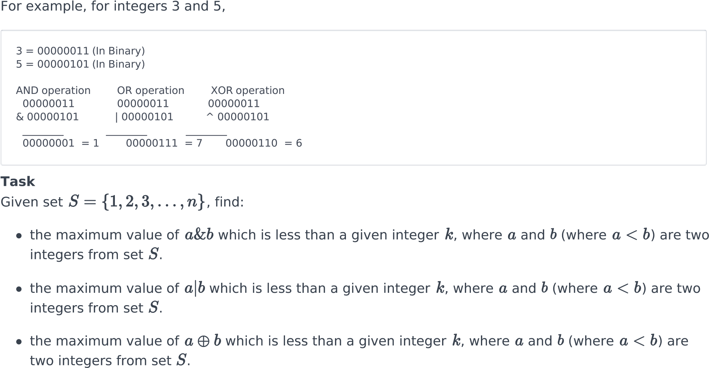

**Input Format**

The only line contains space-separated integers, and , respectively.

**Constraints**

**Output Format**

The first line of output contains the maximum possible value of

.

.

The second line of output contains the maximum possible value of

The second line of output contains the maximum possible value of .

**Sample Input 0**



5

4

**Sample Output 0**



2

3

3

