Alex Pizarro & Paul Murphy
Fei Xu
CSC 300-501
3/9/2026

Mini Project Report’
Introduction

The project we were tasked with was to create a program that would read in an image file, and then scan the image for the connected components. The image would be converted to black and white, where the white signified shapes of interest, while the remaining scene would be colored black for the background. We were tasked with using the data structures we recently covered in class, Union Find and Lists. Lists would hold our data for processing, with the Union Find allowed us to create the algorithm that detected the objects of interest.

Code Architecture

Our solution starts by loading in an image, rasterizing it, and turning it into a boolean 2D array. The objects of interest are marked true, marking them as white pixels. The background is marked false, making those pixels black. This is done by comparing the pixel’s data against a threshold. We then feed this boolean array of arrays into img2UF() which serves two purposes. First, it of course builds the Quick Union object and identifies contiguous horizontal pixel intervals. To avoid redundant operations, we only union pixels with their immediate top and left neighbors as we traverse through the 2D array.
In genCC(), we take in the resulting QuickUnion object and the rawCC list. The rawCC list contains pixel intervals to be consolidated. We do this by checking the connectivity of the lead pixels in each interval using the Quick Union connected() function. If they’re connected, then they get merged to create the larger completed connected component. Those intervals that don’t merge stand alone as separate connected components. The result of the function is a LinkedList of ArrayLists, where each ArrayList contains all the flattened pixel indices for a single connected component.
In separateCC(), we take in the LinkedList of ArrayLists. We also take in the image’s resolution and run comparisons against a threshold to determine what shape each connected component makes. We’re using a threshold of 0.75. This is the middle between the perfect square and a triangle. The ratio of the connected component to its boundary box will allow us to determine what shape each CC has created. Those closer to filling the whole box (closer to a 1.0 ratio) are squares, whereas those with closer to 0.5 are marked as triangles.
We then had to optimize a skeleton implementation of the Quick Union data structure, incorporating both the weighted and path compression changes. By adding a separate size array, we could limit unnecessary depth by being able to compare the size of trees when unioning them together. This made sure that when we put two trees together, we avoided having super deep trees, which would end up pushing our Find() and Union() time complexity to O(N). By adding the smaller tree to the larger one, we turned our two functions to O(LogN) time complexity.
For our second optimization to the Quick Find data structure, we added path compression. Our implementation was a two-pass solution. Our root() function first found the root of the tree, and then for the second pass, it changed every parent pointer to that of the root of the tree. This flattening greatly reduced the depth of our trees, allowing for faster lookup times.
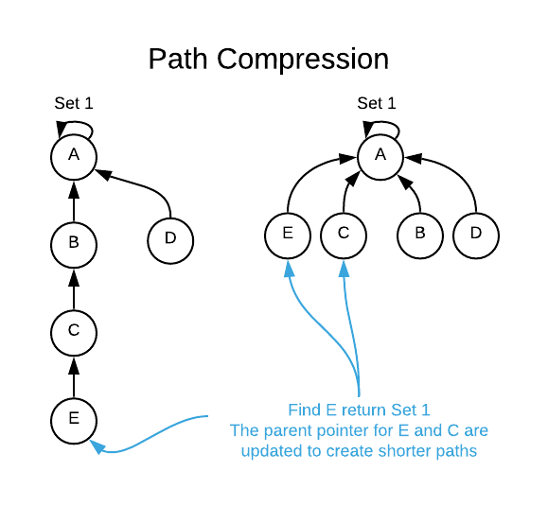
Figure 1. Depiction of the two-pass algorithm. (Source: https://tarunjain07.medium.com/union-find-disjoint-set-union-dsu-notes-24f3e228858d)
Computer Specs
I ran the tests on my laptop, which as a Ryzen 7 7730U alongside 40GB of DDR4 3200MHz ram. I also have a 2TB NVMe SSD, which is where I saved my project.
Results
Data Collection Part 1:

Filename | Resolution | AvgTime | Rects | Tris | Total
img_00.png | 10000 | 0.000931 | 3 | 1 | 4
img_01.png | 10000 | 0.000276 | 1 | 3 | 4
img_02.png | 10000 | 0.000303 | 5 | 3 | 8
img_03.png | 10000 | 0.000308 | 3 | 5 | 8
img_04.png | 10000 | 0.000533 | 8 | 8 | 16
img_05.png | 10000 | 0.000641 | 8 | 8 | 16
img_06.png | 10000 | 0.001211 | 14 | 18 | 32
img_07.png | 10000 | 0.001245 | 14 | 18 | 32
img_08.png | 10000 | 0.003453 | 27 | 37 | 64
img_09.png | 10000 | 0.003145 | 28 | 36 | 64
img_10.png | 20000 | 0.000198 | 1 | 3 | 4
img_11.png | 20000 | 0.00022 | 3 | 5 | 8
img_12.png | 20000 | 0.000323 | 5 | 11 | 16
img_13.png | 20000 | 0.000841 | 9 | 23 | 32
img_14.png | 20000 | 0.003983 | 23 | 41 | 64
img_15.png | 20000 | 0.000225 | 1 | 3 | 4
img_16.png | 20000 | 0.000169 | 3 | 5 | 8
img_17.png | 20000 | 0.001022 | 7 | 9 | 16
img_18.png | 20000 | 0.001321 | 10 | 22 | 32
img_19.png | 20000 | 0.003732 | 24 | 40 | 64
img_20.png | 40000 | 0.0019 | 0 | 4 | 4
img_21.png | 40000 | 0.000871 | 2 | 2 | 4
img_22.png | 40000 | 0.000387 | 4 | 4 | 8
img_23.png | 40000 | 0.000442 | 2 | 6 | 8
img_24.png | 40000 | 0.00058 | 6 | 10 | 16
img_25.png | 40000 | 0.000548 | 5 | 11 | 16
img_26.png | 40000 | 0.001921 | 17 | 15 | 32
img_27.png | 40000 | 0.00235 | 12 | 20 | 32
img_28.png | 40000 | 0.010574 | 26 | 38 | 64
img_29.png | 40000 | 0.008996 | 26 | 38 | 64
img_30.png | 80000 | 0.000521 | 2 | 2 | 4
img_31.png | 80000 | 0.000568 | 1 | 7 | 8
img_32.png | 80000 | 0.000698 | 5 | 11 | 16
img_33.png | 80000 | 0.0016 | 14 | 18 | 32
img_34.png | 80000 | 0.009005 | 24 | 40 | 64
img_35.png | 80000 | 0.000487 | 1 | 3 | 4
img_36.png | 80000 | 0.000517 | 0 | 8 | 8
img_37.png | 80000 | 0.000695 | 9 | 7 | 16
img_38.png | 80000 | 0.001618 | 13 | 19 | 32
img_39.png | 80000 | 0.008333 | 26 | 38 | 64
img_40.png | 160000 | 0.001467 | 1 | 3 | 4
img_41.png | 160000 | 0.001494 | 1 | 3 | 4
img_42.png | 160000 | 0.001424 | 1 | 7 | 8
img_43.png | 160000 | 0.001393 | 5 | 3 | 8
img_44.png | 160000 | 0.002063 | 6 | 10 | 16
img_45.png | 160000 | 0.00189 | 5 | 11 | 16
img_46.png | 160000 | 0.005496 | 16 | 16 | 32
img_47.png | 160000 | 0.005647 | 19 | 13 | 32
img_48.png | 160000 | 0.046723 | 33 | 31 | 64
img_49.png | 160000 | 0.041789 | 16 | 48 | 64
img_50.png | 320000 | 0.002635 | 3 | 1 | 4
img_51.png | 320000 | 0.002934 | 4 | 4 | 8
img_52.png | 320000 | 0.003583 | 4 | 12 | 16
img_53.png | 320000 | 0.006751 | 14 | 18 | 32
img_54.png | 320000 | 0.04894 | 23 | 41 | 64
img_55.png | 320000 | 0.002572 | 0 | 4 | 4
img_56.png | 320000 | 0.00206 | 3 | 5 | 8
img_57.png | 320000 | 0.002578 | 6 | 10 | 16
img_58.png | 320000 | 0.006651 | 14 | 18 | 32
img_59.png | 320000 | 0.048523 | 19 | 45 | 64
img_60.png | 640000 | 0.004044 | 1 | 3 | 4
img_61.png | 640000 | 0.004058 | 2 | 2 | 4
img_62.png | 640000 | 0.004618 | 5 | 3 | 8
img_63.png | 640000 | 0.004676 | 2 | 6 | 8
img_64.png | 640000 | 0.006256 | 5 | 11 | 16
img_65.png | 640000 | 0.008316 | 5 | 11 | 16
img_66.png | 640000 | 0.032122 | 13 | 19 | 32
img_67.png | 640000 | 0.025821 | 10 | 22 | 32
img_68.png | 640000 | 0.224967 | 28 | 36 | 64
img_69.png | 640000 | 0.241631 | 30 | 34 | 64

Data Collection Part 2:
Total Shapes (M) | Min Time (s) | Max Time (s) | Average Time (s) | Median Time (s)
4 | 0.000198 | 0.004058 | 0.001549 | 0.001199
8 | 0.000169 | 0.004676 | 0.00143 | 0.000543
16 | 0.000323 | 0.008316 | 0.002123 | 0.00086
32 | 0.000841 | 0.032122 | 0.006757 | 0.002136
64 | 0.003145 | 0.241631 | 0.050271 | 0.00979

Resolution (Pixels) | Min Time (s) | Max Time (s) | Average Time (s) | Median Time (s)
10000 | 0.000276 | 0.003453 | 0.001205 | 0.000786
20000 | 0.000169 | 0.003983 | 0.001203 | 0.000582
40000 | 0.000387 | 0.010574 | 0.002857 | 0.001386
80000 | 0.000487 | 0.009005 | 0.002404 | 0.000697
160000 | 0.001393 | 0.046723 | 0.010938600000000001 | 0.001977
320000 | 0.00206 | 0.04894 | 0.012722699999999998 | 0.003259
640000 | 0.004044 | 0.241631 | 0.055651 | 0.007286

Data Collection Part 3:
Resolution | 4 | 8 | 16 | 32 | 64
10000 | 0.000604 | 0.000306 | 0.000587 | 0.001228 | 0.003299
20000 | 0.000212 | 0.000195 | 0.000672 | 0.001081 | 0.003858
40000 | 0.001386 | 0.000415 | 0.000564 | 0.002136 | 0.009785
80000 | 0.000504 | 0.000543 | 0.000697 | 0.001609 | 0.008669
160000 | 0.001481 | 0.001409 | 0.001977 | 0.005572 | 0.044256000000000004
320000 | 0.002604 | 0.002497 | 0.003081 | 0.006701 | 0.048732
640000 | 0.004051 | 0.004647 | 0.007286 | 0.028971499999999997 | 0.233299

Analysis
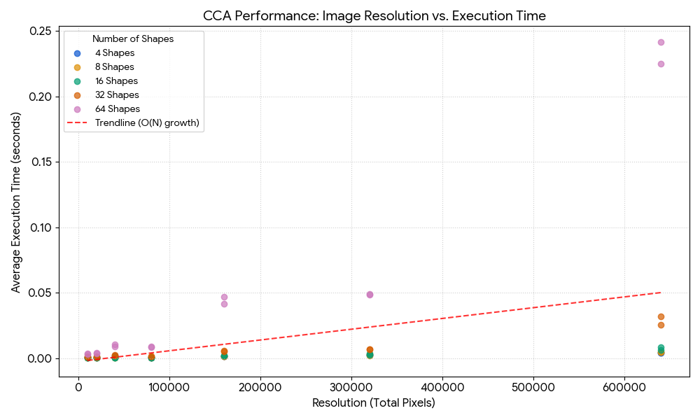
Figure 2. Performance analysis. This scatter plot shows the relationship between the number of connected components (shapes), and the average time taken for running the analysis. The trendline supports our theory of O(N) time complexity.

The effect of resolution & shapes.
The resolution of the input image has the most significant impact on the img2uf() phase of the algorithm. Since the program must iterate over every pixel in the 2D Boolean array. As resolution increases (thus meaning more pixels are present), so does the average processing time in an almost linear fashion. If we look at the Correlation table (the data collection 3 table) you can see this trend clearly when holding the number of shapes constant. For images containing only 4 shapes, the processing time increases from 0.00603 seconds at 10k resolution to 0.001386 seconds at 40k, and up to 0.004051 seconds at 640k resolution. This same trend holds up for the almost of shapes in an image. At 64 shapes, the time jumps from 0.003299 seconds to 0.009785 seconds. My trusty laptop got through these tasks quickly, but the trends are still very visible.

Correlation Analysis
Table 3 puts the conclusion we reached in plain view. Both resolution and the number of shapes work together to become more computationally expensive as their sizes are increased.

New Application

Alex here! My sister is studying Electrical Engineering at Marquette University, and a project we want to do over spring break is build a cat snack dispenser. She’ll wire up the components, and through repurposing an old webcam, we can add computer vision. This automated snack dispenser will work by applying CCA to a real-time video feed, where the system can (hopefully) distinguish between our two cats and the background environment.
To keep the implementation simpler, we’d fix the webcam in place rather than attempting something like a panning camera. We’d take frames of the current background to save as our reference images. Then, whenever we get any changes picked up on the camera – then we’d be able to analyze that shape to determine if it is a cat or not. This would be in our kitchen, so there’d be a lot of foot traffic, so we’d have to implement some sort of noise filtering. There are windows facing in that let in light, so shadows moving could potentially cause the system to run analysis prematurely. This is where CCA comes in. Noise filtering will work by calculating the total pixel count of every connected component detected, if a shadow moves around and creates a small or skinny connected component, we ignore it. Only when a connected component breaks the pre-set pet threshold do we activate the dispenser.
We’d need to define shape ratios like we did in the project, where squares took up the whole bounding box, and triangles took about half. Here, we know that cats will create a sort of rectangular shape, so we’d have to account for that. Once we find a connected component that matches that shape, and is large enough to break the noise threshold, we can dispense the snacks!
I wonder how our cats will find a way to game the system. We’d certainly need to put a time limit on it too.
Conclusion

This image analyzer program was an actual implementation of the Quick Union, Array List, and Linked List data structures. We successfully optimized a lazy implementation of the Quick Union data structure, implementing weighting and two-pass path compression. This improved our connectivity functions so that they ran in linear time.
We collected data across 70 different images and found that resolution was the main factor in how long the analysis operations would take. Then the number of shapes per image added a multiplicative effect.
This project served to be a closer representation of how it’ll be working once we get into the workforce. Setting up our GitHub repository, working on branches, and keeping ourselves accountable because the other person is counting on us was invaluable experience.

