Table of Contents

Rest API With Spring Boot and H2 Database 2

Getting Started 2

Prerequisites 2

Installing 2

Testing api operations from command line tool on windows using curl 2

API Operations 2

Running and Resting Person API Through Swagger UI 5

Accessing Data from H2 Database 8

Add password to H2DB 10

How to change application port 10

Author 10

# Rest API With Spring Boot and H2 Database

Person Rest API With Spring-Boot and In Memory H2 Database

## Getting Started

These instructions will get you a copy of the project up and running on your local machine for development and testing purposes.

## Prerequisites

Java 1.8

Maven 3

## Installing

1- Clone/Checkout git repository. Or Download it as a zip file and unzip

2- Open command prompt and reach to root directory where code is checked out

3- Execute mvn install command to build the application. On Successful build you will a message as shown below.

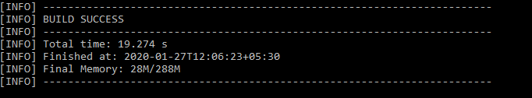

4- Execute mvn spring-boot:run command to start the application

On Successful start you will see a message as shown below.

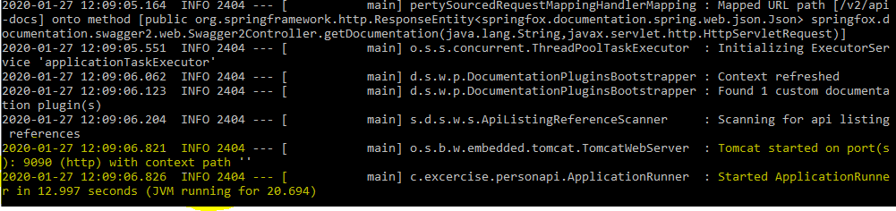

## Testing api operations from command line tool on windows using curl

### API Operations

**/persons/save** - Save person data to H2 DB

execute command as below to save person record

curl -d "{\"person\": [{\"first*_name\": \"Emran\",\"last_*name\": \"Khan\",\"age\": \"35\",\"favourite_colour\": \"Green\",\"hobby\": [\"cricket\", \"volleyball\"]}]}" -H "Content-Type: application/json" <http://localhost:9090/persons/save>



curl -d "{\"person\": [{\"first*_name\": \"John\",\"last_*name\": \"Keynes\",\"age\": \"29\",\"favourite*_colour\": \"red\",\"hobby\": [\"shopping\", \"football\"]},{\"first_*name\": \"Sarah\",\"last*_name\": \"Robinson\",\"age\": \"54\",\"favourite_*colour\": \"blue\",\"hobby\": [\"chess\"]}]}" -H "Content-Type: application/json" <http://localhost:9090/persons/save>

**/persons/showall** - List All Person Records

curl -v localhost:9090/persons/showall

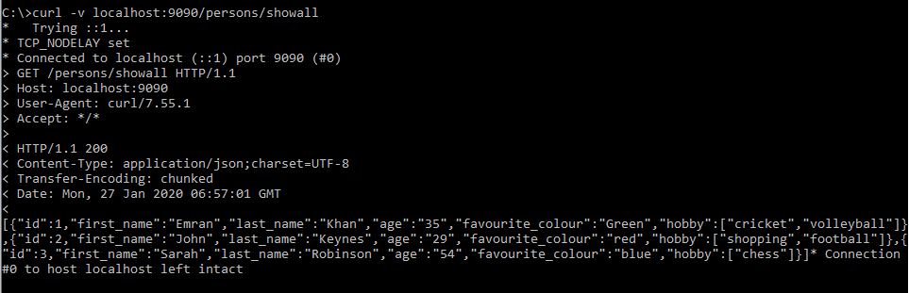

**/persons/delete/1** - **Delete Person By Id**

curl -X DELETE <http://localhost:9090/persons/delete/1>



**/persons/find/2** - **Find Person By Id**

curl -v localhost:9090/persons/find/2

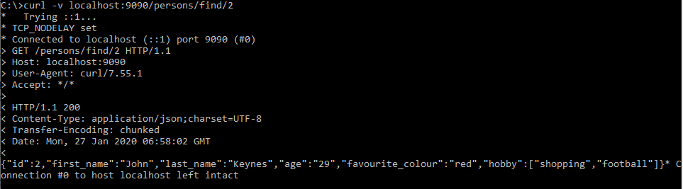

**/persons/update** - **Update Person**

curl -d "{\"id\":2,\"first*_name\":\"Sara\",\"last_*name\": \"Jacob\",\"age\": 35,\"favourite_colour\":\"Blue\",\"hobby\": [\"acting\", \"cooking\"]}" -H "Content-Type: application/json" http://localhost:9090/persons/update



## Running and Resting Person API Through Swagger UI

To add swagger api console add dependencies in pom.xml as show below and add @EnableSwagger2 in com.excercise.personapi.ApplicationRunner.java

Swagger UI enables developers to visualize and test api operation. For more details about swagger api refer to documentation at <https://swagger.io/tools/swagger-ui/>

To access swagger api console try URL - http://localhost:9090/swagger-ui.html

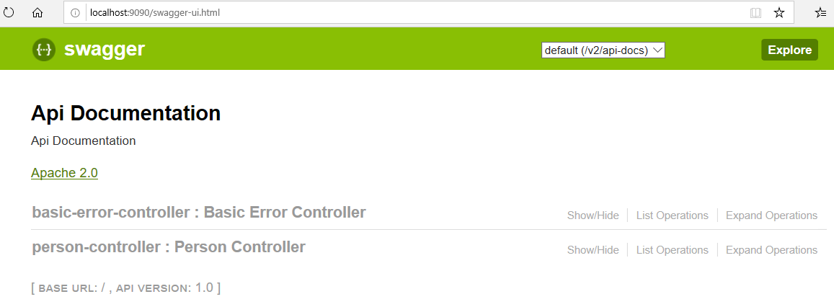

To explore Person API operations, click on Person Controller.

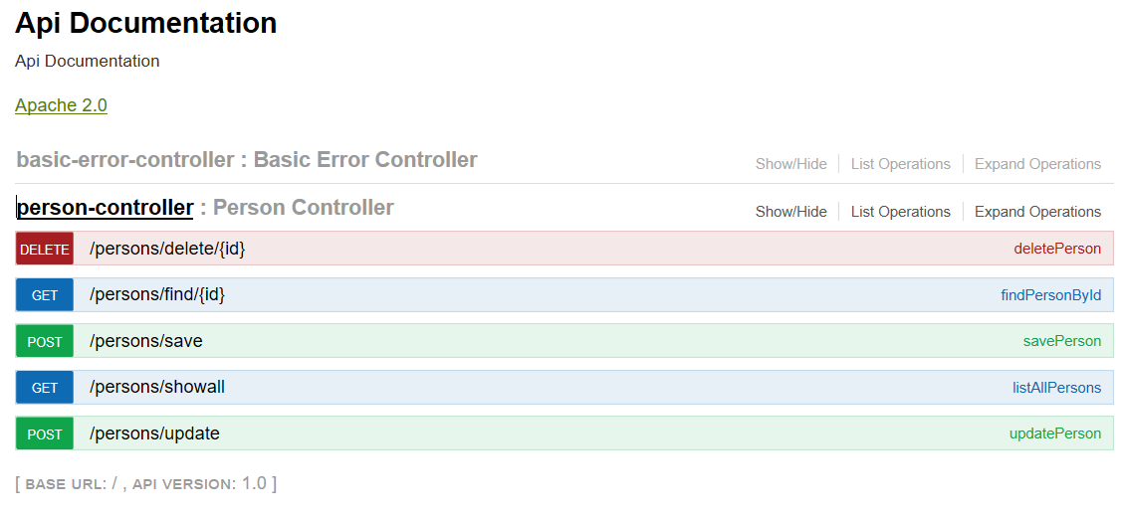

Expand any operation and change request parameters and click on try it out. i.e. /person/showall

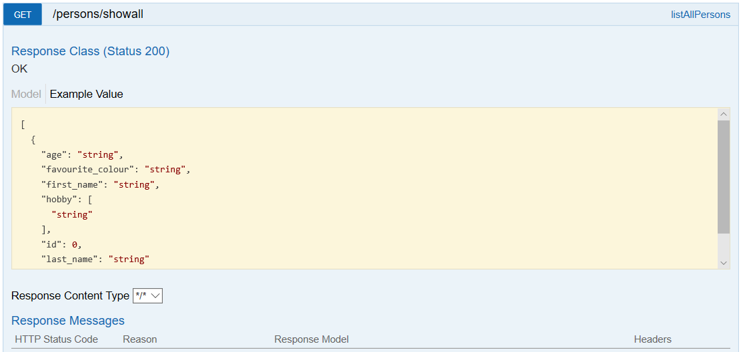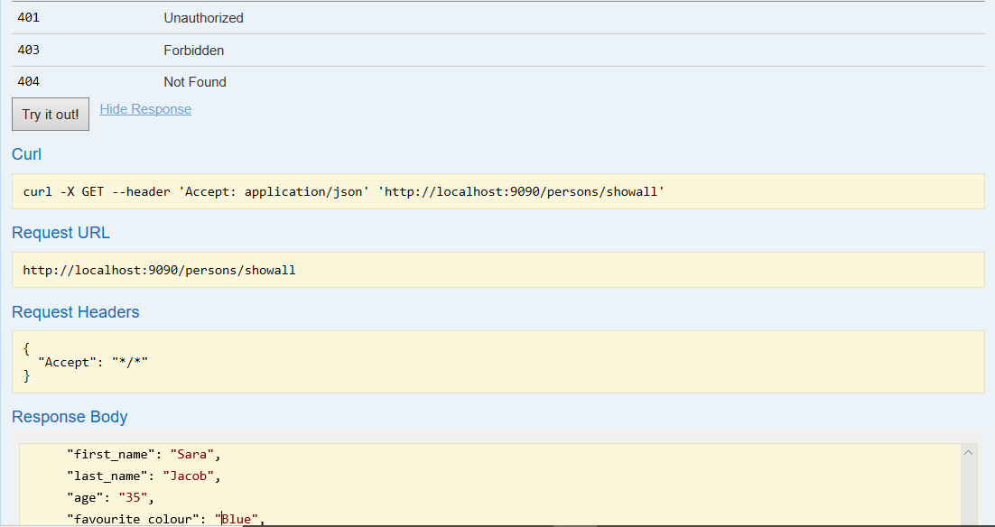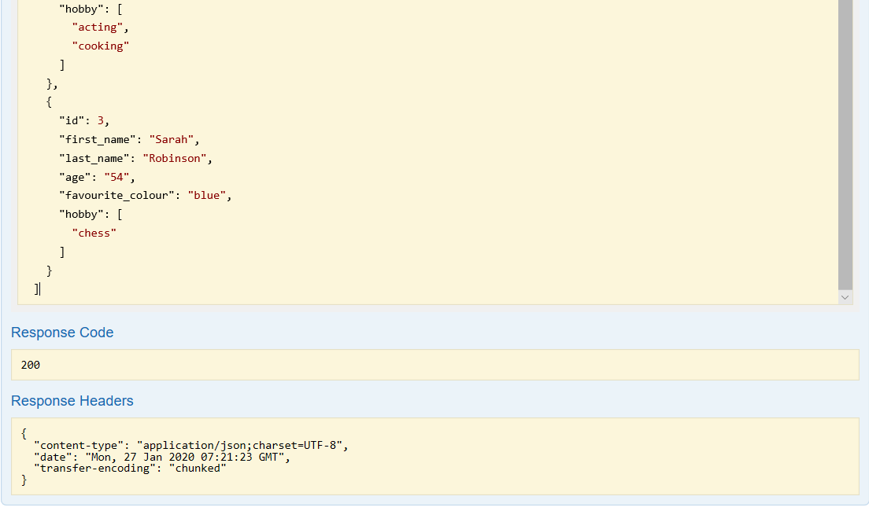

## Accessing Data from H2 Database

Open below URL from your browser to access H2 Database Console. Leave the password blank and click on connect

http://localhost:9090/h2db

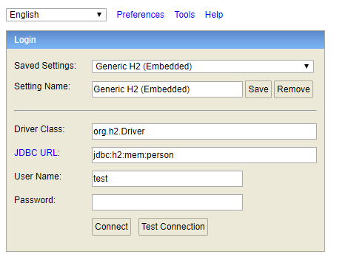

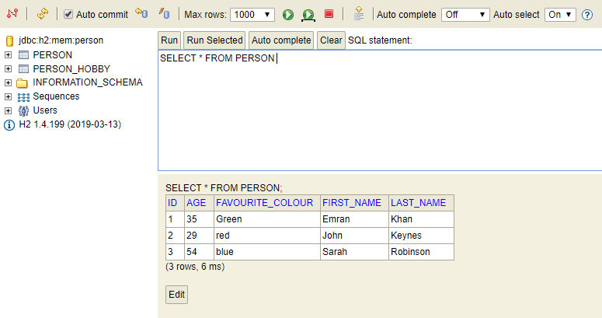

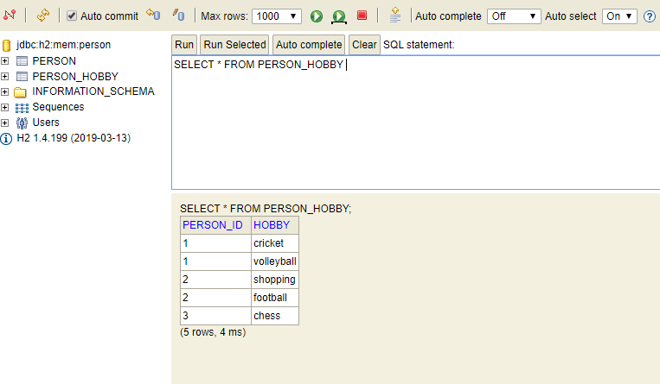

## Add password to H2DB

To add password change below property in src/main/resources/application.properties

spring.datasource.password=

## How to change application port

This rest api using port 9090 which is defined in appication.properties. If port 9090 is not free or some other application using this port, then change server.port value defined in /src/main/resources/application.properties

## Author

Mohd Emran Khan