|  |  |
| --- | --- |
| *ENGR 132 Team Poster* | *Spring 2015* |
| ***Section <013>*** | ***Team <13>*** |

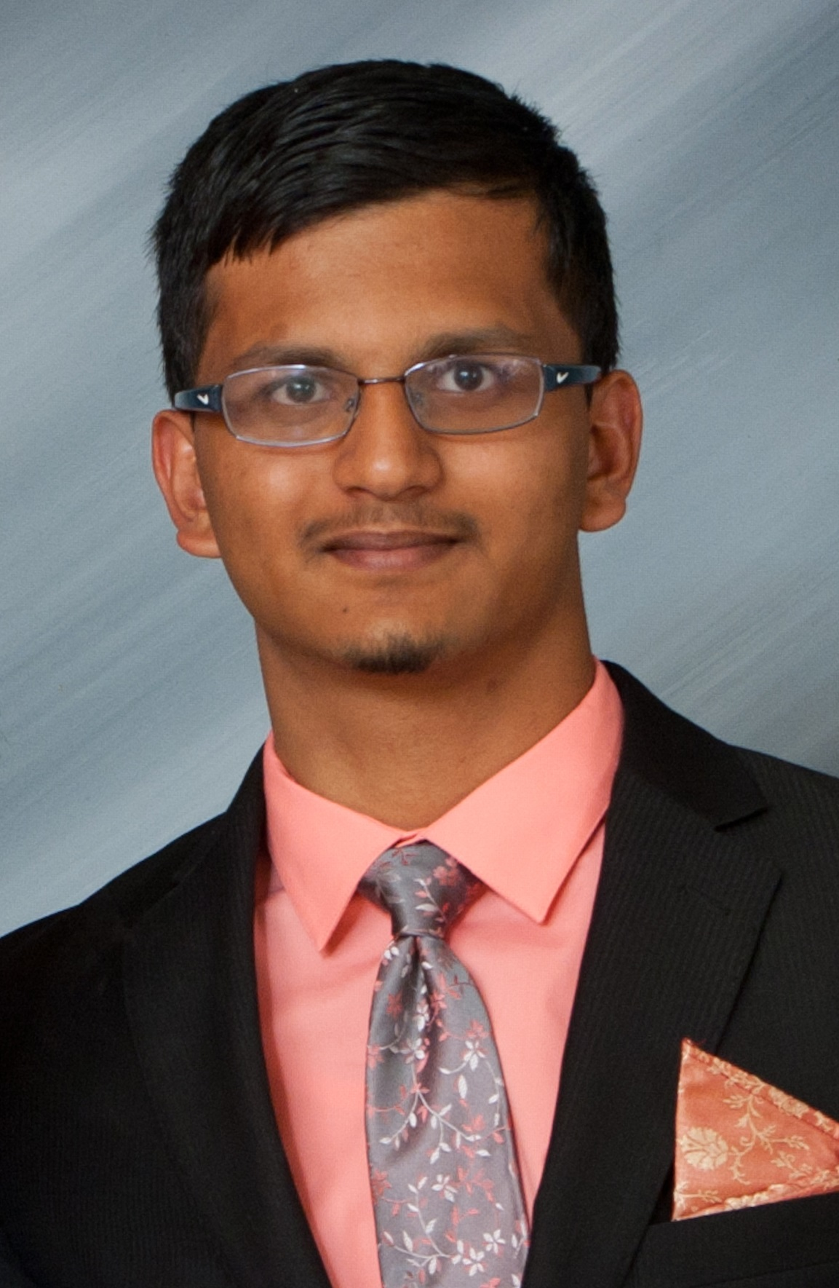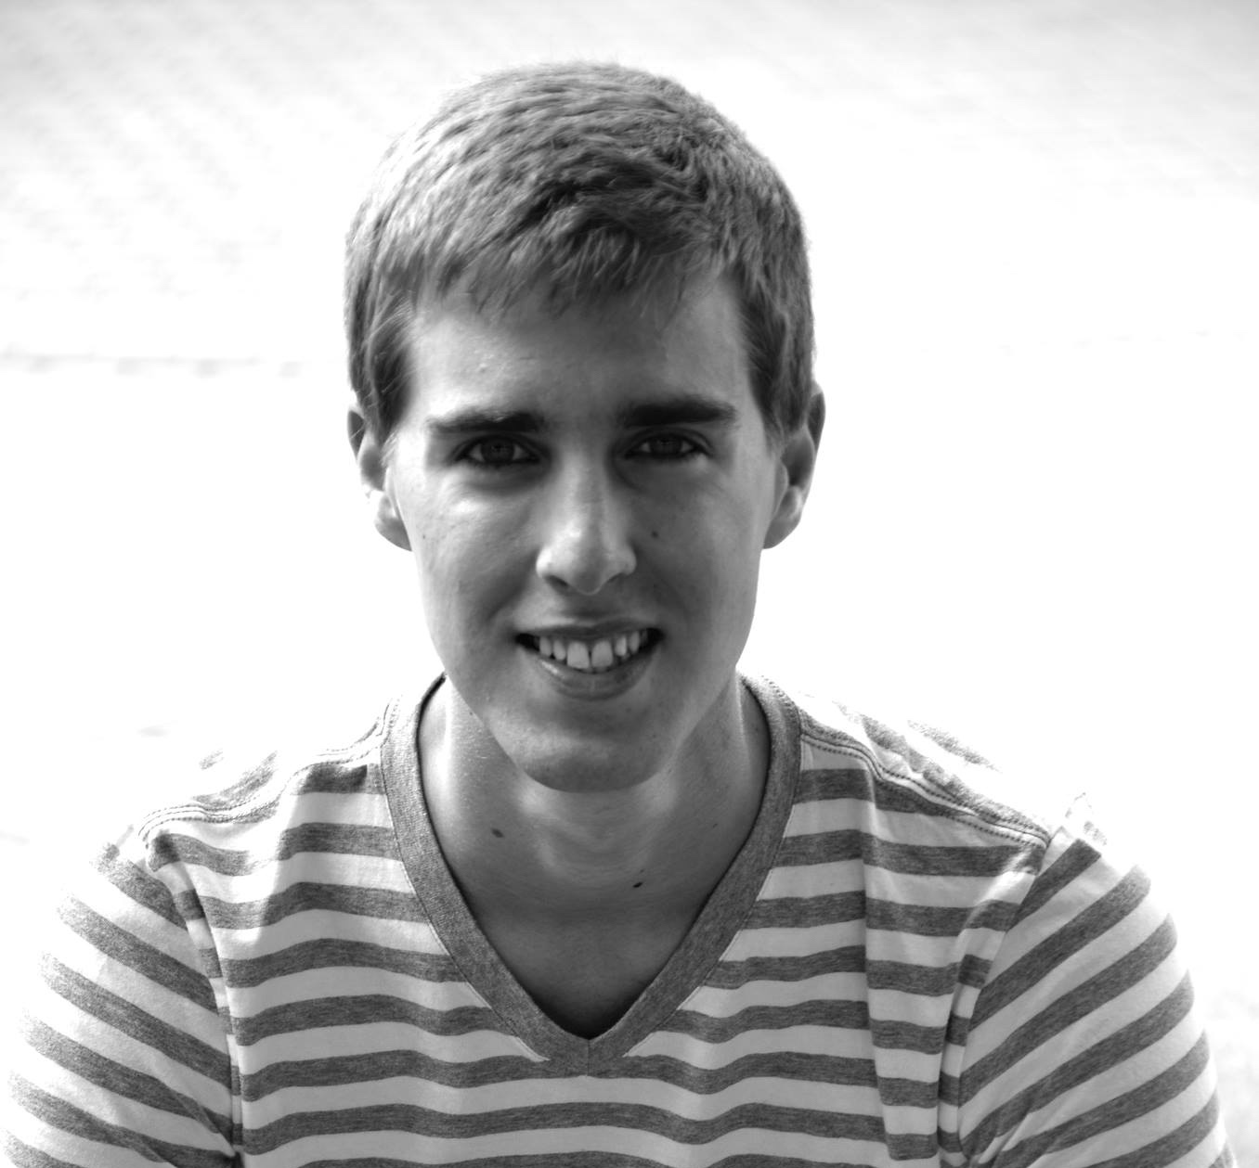

Apoorva Kharche

Broderick Schwartz

I am from Fremont, CA. My favorite thing to do is to find better ways to be lazy (and do insane amounts of work in the process).

I am from Terre Haute, Indiana. I really enjoy playing golf and ultimate Frisbee. I am interested in mechanical engineering.

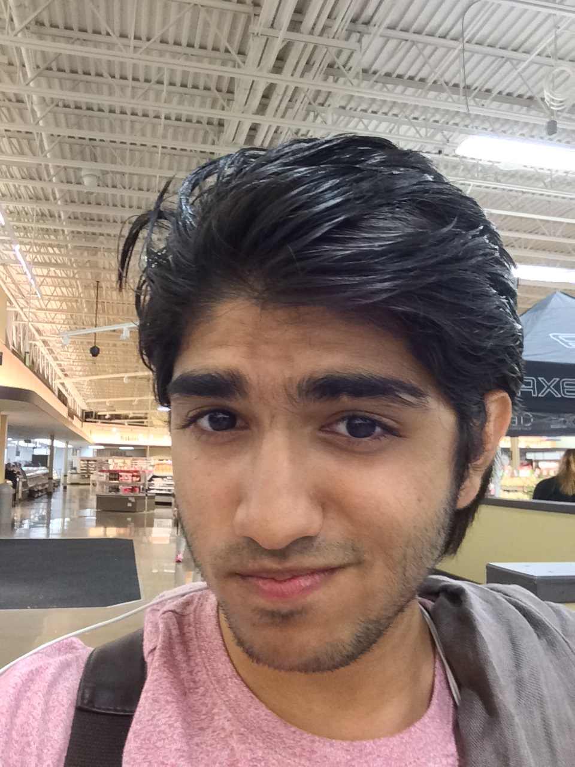

Yash Shah

I am from Dubai (aw yea). I love to sing, I’m interested in public speaking and I enjoy sports and video games.

Team Name: (Un) Lucky thirteen.   
Substitute Name: Thirteen Squared (13^2)

**All team members must sign the table below. *Your signature below indicates your approval of this team poster.***

|  |  |  |  |  |  |
| --- | --- | --- | --- | --- | --- |
| 1 | Broderick Schwartz | 2 | Apoorva Kharche | 3 | Yash Shah |