Xen I/O Performance
EEL6892 – Virtual Computers
Aldo Plaku
Department of Electrical Engineering
University of Florida
Gainesville, Florida, USA
a.plaku@gmail.com

Abstract— Xen’s paravirtualization approach to virtual machines has led to noticeable increases in VM performance. In using a hypervisor and binary translations, Xen allows a host to communicate to an intermediary process as opposed to trapping to the host kernel. However, this is all done through an increase in overhead and the need for specialized guest operating systems. After some study of a Xen Ubuntu system, the biggest apparent bottleneck in performance is in I/O virtualization. Xen’s system has all guest domains talking to a predefined domain zero (Dom0) for all I/O operations. This paper uses Simics and benchmarks to study the credit scheduler implemented in Xen. The focus is on improvements made to increase I/O performance; namely the credit queue sort and domain boosting.
Keywords- Xen, Virtual Machine Monitors, Paravirtualization, Simics, Scheduling, performance, python.

Introduction

Xen
With the ever increasing computational needs in information storage and manipulation, massive servers running parallel processes have become the norm in industry. This has led to an increase in use of virtual machines usage in large server consolidations. Virtual machines offer an inherent level of protection or decoupling of operating systems and the underlying hardware as well as providing more means of control in terms of migration and resource utilization.
The Xen virtual machine is one of the most well know and researched virtual computer system. Xen’s arguably most important innovation is the notion of paravirtualization. Instead of using a transparent virtual machine monitor (VMM), paravirtualization has the guest operating system (OS) aware of the virtual interface. This allows the guest OSs to use Xen’s resources without having to take the more time intensive route of trapping all the way to the host kernel. Xen implements various levels of privilege to create a hierarchy of virtual machines, the VMM, and the host. Xen introduces a hypervisor that acts like a virtual kernel that guest OSs can send even calls to in case of a privileged instruction. The hypervisor creates the first guest OS called dom0. This domain has special privileges and access to hardware. Dom0 can be used by administrators to control and monitor the other running domains or domU.
Since dom0 has access to hardware resources, all domUs have to use Xen’s event handler to send I/O requests to dom0 for handling and execution. Having dom0 service all I/O requests keeps the virtual decoupling between guests and the hardware and gives the VMM control to verify any requests and preserve system integrity and security. It is easy to see, however, that this can create a performance bottleneck. It is still much faster than the alternative of having to pass all I/O request down to the host kernel for service. Even if the large latency and performance hit of trapping to the kernel is ignored, the ability to run different OSs in Xen means that the host kernel would have to deal with I/O requests coming from different machines that could require specialized drivers for hardware I/O. Newer iteration deal with the bottleneck of I/O through dom0 using various scheduling practices. It is these practices that this paper aims to study.

Xen Scheduling
The current default Xen scheduler is the Credit scheduler. Since all the domUs virtual cpus (VCPU) have to timeshare the physical cpu (PCPU), Xen must provide a scheduler to manage switching between the various VCPUs. Each VCPU will manage its own processing using the guest OS kernel, and then Xen manages which VCPU’s processes will run on the PCPU.
The Credit scheduler allocates credits to each VCPU to spend. By running through its processes, a guest VCPU uses up its allotted credits. Each VCPU can also have a weight and cap. The weights are used to setup which domUs are to be prioritized over the others. By default dom0 has a high weight and the rest of the domains have a weight of 256. The cap of a VCPU determines the maximum CPU utilization the VCPU is allowed to utilize. The caps default to zero or unlimited. The VCPUs are ranked into one of three categories: Under, Over and Boost. If a VPCU has less credits than its maximum limit, it is said to be in the Under state. Likewise, if the VCPU has used up all its allowed Credits and has gone into the negative, it is in the Over state. Boosted is a special state that is given to a waking VCPU to allow it a special privilege above the other VCPUs running. If an idle VCPU receives an event interrupt, it is Boosted to allow for any latency sensitive processes. A Boosted domain can preempt any Under domains in the run queue. The run queue is not sorted by credit, but only by state. Any VCPU found to be Over will move back to the other Over states at the back of the list. VCPUs are moves behind any other VCPUs with the same priority state.
This paper studies the credit scheduling algorithm implement in Xen and how scheduling can affect I/O performance. The two main concepts under study are the Boost state and the sorting of the run queue.

Related Work
Since I/O performance is a key aspect in virtual machines used for servers, there have been studies of the Xen system and how it responds to various I/O processes. Server virtual computers have to provide low latency and high throughput in order to perform well enough to warrant using the VMM system. While virtual decoupling, consolidation, and migration is important, if the server cannot perform well as a server, then there is no point in the implementation.
There were three main studies found to help understand the credit scheduler and its effect on I/O performance (see references). Each paper used various benchmarks running on different domains under Xen and studies the performance through the benchmarks under various configurations.
The first study by Gaurav Somani and Sanjay Chaudhary at the Dhirubhai Ambani Institute of Information and Communication Technology looked at how well the scheduler in Xen was able to isolate the domains and maintain performance [1]. The key focus was to run benchmarks on separate domains and see how well Xen could schedule both domains. The benchmarks could be CPU intensive, disk intensive or network intensive. Xen had two domains created, dom1 and dom2. These domains would have one of the three benchmarks running on them. All six permutations of the benchmark to domain combinations were run.
The benchmarks used were as follows. The cpu stress test was an iterative loop containing a large amount of numerical computations on integer and floating point operations. The disk test ran Iozone, which is a filesystem stress test that runs various file commands like open, read, write, unlink, etc. Finally, the net test used Iperf to test the throughput over a TCP network attached to the virtual machine.
The paper found that, overall, the credit schedule does a good job of isolating the performance of parallel domains. Xen provides a fair scheduling algorithm that helps mitigate the performance of the different stresses put on the domains. Each of the tests showed that no matter what other benchmark was running alongside, there performance generally stays the same throughout all the permutations. This means that Xen was able to schedule the domains in a fair way and maintain the performance needed. However, it was shown that the credit scheduler does not provide good performance for processes that need time sensitive operations. Since the credit scheduler cannot make any time guarantees it is outperformed by the older SEDF scheduler which uses the deadlines given by the VCPUs to schedule the earliest deadline first.
The second study by Xianghua Xu, Peipei Shan, Jian Wan, Yucheng Jiang at the Grid and Service Computing Lab in the School of Computer Science and Technology, Hangzhou Dianzi University also studies the performance isolation of various types of workloads in Xen [2]. However, they also focused on the impact of the weights and caps of the running domains.
They too ran different combinations of benchmarks on parallel Xen domains and studies the cpu and network response in Xen on a server load. Their setup had a CPU stress running an infinite loop of arithmetic operations. They ran Netperf and Httpefp to study network throughput and web server performance respectively. Once again Iozone was run to study the disk I/O performance.
On top of running the different benchmarks consolidated together, this study also varied the weights ration between the different domains to see how isolation and performance changed as some domains were given higher priority than the others. Once again the results show that Xen can handle performance isolation of domains running CPU intensive loads very well. However, here again, the network and I/O performance in terms of latency was low due to the time insensitive nature of the credit scheduler. The added work on weights and caps did provide some more answers though. Giving network intensive domains a higher weight proved to give rise to better performance while still maintaining respectable performance on the adjacent domains. This makes sense as the domains with higher weight will be scheduled more often so any time sensitive operations will happen more often given the higher weight. The cap provided no such improvement. Since I/O workloads do not require much CPU time, giving that domain a higher or lower percent of the PCPU showed no effect on performance.
The final study by Diego Ongaro, Alan L. Cox, and Scott Rixner at Rice University was completely focused on scheduling and the performance of I/O in Xen [3]. Once again various benchmarks were run in tandem on different domains in Xen. This study used a burn script to run an infinite loop for a CPU stress test. A stream benchmark was used to try and fully utilize the network resources and a ping benchmark to study latency.
The biggest change in this study was that they went in and made actual changes to the Credit scheduler source code to study how changes would affect performance. First, they studied the fairness of Xen’s scheduler in terms of CPU time as well as checking the importance of the Boost domain state. Next they made three changes to the scheduler: fix even notification, minimize preemptions, and ordering the run queue.
The issue the paper has with the event notification is due to network issues. Say dom2 gets a packet from the NIC. The driver domain will receive and interrupt and send the packet to dom2 through the event channel and notify dom2 to wake it. The scheduler will then tickled and wake dom2 to act on the packet. Dom2 then acts on the packet as usual. However, if during this time another packet has come in, say from a stream, for dom2 again. Once dom2 is done acting on the first packet, the driver domain will be scheduled again to handle the new packet. This can create situations where the inbound packets are moved in and sent to dom2 immediately, but outbound packets are preempted by the driver domain having to handle the inbound packets. While the inbound performance will be fine, the outbound network throughput and latency will suffer.
The second issue that can arise is due to the Boost state preempting domains that are awoken form idle. The authors suggest that by boosting a domain, there can be preemption of the driver domain which can lead to unwanted scrambling of I/O packet events. Since the driver domain also has credits, if the driver domain is Over, there can be added delays due to Boosted domains acting on interrupts.
Finally, they argue that sorting the run queue based on credits left is an intuitive change to make in order to have I/O domains perform better. Since credits are used when a VCPU runs processes on the PCPU, I/O domains should not use credits very fast since they are waiting for hardware I/O to proceed more so than a CPU intensive domain.
These studies provide a good framework for us to study the I/O performance in Xen using benchmarks. Using the experimental setup of these works as well as the changes to implemented we could move to study Xen using Simics and a few benchmarks.

Experimental Setup

General Architecture
To study the I/O performance in Xen, the Grid Appliance system from UF’s ACIS lab was used. The appliance was run on VMware virtual machine. The appliance was stocked with a copy of Xen using the Ubuntu Linux operating system. Also present was Simics, an operating system simulator. Simics allows for us to run an operating system, Xen-Ubuntu in this case, and have access to a plethora of CPU information and control. We also had access to Condor to utilize remote runs of our simulations using the IPOP system running on the Grid Appliance.
In order to study the isolation and performance of I/O operation, we chose to use the same setup as in the studies detailed in Section II: running multiple domains with different benchmarks. Here, however, we only used two benchmarks on three domains. This was done for various reasons. The first of which is time considerations. Since the setup is a recursive virtual machine network running simulations all on commercial hardware platforms, each simulation require a significant time investment. The other major change to benchmarks was that we could not test network I/O as easily. Disk and CPU loads are fine, but while our Grid Appliance is connected to an IPOP network, connecting the Xen guest domains to this network would require large reconfigurations that were not deemed necessary. Therefore, this paper uses one benchmark for CPU intensive loads and one for Disk I/O to simulate a standard sever load without testing network responses.
On top of having different benchmarks on different domains, there were also different configurations of the Xen scheduler. We first ran a control simulation with no changes. The two changes implemented were to remove the Boost state and to sort the run queue. Subsection E will provide more info.

Benchmarks
The two benchmarks used in this experiment were a gcc cpu stress test and the dbench disk I/O benchmark.
-GCC: This benchmark is a C compiler optimization kernel. It generates code for a compiler with numerous optimization flags set [4]. This will cause heavy CPU workload as the optimization are calculated and implemented for the code to be compiled.
-DBENCH: This benchmark provides an emulated server I/O filesystem load. It uses a local file to emulate the filesystem operations that a typical network filesystem would receive. It tests various file commands and gives latency and throughput of the system.

Xen Domain Setup
Each domain ran a single benchmark, but all domains and benchmarks were run simultaneously. Since Simics provides cycle level control we can create a setup where each domain is roughly even in terms of operations running. In dom0, three domUs were created. Each was then paused. One by one, we unpaused and consoled into each domU. The benchmark to be run was started, we moved out of the domU, and paused the domain. After each domU had a benchmark running, a checkpoint was created. Simics allows for taking of snapshots of operating systems to be run later. Using this config file and a python script, the domains were unpaused, and ran for a few cycles to fully unpaused and begin the benchmarks. Afterwards, we used Simic’s Hap capability to measure relevant data during the benchmark runs.
Haps are OS events that Simics can monitor and, more importantly, treat as software interrupts. This allows for callback functions to be created which run whenever a given Haps occurs in the processor. For example, one of the Haps used in the simulations the Control Register Hap. This allows for a user to read and store relevant data whenever the guest OS modifies a privileged register in the PCPU. The next subsection will go into more detail on Haps.
Figure 1 shows the domain setup used for the experimental runs as well as the general architecture of the Xen system. Here, dom1 was running the I/O benchmark DBENCH, dom2 and dom3 was running the CPU stress test GCC. The reason for running two CPU domains was to study the fairness of the domains. If the two CPU domains varied vastly in their results, then obviously Xen is not isolating the two domains well. Therefore, this setup was chosen to study the fairness and performance isolation in Xen as well as to see how I/O domains perform when other domains are vying for PCPU time.
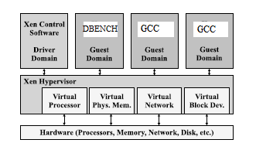
Figure 1. Domain Setup (base figure from [1])

HAPS
A Hap is a significant event in Simics which has a measurable change to the system under test or the simulator itself. This can include interrupts, control register R/W, or device access. Three main Haps were implemented for the experiment: magic instruction, cr3 changes, and memory operations.
For the x86 architecture the magic instruction is “xcbh %bx, %bx. This instruction takes what is in the bx register and exchanges it with what is in the bx register. Therefore, it doesn’t actually accomplish anything. It just moves the same data into the register. It is just useful here to cause a magic breakpoint. Simics implements these magic instructions to allow for user defined operations and data measurement. For our experiment we added the magic instruction whenever there was a domain change in Xen. This allows us to keep track of how much PCPU time each domain using. We can log this data to measure fairness and plot a timeline of PCUP usage per domain.
The second Hap occurs whenever a domain tries to modify the cr3 control register in the x86 architecture. Whenever this happens we know that the domain has to issues a hypervisor call in order to process the instruction. The cr3 register is a control register in x86 and cannot be accessed in user mode. By looking at the number of cr3 changes we can get an accurate picture of how many privileged instructions each domain is issuing. By keeping track of the changes and comparing between registers we can see how much overhead each domain has in terms of trapping or hypervisor calls.
The final Hap used occurs on core device access of memory. This will trigger whenever a domain needs to write to memory. By measuring this we can see two things. We can compare between domains to see number of memory reads. More importantly, we can use it to see how the different scheduler configurations lead to different memory access amounts. If a particular implementation leads to fewer accesses, then the performance will be better than the others since memory access generally lowers performance timing.
See the attached Simics script for more detail on the Haps callback function.

Scheduler Changes
There were two credit scheduler changes made: remove Boost state and sort the run queue by credits. Only two were chosen due to the time constraint of the experimental setup. More complex and varied changes are to be considered for more long term experimentation.
The related works on Xen I/O performance showed that Boost was a major factor. It is implemented by Xen specifically to help with I/O intensive work. To test the validity and impact, waking domains were not Boosted. Instead they retained the credit state they had when they went idle. Comparing this new Xen scheduler to the default Xen scheduler would provide insight on just how much Boosting waking domains helps with performance.
The second change came from Ongaro et al [3]; they sorted the domain run queue by credits left. Their motivation came from I/O domains generally using fewer credits than CPU domains. If the run queue in the scheduler was changed to place domains with more credits left at the front of the queue whenever the scheduling algorithm sorted the current domains. Again, the Xen source code was changed. Here, whenever the queue was walked to place any domains in the Under state in front of any with Over, instead of placing the Under at the back of the other domains in Under, it was instead sorted it into place based on how many credits it had with respect to the other Under domains.

Results and Analysis
The three Xen configurations were run on the Grid Appliance and all data tabulated. The following shows all the data found and how each configuration compares in terms of performance.

Fairness / Time in domain
Figure 2 shows the percentage of time each domains was run for all three configurations. In terms of fairness, each configuration was nearly identical. Dom0 dominated in terms of cycles spent on the PCPU. This was to be expected as dom0 has a higher weight than the other domains. Also, since dom1 was running I/O operations dom0 had to be called on numerous times to handle the I/O events. It is important to note that the domUs did not have significant difference in terms of runtime. This is due to the inherent fairness in the credit scheduler. While the order of the domains scheduling may change, as long as each domain has the same weight and cap it should expected an equal piece of the PCPU.
The two changes implemented did not affect fairness much if at all. Not boosting domains does not mean that the domain will not eventually run whatever processes it needs to on the PCPU. Sorting the queue, similarly only changes the order of the running VCPUs and not how much of the PCPU each domain takes.
These runs demonstrate that Xen credit scheduler, even with changes, provides fair and balanced performance isolation between multiple running domains.
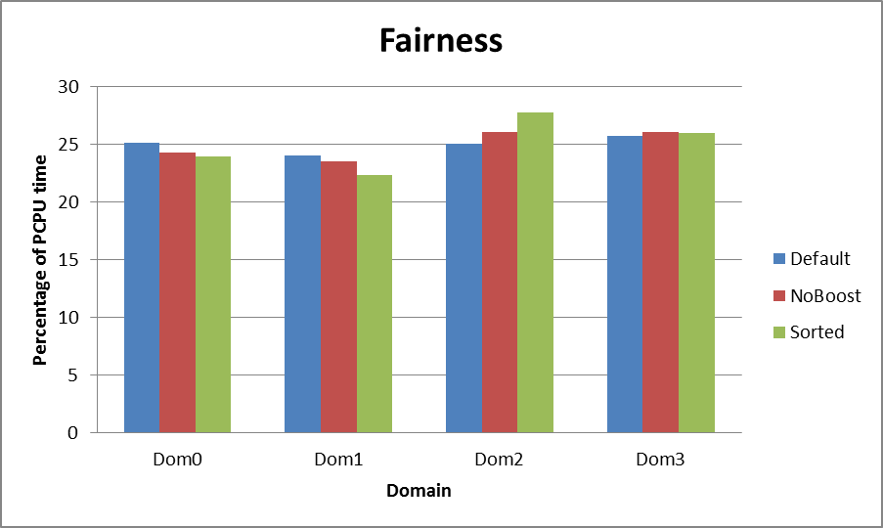
Figure 2. Per Domain Fairness

I/O performance – cr3 and Memroy Operations
Figure 3 and 4 show the cr3 changes and number of memory operations of each configuration.
The default Xen and sorted run queue Xen have nearly the same amount of cr3 changes and memory operations. The domains running gcc had orders of magnitude less of each Hap. However, with no Boost state, there are much fewer memory operations and cr3 changes. It is hard to pinpoint exactly why this is the case. More research has to be done on the effects of Boost on mode changes and memory writes. One preliminary hypothesis would be that by no allowing Boosting domains to preempt currently running Under domains, there are fewer cache misses and page table changes. Since the other domains cannot interrupt a running domain through the Boost system, the domains can run for with the current domain’s cached data for longer. This would require less accesses to the cr3 or other control registers as well as require less overall memory operations as more and more can be done in parallel.
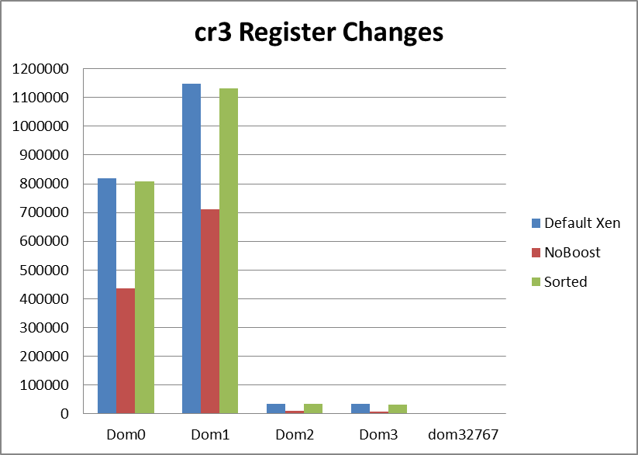
Figure 3. Cr3 Changes
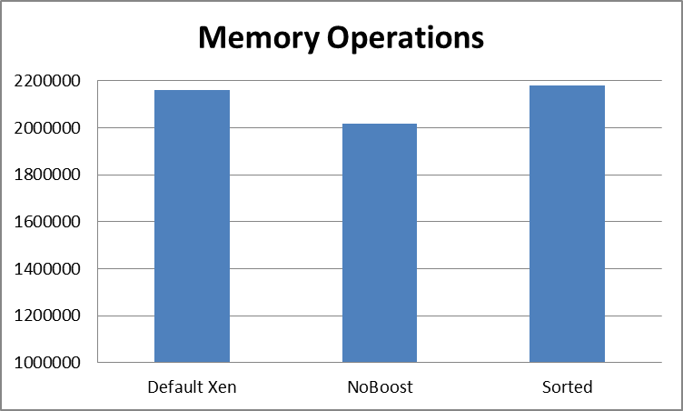
Figure 4. Memory Operations

