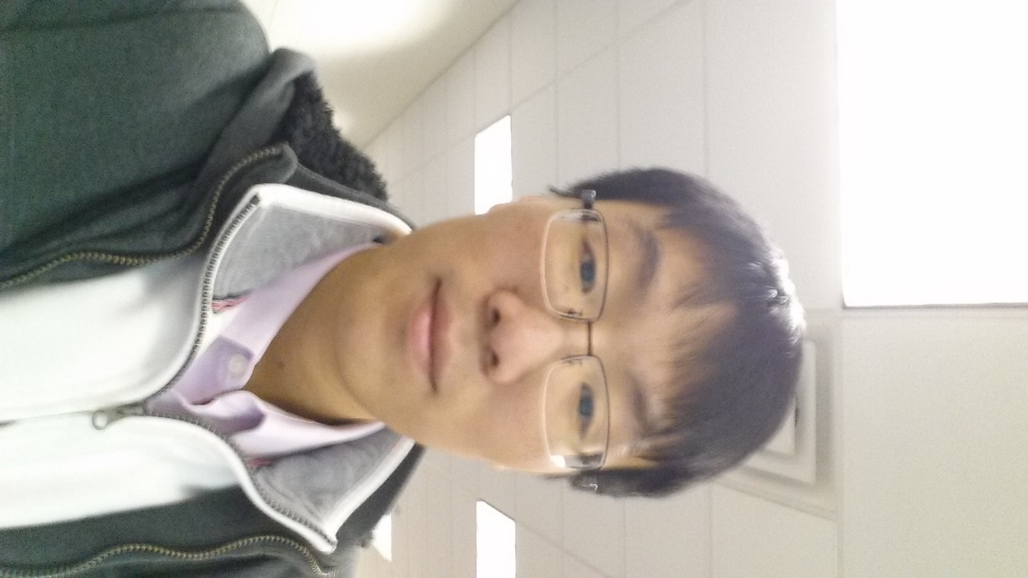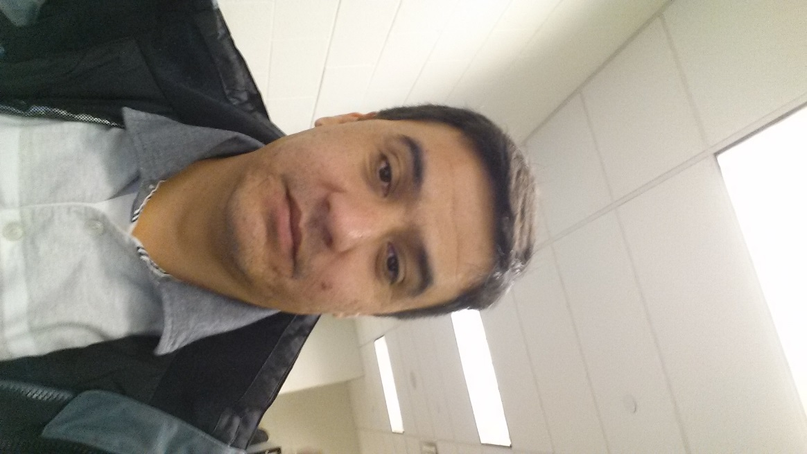

Aplomb TR Huang ID# 6856925 Partner: Vahob, Shokirov

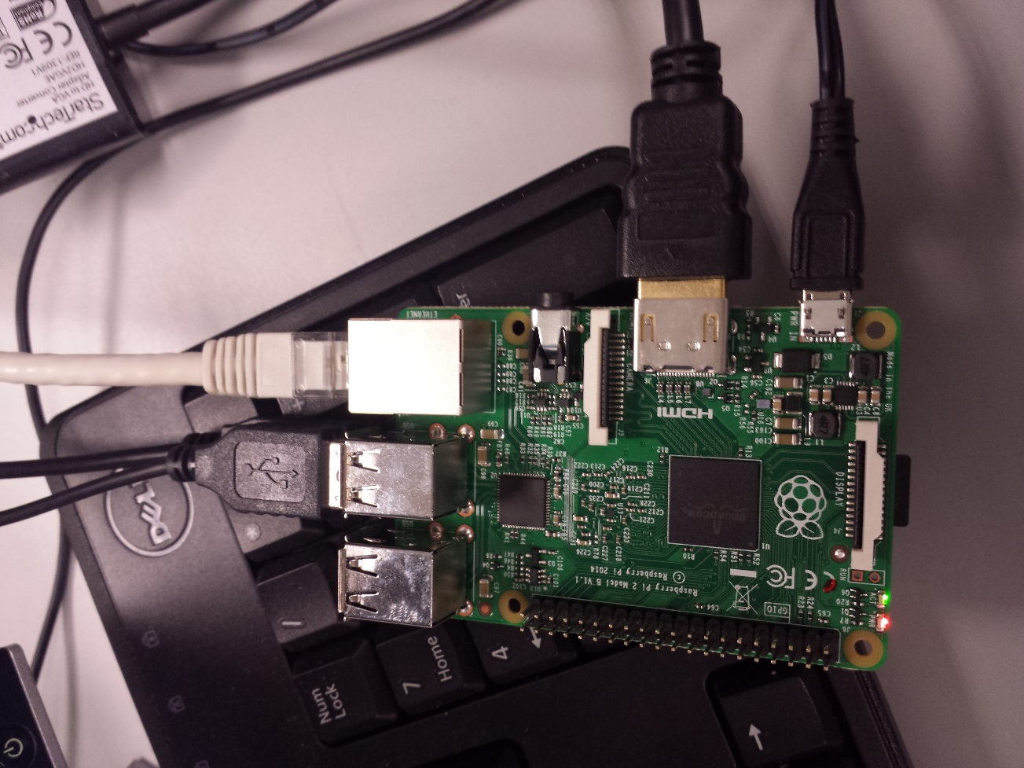

In this lab, we assembled the raspberry pi by connecting the USB mouse and keyboard, HDMI to VGA cable, inserted the sd card, and powered the pi up. After that we installed the Raspian OS on to the SD card. After we installed the OS, we were in a graphic UI, but I managed to reboot into command line UI.

We also used pencil to circle out different components on the Raspberry Pi, like CPU, USB PORT, HDMI PORT, LED indicating light, etc.

That was it for Lab1.