**After Registration of SAS Account**

1. Type in this URL on any browser: <https://welcome.oda.sas.com/login>

You should see a page as below:

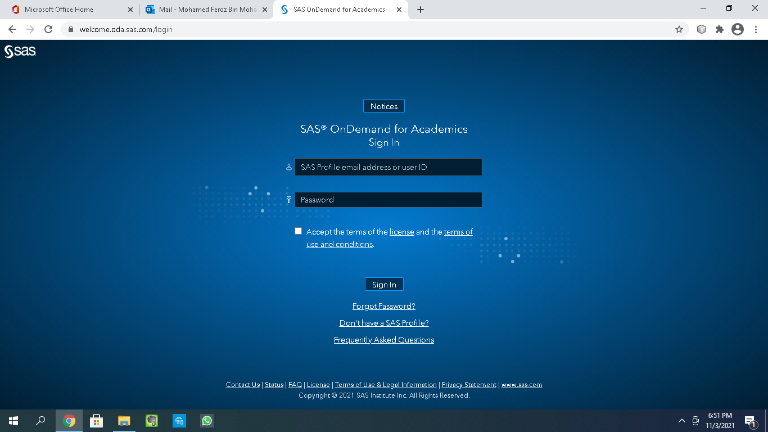

1. Enter the following:
   1. SAS Profile email address
   2. Password
   3. You have to tick the ‘***Accept the terms of the license***’ box before can access the portal (please read the contents first before deciding).
2. After successfully logged-in, you should see:

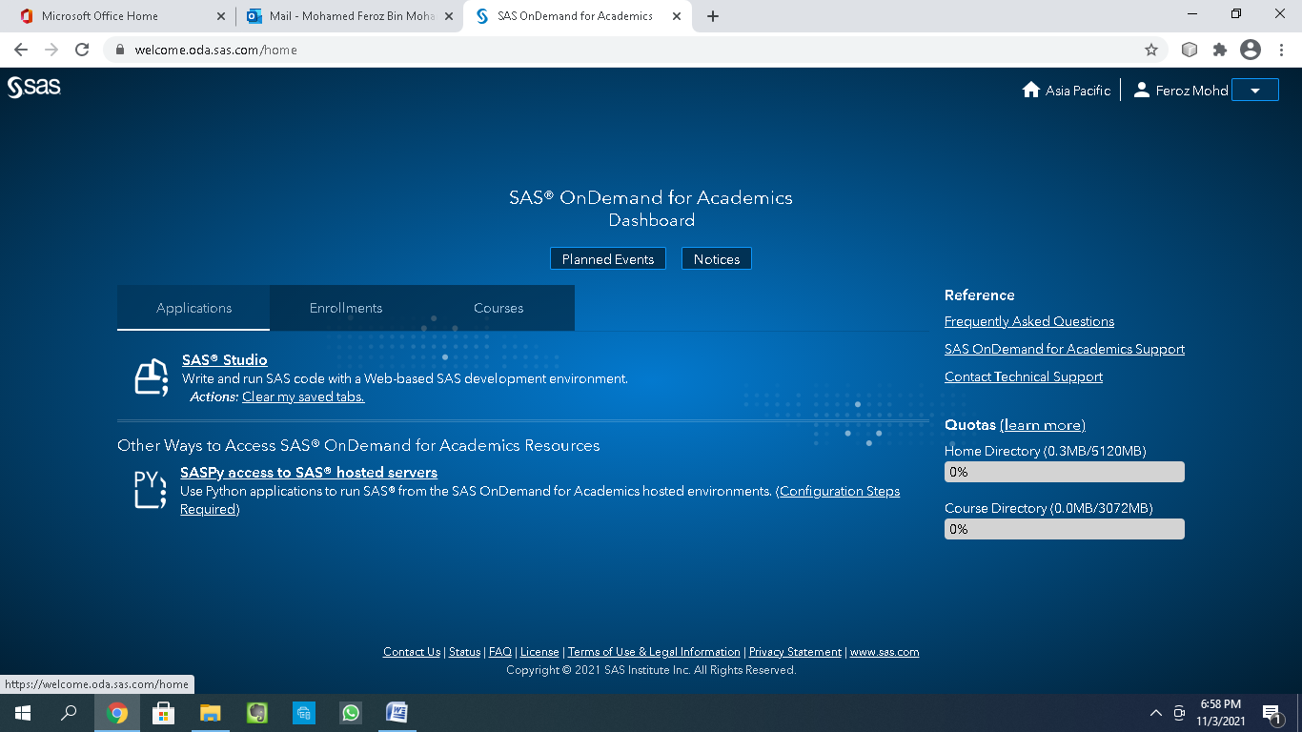

**The End**