SUMMARY

Reviewer asked for this

Weakness/room for improvement

Reviewer Comment 1
In the method section, it seems that the joint approach is more general than the disjoint approach, why is the disjoint approach still needed? Please clarify the possible advantages of the disjoint approach.

The disjoint approach is included for two reasons.

First, the gumbel method is not applicable to every causal graph. In such cases, we can use the disjoint method to tackle the problem.

There are two possible Markov Blankets for which we cannot use the Gumbel Method: CG2 and CG4.

In CG2, the causal graph is simply Y->X_E. This instance is an established case which is well-explored by existing methods, as explained in the paper. In this instance, there is no clear reason why we would prefer the disjoint method over any other mehods. In our reslust, we include it to demonstrate the didference in SSL over CG1 vs CG2 graphs. We aim to give some intuition for the earlier discussed results that SSL is only possible in principle if there is some Y->X_E.

In CG4, the causal graph is Y-> X_E <- X_S. In this case, the Gumbel method cannot give more information. We argue that the disjoint method is preferable to other baselines in this instance because we explicitly separate the features X_S and X_E. Given that SSL methods implicitly assume that all causal relationship are Y->X, one expects the SSL algorithm to learn a relationship Y->(X_S,X_E), or X_S<-Y->X_E. Y and X_S are independent, so if we are implicitly using unlabelled X_S to estimate P(Y|X_S,X_E), the convergence of the approach may become inferior to a model which considers P(Y|X_E) only.

The results for CG4 are not super supportive of this..maybe provdie a counter example???

To model the conditional distributions following a causal graph, this paper uses the MMD-based generative adversarial networks. Why choose this generative model? There are many other generative models such as GANs with neural networks as discriminator, variational autoencoders, and diffusion models.

MMD can be used as a loss function instead of discriminator

The advantage of using MMD GAN instead of Discriminator GAN in this case was the following:

1. MMD is easy to train. Quadratic-time with efficient approximations, stable

2. Is using moment-matching objective still adversarial? Saddle point inherently unstable in GAN

Our use case is general purpose data. Maybe if we were doing images we would appeal to some established GANS like stylegan and so on. In general, if there is a pretrained discriminator on a data domain of interest (images, audio, etc), it may improve results using the weights and fine-tuning. But for our use case, our data is not images. Given the success of our results, we didn't feel it necessary to try using discriminator architecture. It may be possible to get a better result but the main goal of our paper was to simply illustrate the potential for using causal generative modelling in SSL. A central part of our method involves decomposing the distribution according to the causal graph, where we consider low-dimensional decompositions. In these instances, MMD based approach was good enough to demonstrate good results.

Diffusion models, a more recent approach for generative modelling, typically are useful for high-dimensional data, and in these contexts they can surpass GANs. In our case we consider modelling the causal modules according to the graph, hence since these modules are low-dimensional we do not expect better performance in our method.
@TODO: Implement causal modules with VAE architecture [] ← dont do this, just explain why we chose GAN.

The proposed approach considers different scenarios. In practice, how can one quickly which scenario a given dataset belong to?
The method is applicable if we know the causal structure only. One shortcoming of the method is that we need to know this priori. In addition, we assume the causal markov condition which is a strong assumption and may not hold in practice.
The causal structure may be recoverable via causal discovery algorithms, as we considered for real world datasets. If causal discovery is not helpful for learning the DAG, one approach may be to appeal to expert knowledge to construct the grap, rather than using automated approaches.

To quickly know which scenario is relevant, we assume the causal Markov condition, P(X,Y) decomposes into the causal graph which has inherent structure over causal modules: this leads directly to identification of causal structures for CG1-CG7, with either X_C, X_E, X_S and their relationships. In particular it could also tell us if SSL might not be worth pursuing, in the instance X → Y is the entire DAG.

If I understand correctly, the proposed method requires the causal structure to be fully known. In practice, one may only get a dataset, how can one get the causal structure as well?

- we used fges-mb model in the paper to get the cauasl structure (in appendix), for real world dataset breast cancer

- don't necessariyl need to know the full DAG , we can condition on all common causes

Some very related references should be included in the revision, i.e. "Semisupervised Feature Analysis by Mining Correlations Among Multiple Tasks" and "Adaptive Semi-Supervised Feature Selection for Cross-Modal Retrieval".

- put in new simulations here

"Adaptive Semi-Supervised Feature Selection for Cross-Modal Retrieval". demonstrates compelling results.

typically it's for cases where they want to identify multiple features. like multi labels in images. each subtask is to identify a single feature. ie 'dog' 'sun' 'grass' 'walking' could all be features of some image of a person in a park with their dog.

Given two correlated features X1, X2, and the feature label Y, we want to estimate it like this P(Y|X1,X2). In the causal setting, a simplified model could be either X1 ← Y → X2 or X1 → Y → X2. The algorithm regresses parameters for a projection matrix which maps features down into a lower dimensional subspace d of same dimension as the label variable. In this new subspace, features of same semantic attributes are closer.

My implementation.

Vectorised for fast comp,
Specifically have tried with two feature variables. COnsidering how to use three features. Ther are some erros in their paper / algorithm. I think I have figured out the imstakes in the notation in their paper

Try to tune with ray tuner, unclear if there is a best set of hyperparmeters for entire model. performance seeems comparable to our methods (need to summarise)

Very quick to converge, typically in 1-2 iteration. Leave for longer results become unstable.

Problem: set sigma? to median pairwise distance? @TODO

Also mapping matrices: projection onto 2dim subspace. If we use X in R^{4}, mapping is not symmetric matrix, so how can we initialise it? it says in their code that initialise mapping to identity. but we cna't do this if not symmetric?

adapt it by simply using d=2 for the common latent subspace (sugested by earlier work they reference) and I then use softmax to convert to prob...softmax not technical;ly needed, we just take max value.

For evaluation, I predict on val, select run with best val acc, then predict on unlabeleld partition. rrport the predictio on unalbeleld partition. try 10 runs, add some noise to inital matrices to see if pertuyrb final result. but it's stable.

Have tuned with ray tune to try find optimal hyperparameters. It seems that if we take large knn, at least 200, we get better perfgormance. Other than this it doesn’t seem obvious that there is a robust choice of hyperparameters for the algo. In addition, the original authors of this method didnt specify how they chose their hyperparams.
I have not run their code on their datasets to check if my impmeentation is the same.
However, the algorithm converges and performacne is similar to other baaselie SSL methods, so I think it’s okay – implementation is likely correct enough.
- summarise results into table []

Semisupervised Feature Analysis by Mining Correlations Among Multiple Tasks

in middle of writing algorithm

unclear on their notation but looked at previous reference to double check. i will continue work on algo today and see if it works. results should be quick like the first paper. I am concerned that the laplacian matrix I don't have correct formulation, but easy to debug once whole algo done.

#---------

2nd reviewer

There are several point I would like to see addressed, which I hope would help make the paper even more valuable.

The causal structure is assumed to be known throughout the work. I think this is a fair assumption. However, it would still be interesting to see some results based on a learned causal structure (e.g., using a method such as NOTEARS [1]).

For Breast Cancer dataset, we learned the causal structure based on FGES-MB algorithm, and this was used for results. In contrast, we tried several other causal discovery algorithm, and they didn’t converge.
@TODO: Try use Notears Linear and Nonlinear on Breast Cancer to learn the causal structure

@TODO: Try use Notears Linear and Nonlinear on SACHS dataset to learn the causal structure

https://github.com/xunzheng/notears

- Tried Notears L:inear and Nonlinear on Breast Cancer

- No good results. We get some DAG but nothing on diagnosis variable

- We get some causal structure.

NONLINEAR NOTEARS
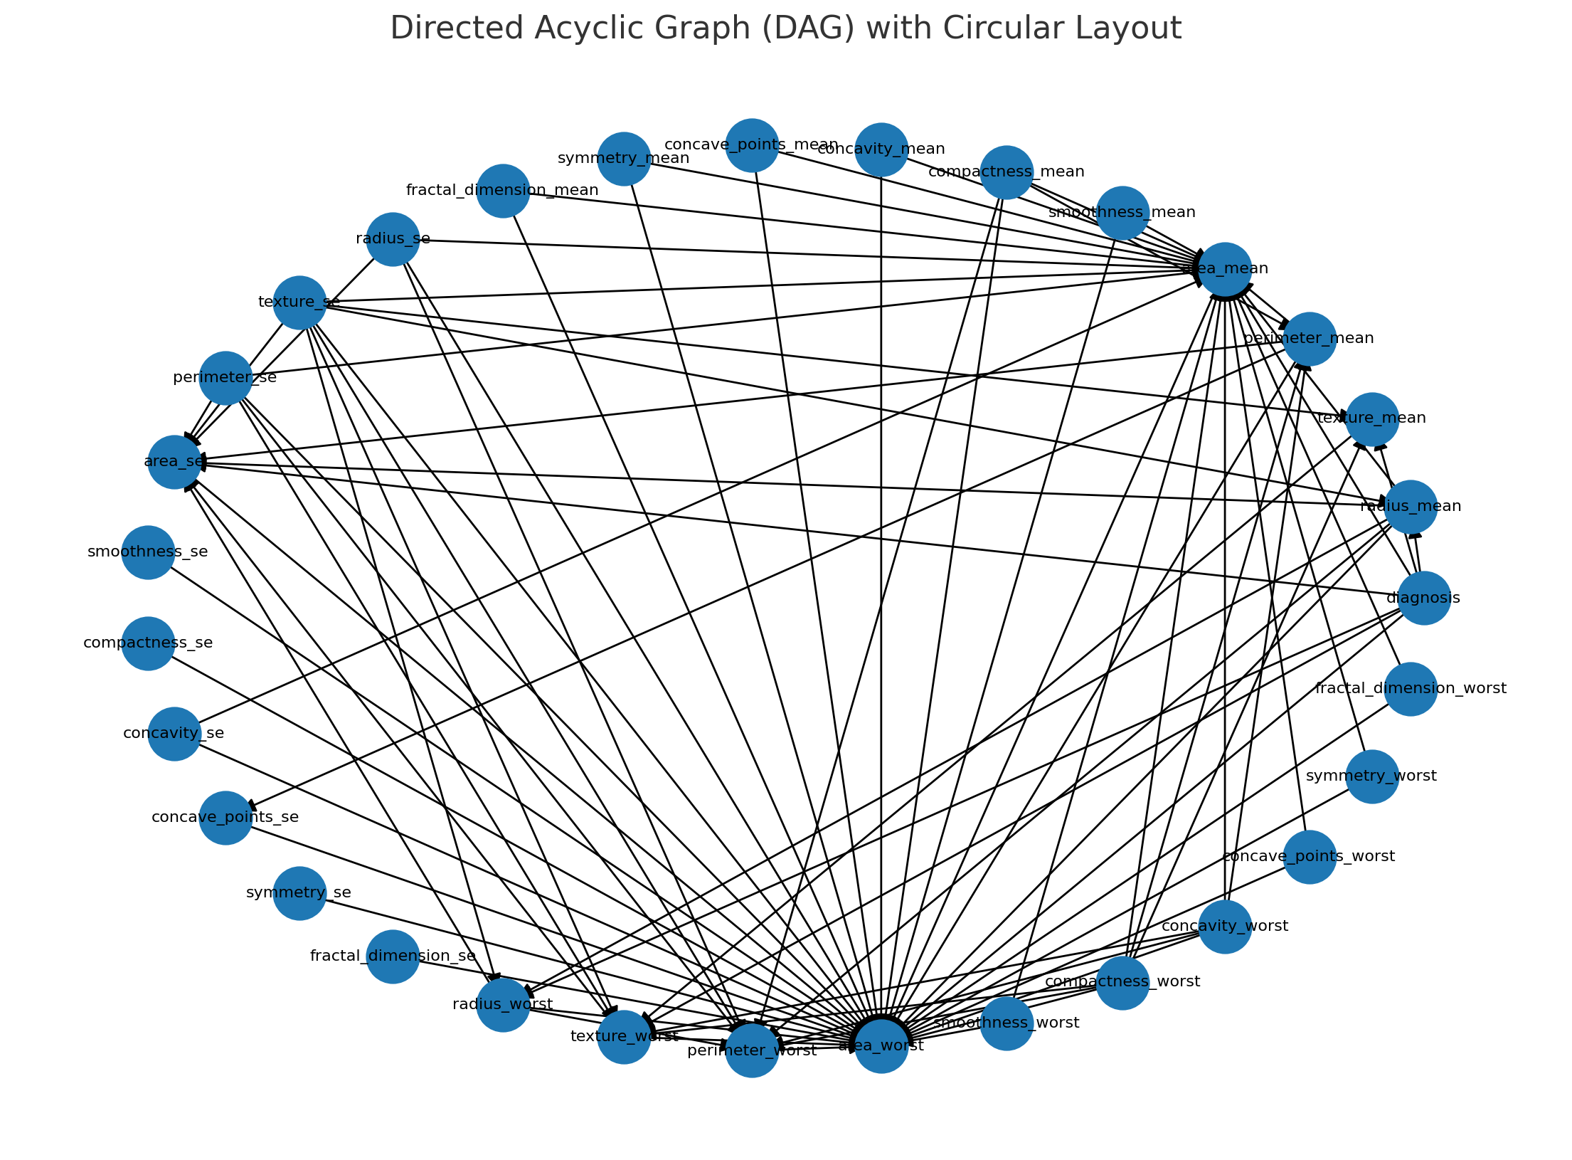
What to do? I was considering doing nonlinear NOTEAARS and try to tune it a bit. Or different causal discovery method.

I have some remarks regarding the empirical results. First, all experiments are conducted with a 3-layer MLP with a hidden layer size of 100. Should this not be tuned for each data set? Especially given the small data set sizes? Related to this, I would be interested to see how the different methods perform with more data.
Two components: consider different MLP sizes, and consider how using more data changes perofrmance.
Componnent 1: MLP size / tuning of our models.
some tuning was performed over sizes 50,100,200 neurons and n hidden layers = 1,3,5.

@TODO: redo results with these architecture changes illustrate performnace change. just compare performance simply, like 50,100,200 neurons to see if signifncant change. from memory 100 was best perofmrance. but do experiemnts with differnt neurons and illustrate whether it's better or worse. []

Component 2: Data

- synthesise more examples. currently we use 2000 unlabelled, 40 labelled.

- 10,000 unlabelled, 40 labelled

- 100,000 unlabeled, 40 labelled

- number of labels could try 50 or less. if we have too many labels, ssl not necessary.

@TODO:

- maybe can just increase number of unlabelled data, this is easy to do. try with two more 10,000 and 100,000 []

USING 10000 unlabeleld, 40 labelled
- did 10000 with batch size 256, no other tuning. VAT works well. disjoint poorly performs.

- CGAN-SSL disjoint algo weights loss terms equally for labelled nad unlableld data. maybe not best approach in this context. Perhaps algo needs to be modified to weight labelled and unlabeleld data differntly.

Old: 2000 unlabelled, 40 labelled.

Every minibatch = train on 32 unlabel, 4 label cases.

New: 10000 unlabelled, 40 labelled

Every minibatch = traiin on 2048 unlabel, 40 label cases.

Loss:
loss_labelled + loss_unlabelled

w_lab = batch_size/N_labelled

= 4/40

w_unlab = 32/100000 << w_unablled_orig

- gumbel method takes aages, need to optimise code, MMD calls and so on. Entire results for gumbel not compiled. But it seems to still work well.

- other methods apart from VAT don't work well.

USING 100000 unlabeleld, 40 labelled
100,000 unlabeleld is too much, it takes too long.

try instead:

10,000 and 20 labelled?
2,000 and 20 labelled?
2,000 and 10 labelled?
5000 and 40 labelled?
5000 and 40 labelled?

40,000 and 40 labeleld? anyting over 10,000 seem to take ages

If we try 5000, 10,000.
Finally, I was wondering whether the authors could add some more insights on the performance of GCGAN-SSL compared to CGAN-SSL. When does one outperform the other?

- when there is join dependence between x1->X2 in graph x1->y->x2

Does this depend on the causal structure of the data? The authors state that "the joint Gumbel-Softmax method GCGAN-SSL seems able to exploit information in unlabelled data more effectively ...". Why does this not holld for the real data sets?

- AUPRC plot could be insightful to compare precision and recall. we can identify cases where gumbel method is superior, compare wtih disjsoint method directly. interesting to see if it's at decision boundary or towards more certian prediction of class.

- latent confounders?

- think more about this.

[1] Zheng, X., Aragam, B., Ravikumar, P. K., & Xing, E. P. (2018). Dags with no tears: Continuous optimization for structure learning. Advances in neural information processing systems, 31.

