Use Responsive Design with Bootstrap Fluid Containers

In the HTML5 and CSS section of FreeCodeCamp we built a Cat Photo App. Now let's go back to it. This time, we'll style it using the popular Bootstrap responsive CSS framework.

Bootstrap will figure out how wide your screen is and respond by resizing your HTML elements - hence the name Responsive Design.

With responsive design, there is no need to design a mobile version of your website. It will look good on devices with screens of any width.

You can add Bootstrap to any app by adding the following code to the top of your HTML:

<link rel="stylesheet" href="//maxcdn.bootstrapcdn.com/bootstrap/3.3.1/css/bootstrap.min.css"/>

In this case, we've already added it for you to this page behind the scenes.

To get started, we should nest all of our HTML in a div element with the class container-fluid.

Make Images Mobile Responsive

First, add a new image below the existing one. Set its src attribute to https://bit.ly/fcc-running-cats.

It would be great if this image could be exactly the width of our phone's screen.

Fortunately, with Bootstrap, all we need to do is add the img-responsive class to your image. Do this, and the image should perfectly fit the width of your page.

Center Text with Bootstrap

Now that we're using Bootstrap, we can center our heading element to make it look better. All we need to do is add the class text-center to our h2 element.

Remember that you can add several classes to the same element by separating each of them with a space, like this:

<h2 class="red-text text-center">your text</h2>

Create a Bootstrap Button

Bootstrap has its own styles for button elements, which look much better than the plain HTML ones.

Create a new button element below your large kitten photo. Give it the class btn and the text of "Like".

Create a Block Element Bootstrap Button

Normally, your button elements with a class of btn are only as wide as the text that they contain. For example:

<button class="btn">Submit</button>

This button would only be as wide as the word "Submit".

Submit

By making them block elements with the additional class of btn-block, your button will stretch to fill your page's entire horizontal space and any elements following it will flow onto a "new line" below the block.

<button class="btn btn-block">Submit</button>

This button would take up 100% of the available width.

Submit

Note that these buttons still need the btn class.

Add Bootstrap's btn-block class to your Bootstrap button.

Taste the Bootstrap Button Color Rainbow

The btn-primary class is the main color you'll use in your app. It is useful for highlighting actions you want your user to take.

Add Bootstrap's btn-primary class to your button.

Note that this button will still need the btn and btn-block classes.

Call out Optional Actions with Button Info

Bootstrap comes with several pre-defined colors for buttons. The btn-info class is used to call attention to optional actions that the user can take.

Create a new block-level Bootstrap button below your "Like" button with the text "Info", and add Bootstrap's btn-info and btn-block classes to it.

Note that these buttons still need the btn and btn-block classes.

Warn your Users of a Dangerous Action

Bootstrap comes with several pre-defined colors for buttons. The btn-danger class is the button color you'll use to notify users that the button performs a destructive action, such as deleting a cat photo.

Create a button with the text "Delete" and give it the class btn-danger.

Note that these buttons still need the btn and btn-block classes.

Use the Bootstrap Grid to Put Elements Side By Side

Bootstrap uses a responsive grid system, which makes it easy to put elements into rows and specify each element's relative width. Most of Bootstrap's classes can be applied to a div element.

Here's a diagram of how Bootstrap's 12-column grid layout works:

**[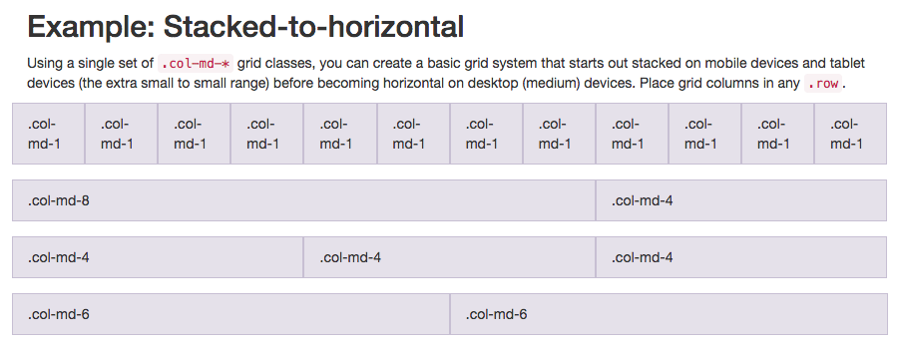](https://i.imgur.com/FaYuui8.png)**

Note that in this illustration, the col-md-* class is being used. Here, mdmeans medium, and * is a number specifying how many columns wide the element should be. In this case, the column width of an element on a medium-sized screen, such as a laptop, is being specified.

In the Cat Photo App that we're building, we'll use col-xs-*, where xs means extra small (like an extra-small mobile phone screen), and * is the number of columns specifying how many columns wide the element should be.

Put the Like, Info and Deletebuttons side-by-side by nesting all three of them within one <div class="row"> element, then each of them within a <div class="col-xs-4"> element.

The row class is applied to a div, and the buttons themselves can be nested within it.

Ditch Custom CSS for Bootstrap

We can clean up our code and make our Cat Photo App look more conventional by using Bootstrap's built-in styles instead of the custom styles we created earlier.

Don't worry - there will be plenty of time to customize our CSS later.

Delete the .red-text, p, and .smaller-image CSS declarations from your style element so that the only declarations left in your styleelement are h2 and thick-green-border.

Then delete the p element that contains a dead link. Then remove the red-text class from your h2element and replace it with the text-primary Bootstrap class.

Finally, remove the "smaller-image" class from your first img element and replace it with the img-responsiveclass.

Use Spans for Inline Elements

You can use spans to create inline elements. Remember when we used the btn-block class to make the button fill the entire row?

This image illustrates the difference between inline elements and block-level elements:

**[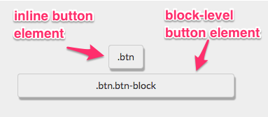](https://i.imgur.com/O32cDWE.png)**

By using the span element, you can put several elements together, and even style different parts of the same element differently.

Nest the word "love" in your "Things cats love" element below within a span element. Then give that spanthe class text-danger to make the text red.

Here's how you would do this with the "Top 3 things cats hate" element:

<p>Top 3 things cats <span class = "text-danger">hate:</span></p>

Create a Custom Heading

We will make a simple heading for our Cat Photo App by putting the title and relaxing cat image in the same row.

Remember, Bootstrap uses a responsive grid system, which makes it easy to put elements into rows and specify each element's relative width. Most of Bootstrap's classes can be applied to a div element.

Here's a diagram of how Bootstrap's 12-column grid layout works:

**[](https://i.imgur.com/FaYuui8.png)**

Note that in this illustration, the col-md-* class is being used. Here, mdmeans medium, and * is a number specifying how many columns wide the element should be. In this case, the column width of an element on a medium-sized screen, such as a laptop, is being specified.

In the Cat Photo App that we're building, we'll use col-xs-*, where xs means extra small (like an extra-small mobile phone screen), and * is the number of columns specifying how many columns wide the element should be.

Nest your first image and your h2element within a single <div class="row"> element. Nest your h2 element within a <div class="col-xs-8"> and your image in a <div class="col-xs-4"> so that they are on the same line.

Notice how the image is now just the right size to fit along the text?

Add Font Awesome Icons to our Buttons

Font Awesome is a convenient library of icons. These icons are vector graphics, stored in the .svg file format. These icons are treated just like fonts. You can specify their size using pixels, and they will assume the font size of their parent HTML elements.

You can add Font Awesome to any app just by including it by adding the following code to the top of your HTML:

<link rel="stylesheet" href="//maxcdn.bootstrapcdn.com/font-awesome/4.5.0/css/font-awesome.min.css"/>

In this case, we've already added it for you to this page behind the scenes.

The i element was originally used to make other elements italic, but is now commonly used for icons. You add the Font Awesome classes to the ielement to turn it into an icon, for example:

<i class="fa fa-info-circle"></i>

Use Font Awesome to add a thumbs-up icon to your like button by giving it an i element with the classes faand fa-thumbs-up.

Add Font Awesome Icons to all of our Buttons

Font Awesome is a convenient library of icons. These icons are vector graphics, stored in the .svg file format. These icons are treated just like fonts. You can specify their size using pixels, and they will assume the font size of their parent HTML elements.

Use Font Awesome to add an info-circle icon to your info button and a trash icon to your delete button.

Responsively Style Radio Buttons

You can use Bootstrap's col-xs-*classes on form elements, too! This way, our radio buttons will be evenly spread out across the page, regardless of how wide the screen resolution is.

Nest all of your radio buttons within a <div class="row"> element. Then nest each of them within a <div class="col-xs-6"> element.

#### Style Text Inputs as Form Controls

You can add the fa-paper-planeFont Awesome icon by adding <i class="fa fa-paper-plane"></i>within your submit button element.

Give your form's text input field a class of form-control. Give your form's submit button the classes btn btn-primary. Also give this button the Font Awesome icon of fa-paper-plane.

#### House our page within a Bootstrap Container Fluid Div

Now let's make sure all the content on your page is mobile-responsive.

Let's nest your h3 element within a div element with the class container-fluid.

#### Create Bootstrap Wells

Bootstrap has a class called wellthat can create a visual sense of depth for your columns.

Nest one div element with the class well within each of your col-xs-6div elements.

#### Add Elements within your Bootstrap Wells

Now we're several div elements deep on each column of our row. This is as deep as we'll need to go. Now we can add our button elements.

Nest three button elements within each of your well div elements.

#### Create a Class to Target with jQuery Selectors

Not every class needs to have corresponding CSS. Sometimes we create classes just for the purpose of selecting these elements more easily using jQuery.

Give each of your button elements the class target.

#### Add ID Attributes to Bootstrap Elements

Recall that in addition to class attributes, you can give each of your elements an id attribute.

Each id must be unique to a specific element and used only once per page.

Let's give a unique id to each of our div elements of class well.

Remember that you can give an element an id like this:

<div class="well" id="center-well">

Give the well on the left the id of left-well. Give the well on the right the id of right-well.