**Screenshots:**

1)index.html

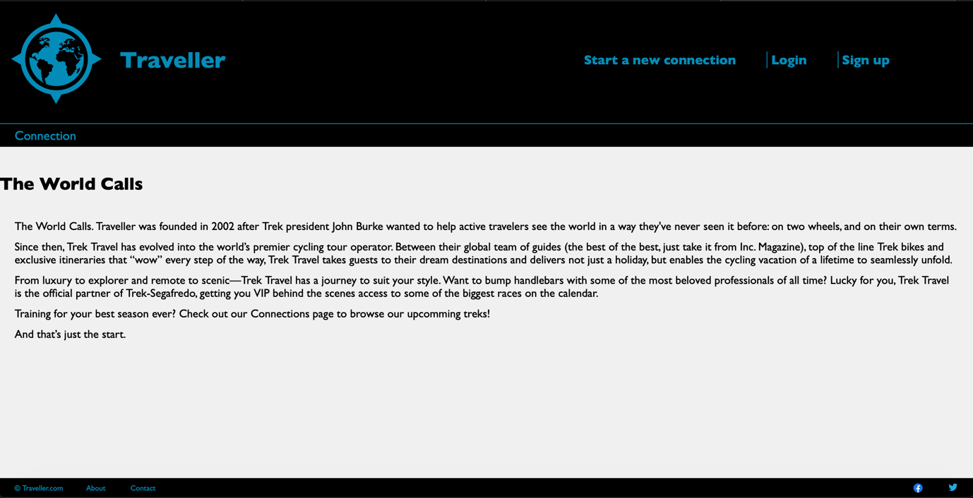

**Status**:- The Traveller website has four static pages namely index.html, connections.html, connection.html and savedconnection.html. All the web pages are complete as per requirements from milestone1 and working perfectly.

**Easy and hard tasks:-**

Easy task was to create a html pages.

Hard task include to style the whole website and align contents as that was a bit tricky. But I completed that with the help of modules and links.