**Screenshots:**

1)index.html

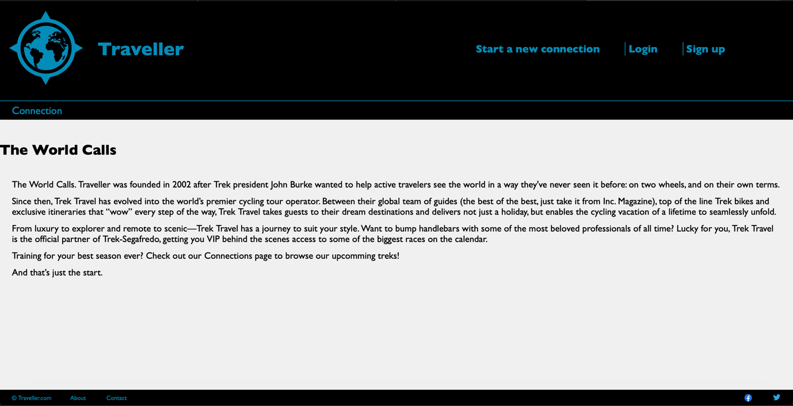

1. Additional features

* None

1. Status, Stopping Point or Issues

The assignment status is complete. No Stopping Points.

1. Experience

* Challenges
* None
* Solutions
* Referred to previous tutorials and examples
* Doubt was cleared on Piazza
* Easy part
* Most of the part went smoothly

Note: The login checks user with database. Please use ‘apnav24’ as login and password can be anything.