Code Challenge

**Doctor Appointment System.**

Dr. Mehta owns a clinic and he seats in a clinic 10:00 am to 2:00 pm daily to consult OPDs.

He needs online computerized system via which patients can book the appointment with the doctor.

Doctors takes 20 minutes to consult one patient. So, daily he consult around 12 patients who booked appointment. Below is the design requirement given,

Our Software company analysed the following list of object and class structure.

List of Classes.

1. Patient.
2. Appointment
3. AppointmentManager.
4. AppointmentController.
5. Patient.

|  |  |  |  |  |
| --- | --- | --- | --- | --- |
| Sr. No. | Property Name | Data Type | Validators | Description |
| 1 | PID | int | NA | NA |
| 2 | FirstName | string | Required | Will hold first name of patient and error message will be ‘Please enter first name.’. |
| 3 | MiddleName | string | Required | Will hold middle name of patient and error message will be ‘Please enter middle name.’. |
| 4 | LastName | string | Required | Will hold last name of patient and error message will be ‘Please enter last name.’. |
| 6 | Gender | string | Required | Will hold gender of patient and error message will be ‘Please select gender.’. |
|  | Mobile | string | Required & RegularExpression | Will hold mobile of patient and error message for required validator will be ‘Please enter mobile no.’ and for regularexpression validator will be ‘Please enter valid mobile no.[+91 0000000000]’. |

1. Appointment.

|  |  |  |  |  |
| --- | --- | --- | --- | --- |
| Sr. No. | Property Name | Data Type | Validators | Description |
| 1 | AID | int | NA |  |
| 2 | PatientID | int | NA | Will act as foreign key. |
| 3 | APatient | Patient | NA | Will be Navigation Property for Patient. |
| 4 | ADate | DateTime | Required | Will hold appointment date of patient and error message will be ‘Please select appointment date.’. |
| 5 | ATime | DateTime |  |  |
| 6 | AStatus | Enum AppointmentStatus |  |  |
| 7 |  |  |  |  |

1. AppointmentManager

|  |  |  |  |  |
| --- | --- | --- | --- | --- |
| Sr.No | Method Name | Return Type | Parameters | Description. |
| 1 | MakeAppointment | Appointment | Appointment | This make record will act on appointdata come from controller,   * It will check schedule availability if not then throws exception message ‘No Schedule is available’. * If Available then a lot next slot. * Implement the code to autogenerate AID and PID i.e increment the max AID and PID. |
| 2 | GetAppointment | Appointment | id | Will take the apoointment ID as Parameter and will return Appointment with Patient Details.(Please use Include to Load Patient details) |

1. AppointmentController.

This Controller class will utilize the AppointmentManager

|  |  |  |  |
| --- | --- | --- | --- |
| Sr.No | Action Name | Parameter | Description |
| 1 | MakeAppointment | NA | Will navigate to MakeAppointment View to accept appointment date with patient details. |
| 2 | MakeAppointment_Post | Appointment | If error exist in input of data then navigate to MakeAppointment View with the error messages. If data is ok then redirect to SuccessAppointment Action with the AppointmentID as route data. |
| 3 | SuccessAppointment | int | Will fetch the Appointment Data from database and navigate to SuccessAppointView with Appointment data as model. |

There will be three views involved into it.

1. Index.cshtml
2. MakeAppointment.cshtml
3. SuccessAppointment.cshtml

Below is the MakeAppointment.cshtml snapshot.

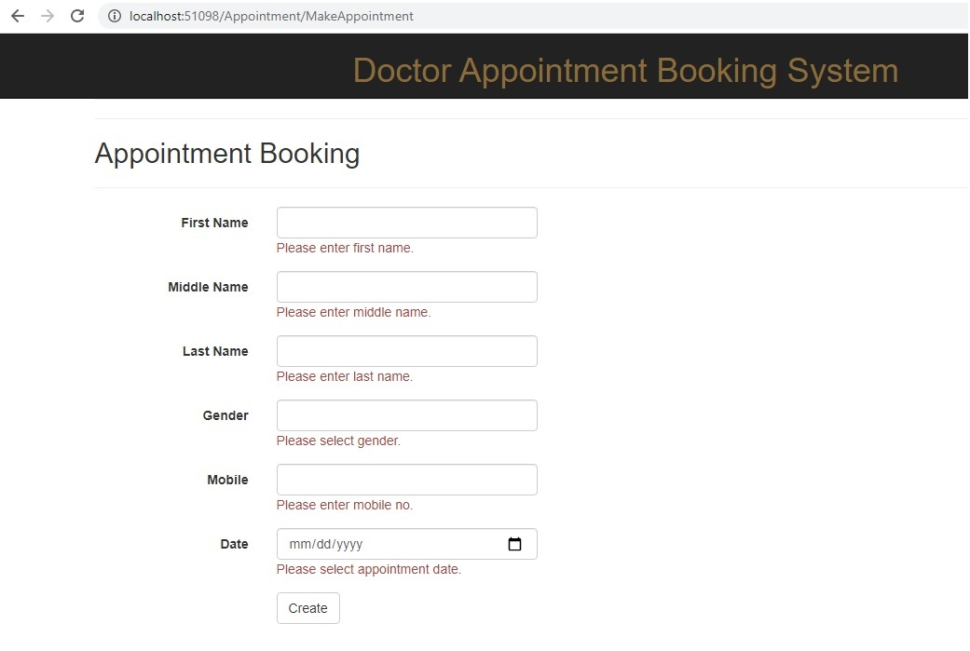

Below is the SuccessAppointment.cshtml snapshot.

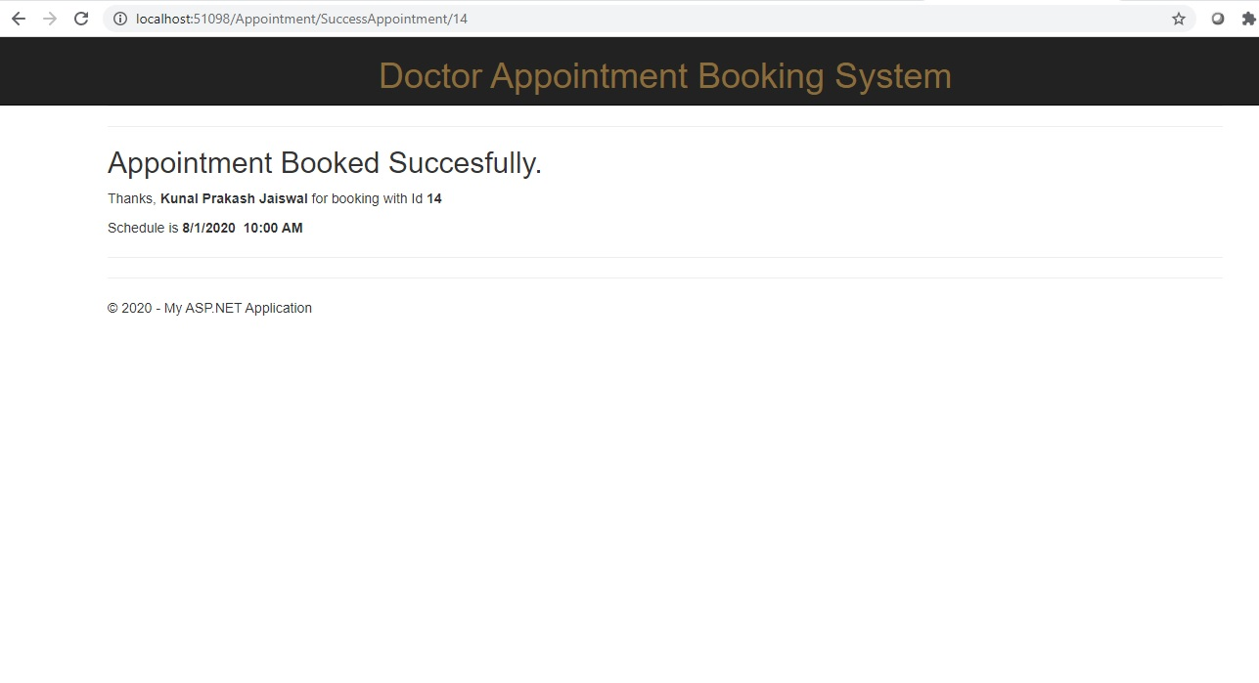As per the snap implement the cshtml files i.e MakeAppointment.cshtml and SuccessAppointment.cshtml.

**Note. Please do not modify the existing code.**