***COMPUTER PROGRAMMING JAVA***

***BCSE103E***

**PROBLEM 1:**

VIT Chennai was established with UG courses like B.Tech and MS. The following details of UG students were stored: Name, Degree, Branch, GPA, Semester, Secondary School Name and % of marks in Secondary education. Later they started Master Degree Program for which some additional information of students was stored: Basic Degree, College Name, and CGPA. After a couple of years, they offered PhD degree and for research students the following data was stored: Master Degree, College Name, CGPA, Area of Specialization, Supervisor's Name, in addition to the above information. Make sure that there must be the facility to store and display the data in every course.

Being a system programmer of VIT Chennai, you are asked to implement an application in Java with suitable inheritance.

**Solution:**

**CODE:**

import java.util.*;

class UG

{

String name;

String degree;

String branch;

double gpa;

int sem;

String sec_sch;

int marks;

void input()

{

Scanner s=new Scanner(System.in);

name=s.next();

degree=s.next();

branch=s.next();

gpa=s.nextDouble();

sem=s.nextInt();

sec_sch=s.next();

marks=s.nextInt();

}

void disp()

{

System.out.println("Name: "+name);

System.out.println("Degree: "+degree);

System.out.println("Branch: "+branch);

System.out.println("GPA: "+gpa);

System.out.println("Semester: "+sem);

System.out.println("Secondary School: "+sec_sch);

System.out.println("Marks(percentage): "+marks);

}

}

class Master extends UG

{

String clg;

double cgpa;

void Mas_inp()

{

input();

Scanner s=new Scanner(System.in);

clg=s.next();

cgpa=s.nextDouble();

}

void Mas_disp()

{

disp();

System.out.println("Degree: "+degree);

System.out.println("College: "+clg);

System.out.println("CGPA: "+cgpa);

}

}

class PHD extends Master

{

String mas_deg;

String area;

String superv;

void ph_inp()

{

Mas_inp();

Scanner s=new Scanner(System.in);

mas_deg=s.nextLine();

area=s.nextLine();

superv=s.next();

}

void ph_disp()

{

Mas_disp();

System.out.println("Masters Degree: "+mas_deg);

System.out.println("College: "+clg);

System.out.println("CGPA: "+cgpa);

System.out.println("Area of Specialization: "+area);

System.out.println("Supervisor: "+superv);

}

}

class VIT

{

public static void main(String[] args)

{

PHD o=new PHD();

o.ph_inp();

o.ph_disp();

}

}

**SNAPSHOT:**

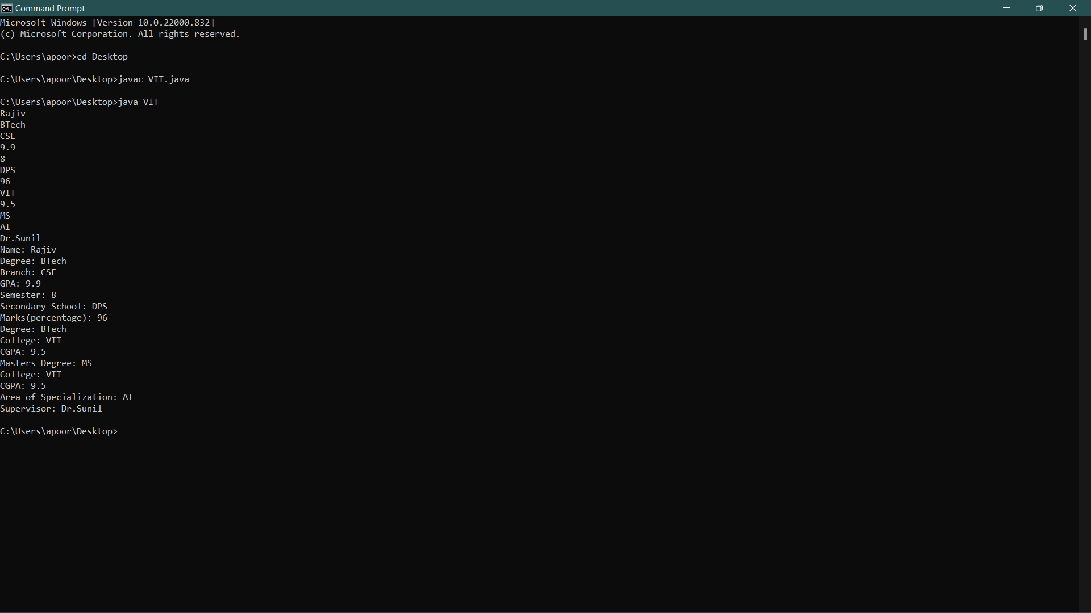

**PROBLEM 2:**

In a Manufacturing Unit, there are workers like Part-time workers and Full-Time workers. Write a superclass Total_workers and subclasses Part-timer Workers and Full-Time Workers. Every worker has a name, designation, number of hours worked and salary. Design a Parameterised method that computes the weekly pay for every worker. A Part-Time worker gets paid the hourly wage for the actual number of hours worked, if hours are at most 30. If the hourly worker worked more than 30 hours, the excess is paid at time and a half. The Full-Time worker gets paid the hourly wage for 50 hours, no matter what the actual number of hours is. Design a java program that computes the pay of any worker. Apply suitable Java inheritance that executes these classes and methods.

**Solution:**

**CODE:**

import java.util.*;

class Total_workers

{

int total;

void inp()

{

Scanner s=new Scanner(System.in);

total=s.nextInt();

}

void disp()

{

System.out.println("Workers:"+total);

}

}

class Partime_workers extends Total_workers

{

String n1;

String desig1;

int hr1;

int sal1;

double tot1;

void p_inp()

{

inp();

Scanner s=new Scanner(System.in);

n1=s.next();

desig1=s.next();

hr1=s.nextInt();

sal1=s.nextInt();

}

void p_comp(int hr1)

{

if(hr1<30)

tot1=sal1*hr1;

else

tot1=sal1*30+1.5*sal1*(hr1-30);

}

void p_disp()

{

disp();

System.out.println("Part-Time");

System.out.println("Name:"+n1);

System.out.println("Designation:"+desig1);

System.out.println("Hours:"+hr1);

System.out.println("Total Salary:"+tot1);

}

}

class Fulltime_workers extends Total_workers

{

String n2;

String desig2;

int hr2;

int sal2;

double tot2;

void f_inp()

{

inp();

Scanner s=new Scanner(System.in);

n2=s.next();

desig2=s.next();

hr2=s.nextInt();

sal2=s.nextInt();

}

void f_comp(int hr2)

{

tot2=sal2*50;

}

void f_disp()

{

disp();

System.out.println("Full-Time");

System.out.println("Name:"+n2);

System.out.println("Designation:"+desig2);

System.out.println("Hours:"+hr2);

System.out.println("Total Salary:"+tot2);

}

}

class Workers_Pay

{

public static void main(String[] args)

{

Partime_workers p=new Partime_workers();

p.p_inp();

p.p_comp(p.hr1);

Fulltime_workers f=new Fulltime_workers();

f.f_inp();

f.f_comp(f.hr2);

p.p_disp();

f.f_disp();

}

}

**SNAPSHOT:**

