**PAT-7**

**Class number : CH2022231001308 Date : 07-11-2022**

In an Educational institution, information of all students like Regdno, Studname, branchname stored in stud.java inside Student package and also the information related to Faculty like Faculty-id, Faculty name, department name, subject handled stored in Faculty.java inside Faculty package. Using Java code, access both the packages and display department name, Faculty-id, Regdno, and student name.

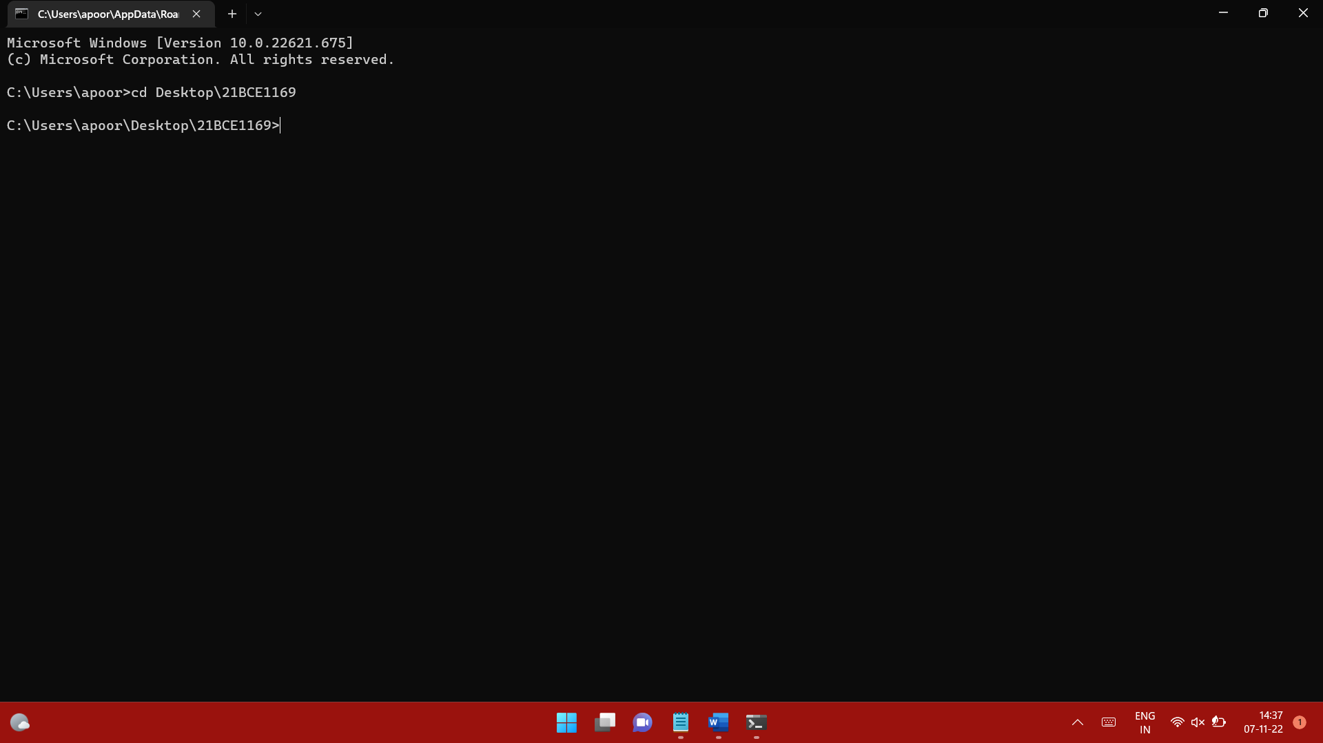

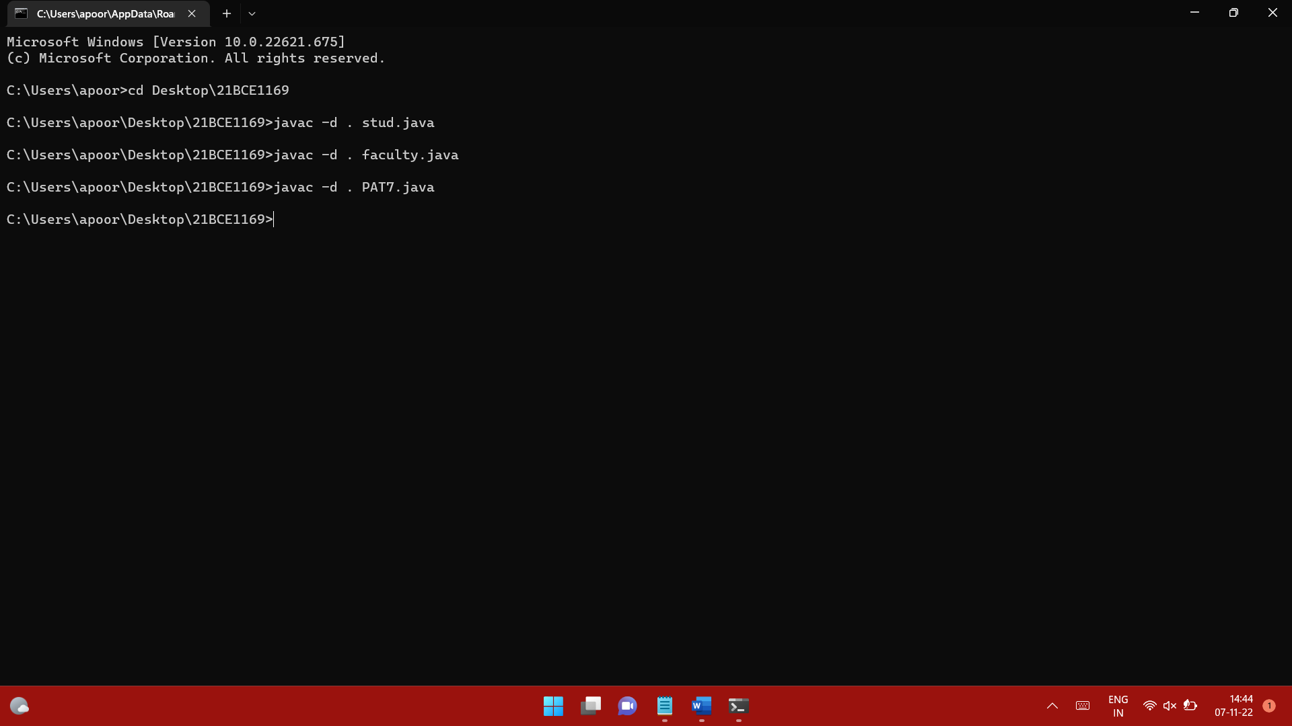

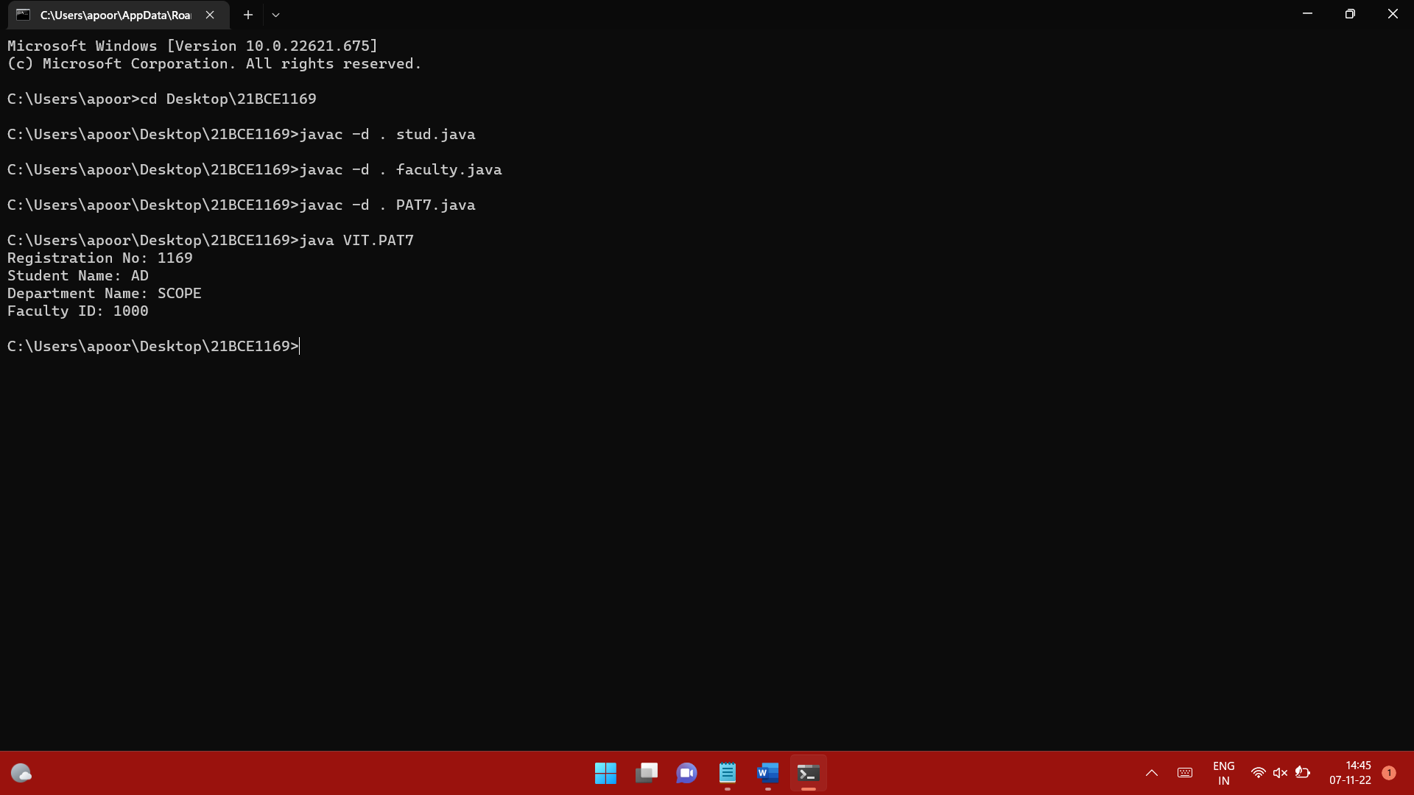

stud.java

package Student;

public class stud{

public void sinfo(){

int regdno=1169;

String studname="AD";

String branchname="CSE";

System.out.println("Registration No: "+regdno);

System.out.println("Student Name: "+studname);

}

}

faculty.java

package Faculty;

public class faculty{

public void finfo(){

int facid=1000;

String facname="Dr. ABC";

String depname="SCOPE";

String sub="JAVA";

System.out.println("Department Name: "+depname);

System.out.println("Faculty ID: "+facid);

}

}

PAT7.java

package VIT;

import Student.*;

import Faculty.*;

public class PAT7{

public static void main(String args[]){

stud st=new stud();

st.sinfo();

faculty fy=new faculty();

fy.finfo();

}

}