**PAT-8**

**Date: 10-11-2022**

In an organization, information of all employees like empid,empname,basic salary,hra,da stored in one package and also the information related to different departments like department name and department number stored in other package. Using Java application, access both the packages and display department name, empid, gross salary and net salary of all the employees.

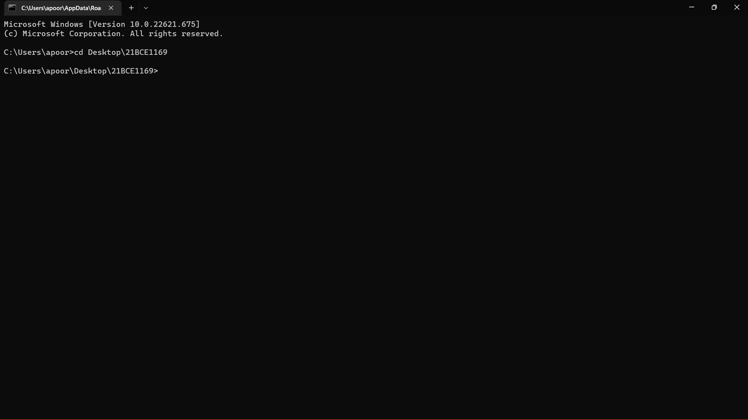

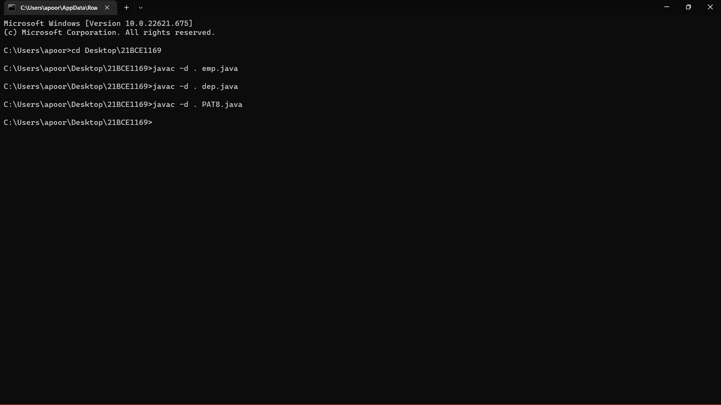

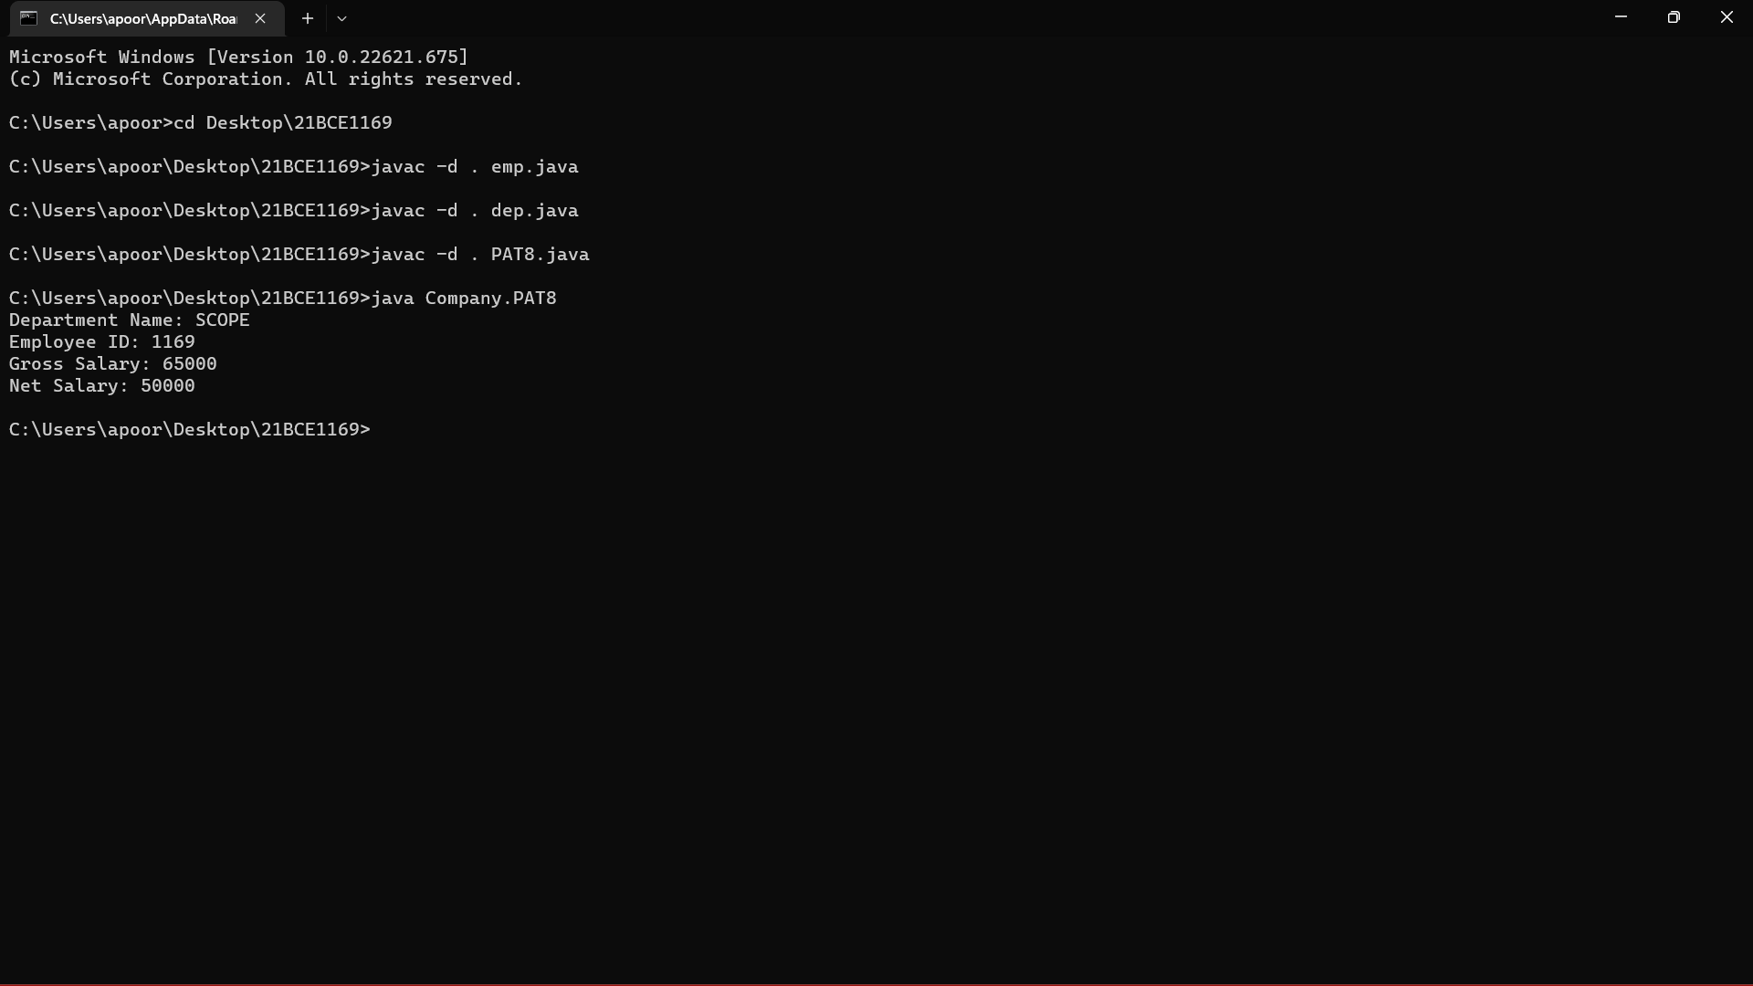

**emp.java**

package Employee;

public class emp{

public void empinfo(){

int empid=1169;

String empname=”AD”;

int bsal=50000;

int hra=10000;

int da=5000;

int gsal=bsal;

int sal=gsal+hra+da;

System.out.println(“Employee ID: “+empid);

System.out.println(“Gross Salary: “+gsal);

System.out.println(“Net Salary: “+netsal);

}

}

**dep.java**

package Departments;

public class dep{

public void depinfo(){

String depname="SCOPE";

int depno=1;

System.out.println("Department Name: "+depname);

}

}

**PAT8.java**

package Company;

import Employee.*;

import Departments.*;

public class PAT8{

public static void main(String args[]){

dep d=new dep();

d.depinfo();

emp e=new emp();

e.empinfo();

}

}