**Procedure for Renewal of DSC certificate in epass token**

***A. Instructions to delete existing certificate from token***

**Step-1:** the **tray** icon of epass token is located in the Windows Taskbar in bottom right corner. as shown in below figure.

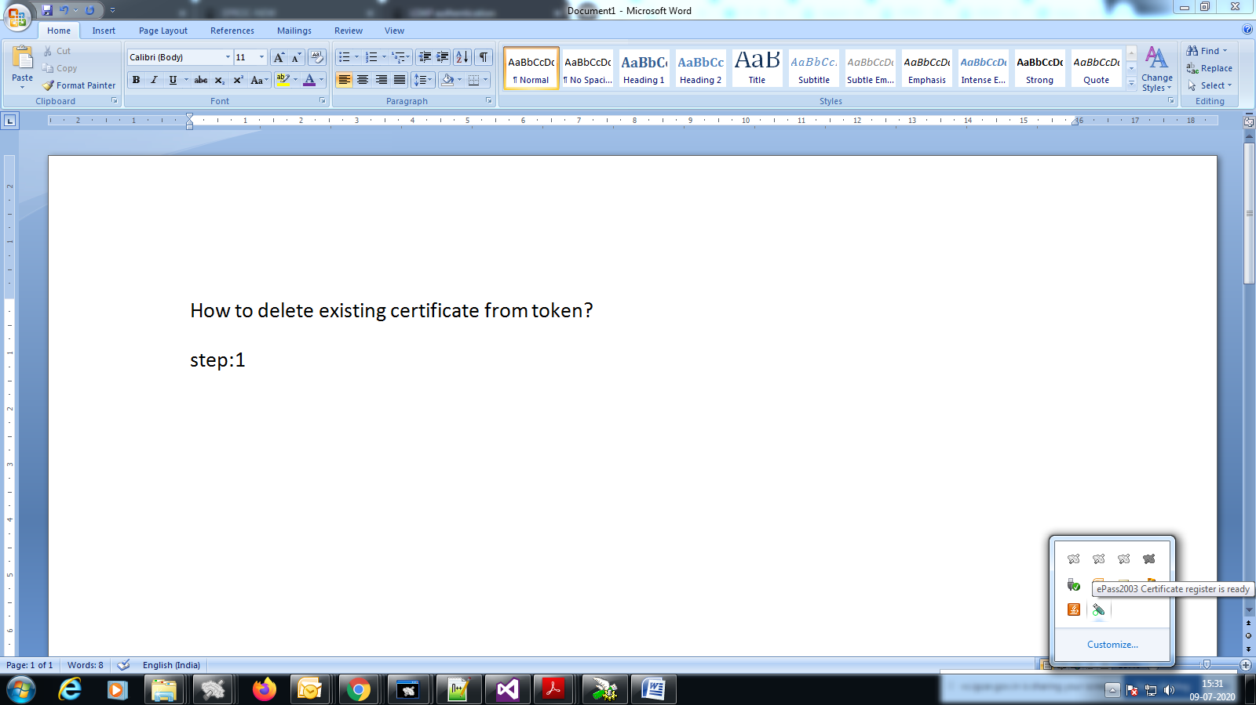

**Step-2:** double click on the tray icon. Then an application will open. Click on **login** icon. As shown in below figure.

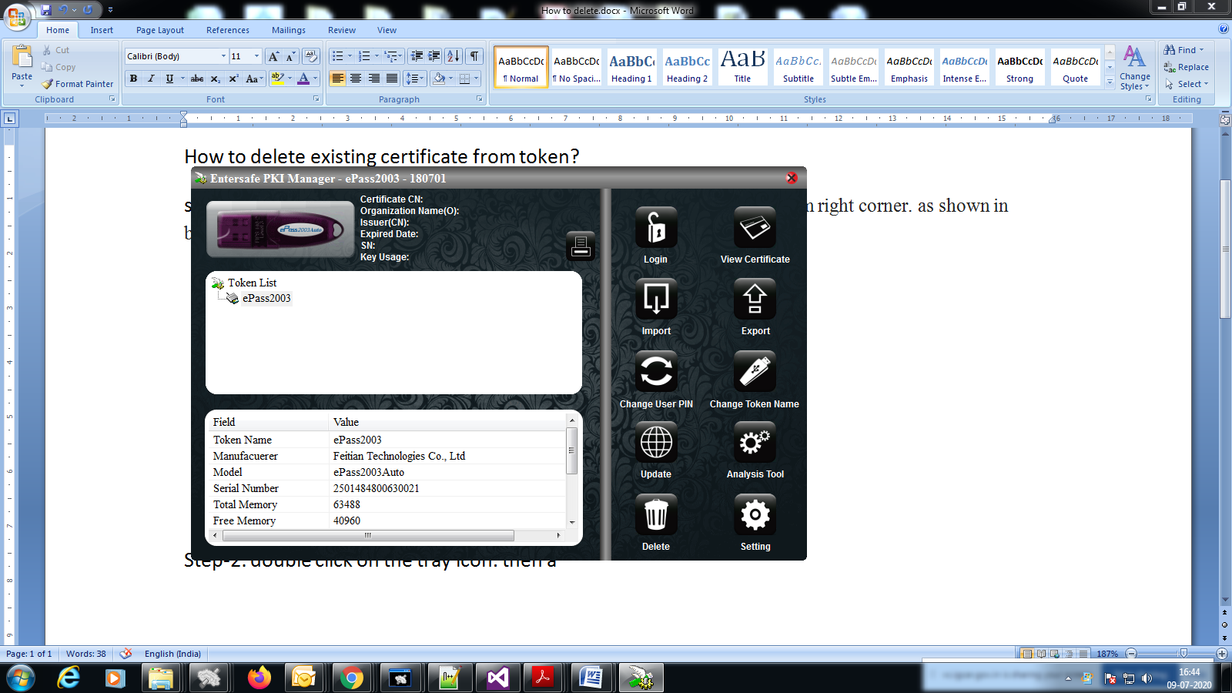

**Step-3:** Application will ask digital pin. Enter the **digital certificate pin** and click on 'ok' button.As shown in below figure.

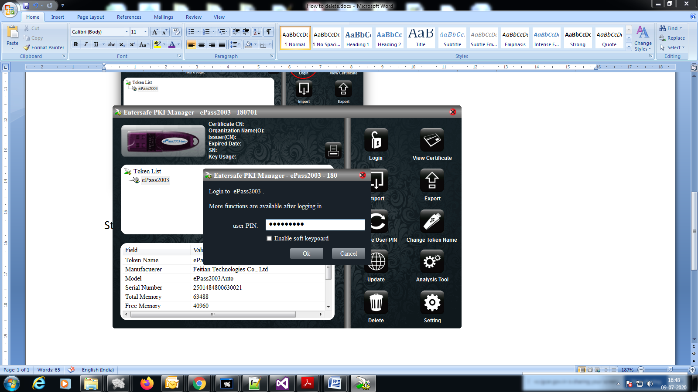

**Step-4:**The list of digital certificates will be shown under "**Token list".** Select **the certificate having your name under user certificate** and click on **delete** icon.

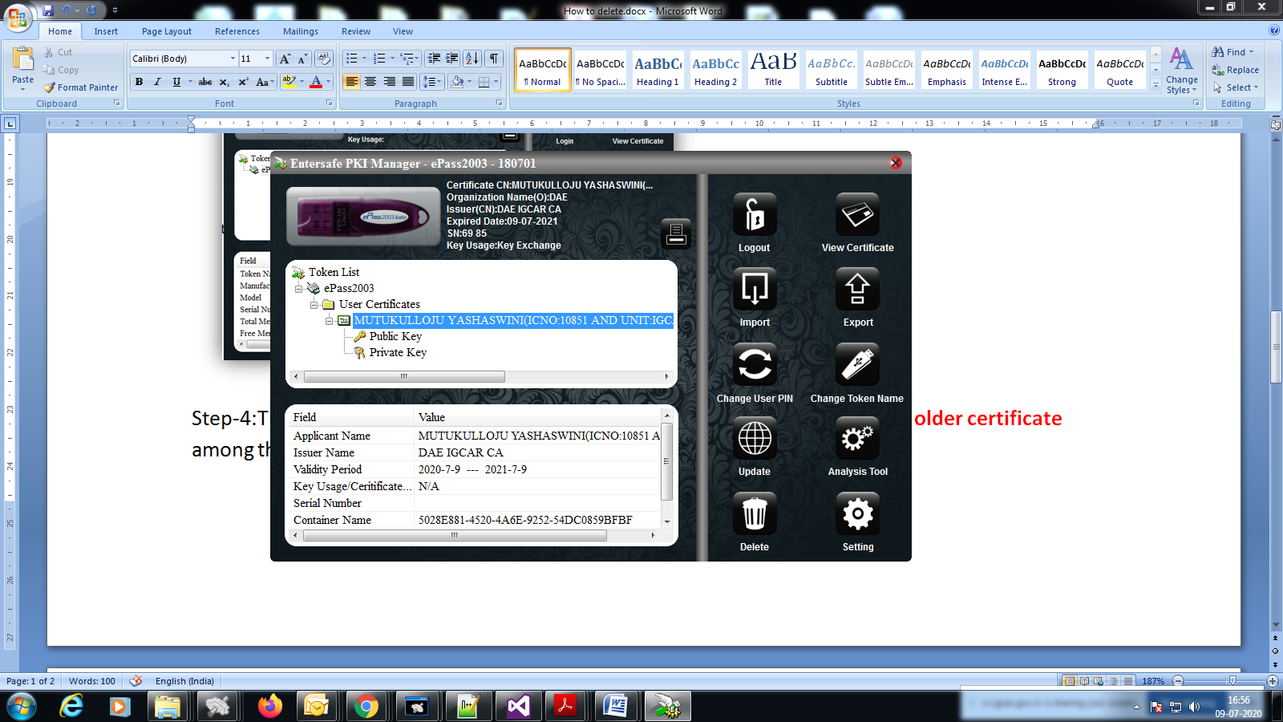

**Step-5:**After clicking on Delete icon, application will ask for **digital pin**. Enter the digital pin click on OK. Then it will ask for confirmation, click on **yes**.

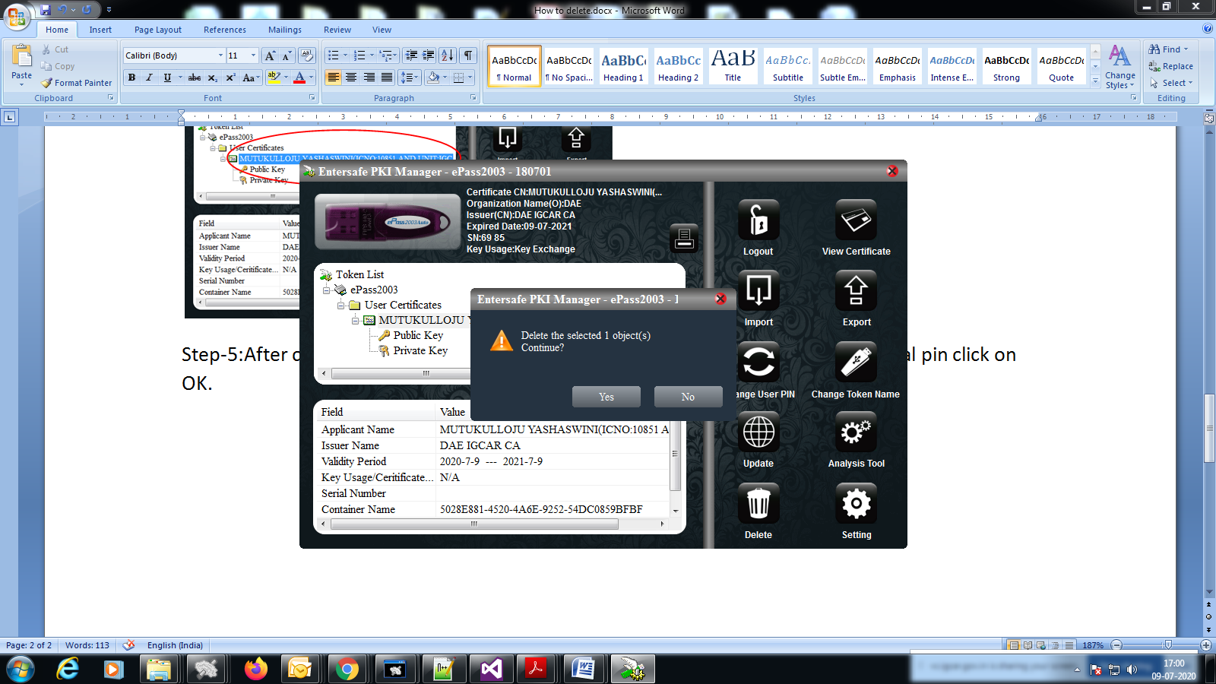

**Step-6:** click on logout icon and close the application.

***B. Instructions for the Renewal of the digital certificate***

**Step-1:** login to DSC portal(http://dsca.igcar.anunet.in). Renew button will be shown for the corresponding certificate which is expired. click on **Renew** button. As shown in below figure.

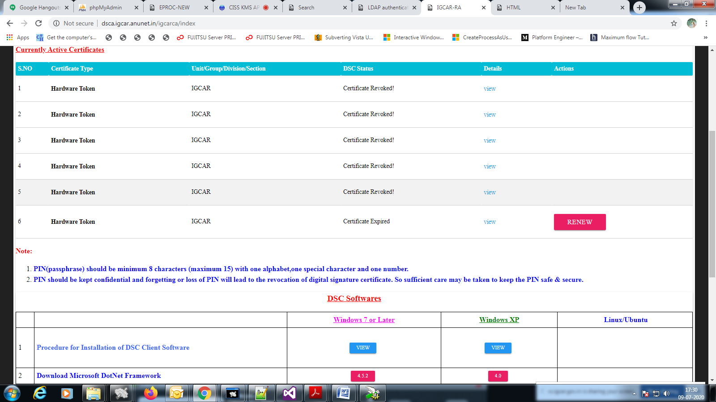

**Step-2:** Enter the new certificate pin two times and click on “Renewal request”. Then a success message will be shown. The steps are shown in below screenshots.

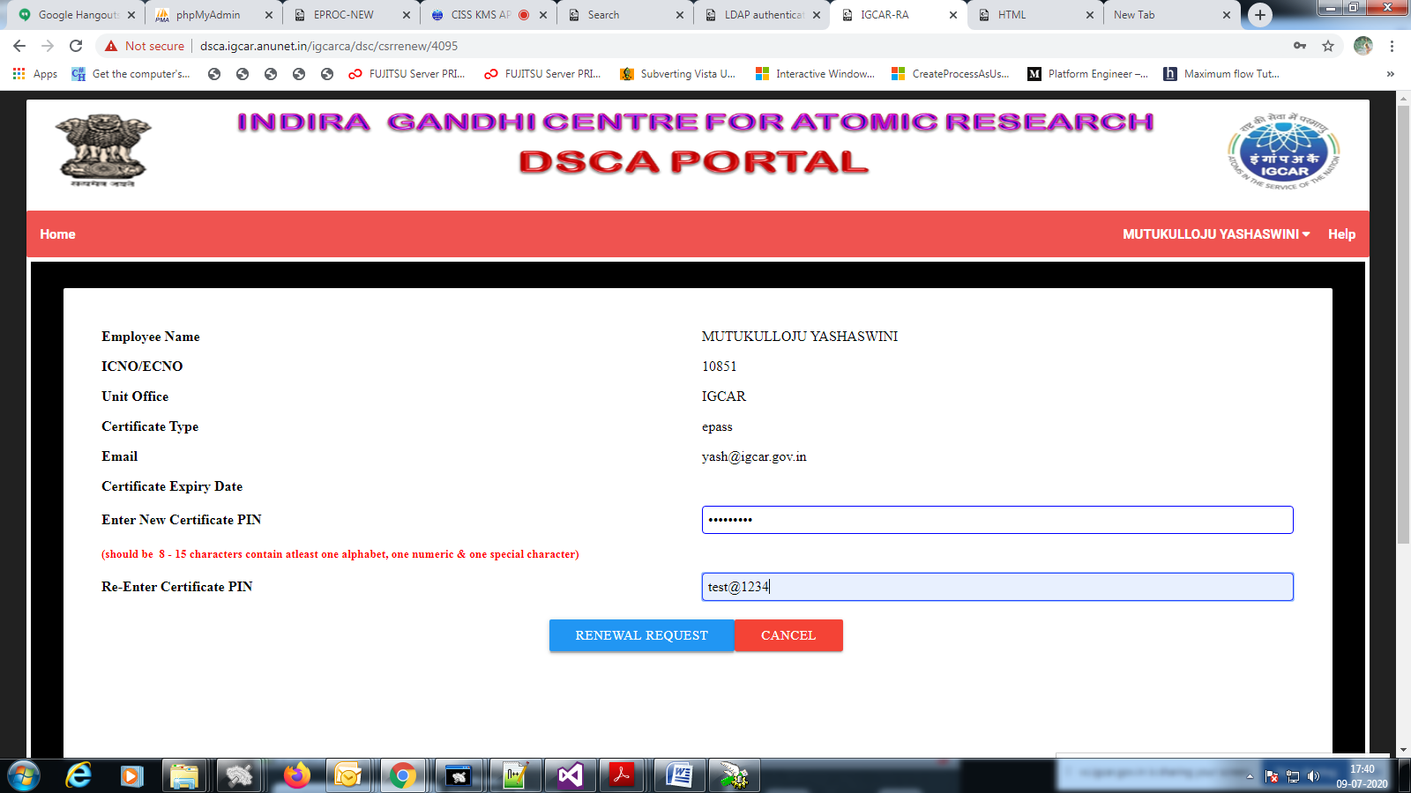

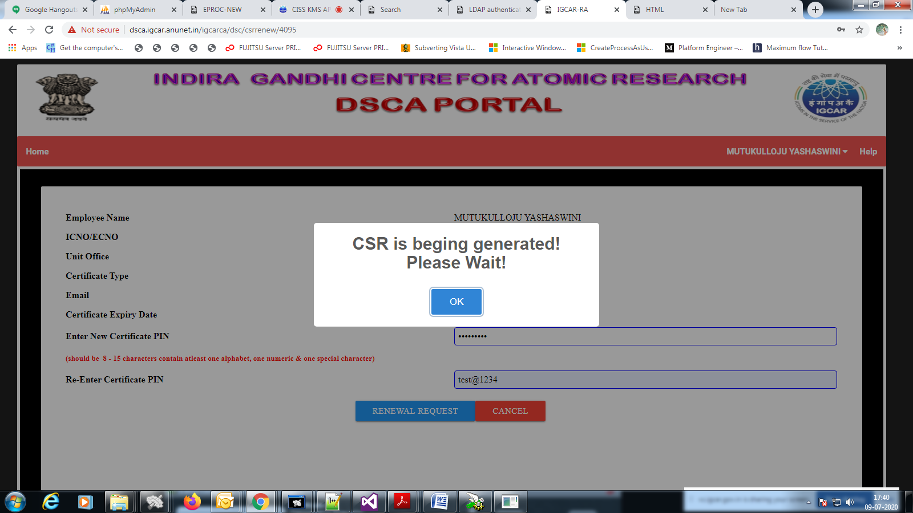

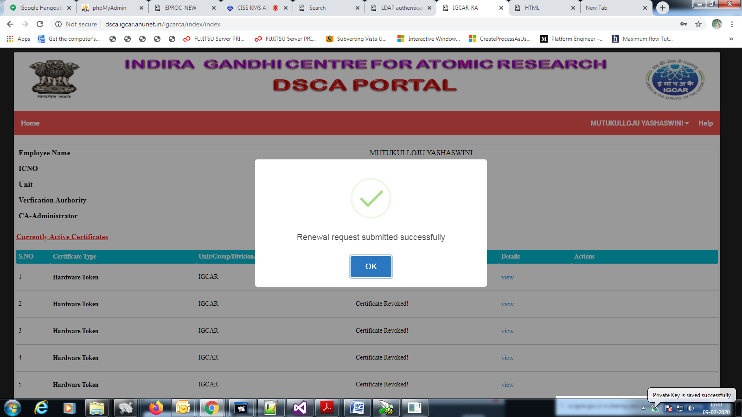

***C.Instructions to Activate the newly generated certificate***

**Step-1:** After CA approval, “activate” button will appear for the newly generated certificate.click on **activate** button.then it will redirects to another page.

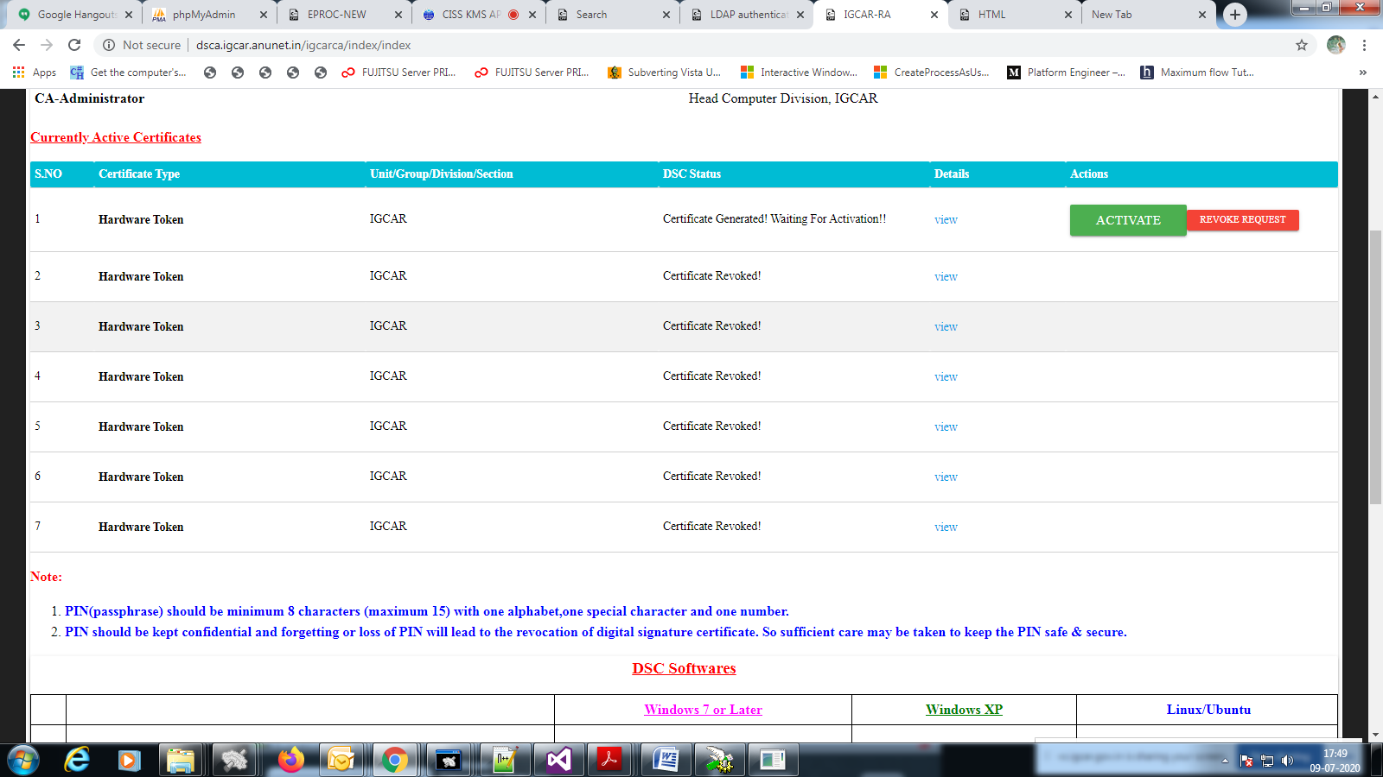

**Step-2:** Enter digital pin and click on “activate” button then it will show successful message. Procedure is shown in below screenshots.

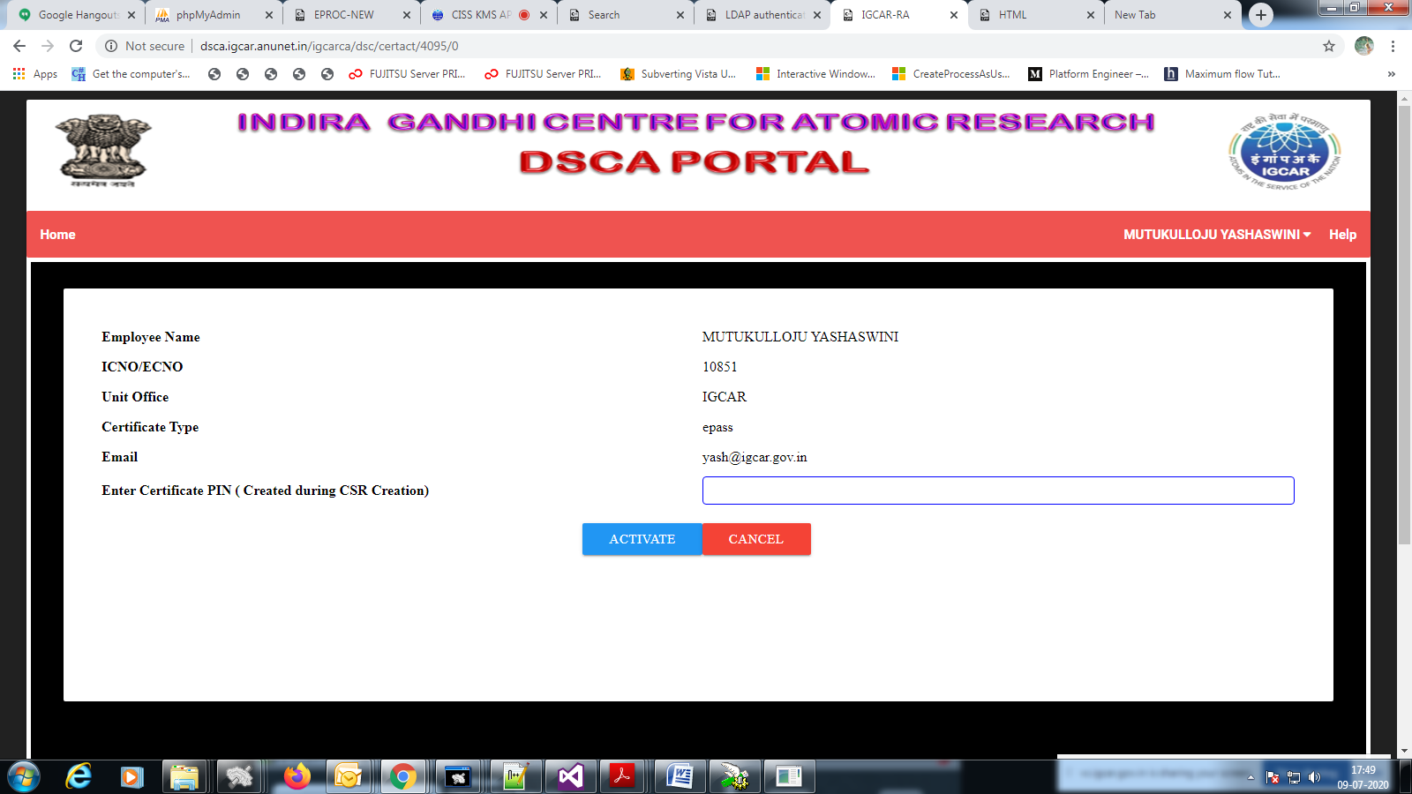

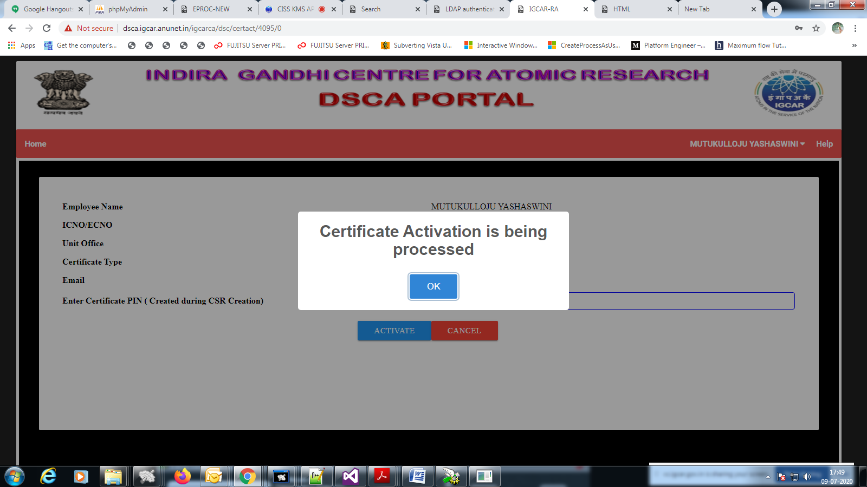

**Step-3:**Now new certificate is generated, certificate can be seen in the token. Screenshot is shown below.

