**Procedure for Renewal of DSC certificate**

***B. Instructions for the Renewal of the digital certificate***

**Step-1:** login to DSC portal(http://dsca.igcar.anunet.in). Renew button will be shown for the corresponding certificate which is expired. click on **Renew** button. As shown in below figure.

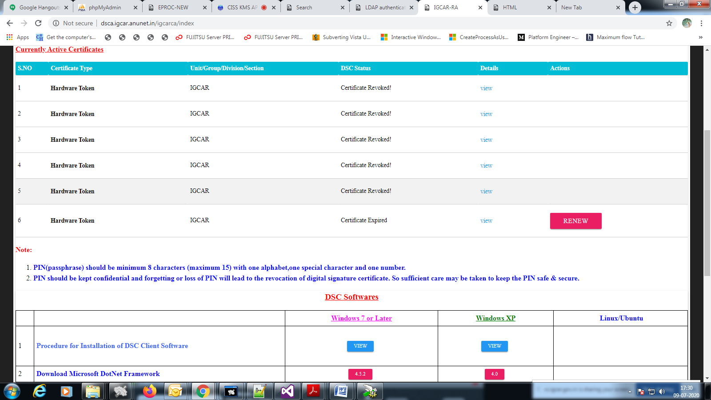

**Step-2:**After clicking on Renew, another page will open, it contains details of the employee. Click on Renew button again.it will redirects to another page.

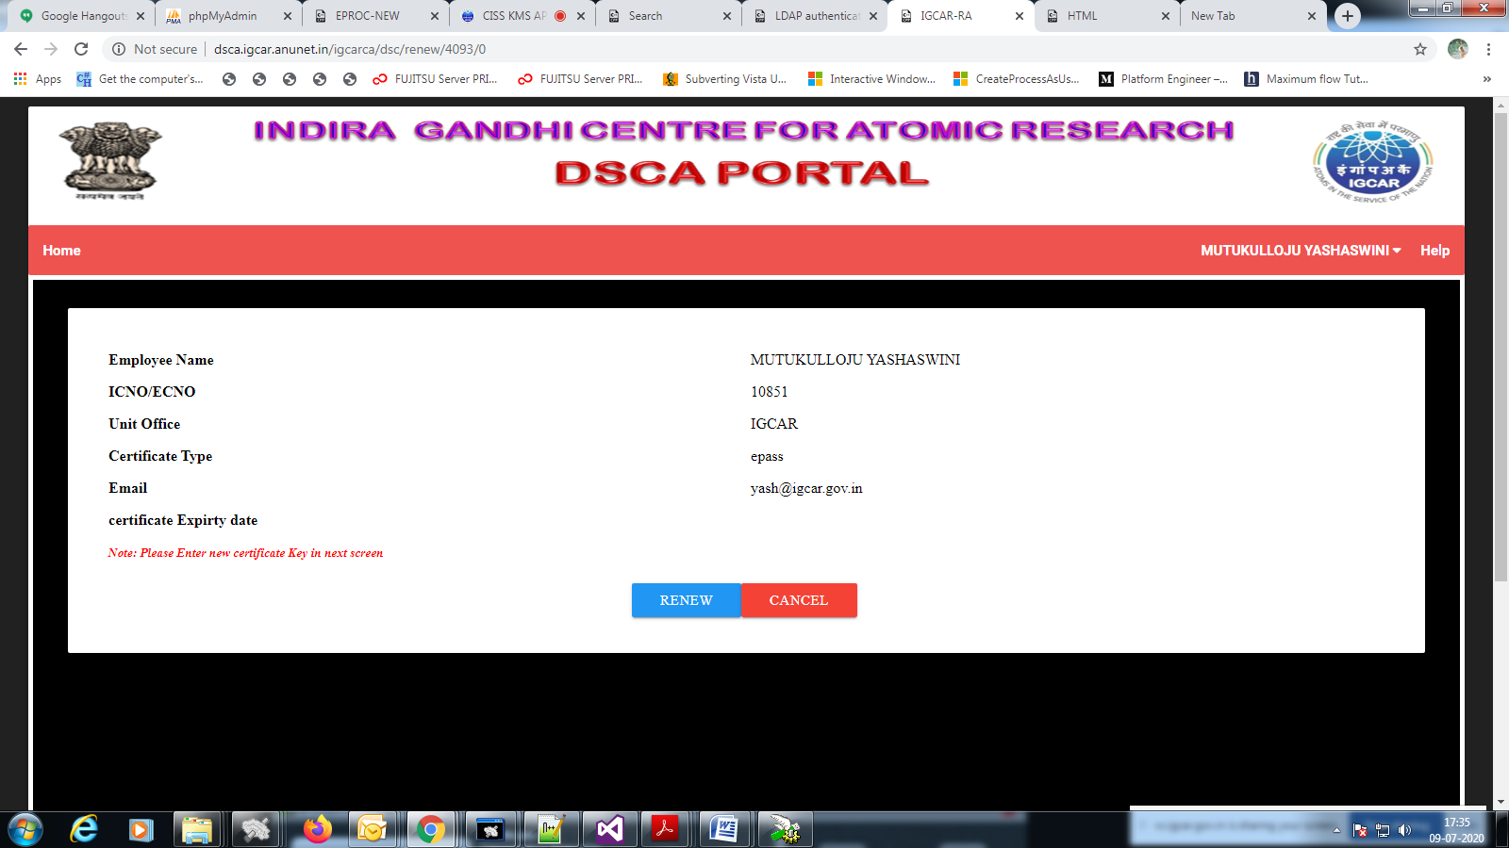

**Step-3:**Enter the new certificate pin two times and click on “Renewal request”.Then a success message will be shown. The steps are shown in below screenshots.

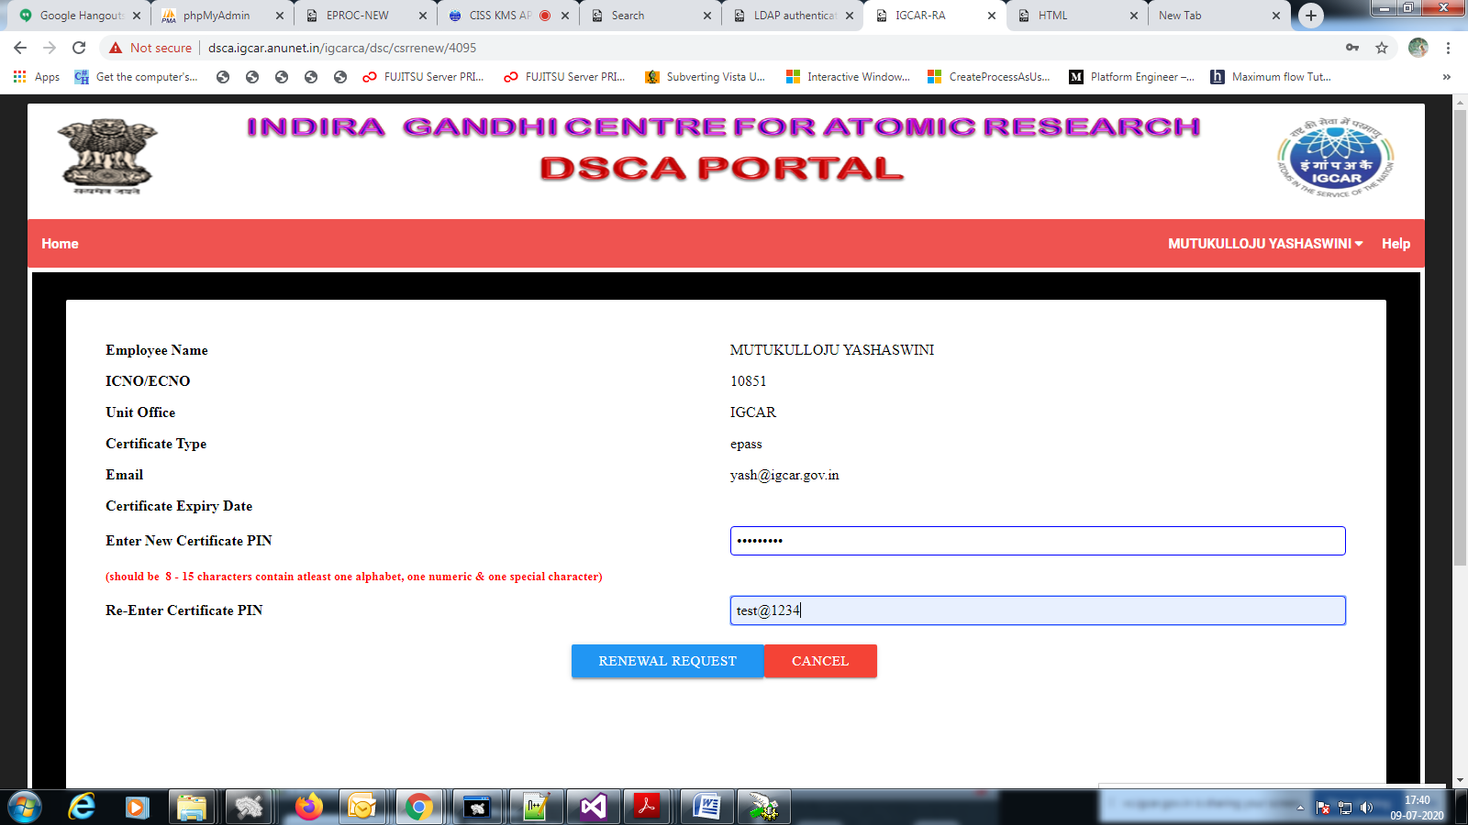

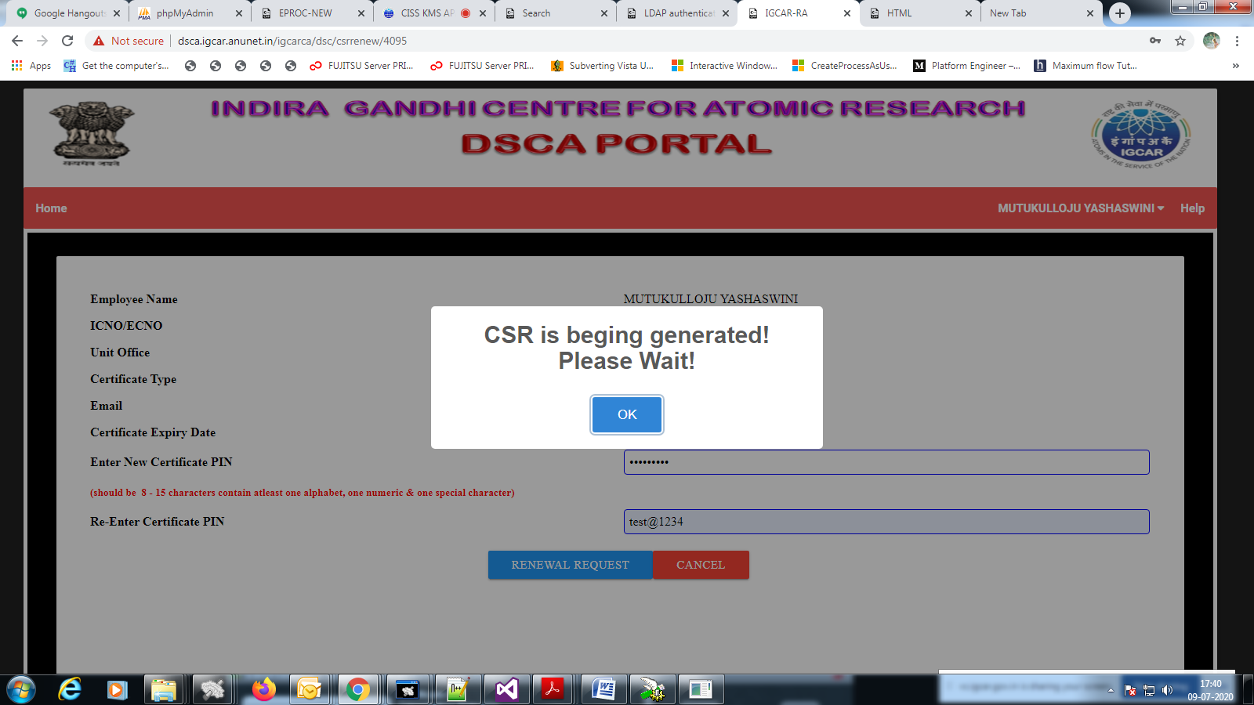

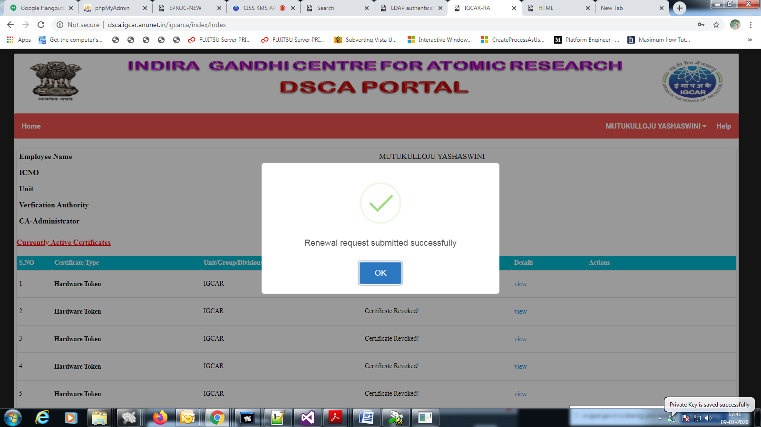

***C.Instructions to Activate the newly generated certificate***

**Step-1:** After CA approval, “activate” button will appear for the newly generated certificate.click on **activate** button.then it will redirects to another page.

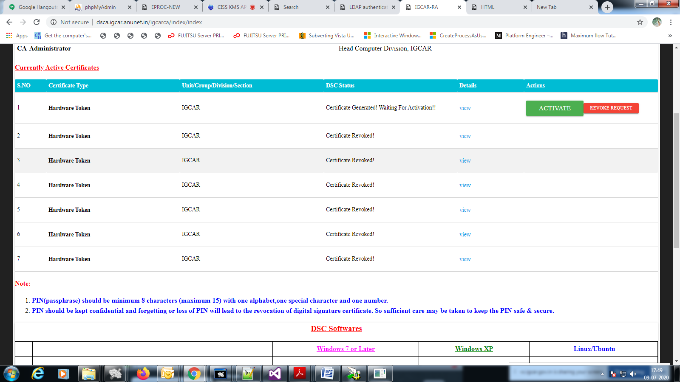

**Step-2:** Enter digital pin and click on “activate” button then it will show successful message. Procedure is shown in below screenshots.

