AC31001 Data Communications – DNS and Wireshark

Purpose of Lab and Coursework
To discover through examples how DNS (Domain Name Service) works.

The deadline for this coursework is 12:00 Noon on Friday 5th November 2010 (end of week 8), it is worth all of the coursework marks on AC31001 - 20% of your overall module mark. Expected effort (including lab hours) is 15.0 hours. This exercise is to be conducted individually.

You are reminded that material covered in practical classes may be examined in the degree examinations.

Tools
You will be using a DNS library with Java to examine DNS records. In the second half of the coursework you will be working with a network monitor called Wireshark.

Note: If you copy source code or command lines from this document it may not work as expected. Please type the commands or code yourself.

Practical Work 1: Programming DNS lookups.
Ensure that you have set drive P: as \\auntie\apps and drive Y: as \\auntie\share respectively. All the files you need are on the share drive under the following directory:

Y:\AC 3rd year modules\AC31001 Networks and Datacomms\Practical Labs\DNS\dns-2008

- Create a new directory on your U: drive for your work on this assignment
- Copy the entirety of the DNS-2009 folder from Y:\\AC 3rd year modules\AC31001 Networks and Datacomms\Practical Labs\DNS to the new directory on your u: drive
- Set the PATH for Java:
  - Open a command prompt from the start menu. (click on start, select run and type cmd press return)
  - Use the CD command to go to the new dns-2009 folder on your U: drive.
  - Type:
set PATH=p:\j2sdk1.4.1_02\bin;%PATH%
- Set the CLASSPATH
  - Type
Set CLASSPATH=. note the “.” !

You should now be ready to use Java. From the command prompt, then compile the Java lookup class:

javac lookup.java

Using Lookup to examine SOA records.
Once it is compiled you should be able to look up the SOA records for various domains. The SOA (Star of Authority) records indicate that this server is the best source of information for this domain. From the command prompt type:

java lookup computing.dundee.ac.uk

You should get a response that looks something like this (if you get a security exception ignore it and carry on).:

computing.dundee.ac.uk:
computing.dundee.ac.uk. 3600 IN SOA filegate.computing.dundee.ac.uk. acobley.computing.dunde.ac.uk. 2005102832 1800 600 86400 3600

Try looking up the following domains, and record the answers you get in a Notepad window:

bbc.co.uk
btinternet.com
demon.com
sol.co.uk
primenet.com

Notice how each of the answers, while generally the same, is slightly different.

We can alter our lookup.java program to extract information from the SOA record and display it more clearly. Open the lookup.java file in a text editor (you can use Notepad though I prefer HTML Kit ). Find the PrintAnswer method:

public static void
printAnswer(String name, Lookup lookup)

Considering the following lines:

Record [] answers = lookup.getAnswers();

This is the line that gets the record answers from the DNS server

System.out.println(answers[i]);

This simply prints the answer out. So we need to change:

for (int i = 0; i < answers.length; i++)
System.out.println(answers[i]);
To:
for (int i = 0; i < answers.length; i++){
System.out.println(answers[i]);
SOARecord SOAAnswer= (SOARecord)answers[i];
System.out.println("Host :" +SOAAnswer.getHost() );
}

Change these lines, then recompile the Java file and look up the above domains again.

There are a number of other methods in the SOARecord class for decoding other fields from the SOA record which can be tried in the same way:

- getHost()
- getAdmin()
- getSerial()
- getRefresh()
- getRetry()
- getExpire()
- getMinimum()
( These are detailed here: Y:\AC 3rd year modules\AC31001 Networks and Data Comms\Practical Labs\DNS\doc\index.html )

Use these methods to decode more of the SOA record e.g. to get the Serial number add a line such as:

System.out.println("Serial: "+record.getSerial() );

Use your modified program to lookup the SOA records to look up the domains again.

Using Lookup to Examine “A” Records

“A” records are the primary mapping between internet addresses and IP numbers. The A record for www.computing.dundee.ac.uk is:

www.computing.dundee.ac.uk. 86400 IN A 134.36.36.16

which maps the www server of computing.dundee.ac.uk to the address 134.36.36.16

Copy the original lookup.java program from the share directory again (You might want to rename the program you’ve just created to keep a copy of it). Alter the following line:

int type = Type.SOA;
so that it reads:

int type = Type.A;

Recompile the program and look up the following records, noting what you find:

www.computing.dundee.ac.uk
www.bbc.co.uk
www.btinternet.com
www.demon.com
www.sol.co.uk
www.primenet.com

NOTE: You are looking for an answer in “dot” notation (For example 134.36.36.35). If you get an answer with the IP address in HEX form (such as this 86242410 ) you will need to use a ARecord type to call the getAddress () method. This is similar to the method we used for the SOA record.

Practical Work 2: Using Wireshark
Wireshark is the world's foremost network protocol analyzer, and is the standard in many industries. The website for the software is :

http://www.wireshark.org/

Wireshark allows you to capture packets on the network in real time, save them and examine their contents at a later date. Before you begin you should read the FAQ (URL below) and also be aware of the implications of using this software. Because Wireshark collects network traffic (network sniffing) it can be used to “spy” on other network users. You should only use Wireshark to diagnose network problems, for educational purposes and in some circumstances as part of a forensic investigation. Take a look at the FAQ now:

http://www.wireshark.org/faq.html

Starting with Wireshark to investigate DNS traffic.
Start Wireshark form the start menu as normal. If you go to the menu item Capture/Interfaces you should see the network interface the machine has listed along with active IP address and the number of packets that Wireshark is seeing on the network. Take a note of the active device and close down this dialog box. We need to set the active capture device so go to capture/options. In the Interface box use the drop down menu to select the device you noted previously as the active device as shown in the example below.

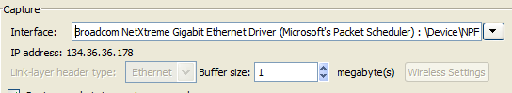

Click the start button and watch the main interface which shows the traffic on your network segment. You should see quite a lot of traffic , so much so that it’s overwhelming. There is too much information here for us to use so, we need to filter the traffic. Choose Capture/Stop from the menu to halt the network capture.
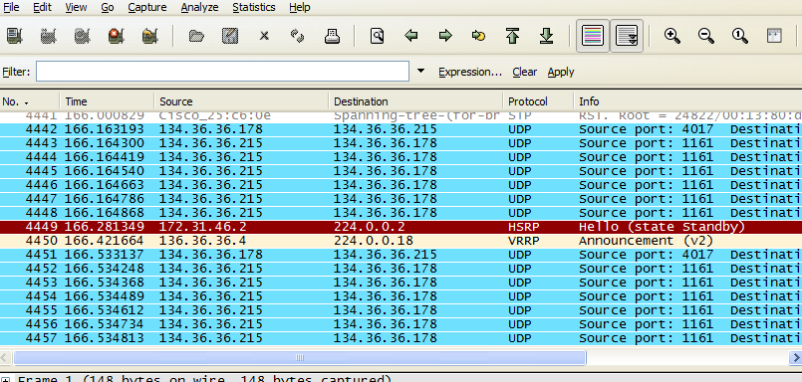

Click on Expression button (just above the data window) and scroll down to the DNS entry (in the left of the dialog box that appears) and highlight it. Then click on OK (the default condition “is present” is all we need for now. You will need to click the Apply button and then start the capture again. Now the amount of data displayed is a lot more manageable. Open a command prompt and type:

Nslookup www.computing.dundee.ac.uk

Look at the capture screen and see if you can see the DNS lookup happening.

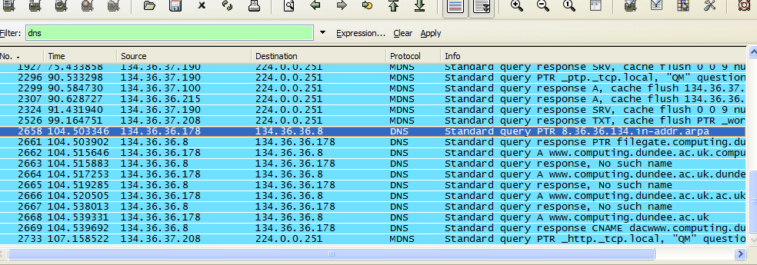

You can look at a the DNS query and answers in more detail. Select the line in the capture that says “Standard Query A www.computing.dundee.ac.uk”. In the lower pane click on the little plus sign next to the Domain Name System, (query) and then the plus sign next to the Flags section. You should then see something similar to the screen below.

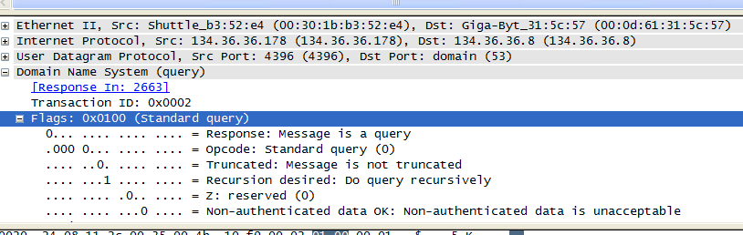

Examine the contents of the submission and the responses in some detail and try to relate what you are seeing to what you know about the IP protocol and DNS in particular.

Questions for you to Answer for your submission
- Find the final response to your query, there are two answers in the data, what are they and why are there 2 answers?

- If you used nslookup you will see that there are a number of “no such name” responses in the data. By looking into the packets why do you think this is happening? Use one of your java programs to do the same sort of lookup you will see that it doesn’t get these responses, why do you think this is?

- Start a new capture and get a friend on another machine to do a nslookup (of www.computing.dundee.ac.uk for instance). Do you see that query being captured? If not why not? (You will need to think about the possible topology of the departmental network.)

- Think about your answer to question 3 and the data you’ve captured. You should have seen some captured data using the protocol MDNS. Do some research and write a paragraph explaining what this protocol is and what it is used for. Why did these packets show up in your data capture?

COURSEWORK SUBMISSION

Please submit hard copy of your coursework answers to the AC31001 coursework box by the deadline 12:00 Noon on Friday 14th November 2008 (end of week 8).

1. You should have SOA records for:
bbc.co.uk
btinternet.com
demon.com
sol.co.uk
primenet.com
and A records for:
www.computing.dundee.ac.uk
www.bbc.co.uk
www.btinternet.com
www.demon.com
www.sol.co.uk
www.primenet.com
Print out a list of the records you obtained for all of these. [ 10 % ]

2. Use resources on the internet and in relevant documentation to discover what the following fields in the SOA record mean, and write a brief description of each:
Host
Admin
Serial
Refresh
Retry
Expire
Minimum [ 10 % ]

3. There are a number of other record types that the DNS library can look up. Modify your program to:
- find out the IP address of the mail server for Applied Computing e.g. if mail is sent to acobley@computing.dundee.ac.uk, what is the address of the SMTP server that a mail program must attach to? You will find that there is more than one address for the mailserver, your program should print the IP address for each of them. Which is the primary mailserver for the department ? [ 20 % ]

- find the primary name server for the domain bbc.co.uk (any site on the Internet will have a primary “Name Server”). Again, you may find there is more than Name Server, again your program should print out the IP address for each. [ 20 % ]

Submit both your code and program output for part 3.
Hint: your solution will involve what you have seen before, including MX and NS records – the remainder you should work out for yourself.

4. Include your answers to part 2 (Wireshark) in your submission. That is:

- Find the final response to your query, there are two answers in the data, what are they and why are there 2 answers?

- If you used nslookup you will see that there are a number of “no such name” responses in the data. By looking into the packets why do you think this is happening? If you use your java program you will see that it doesn’t get these responses, why do you think this is?

- Start a new capture and get another student on another machine to do a nslookup (of www.computing.dundee.ac.uk for instance). Do you see that query being captured? If not why not? (You will need to think about the possible topology of the departmental network.)

- Thinking about your answer to question 3 and the data you’ve captured. You should have seen some captured data using the protocol MDNS. Do some research and write a paragraph explaining what this protocol is and what it is used for. Why did these packets show up in your data capture?

[ 40 % ]

END OF COURSEWORK

