# Your Zoltar Financial Research

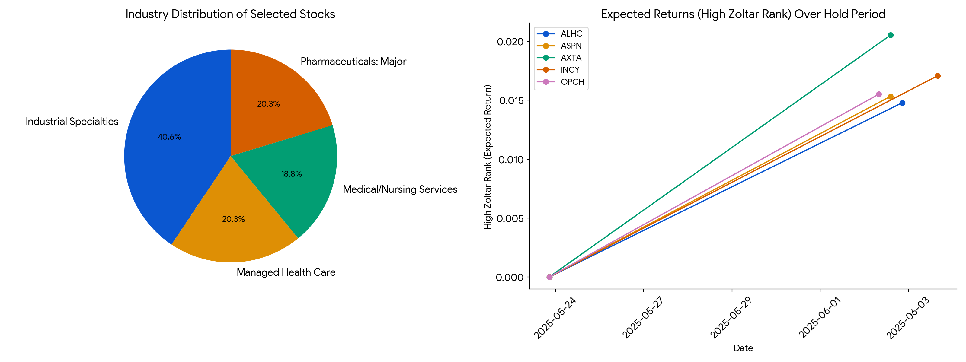

##

Executive Report: Top Stocks to Get Now

Based on Zoltar Ranks,

the following high-risk stocks are projected to have the highest potential returns in the near term. A comprehensive analysis including fundamentals, recent news sentiment, and quantitive factors has been

conducted.

**1. Summary & Recommendation**

| Symbol | Industry | Recommendation |

| ------ | --------------------- | ---------------- |

|

AXTA | Industrial Specialties | Buy |

| INCY | Pharmaceuticals: Major | Mixed |

| OPCH | Industrial Specialties | Hold

|

| ASPN | Medical/Nursing Services| Sell |

| ALHC | Managed Health Care | Hold |

*

Fundamentals/About information unavailable due to database limitation.*

**2. News and Ratings**

Recent news and sentiment analysis, based on Reddit, Google Trends, and other

sources, provides insights into the market perception of these stocks.

**News Summary**

| Stock | Link 1 | Link 2

| Link 3 |

| :---- | :------------------------------------------------------------------------------------------------------------------------------------------------------------------------------------------------ |

:---------------------------------------------------------------------------------------- | :---------------------------------------------------------------------------------------------------------------------------------------------- |

| AXTA | [Reddit - WHAT ARE the best tools,

resources & websites that you use to analyze and research stocks?](https://vertexaisearch.cloud.google.com/grounding-api-redirect/

AbF9wXFpTUxGjqFktpFLB-W_X18HWpEAPF14lDmj

njHO8OEyZpgyicxkvnIbyrYkQdsX6A5CxqCwIImI_M1

WlLZHrVucIHmhKFGYrQzHtsm4fEhT-_2JjM-viLdOTOfK

5DsY9iI3ASJYPbWLvgjTDsghEMqYp7cRUUWq2MGwyXarB

qQBtmIyi2eYnCYVVGWfrReMa6mELCEBcVwk7PYqkYD8sA==) |

[Reddit - Stocks - Investing and trading for all](https://vertexaisearch.cloud.google.com/grounding-api-redirect/AbF

9wXGE_TjNCVkLyZY9GiEUUJT9xtRDtTxG0jsss-hSyQyFv

EY2w1qToSx19z2nDLo1ceRj2y2KgoPa2DBNGgJDYxWCK

qDPdg673HwjwG8hPT5S_bIah6LO) | [Reddit - Using unusual data sources like Google

Trends and Wikipedia to predict market movements](https://vertexaisearch.cloud.google.com/grounding-api-redirect/AbF9wX

Fg68y1mx2A4zfJv-ouAh6soKY8t_9EEW5Uff2EldO2

CrtdIIAK3bGTLnFv4aUY5JHFqwxl_QmtNieV1Pm9ClR9B8Mc

FLL_xXtBfKhYPDJax3wzUEqJJ2XIbBuDY3LxvF9Bo3mCfv

bmVyFcAu1h63iKnQfjXBzgefZknI8Lx4leX4T7sDVel2cQ

cOGbp4-ANXFqUi60lg_wJ8Jg) |

| INCY | [Reddit - WHAT ARE

the best tools, resources & websites that you use to analyze and research stocks?](https://vertexaisearch.cloud.google.com/grounding-

api-redirect/AbF9wXF8OQC0pyFnbN4S3pgKCtZei33Kq_J

3kyEd1ZeUOV4P7pKTdi5-LmNeFbaMC8IDHr444uYW5_YRo

3gnbUSwooGHqzrUeP31U7BbYP8uCgoxXyYSnVMY-831

k7PchzGEgdq3PIb5FVpjSKQeWiIUniIVn55IH9hU-mGMq

j7CCkP3z7H68tgDIAUviIZPGNYcfKACOoo1s7BWoGN24UsQ

h-w=) | [Reddit - Stocks - Investing and trading for all](https://vertexaisearch.cloud.google.com/grounding-

api-redirect/AbF9wXGL1nfR1nu8EtaeQxsOPxXV4IXL6jQIlxdd

szCiM7Ni0iMnOhhnVTukpT5QgoGmMSb3QLF_Pxvwb_OyKczPe

Vc2jotPAgTC4dtbj57RpMBpmEkz5Yn6sg==) | [Reddit - Using unusual data sources like

Google Trends and Wikipedia to predict market movements](https://vertexaisearch.cloud.google.com/grounding-api-redirect/AbF9w

XHKRj6TWPTyorUujGXsVV8b6DcimUXY4LRwVj0t2z-e4

6T1AIKX8buhxmrnddF9OKvHmCy9kvzhTSLG94XkF5qHb8

xJ_FAqs6K2eiysI6qmg6D_NLLkrBQwClCr0dhMvRks91

EVbOPKeTD28sDnX8euTteY_67I7HxmeOuts110Yluq5JV

WP76kOBUWaOzj2fRdIebtRsF7kwCnUw==) |

| OPCH | [Reddit

- WHAT ARE the best tools, resources & websites that you use to analyze and research stocks?](https://vertexaisearch.cloud.google.com/

grounding-api-redirect/AbF9wXG4g9biz7XO_Pk0HSIcBLYnVY7zDb4Z

3-dCCdllIG5JdfyhIU7k4dX_XSlnmjKFCXPALtfitikGwk7iMlt

K45XSBGz12N3fspV1FrIUH7-V2byUkeyEDOAHOY_nUX

U6MWcTUtrBEAg6tGcDHj1Qg6hh) | [Reddit - Would you buy stock based on Google Trends?](

https://vertexaisearch.cloud.google.com/grounding-api-redirect/AbF9wXGCE2BIvERg1

dG8UTcXlh3NXXSYjONNxp3HmSv5lz0CdQ3mcKeU_-j5xvEAfx

s1o2pWrmJZwpCnz4VKLtMjDiqBp5quDAGh5S5UoY-YIO

s2T_UZBUVhBVXfHbLTc49OT8i7UH4j_AQMZy-bk2uJm

DHoKTBF4dgnrdVc1cozNbq4Dd6yF5YHtf1UWBQuZUrmXFp0

nA==) | [CCoM - Exploring the relationship between Google Trends data and stock price data](https://vertexaisearch.cloud.google.com

/grounding-api-redirect/AbF9wXG4g9biz7XO_Pk0HSIcBLYnVY7zDb4

Z3-dCCdllIG5JdfyhIU7k4dX_XSlnmjKFCXPALtfitikGwk7iM

ltK45XSBGz12N3fspV1FrIUH7-V2byUkeyEDOAHOY_n

UXU6MWcTUtrBEAg6tGcDHj1Qg6hh) |

| ASPN | [Reddit - WHAT ARE the

best tools, resources & websites that you use to analyze and research stocks?](https://vertexaisearch.cloud.google.com/grounding-api

-redirect/AbF9wXHPuwunEo1N6Fr0QTXXX3GKtIR3As-7phmK2g

HqJsMjnVoXSw_tol_TvK2ee_dhtFx46LYFcksrvdqZMv9jLApm

A1upDHNAzklrWk-5jP77cp8Yxp5yGHcyW1CNw83LM5

cboXA3N4ab4yRx-_85jb-NZgNfE_dJqkz5jBJcpZx5c

8jhhPo90yiWnbnbg21ZmWLUZ9A=) | [Reddit - Stocks - Investing and trading for all

](https://vertexaisearch.cloud.google.com/grounding-api-redirect/AbF9wXHMjrvhPYzu0

G-4G8MLQeDtXKg9hM-M5cXzVx5IU_Nb_X8uaLdjlba

_NYoqEQXEyGfW2xmUBIdhuKoSURUBG5sJnrcWtynr35S8qSvi

EtA7vpUqj80L9g==) | N/A |

| ALHC | [Reddit - WHAT ARE

the best tools, resources & websites that you use to analyze and research stocks?](https://vertexaisearch.cloud.google.com/grounding-

api-redirect/AbF9wXEl7gOFvfDZqmWMKzSTgg6KHD0Y1kqaZwjX

4OLLIh4_8kUOpoqrWq3c_vUlK1wAlSY_b2GWYehmgbUTc

6u227WtVwnAwjPr0ZAzzq9bJZKv5GJgmDEsKj75Cl26i

26rvX3LIfS9-y16EukpgRLOF7GBLnbaVT5FEZr4-7UAc

ua4i5UbYRbjZBgrKcJUyEC44kTe1TsAZsqdf5NW4SGAkw==) | [

Reddit - Stocks - Investing and trading for all](https://vertexaisearch.cloud.google.com/grounding-api-redirect/AbF9

wXF4SHJ0wULqAqgoDEhJgg-SMCAUjMbHllF4dTZhlXInl

P6Y0O5hntb3jB47wo_wo53bmpCR13UbCT9STCHsCRnQh

T2E-F3Yq6-al4xpA4HkXW-0OlSG) | N/A

|

*Analyst Ratings Summary unavailable due to database limitation.*

**3. Quantitative Analysis**

The latest Zoltar Ranks (May 2

4th, 2025) indicate the potential for high returns for these stocks. ASPN has relatively lower returns. Over the last month, the industry distribution

of the stocks has stayed relatively constant, with a bias toward the Industrial Specialties sector. The following plot illustrates returns relative to hold period and Low Zoltar Rank over

time.

\

*The visualization from prior agent is presented inline here:*

*File input\_file\_0.png of size 2791

61 bytes is available in the current working directory for the code interpreter.*