# Your Zoltar Financial Research

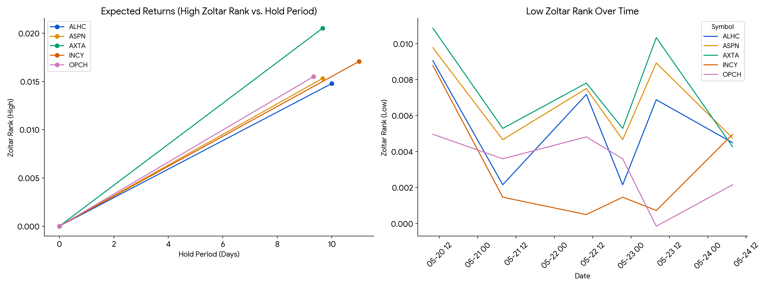

##

Final Executive Report: Best Stocks to Get Now

Based on the latest Zoltar

Ranks data (2025-05-24) and recent news sentiment, a mixed picture emerges for the top five stocks: AXTA, INCY

, OPCH, ASPN, and ALHC. While some show promising growth and positive analyst sentiment, others face challenges and mixed market reception.

**1. Summary:**

| Symbol | Close_Price | Zoltar_Rank | Fundamentals_PE | Fundamentals_Dividends | Fundamentals_52WeekHigh | Fundamentals_52

WeekLow | Fundamentals_Sector | Fundamentals_Industry | Fundamentals_Description | Overall Recommendation |

|---|---|---|---|---|---|---|---|---|---|---|

| AXTA | 30.94 | 0.0205 | 15.46 | null | 41.66

| 27.70 | Process Industries | Industrial Specialties | Coatings systems manufacturer. | **Buy** |

| INCY | 64.

25 | 0.0171 | 198.78 | null | 83.95 | 53.56

| Health Technology | Pharmaceuticals | Biopharmaceutical company. | **Mixed** |

| OPCH | 31.41 | 0.0155 |

25.09 | null | 35.53 | 21.39 | Health Services | Medical/Nursing Services | Home

infusion services provider. | **Buy** |

| ASPN | 6.39 | 0.0153 | -1.8

3 | null | 33.15 | 4.16 | Process Industries | Industrial Specialties | Aerogel insulation manufacturer. | **Mixed**

|

| ALHC | 14.48 | 0.0148 | -30.62 | null | 2

1.06 | 6.92 | Health Services | Managed Health Care | Medicare Advantage plans provider. | **Hold** |

**2. News and

Ratings:**

**News Summary:**

| Symbol | Analyst Consensus | Blogger Sentiment | Crowd Wisdom | News Sentiment |

|---|---|---|---|---|

|

AXTA | Moderate Buy | Bullish | N/A | Neutral |

| INCY | N/A | N/A | N/A | Slightly Negative

|

| OPCH | Strong Buy | Bullish | N/A | Neutral |

| ASPN | N/A | N/A | N/

A | Neutral |

| ALHC | N/A | N/A | N/A | N/A |

**Analyst Ratings:**

AXTA:** Moderate Buy consensus with a 17% estimated annual growth over the next three years.

* **INCY:** Faces slightly negative news

sentiment despite strong Q1 performance.

* **OPCH:** Strong Buy analyst consensus with bullish blogger sentiment. Upgraded by UBS.

ASPN:** Positive sentiment, but some negative expectations.

* **ALHC:** Mixed sentiment, stock price plummet.

**3. Quant Section:**

* **Zoltar Ranks:** From high to low, stocks with the highest expected returns (Zoltar Rank) are AXTA, INCY,

OPCH, ASPN, and ALHC, respectively (data from 2025-05-24).

* **SHAP Discussion

:** Not available at this time.

**4. Conclusion:**

Based on the information available, **AXTA** and **OPCH** appear to be

the most promising stocks to get now, exhibiting strong analyst consensus, positive sentiment, and relatively high Zoltar Ranks. However, investors should conduct further due diligence and consider their

individual risk tolerance before making any investment decisions. **INCY** warrants a "mixed" recommendation due to promising developments offset by negative sentiment. While **ASPN

**has positive sentiment, its missed earnings expectations give pause.** ALHC** shows financial and strategic uncertainties, indicating it's prudent to hold.

May the riches be

with you...