Your Zoltar Financial Research
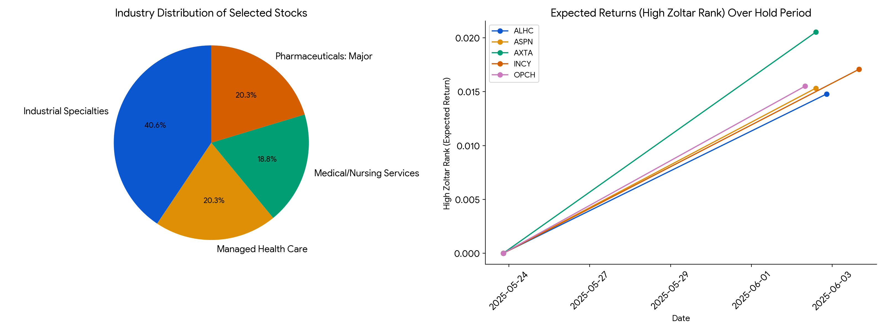
##
Executive Report: Top Stocks to Get Now

Based on Zoltar Ranks,
the following high-risk stocks are projected to have the highest potential returns in the near term. A comprehensive analysis including fundamentals, recent news sentiment, and quantitive factors has been
conducted.

1. Summary & Recommendation

| Symbol | Industry | Recommendation |
| ------ | --------------------- | ---------------- |
|
AXTA | Industrial Specialties | Buy |
| INCY | Pharmaceuticals: Major | Mixed |
| OPCH | Industrial Specialties | Hold
|
| ASPN | Medical/Nursing Services| Sell |
| ALHC | Managed Health Care | Hold |

*
Fundamentals/About information unavailable due to database limitation.*

2. News and Ratings

Recent news and sentiment analysis, based on Reddit, Google Trends, and other
sources, provides insights into the market perception of these stocks.

News Summary

| Stock | Link 1 | Link 2
| Link 3 |
| :---- | :------------------------------------------------------------------------------------------------------------------------------------------------------------------------------------------------ |
:---------------------------------------------------------------------------------------- | :---------------------------------------------------------------------------------------------------------------------------------------------- |
| AXTA | [Reddit - WHAT ARE the best tools,
resources & websites that you use to analyze and research stocks?](https://vertexaisearch.cloud.google.com/grounding-api-redirect/
AbF9wXFpTUxGjqFktpFLB-W_X18HWpEAPF14lDmj
njHO8OEyZpgyicxkvnIbyrYkQdsX6A5CxqCwIImI_M1
WlLZHrVucIHmhKFGYrQzHtsm4fEhT-_2JjM-viLdOTOfK
5DsY9iI3ASJYPbWLvgjTDsghEMqYp7cRUUWq2MGwyXarB
qQBtmIyi2eYnCYVVGWfrReMa6mELCEBcVwk7PYqkYD8sA==) |
[Reddit - Stocks - Investing and trading for all](https://vertexaisearch.cloud.google.com/grounding-api-redirect/AbF
9wXGE_TjNCVkLyZY9GiEUUJT9xtRDtTxG0jsss-hSyQyFv
EY2w1qToSx19z2nDLo1ceRj2y2KgoPa2DBNGgJDYxWCK
qDPdg673HwjwG8hPT5S_bIah6LO) | [Reddit - Using unusual data sources like Google
Trends and Wikipedia to predict market movements](https://vertexaisearch.cloud.google.com/grounding-api-redirect/AbF9wX
Fg68y1mx2A4zfJv-ouAh6soKY8t_9EEW5Uff2EldO2
CrtdIIAK3bGTLnFv4aUY5JHFqwxl_QmtNieV1Pm9ClR9B8Mc
FLL_xXtBfKhYPDJax3wzUEqJJ2XIbBuDY3LxvF9Bo3mCfv
bmVyFcAu1h63iKnQfjXBzgefZknI8Lx4leX4T7sDVel2cQ
cOGbp4-ANXFqUi60lg_wJ8Jg) |
| INCY | [Reddit - WHAT ARE
the best tools, resources & websites that you use to analyze and research stocks?](https://vertexaisearch.cloud.google.com/grounding-
api-redirect/AbF9wXF8OQC0pyFnbN4S3pgKCtZei33Kq_J
3kyEd1ZeUOV4P7pKTdi5-LmNeFbaMC8IDHr444uYW5_YRo
3gnbUSwooGHqzrUeP31U7BbYP8uCgoxXyYSnVMY-831
k7PchzGEgdq3PIb5FVpjSKQeWiIUniIVn55IH9hU-mGMq
j7CCkP3z7H68tgDIAUviIZPGNYcfKACOoo1s7BWoGN24UsQ
h-w=) | [Reddit - Stocks - Investing and trading for all](https://vertexaisearch.cloud.google.com/grounding-
api-redirect/AbF9wXGL1nfR1nu8EtaeQxsOPxXV4IXL6jQIlxdd
szCiM7Ni0iMnOhhnVTukpT5QgoGmMSb3QLF_Pxvwb_OyKczPe
Vc2jotPAgTC4dtbj57RpMBpmEkz5Yn6sg==) | [Reddit - Using unusual data sources like
Google Trends and Wikipedia to predict market movements](https://vertexaisearch.cloud.google.com/grounding-api-redirect/AbF9w
XHKRj6TWPTyorUujGXsVV8b6DcimUXY4LRwVj0t2z-e4
6T1AIKX8buhxmrnddF9OKvHmCy9kvzhTSLG94XkF5qHb8
xJ_FAqs6K2eiysI6qmg6D_NLLkrBQwClCr0dhMvRks91
EVbOPKeTD28sDnX8euTteY_67I7HxmeOuts110Yluq5JV
WP76kOBUWaOzj2fRdIebtRsF7kwCnUw==) |
| OPCH | [Reddit
- WHAT ARE the best tools, resources & websites that you use to analyze and research stocks?](https://vertexaisearch.cloud.google.com/
grounding-api-redirect/AbF9wXG4g9biz7XO_Pk0HSIcBLYnVY7zDb4Z
3-dCCdllIG5JdfyhIU7k4dX_XSlnmjKFCXPALtfitikGwk7iMlt
K45XSBGz12N3fspV1FrIUH7-V2byUkeyEDOAHOY_nUX
U6MWcTUtrBEAg6tGcDHj1Qg6hh) | [Reddit - Would you buy stock based on Google Trends?](
https://vertexaisearch.cloud.google.com/grounding-api-redirect/AbF9wXGCE2BIvERg1
dG8UTcXlh3NXXSYjONNxp3HmSv5lz0CdQ3mcKeU_-j5xvEAfx
s1o2pWrmJZwpCnz4VKLtMjDiqBp5quDAGh5S5UoY-YIO
s2T_UZBUVhBVXfHbLTc49OT8i7UH4j_AQMZy-bk2uJm
DHoKTBF4dgnrdVc1cozNbq4Dd6yF5YHtf1UWBQuZUrmXFp0
nA==) | [CCoM - Exploring the relationship between Google Trends data and stock price data](https://vertexaisearch.cloud.google.com
/grounding-api-redirect/AbF9wXG4g9biz7XO_Pk0HSIcBLYnVY7zDb4
Z3-dCCdllIG5JdfyhIU7k4dX_XSlnmjKFCXPALtfitikGwk7iM
ltK45XSBGz12N3fspV1FrIUH7-V2byUkeyEDOAHOY_n
UXU6MWcTUtrBEAg6tGcDHj1Qg6hh) |
| ASPN | [Reddit - WHAT ARE the
best tools, resources & websites that you use to analyze and research stocks?](https://vertexaisearch.cloud.google.com/grounding-api
-redirect/AbF9wXHPuwunEo1N6Fr0QTXXX3GKtIR3As-7phmK2g
HqJsMjnVoXSw_tol_TvK2ee_dhtFx46LYFcksrvdqZMv9jLApm
A1upDHNAzklrWk-5jP77cp8Yxp5yGHcyW1CNw83LM5
cboXA3N4ab4yRx-_85jb-NZgNfE_dJqkz5jBJcpZx5c
8jhhPo90yiWnbnbg21ZmWLUZ9A=) | [Reddit - Stocks - Investing and trading for all
](https://vertexaisearch.cloud.google.com/grounding-api-redirect/AbF9wXHMjrvhPYzu0
G-4G8MLQeDtXKg9hM-M5cXzVx5IU_Nb_X8uaLdjlba
_NYoqEQXEyGfW2xmUBIdhuKoSURUBG5sJnrcWtynr35S8qSvi
EtA7vpUqj80L9g==) | N/A |
| ALHC | [Reddit - WHAT ARE
the best tools, resources & websites that you use to analyze and research stocks?](https://vertexaisearch.cloud.google.com/grounding-
api-redirect/AbF9wXEl7gOFvfDZqmWMKzSTgg6KHD0Y1kqaZwjX
4OLLIh4_8kUOpoqrWq3c_vUlK1wAlSY_b2GWYehmgbUTc
6u227WtVwnAwjPr0ZAzzq9bJZKv5GJgmDEsKj75Cl26i
26rvX3LIfS9-y16EukpgRLOF7GBLnbaVT5FEZr4-7UAc
ua4i5UbYRbjZBgrKcJUyEC44kTe1TsAZsqdf5NW4SGAkw==) | [
Reddit - Stocks - Investing and trading for all](https://vertexaisearch.cloud.google.com/grounding-api-redirect/AbF9
wXF4SHJ0wULqAqgoDEhJgg-SMCAUjMbHllF4dTZhlXInl
P6Y0O5hntb3jB47wo_wo53bmpCR13UbCT9STCHsCRnQh
T2E-F3Yq6-al4xpA4HkXW-0OlSG) | N/A
|

*Analyst Ratings Summary unavailable due to database limitation.*

3. Quantitative Analysis

The latest Zoltar Ranks (May 2
4th, 2025) indicate the potential for high returns for these stocks. ASPN has relatively lower returns. Over the last month, the industry distribution
of the stocks has stayed relatively constant, with a bias toward the Industrial Specialties sector. The following plot illustrates returns relative to hold period and Low Zoltar Rank over
time.

\
*The visualization from prior agent is presented inline here:*

*File input\_file\_0.png of size 2791
61 bytes is available in the current working directory for the code interpreter.*

