Evaluation Report of the chromebook achievement program

Gilbert S. Apodaca

Submitted to Dr. John Thompson, ED Tech 505

Table of Contents

**Summary** 3

**Program Description** 3

Program Objectives 4

Program Components 4

**Evaluation Method** 4

Participants 4

Procedures 5

Data Sources 5

**Results** 6

**Discussion** 8

**Program Evaluation Cost** 11

**Appendix A – Student Performance Information** 12

**Appendix B – Administrator Survey** 14

**Appendix C – Teacher Survey** 15

**Appendix D – Parent/Guardian Survey** 16

**Appendix E – Parent/Guardian Survey Results** 17

# **Summary**

The Chromebook Achievement Program (CAP) seeks to aid in the overall academic growth of all students at the middle school by providing each student with a Samsung Chromebook for home and school use. The intent is to have a common tool that can be used to enhance individualized instruction, provide media lessons to prepare students for new content, and improve overall communication between students, parents, teachers, and administrators.

The purpose of this evaluation report is to inform stakeholders about the overall usefulness of the CAP and provide recommendations for the continuation and expansion of the program. To reach these recommendations, the following major steps were undertook. A diagnostic and end of the semester exam to determine trends in academic growth. Survey instruments were created for each of the identified reporting groups, parents, teachers, and administrators. A sample of parents was identified and surveys were sent out, while teachers and administrators were interviewed and provided surveys afterword. Finally an analysis of the information obtained was completed and submitted as this report.

This evaluation found that the program is successful in terms of improving communication and academic discourse and improving access to differentiation tools and strategies. P0reparing students by sending home media enhanced lessons has been underutilized and has not been identified as a particularly useful area of this program. The overall goal, improving academic achievement, was not implicitly demonstrated at the end of this evaluation. Student growth was inconsistent and not all students demonstrated the expected growth that was identified.

# **Program Description**

The Chromebook Achievement Program (CAP) is a program that has the intent of assisting academic achievement through the incorporation of technology. In this program, each middle school student received a Chromebook to use as a personal educational device. These devices were primarily used in the core classes; math, language arts, and science. Devices were also made available for students to take home so they can view media lessons and complete homework on them.

This is a new program that the school district is interested in developing if it is considered useful. The CAP will initially run for one semester with the intent to continue and potentially expand within the district with recommended modifications in the near future. The purpose of this evaluation is to provide recommendations for the future of this program.

This program was created from a stakeholder meeting involving school board members, teachers, administration, and other members of the community. It is paid for using district general funds. This program is new in the sense that students have never had a device that is checked out to them, they have only had access to using classroom or lab computers previously.

## Program Objectives

The primary goal for this program, is to support increases in academic achievement of students. Chromebooks have been identified as serving multiple roles leading to this goal. Four specific objectives were identified for this program:

* All students demonstrate growth in reading, writing, and mathematics
* Improve access to Differentiation tools and strategies
* Improve classroom instruction through providing media resources to view at home
* Improve academic discourse and communication of grades and student progress

## Program Components

The program began prior to purchasing the Chromebooks. The classroom instructors that were involved in the program met to discuss the objectives and how they can effectively use the technology to meet them. From there, the program leader and the school principal hosted a “kick-off” event for all students and parents. At this event, parameters and safety were discussed and questions from parents were fielded and concluded with students taking home the Chromebooks.

The program moved into its ongoing state where students were expected to bring Chromebooks to and from class daily to use in class. Teachers continued to implement technology tools and have biweekly meetings and other planning sessions to discuss challenges and successes. The program moved forward as teachers worked to integrate the Chromebooks into their curriculum.

# **Evaluation Method**

## Participants

There were four primary groups involved in this evaluation. Parents/Guardians, teachers, administrators, and students. A sample of 40 parents/guardians were chosen from fifty total families. This sample was randomly selected using a random sort order in a spreadsheet. Surveys were sent home to each of these families and responses were recorded in a spreadsheet.

Three teachers and two administrators were involved in the evaluation. The three teachers are the core teachers in the school and teach science, math, and language arts. All teachers received one day of training on specific uses prior to implementing this program and continued to participate in cooperative learning through the program. The two administrators, the school principal and district superintendent, were completely supportive of the program and worked with teachers to make it useful. Since these populations were small, one-on-one conversations were the focus of the evaluation. In addition to the conversations, teachers and administrators completed surveys created for their groups respectively.

To evaluate the program in terms of the overall district goal of improving academic achievement, it was important to involve the students involved in the program. The progress of all students in the school was measured by a computer program that is used to determine their competencies in math, reading, and general science. The data coach for the district was integral in the setup and testing of students.

## Procedures

The initial procedure for procuring information began in the third week of the semester when students took their diagnostic exams using NWEA testing software. These results were recorded on a spreadsheet that was updated with the end of semester results. A link to the spreadsheet is available on Appendix A.

Teachers and administrators were interviewed multiple times throughout the evaluation. The first interview occurred early in the program and helped to determine the objectives of the program. Later they were about any changes that were made to the program and finally were about their observations and perceptions about the program. At the conclusion of interviews, teachers and administrators were asked to participate in short surveys created and delivered using Google Forms. One survey was created for each group. The administrator survey consists of three scale questions ranging from “I disagree” to “I agree” and two short response questions. The teacher survey also has three scale questions with the same range as the administrator survey and it includes two other multiple choice questions. The complete administrator and teacher surveys are included on Appendixes B and C, respectively.

Parent perceptions of the program were considered as important to the overall success of the program. A third survey was created using Google Forms and created for parents to take. Since many families do not have access to internet at home and work odd hours making a meeting at the school was difficult to arrange, taking the survey on paper was the route taken to collecting their information. A survey was provided to students of families identified to be part of the random sample, 40 families’ total, representing 42 of the 53 students. The survey was created to be concise and readable by a group of diverse skill levels. All surveys were returned within a week. The parent/guardian survey is attached as Appendix D to this report. The evaluator did have contact with multiple parents who had questions about the content of the survey.

The program operated normally during the evaluation procedures. Students maintained access to the Chromebooks and they were in full use during these procedures.

## Data Sources

Data was collected from a variety of sources based on each objective. The factors involved were parent perception of the effectiveness of the program, Teacher utilization of the technology resources, administrator observations of effectiveness, and overall student performance in academic subjects.

To obtain information on parent perception, a survey was created and distributed to a sample of parents who have students in the school. This survey was created to be short and simple and based on scale questions. Teacher utilization was obtained through the creation and distribution of a teacher questionnaire that was used to supplement discussion on the use of the technology. In a similar fashion, administrators were provided their own survey based on interview questions to quantify their perceptions based on their observations. Each of the instruments were created to match the objectives of the program based on the need for each group.

# **Results**

*Administration Interviews / Survey*

Results of the survey and key quotes from the interview are included in Table 1: Administrator Survey Results. Administrators were in agreement that technology provides additional opportunities to differentiation resources but were not necessarily in agreement that the Chromebook program were improving communication in desirable ways.

|  |  |  |
| --- | --- | --- |
| Table 1: Administrator Survey Results | |  |
| *Classrooms with Chromebooks have increased the number of differentiation tools and have become more student oriented.* | 4 - Agree | 4 - Agree |
| *Please describe any changes involving content differentiation that you have observed in classrooms with Chromebooks.* | "more resources are available for the various levels" | "teachers are using the Chromebooks to access more differentiation resources" |
| *Communication in terms of expectations, grades, and other important classroom aspects has improved since the integration of Chromebooks.* | 3 - Neutral | 4 - Agree |
| *Please describe any changes involving communications that you have observed in classrooms with Chromebooks.* | "conversations have changed but still not to the level needed for successful implementation" | "students are more capable using technology to share ideas and concerns than ever before" |

*Teacher Interviews / Survey*

The final discussion with the core teachers provided some valuable insight to their perceptions of the program based on their observations. As the results of the post interview survey scale questions, which are displayed in Table 2, show how they feel the program went. Overall, teachers feel that having access to Chromebooks helped them access differentiation tools/techniques, but not all tools/techniques were dependent on the technology. All teachers agreed strongly that using the technology has improved student/teacher communication.

|  |  |
| --- | --- |
| Table 2 – Teacher Survey Results | Median |
| Use of the Chromebooks has improved access to differentiation tools and/or techniques. | 5* |
| How many of the differentiation techniques and/or tools do you use per week are mostly dependent on the Chromebooks? | 3** |
| Use of the Chromebooks has improved the communication of information between myself and my students. | 5* |
| *\*SCALE: 1 = “Strongly Disagree” | 5 = “Strongly Agree”* | |
| *\*\*SCALE: 1 = “None of them” | 5 = “All of them”* | |

Two of the questions on the survey were nominal multiple choice questions. The first of the two questions, “How many different differentiation techniques and/or tools do you use per week,” had a mode of “Between 2 and 4 different techniques/tools.” The third response was “Between 4 and 6 different techniques/tools.” The other multiple choice question, “How often do you send home media (audio, video, other) or digital readings containing background material for the next day’s lesson for students to review prior to class,” had a unanimous response of “three to five times per month.”

*Parent Surveys*

Due to the ordinal nature of the scale questions on the parent/guardian survey, the measure of central tendency to represent the value was determined to be the median, or middle value. The results are shown in Table 3. For reference, 1 is on the far left of the scale which represents “strongly disagree” and 5 is on the other end of the scale and represents “strongly agree.”

|  |  |
| --- | --- |
| Table 3 – Parent Survey Results | Median* |
| Using the Chromebooks has helped my son/daughter improve academically | 4 |
| Access to technology has allowed instruction to be more personalized to the needs of my student | 4 |
| Having access to Chromebooks and viewing content (videos, readings, etc. at home has allowed my student to be better prepared for class. | 3 |
| My student is more willing and able to communicate with classmates, parents/guardians, and teachers about schoolwork. | 4 |
| Using the newly available technology, my student is more aware of their progress in their classes. | 4 |
| *\*SCALE: 1 = “Strongly Disagree” | 5 = “Strongly Agree”* | |

Parents mostly agreed that Chromebooks helped with academics, differentiated instruction, communication, and progress monitoring. The results that were most heavily favored toward strongly agree were observed in question 4, which asked about communication. The perception from parents is that communication is an area where they feel Chromebooks have helped out. The question with the most balance of answers and resulted in a neutral median of three was about using Chromebooks for home use. Parents were neutral when asked about the usefulness about class preparation through using these devices for media at home. Complete parent survey results are included in Appendix E of this report.

*Student Growth*

Student growth is measured from a diagnostic pre-assessment given in the first three weeks of the semester and measured again at the beginning of December. A RIT scaled score is calculated by the NWEA assessment software. More students grew than remained neutral or decreased in all three subjects. A greater ratio of students demonstrated positive growth in science and math than in reading. This is represented in Figure 1. The average RIT values for each class grew in each subject area for every class except 8th grade math. This was the only class that showed a decrease in any subject area. All other classes showed a steady moderate increase in overall mean growth.

Figure - More than 50% of students grew in each subject

Additional information based on each class and each subject area is provided in Appendix A.

# **Discussion**

The purpose of this evaluation is to provide recommendations for the modification and continuation of the program. The intended goal of the program is to help improve academic achievement through providing access to additional differentiation tools, improve classroom discussion through home media access to prep for lessons, and help improve overall academic discourse and progress monitoring for students.

Student performance data was mixed, some previously successful students demonstrated negative growth on the assessment while other students had tremendous successes. There were a few instances of students who were above grade level who either stayed the same or slightly fell, which is not a great worry for the overall success of the school.

Administrators were mixed with their perceptions of the program. While discussions with the administrative team showed that there is quite a bit of support for the program, it was not clear if they have observed many of these objectives being met. They recognize that changes are in place, but it is not clear if they are moving toward desirable outcomes.

Parent perceptions seemed to be overall positive. The majority of the information provided on the surveys were supportive of the programs goals. Overall, parents felt that the program was successful with many of the ideas that the program is attempting to achieve. There were a few surveys that came back with negative feedback on many of the questions, but since it was an anonymous survey, the evaluators were unable to access further information.

Teachers overall felt that the program was benefiting their classrooms. They demonstrated that they have additional access to differentiation tools and/or techniques and are using a variety of sources to meet the needs of their students. Improved communication was a major positive area of their needs. The next section will go into further detail on evaluation discussion based on individual goals.

***All students demonstrate growth in reading, writing, and mathematics***

A key objective to achieving academic success is constant success of all students. This was measured through assessments that have been used in the district for a few years. Not all students demonstrated growth in all subject areas. Anywhere from one-third to nearly one-half of all students did not demonstrate growth from fall to winter assessments depending on the subject area. Discussions with the school principal and teachers show that this is consistent with previous years, but there was no discernable demonstration of growth that can be attributed to this program up to this point.

***Improve access to differentiation tools and strategies***

Teachers and administrators feel that having access to this technology has improved the access to and use of differentiation tools and strategies in the classroom. Parents mostly agreed that this led to an increase in personalized instruction for their students. Even though teachers had access to many more tools, they did not feel that they were reliant on these resources to maintain differentiated instruction.

***Improve classroom instruction through providing media resources to view at home***

This is an area where teachers did not feel that they were sending home enough resources and parents did not feel as though resources were helping their students prepare for class. When discussing this shortfall with teachers, it became apparent that planning and student lack of internet access caused most of the limitations.

***Improve academic discourse and communication of grades, progress***

Academic discourse results were somewhat mixed. Administrators felt that “conversations have changed but still not to the level needed for successful implementation” yet teachers and parents were mostly pleased with the results. Everyone felt that communication improved through the added resources provided through this program, but it does not sound as though it is up to a successful level.

***Overall***

The results were overall positive for the program, but there are a few areas where it can be modified to meet the goals of the program. This program has demonstrated that it has quite a bit of potential in terms of differentiation and communication both in and about the processes in classroom. A specific area of improvement is the use of Chromebooks at home to prepare for classroom activities the next day. This area appears to be under-utilized and has led to potential causes for concerns. Teachers are only currently sending home media dependent lessons about once per week, so it may not be in the districts best interest to send home the Chromebooks on a daily basis until resources are able to be identified to meet this objective. Additional training and/or resources to meet the requirements of this objective. It seems that the program would be just as effective if the technology were available to take home on an as needed basis.

Another area of improvement is the standardization of differentiation tools in the school. Where available, it would be useful for classrooms to begin sharing tools and techniques that they are finding effective and come to a consensus of resources that they will use in each classroom. Since all teachers share the same students and there is quite a bit of cross-curricular teaching being shared in the building, this can be completed as part of a middle school teacher professional learning community meeting.

This program has significant potential to help students improve academically, it should continue based on the perceptions of the administration, parents, and teachers, but it is important that the components of the program become somewhat standardized before it expands to other classrooms in the district.

# **Program Evaluation Cost**

The total cost of this evaluation is tabulated in the table below. It includes a total of 20 days of evaluator work, 10 days being on site for interviews, surveys, and data collection. Travel is included for the 10 on site days. There is an additional charge of $50 dollars for miscellaneous supplies, such as printing fees and communication charges. The 10 days that were not on site were utilized for data analysis, distance interviews and communication, and finalizing the final evaluation report.

|  |  |  |
| --- | --- | --- |
| **Personnel** |  | Budget |
| Gilbert Apodaca - $350 per day | 20 Days | $7,000 |
|  |  |  |
| **Travel** |  |  |
| 10 miles per day @ $0.45/ mile | 10 Days | $45 |
|  |  |  |
| **Supplies** |  |  |
| Misc. |  | $50 |
|  |  |  |
| **Total Program Cost** |  | $7,095 |

# **Appendix A – Student Performance Information**

Link to Complete Spreadsheet Workbook (Excel): <https://www.dropbox.com/s/slhgyrsx6kal87f/NWEA.Growth.ReportVersion.xlsx>

*\*Note: all student identification information has been hidden on this version.*

# **Appendix B – Administrator Survey**

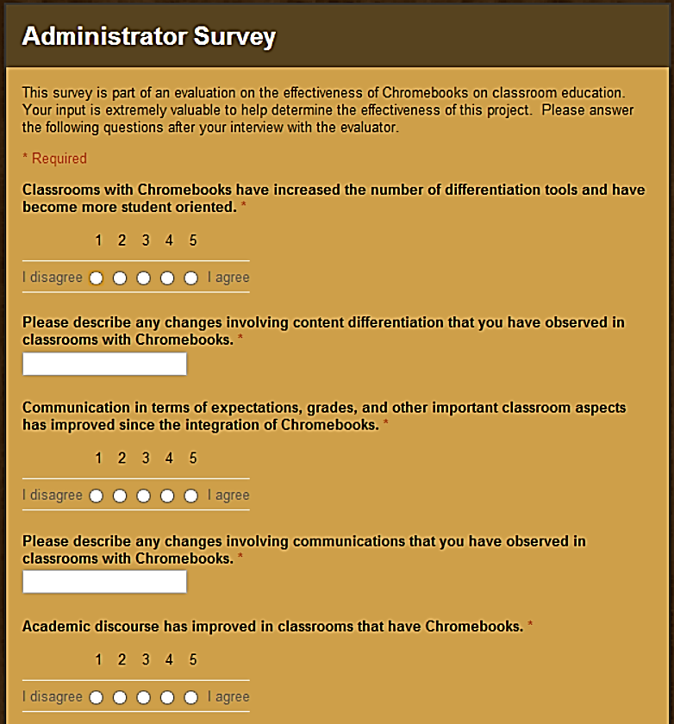

# **Appendix C – Teacher Survey**

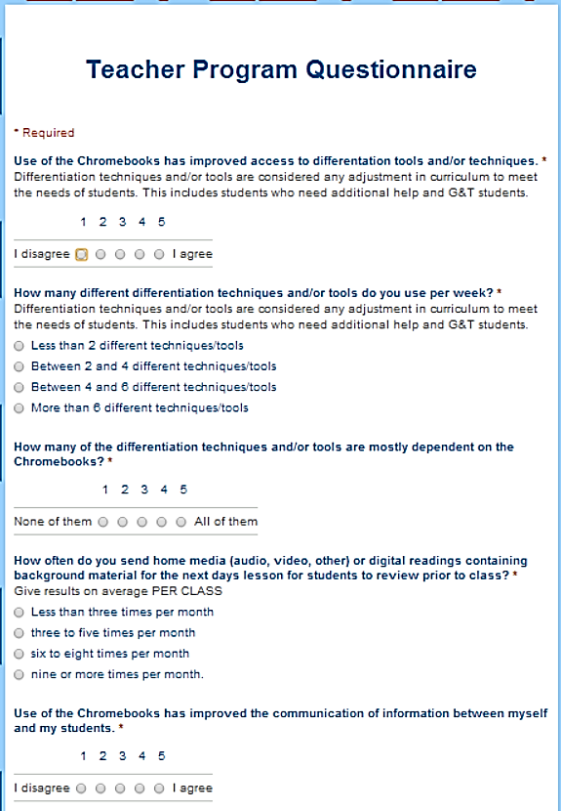

# **Appendix D – Parent/Guardian Survey**

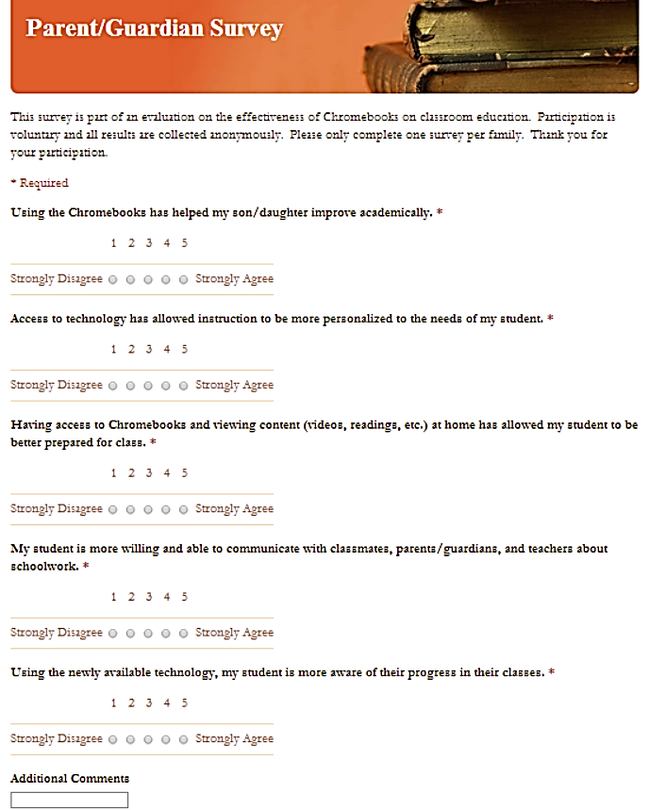

# **Appendix E – Parent/Guardian Survey Results**

|  |  |  |  |  |  |
| --- | --- | --- | --- | --- | --- |
|  | Strongly Disgree |  |  |  | Strongly Agree |
|  | **1** | **2** | **3** | **4** | **5** |
| Question 1 | | 4 | 4 | 3 | **19** | 10 |
| Question 2 | | 6 | 3 | 5 | **16** | 10 |
| Question 3 | | 10 | 4 | **10** | 8 | 8 |
| Question 4 | | 4 | 0 | 2 | **22** | 12 |
| Question 5 | | 3 | 3 | 8 | **20** | 6 |
| Calculated median values are in **bold**. | | | |  |  |