Financial Engineering

MA374 Lab – 03

Submitted by –

Ashish Kumar Poddar

Roll No. – 150123049

Date – 5th February, 2018

Question 1

We needed to find the initial values of the American Call and Put options for different values of the variables and here are the results.

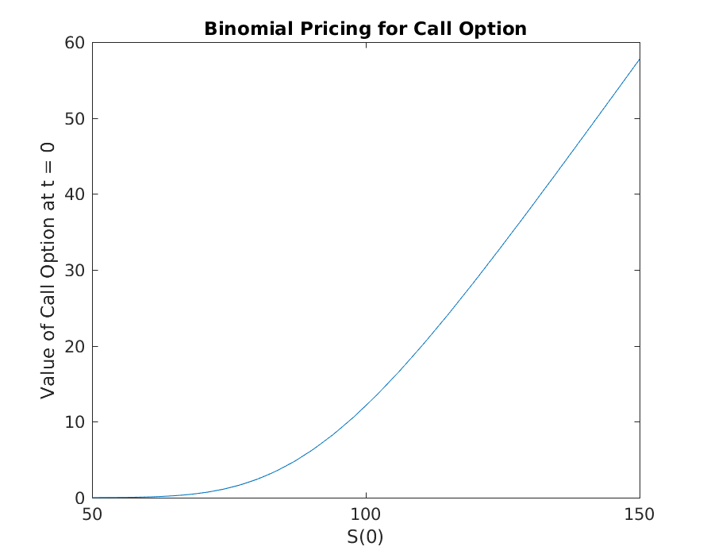

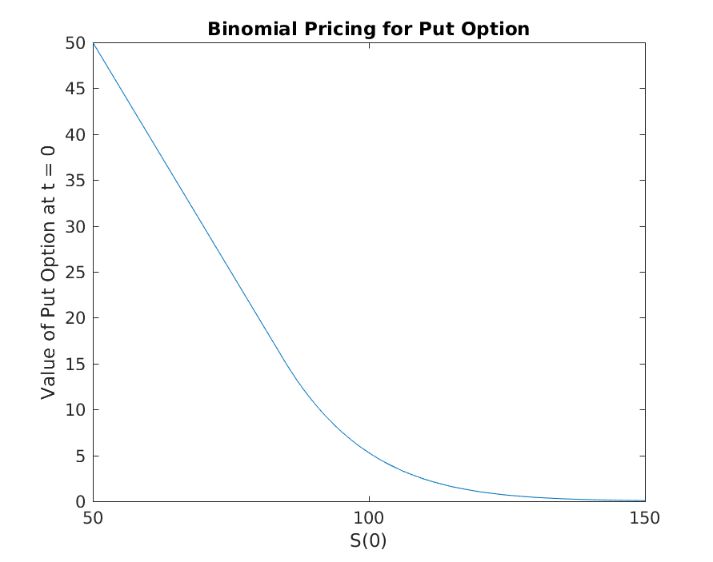

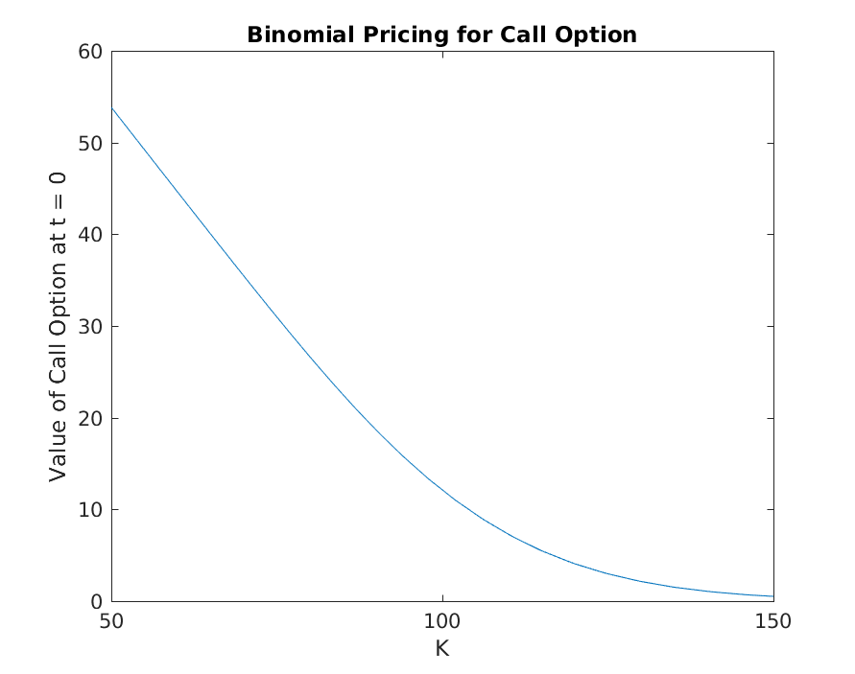

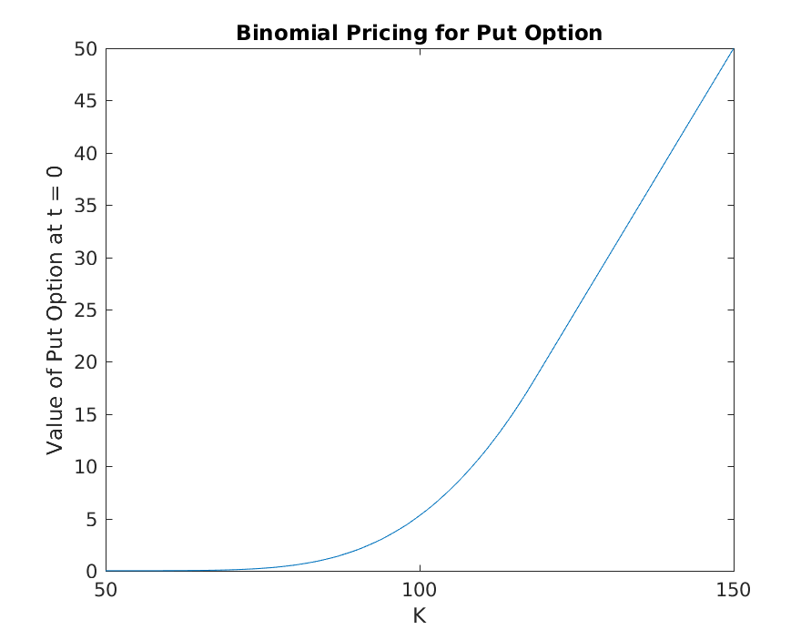

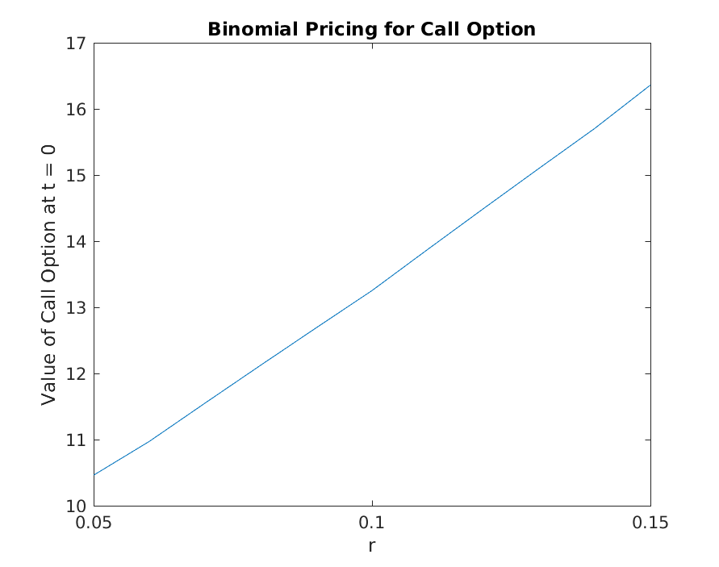

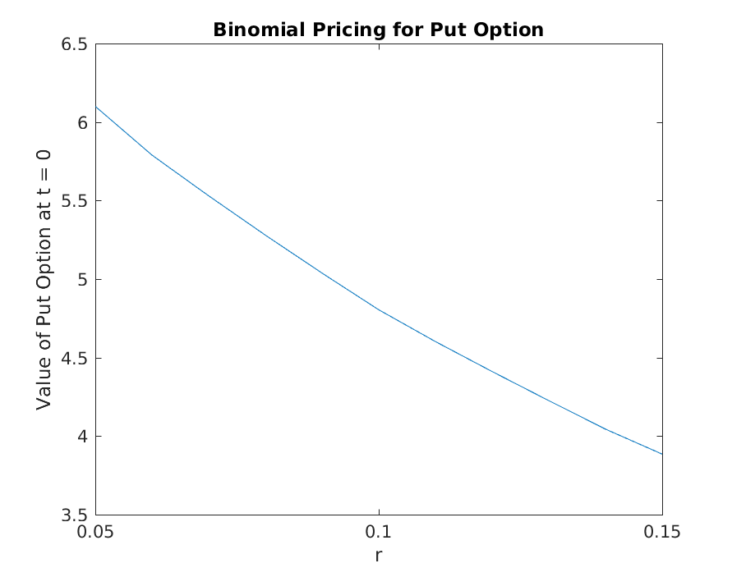

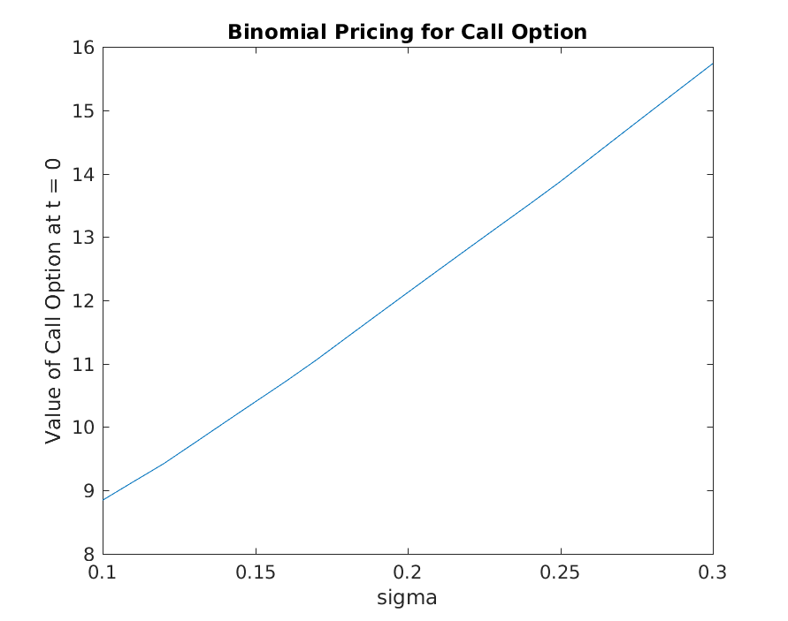

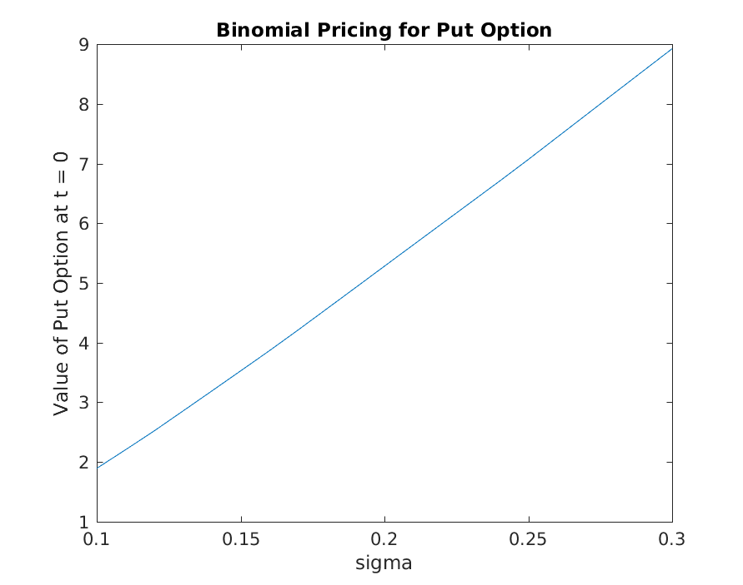

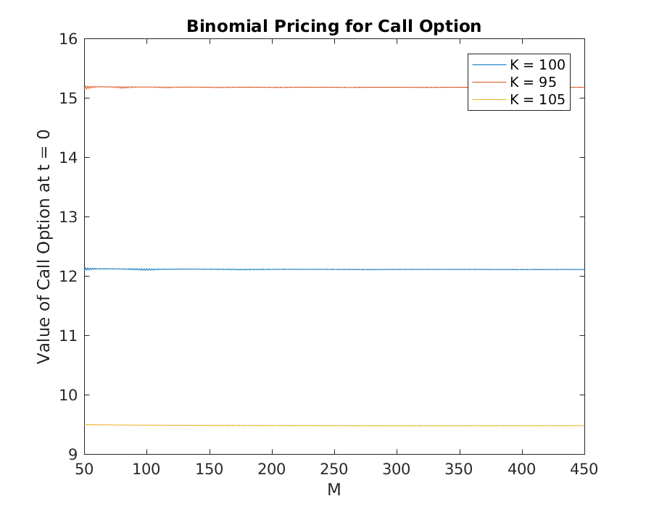

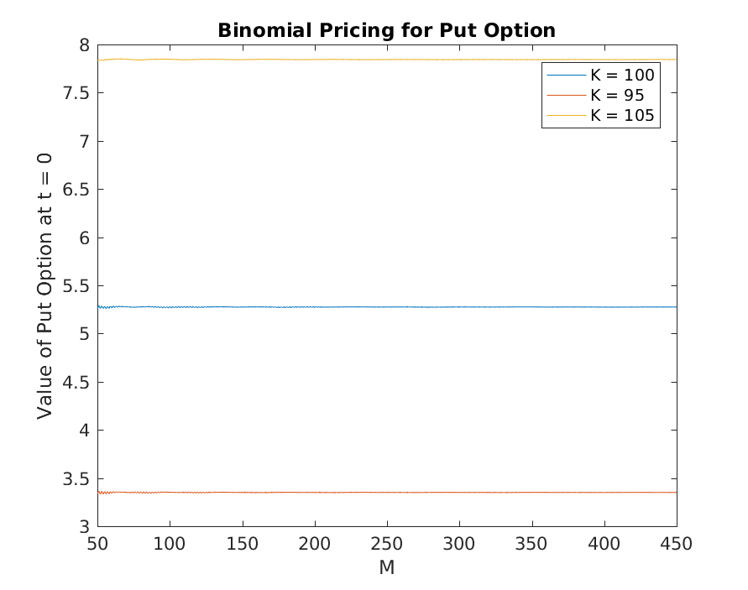

Question 2

The initial value of the lookback option for M = 5 and M = 10 are 9.1193 and 10.0806 respectively. For M = 25 and M = 50, we are unable to run the program using this method due to computational time problems.

The initial value is increasing with increasing value of M here based on the two values obtained.

|  |  |  |  |  |  |
| --- | --- | --- | --- | --- | --- |
| 9.119299 | 9.027951 | 8.548076 | 7.416771 | 5.501639 | 0 |
| 0 | 9.50484 | 9.799119 | 9.955271 | 9.571392 | 11.18141 |
| 0 | 0 | 7.147916 | 6.201916 | 4.60048 | 0 |
| 0 | 0 | 12.16866 | 13.71286 | 15.63185 | 19.45269 |
| 0 | 0 | 0 | 6.201916 | 4.60048 | 0 |
| 0 | 0 | 0 | 8.324615 | 8.003614 | 9.349917 |
| 0 | 0 | 0 | 7.148418 | 6.680843 | 6.374517 |
| 0 | 0 | 0 | 17.58206 | 21.18809 | 25.39456 |
| 0 | 0 | 0 | 0 | 4.60048 | 0 |
| 0 | 0 | 0 | 0 | 8.003614 | 9.349917 |
| 0 | 0 | 0 | 0 | 3.846929 | 0 |
| 0 | 0 | 0 | 0 | 13.07138 | 16.26637 |
| 0 | 0 | 0 | 0 | 3.846929 | 0 |
| 0 | 0 | 0 | 0 | 10.6809 | 13.578 |
| 0 | 0 | 0 | 0 | 10.6809 | 13.578 |
| 0 | 0 | 0 | 0 | 25.05123 | 29.4826 |
| 0 | 0 | 0 | 0 | 0 | 0 |
| 0 | 0 | 0 | 0 | 0 | 9.349917 |
| 0 | 0 | 0 | 0 | 0 | 0 |
| 0 | 0 | 0 | 0 | 0 | 16.26637 |
| 0 | 0 | 0 | 0 | 0 | 0 |
| 0 | 0 | 0 | 0 | 0 | 7.818416 |
| 0 | 0 | 0 | 0 | 0 | 5.330382 |
| 0 | 0 | 0 | 0 | 0 | 21.23498 |
| 0 | 0 | 0 | 0 | 0 | 0 |
| 0 | 0 | 0 | 0 | 0 | 7.818416 |
| 0 | 0 | 0 | 0 | 0 | 2.90135 |
| 0 | 0 | 0 | 0 | 0 | 18.80595 |
| 0 | 0 | 0 | 0 | 0 | 2.90135 |
| 0 | 0 | 0 | 0 | 0 | 18.80595 |
| 0 | 0 | 0 | 0 | 0 | 18.80595 |
| 0 | 0 | 0 | 0 | 0 | 32.10539 |

Question 3

The initial value of the lookback option for M = 5, 10, 25 and 50 are 9.1193, 10.0806, 11.0035 and 11.5109 respectively.

The initial value is increasing with increasing value of M.

For M = 5, the values are –

|  |
| --- |
| (166.06574787682462, 166.06574787682462) :0.0 |
| (150.04587225655362, 138.86445913876912) :11.181413117784501 |
| (150.04587225655362, 150.04587225655362) :5.501638813873981 |
| (138.8644591387691, 138.8644591387691) :0.0 |
| (135.57138705044142, 116.118695507311) :19.452691543130413 |
| (135.57138705044142, 125.46861206060268) :9.57139153170023 |
| (135.57138705044142, 135.57138705044142) :7.416771005131012 |
| (125.46861206060268, 116.118695507311) :9.349916553291678 |
| (125.46861206060268, 125.46861206060268) :4.600479677676438 |
| (122.49321297792528, 116.11869550731102) :6.374517470614265 |
| (122.49321297792528, 97.09864950286031) :25.39456347506497 |
| (122.49321297792528, 104.91706553244704) :15.631851880479829 |
| (122.49321297792528, 113.3650230595177) :9.95527127295782 |
| (122.49321297792528, 122.49321297792528) :8.548076183576446 |
| (116.11869550731102, 116.11869550731102) :0.0 |
| (113.3650230595177, 97.09864950286031) :16.266373556657385 |
| (113.3650230595177, 104.91706553244704) :8.003613780975444 |
| (113.3650230595177, 113.3650230595177) :6.201916453882752 |
| (110.676651999383, 97.09864950286031) :13.578002496522686 |
| (110.676651999383, 104.91706553244704) :6.680842999256647 |
| (110.676651999383, 81.1940548771124) :29.48259712227059 |
| (110.676651999383, 87.73182757949854) :21.188089345345652 |
| (110.676651999383, 94.79602394643446) :13.712862965988537 |
| (110.676651999383, 102.42903178906215) :9.79911875354703 |
| (110.676651999383, 110.676651999383) :9.027951165547757 |
| (125.46861206060267, 116.11869550731099) :9.349916553291678 |
| (125.46861206060267, 125.46861206060267) :4.600479677676438 |
| (116.11869550731099, 116.11869550731099) :0.0 |
| (113.36502305951768, 97.0986495028603) :16.266373556657385 |
| (113.36502305951768, 104.91706553244703) :8.003613780975444 |
| (113.36502305951768, 113.36502305951768) :6.201916453882752 |
| (116.11869550731097, 116.11869550731097) :0.0 |
| (104.91706553244701, 97.0986495028603) :7.8184160295867144 |
| (104.91706553244701, 104.91706553244701) :3.846928884415608 |
| (102.42903178906214, 97.0986495028603) :5.330382286201839 |
| (102.42903178906214, 81.19405487711239) :21.234976911949744 |
| (102.42903178906214, 87.73182757949853) :13.07138097092879 |
| (102.42903178906214, 94.79602394643445) :8.324614669633142 |
| (102.42903178906214, 102.42903178906214) :7.1479157567747444 |
| (100, 97.0986495028603) :2.9013504971397026 |
| (100, 81.19405487711239) :18.805945122887607 |
| (100, 87.73182757949853) :10.680904426029972 |
| (100, 94.79602394643445) :7.1484182081901215 |
| (100, 67.89460596146952) :32.10539403853048 |
| (100, 73.36150254849147) :25.05122945703703 |
| (100, 79.26859549382432) :17.582062714095425 |
| (100, 85.65132955680926) :12.168664659721797 |
| (100, 92.54800352077254) :9.504839866450858 |
| (100, 100) :9.11929898586469 |