Financial Engineering Lab

MA374

Lab – 04

Submitted By –

Ashish Kumar Poddar

Roll No. – 150123049

Date – 12th February, 2018

**Question 1**

Here, we had to make the Markowitz Efficient Frontier. The plot for this looked like –

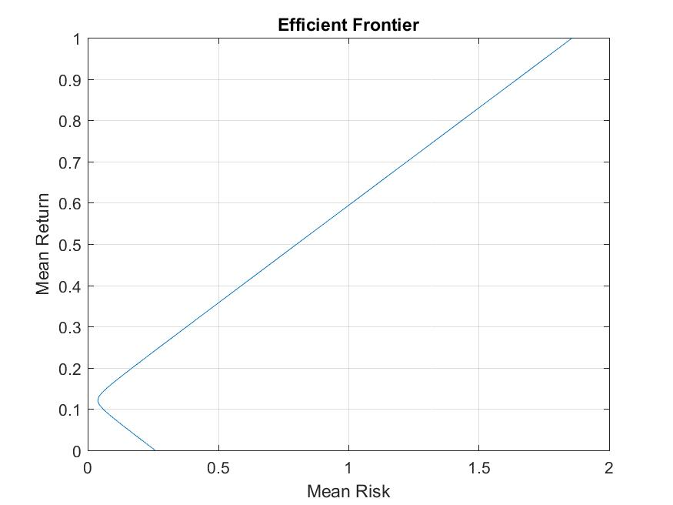

Next, we had to tabulate the tabulate the return, risk and weights for10 different portfolios on the efficient frontier.

The returns, risks and the weights are -

|  |  |  |  |  |  |  |
| --- | --- | --- | --- | --- | --- | --- |
| Return |  | Risk |  | Weight1 | Weight2 | Weight3 |
| 0.1 |  | 0.058733 |  | 1.119266 | 0.119266 | -0.23853 |
| 0.2 |  | 0.171448 |  | -0.31193 | 0.688073 | 0.623853 |
| 0.3 |  | 0.380536 |  | -1.74312 | 1.256881 | 1.486239 |
| 0.4 |  | 0.591344 |  | -3.17431 | 1.825688 | 2.348624 |
| 0.5 |  | 0.802519 |  | -4.6055 | 2.394495 | 3.211009 |
| 0.6 |  | 1.013831 |  | -6.0367 | 2.963303 | 4.073394 |
| 0.7 |  | 1.225209 |  | -7.46789 | 3.53211 | 4.93578 |
| 0.8 |  | 1.436624 |  | -8.89908 | 4.100917 | 5.798165 |
| 0.9 |  | 1.648063 |  | -10.3303 | 4.669725 | 6.66055 |
| 1.0 |  | 1.859516 |  | -11.7615 | 5.238532 | 7.522936 |

Part 3 asked for the maximum and minimum portfolios for 15% risk –

They are as follows –

|  |  |  |
| --- | --- | --- |
| Return | 0.303214 | -0.06121 |
| Weight1 | -1.78911 | 3.42652 |
| Weight2 | 1.27516 | -0.79772 |
| Weight3 | 1.513952 | -1.6288 |

The minimum risk portfolio is 0 risk for weights 1.119, 0.119 and -0.239 respectively.

The CAPM for 10% risk free is –

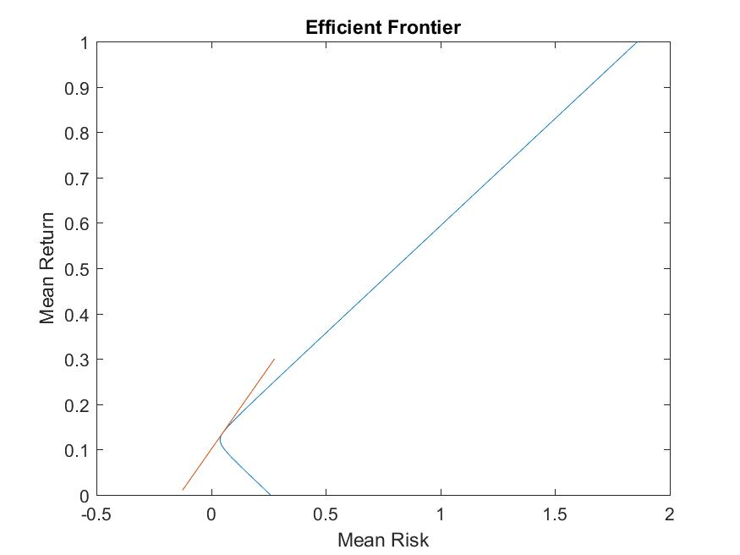

**Question 2**

The Markowitz efficient frontier is –

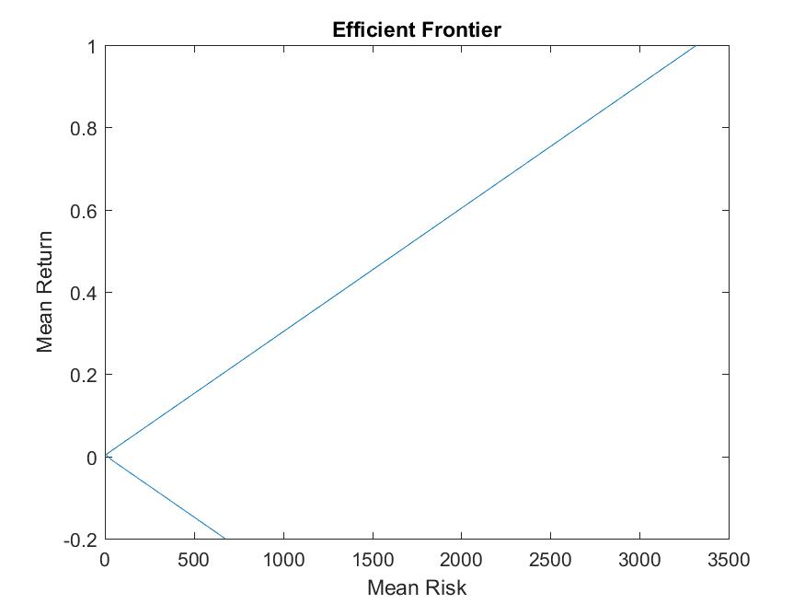

The return is 0. The weights are –

-6.26875464883049

30.6092780165260

37.7691574070848

0.970101688734303

12.5901397868899

-6.66033236735788

15.1581030275600

-98.7261301459895

14.3264212582920

1.23201597709103

The Capital Market Line is –

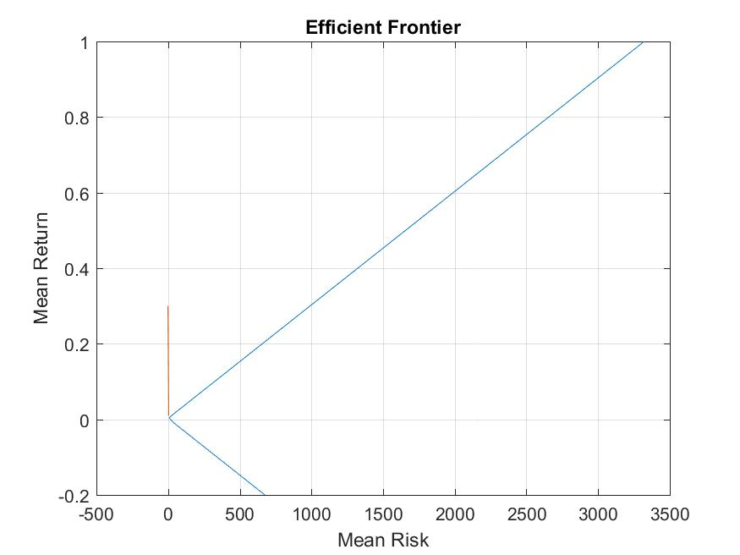

The security line is –

