**Financial Engineering Lab**

**MA374 Lab05**

**Submitted by –**

Ashish Kumar Poddar

Roll No. – 150123049

Date – 21st February, 2018

**Question 1**

We were supposed to construct the efficient frontier, the minimum variance curve and find the feasible region assuming that short sales are not allowed. 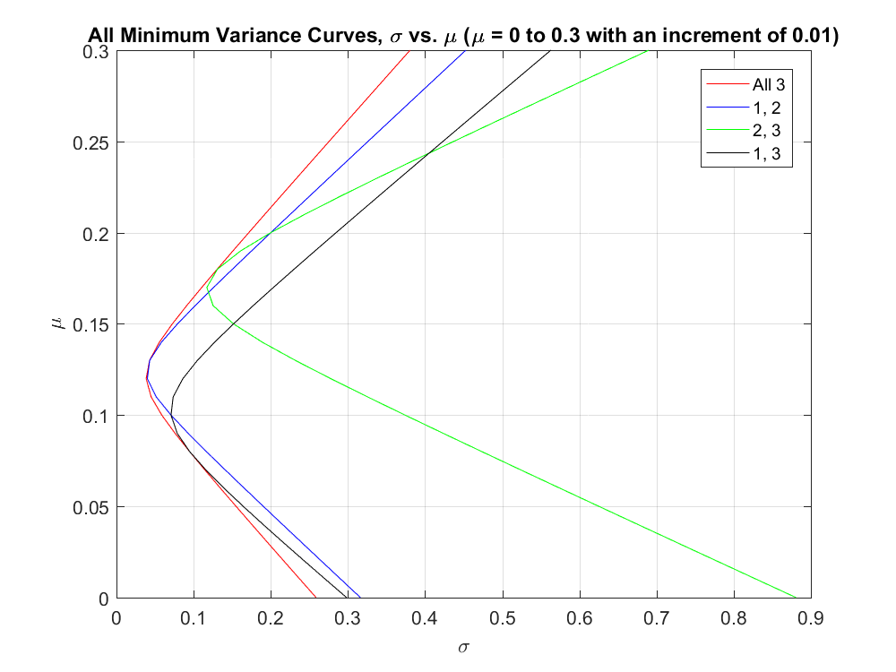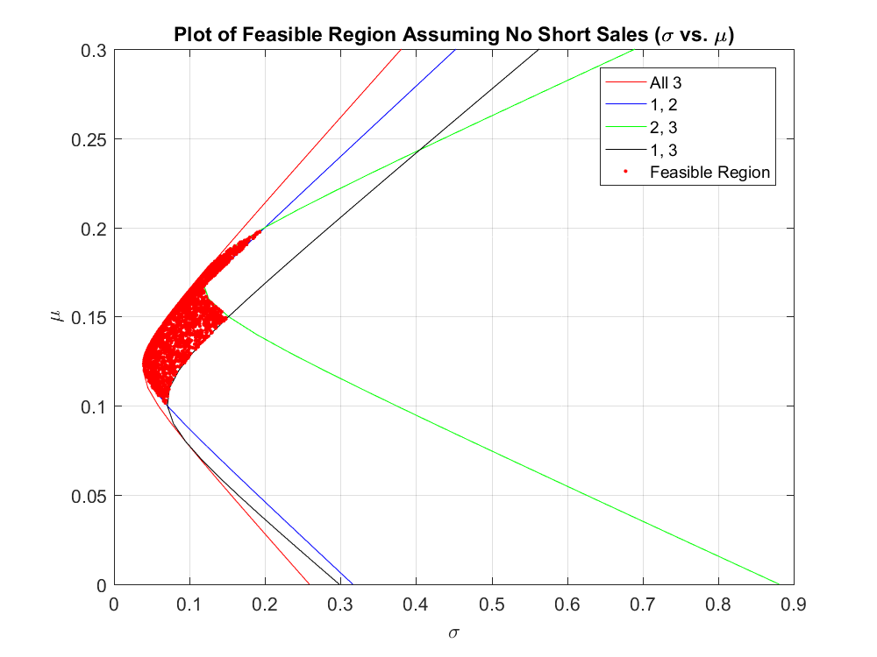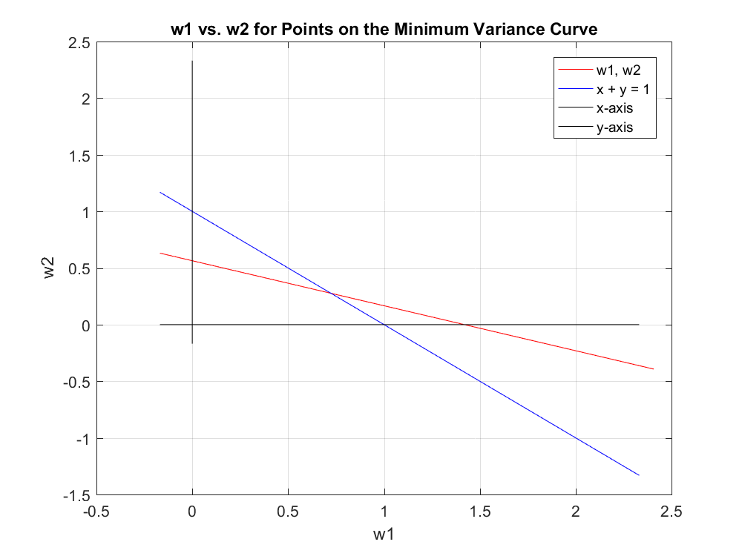

**Question 2**

We calculated the betas of the securities using the actual data and computing it for each index. They came out as –

NSE Indexed Betas -

1.0377 1.0183 1.0132 1.0524 0.9553 0.9830 0.9061 0.9338 0.9540 1.0638

NSE Non-Indexed Betas -

1.0601 1.0191 1.0360 1.0745 0.9307 1.0140 0.9173 1.1208 1.1470 1.1801

BSE Indexed Betas -

0.9089 0.6062 1.0156 NaN 0.9572 0.9851 0.9561 1.0662 0.9346 0.9736

BSE Non-Indexed Betas -

1.0620 1.0208 1.0378 1.0764 0.9324 1.0157 0.9189 1.1228 1.1490 1.1821