**Monitoring Mediterranean Sea: SST and Sea Level with Machine Learning Applications**

Abdallah DWIKAT, Zafer ASLAN

Istanbul Aydin University

Department of Computer Engineering

Istanbul, Türkiye

Email address: [abdallahdwikat@stu.aydin.eu.tr](mailto:abdallahdwikat@stu.aydin.eu.tr), zaferaslan@aydin.edu.tr

## **Abstract**

Sea Surface Height above Sea Level and Sea Surface Temperature (SST) measurements benefit a wide spectrum of operational applications, including climate seasonal monitoring, military defense operations, validation of atmospheric models, tourism, and commercial fisheries management. Understanding SST patterns in time series provides fundamental information on the global climate system and contributes to more effective policymaking. Sea Level Analysis helps in situations of Flooding and Storm Surge Predictions. Through comprehensive model evaluation and comparison, the paper aims to identify the most reliable techniques for ongoing environmental monitoring and prediction, ultimately contributing to sustainable development and climate resilience. These predictions are crucial for mitigating environmental disasters and understanding the impacts of Sea Level and SST on climate change. Various machine learning algorithms like statistical models of Auto-Regressive can be applied for future scenarios of SST. Long-short memory (LSTM) allows us to effectively compare performance between supervised and unsupervised machine learning algorithms by performance metrics showing the advantages and disadvantages of each model usage. These algorithms can uncover complex relationships on historical daily average SST data and Daily Average Sea Surface Height Above Sea Level between 2004 and 2023 in Mersin, Southern Türkiye at the Mediterranean Sea. Special key solutions were applied during building the models to improve the model’s performance first, and to make the model at its best usage for solving real-world solutions in climate change and other benefits. The models were applied in short-term forecasts and long-term forecasts with high-quality results of Sea Level and SST by exploring the best performance of each Auto-Regressive statistical model and LSTM with a window size of 8 performed best results as a short-term dependency forecast with a strong ability to forecast specific trends and seasonality. LSTM with 365 window size able to forecast a year or more of un-seen future which showed increases of minimum SST in winter trends of SST in 2024 with 98.57% R square performance and showed a decrease of Sea Level till July 2024.

**Keywords:** Climate changing, LSTM, Prophet, Auto-Regressive, Mediterranean, Forecasting, Time Series

## **Introduction**

Human-induced actions causing global warming significantly impact the sea temperature and other climate features, consequently leading to substantial changes in Sea Surface Temperature (SST) patterns. The oceans act as a carbon sink, as part of the carbon sink, absorbing and storing carbon dioxide. The oceans also absorb heat from the atmosphere. More than 90% of the excess heat generated as a result of climate change has ended up in the sea, along with roughly 30% of the carbon dioxide produced by humans from burning fossil fuels since the start of the Industrial Revolution [1].

SST is an essential parameter to study marine ecosystems and weather prediction, and it is also important for atmospheric model simulations. Forecasting SST can aid in reducing losses and optimizing resource use. Water covers 71% of Earth's surface. Water is doing a great job of taking up carbon dioxide, however, the huge quantity of carbon dioxide humans has been pumping into the atmosphere is more than the oceans can handle [2]. This saturation of the ocean with carbon dioxide is causing the chemistry of the water to change. Accurate predictions of SST are needed for ultimately contributing to sustainable development and climate resilience. This includes plans and solutions, to operate water resource projects in real-time, manage resources well, and take steps to lessen the impact of climate events on the environment [3].

The primary goal of the study is to forecast SST values in Mersin province by employing machine learning techniques and criticizing the results behind each model for specific real-world usages. Turkey's main gateway to the Mediterranean Sea is Mersin city which has the second largest port in Turkey, and the largest one that is located on the Mediterranean Sea serving as a major hub for container and general cargo with extensive infrastructure to support maritime traffic [4]. For future work usage, we chose Mersin City specifically to uncover the relationship between the SST and maritime traffic which Mersin City can have great impact for this study matter with Port Cargo share handled reaching total of 40 million tons in the last 3 years [5].

The Mediterranean area has been defined as a hot spot for climate change. It is crucial to study the behavior of the Mediterranean Sea in the past and to monitor its current situation to understand possible future scenarios in the region. [6].

Additionally, SST in the region of Mersin south-eastern part of Turkey is one of the highest levels of daily SST in the Mediterranean Sea as shown below in Figure 1. Data, study area, and methodology have been presented in the following part of the paper.

# **DATA AND METHODOLOGY**

17 years of daily average Sea Surface Temperature (SST) data were used for training the models (2004-2020), and 3 years for testing (2021-2023).

For the Sea Surface Height above Sea Level, the data collection was from the beginning of 2004 till July 2023. After data collection of SST, converting the Unit from Kelvin to Celsius was used by subtracting -273.15 from the collected data using Python to have a Celsius unit as a result. Data was collected between the 1st of January 2004 to 31st of December 2023, total of 7305 rows × 1 column. Tuning both the Statistical models of AR and LSTM model steps was applied by providing a full Time Series study on the SST historical data with necessary plots and results to be used before building the models.

## **Study Area**

Daily average of historical Sea Surface Temperature (SST) data gathered for Mersin province is collected from satellite data from NASA Earth data (0.25x0.25) collection in-situ with the coordinates format (minimum longitude, minimum latitude, maximum longitude, maximum latitude) at (34.5165, 36.6871, 34.7665, 36.8371) area is shown in Figure 2 to get the most reliable historical daily data on average Sea Surface Temperatures.

N

**Figure 1.** Area of Study

## **Methodology**

The models we chose can be grouped into three main categories based on three goals: The first is the statistical models (AUTO-Regressive) AR and Auto-Regressive Integrated Moving Average (ARMA), The second is the Prophet additive time series model, and the third is Artificial Neural Network (ANN) Specifically Long Short-Term Memory (LSTM). The LSTM model is a subpart of RNNs in Deep Learning known for its robustness and ability to analyze time series patterns. The indicators used for evaluating the performance of models are MAE, MSE, and R^2 score. For additional step-by-step building the models, GitHub directory includes the four models used can be found at the end of the paper.

Statistical models rely on traditional statistics to study past data and come up with ways to forecast SST which makes it hard to predict the long-future forecasts using the statistical models due to computational cost. We deployed a key solution for this problem by using Walk Forward Validation in the AR models. Walk Forward Validation works by continuous data collection which makes the model rely on real data instead of forecasted ones to lessen the error metric over time due to any change in the water or other impacts such as global warming. This made the forecasts and the study with AR models a current topic and a real-world useful solution by providing useful forecasts for the unseen future with continuous data collection.

* **Auto-Regressive (AR):** Auto-Regressive (AR) statistical models are used for predicting short-future predictions which can be useful for accurate predictions such as military operations and disaster management. Additional AR models are used such as ARMA that improve the model to be able to predict more precisely unusual events/activities in the sea by adding the Q value or what’s called error lag. However, after applying a value for Q in our ARMA model, the model suffered from skipping the forecasts on the test set starting from 95 steps and forward. For this case, we could successfully use the Auto-Regressive (AR) model with a lag of 8.
* **Prophet:** The Prophet additive model was used to predict SST Values for long-future predictions, by adding time features (day of the year, season, month, year. etc.). Using the time features in the Prophet model helps the model understand the dataset and the pattern of SST in seasonal patterns and at different times of the year.
* **Long-Short Term Memory (LSTM):** LSTM model was used and fitted to predict SST by providing a short window size of 8 in one model, and a long window size of 365 in the other. The comparison between the short window size and the long one in the results can show the different advantages and disadvantages for each. The use of neural network technology has brought about many good results in studying water and simulating water resources [7] because they can represent both simple and complex systems without needing the assumptions typical of most traditional statistical methods [8]. LSTM has the ability to recall past inputs and make decisions using information from both past and present inputs. The adoption of more intricate RNN designs and other deep learning methods like long short-term memory has demonstrated superior performance compared to traditional RNNs in certain cases [9, 10].

**Table 1.** Dataset Collection

|  |  |
| --- | --- |
| **Source** | **Features** |
| [**Copernicus Marine**](https://data.marine.copernicus.eu/products) | **Sea Surface Height Above Sea Level,**  **Average Sea Surface Temperature** |
| [**NASA Earth Data - Giovanni**](https://giovanni.gsfc.nasa.gov/giovanni/#service=ArAvTs&starttime=2004-01-01T00:00:00Z&endtime=2024-01-01T23:59:59Z&data=GLDAS_CLSM025_DA1_D_2_2_Swnet_tavg%2CGLDAS_CLSM025_DA1_D_2_2_Lwnet_tavg%2CAIRX3STD_006_RelHumid_A(z%3D1000)%2CAIRX3STD_006_RelHumid_D(z%3D1000)%2CAIRS3STD_006_SurfAirTemp_D%2CAIRS3STD_006_SurfAirTemp_A%2CAIRS3STD_006_RelHum_A(z%3D1000)%2CAIRS3STD_006_RelHum_D(z%3D1000)%2CM2I3NPASM_5_12_4_QV(z%3D1000)%2CMOD08_D3_6_1_Cloud_Fraction_Day_Mean%2CMOD08_D3_6_1_Cloud_Effective_Radius_Ice_Mean%2CGLDAS_NOAH025_3H_2_1_Snowf_tavg%2CGLDAS_NOAH025_3H_2_1_Lwnet_tavg%2CGLDAS_NOAH025_3H_2_1_Tair_f_inst%2CGLDAS_NOAH025_3H_2_1_Qair_f_inst%2CGLDAS_NOAH025_3H_2_1_Rainf_f_tavg%2CAIRS3STD_7_0_Temperature_D(z%3D1000)%2CAIRS3STD_7_0_Temperature_A(z%3D1000)) | **Total Precipitation, Ground Heat Flux, Sea Level Pressure, Net Short Wave Radiation Flux, Net Long Wave Radiation Flux, Average Nighttime Air Temperature, Average Daytime Air Temperature, Relative Humidity Daytime, Relative Humidity Nighttime, Cloud Fraction from Cloud Mask, Surface Air Temperature Nighttime.** |

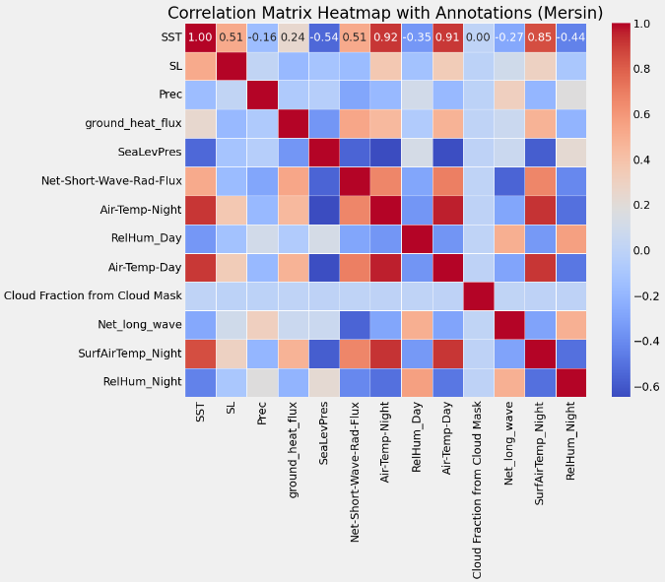

**Figure 2.** Correlation Matrix Heatmap

Correlation matrix heatmap above in figure 2 shows the relationship between the features for the daily dataset in Mersin city. It is noticeable the high positive correlation between the Sea level and the Sea Surface Temperature.

**Table 2.** Descriptive Statistics

|  |  |  |  |  |  |
| --- | --- | --- | --- | --- | --- |
| **Column1** | **SST (oC)** | **Sea Level (meter)** | **Total Precipitation (mm/day)** | **Sea Level Pressure**  **(hpa)** | **Avg-Air Tempereature in Day time**  **(oC)** |
| **count** | 7305 | 7098 | 7305 | 7305 | 7305 |
| **mean** | 22.899 | 0.07 | 4.103 | 1011.993 | 19.541 |
| **std** | 4.668 | 0.074 | 14.187 | 5.686 | 5.838 |
| **min** | 13.595 | -0.131 | 0 | 989.809 | 3.162 |
| **25%** | 18.274 | 0.017 | 0 | 1007.584 | 14.725 |
| **50%** | 22.65 | 0.069 | 0 | 1011.815 | 18.85 |
| **75%** | 27.496 | 0.132 | 0.631 | 1016.02 | 25.163 |
| **max** | 31.725 | 0.286 | 194.63 | 1029.756 | 30.85 |

Table 2 above shows descriptive statistical information for our dataset showing the quartiles for each feature, count as the number of observations for each feature, and the standard deviation value.

# **MODELS AND METRICS**

## **Auto-Regressive (AR)**

In statistics, an autoregressive (AR) model is a representation of a type of random process. It can be used to describe certain time-varying processes in nature, economics, behavior, etc. The autoregressive model output variable depends on its previous values linearly on its previous values and a stochastic term (an imperfectly predictable term); thus, the model is in the form of a stochastic difference equation (or recurrence relation) which should not be confused with a differential equation. Together with the moving-average (MA) model, it is a key component of the more general autoregressive–moving-average (ARMA) and autoregressive integrated moving average (ARIMA) models of time series. They have a more complicated stochastic structure. Contrary to the moving-average (MA) model, the autoregressive model is not always stationary as it may contain a unit root.

Large language models are called autoregressive, but they are not a classical autoregressive model in this sense because they are not linear. The AR model is given by the Equation 1[11]:

There is a direct correspondence between these parameters and the covariance function of the process, and this correspondence can be inverted to determine the parameters from the autocorrelation function.

**Xt=∑i=1pφiXt−i+εt.**However, ARIMA models are also capable of modelling a wide range of seasonal data.

## **Prophet**

Prophet is a procedure for forecasting time series data based on an additive model where non-linear trends are fit with yearly, weekly, and daily seasonality, plus holiday effects. It works best with time series that have strong seasonal effects and several seasons of historical data. Prophet is robust to missing data and shifts in the trend and typically handles outliers well. Prophet fit models in Stan so that you get forecasts in just a few seconds with fully automatic usage and allow users to tune specific forecasts for improvement. Stan is a state-of-the-art platform for statistical modeling and high-performance statistical computation. Many users rely on Stan for statistical modeling, data analysis, and prediction in the social, biological, and physical sciences, engineering, and business.(The official Stan documentation website: <https://mc-stan.org/docs/> )

The Prophet model was introduced by Facebook (S. J. Taylor & Letham, 2018), originally for predicting daily data with yearly and weekly seasonality, plus holiday effects.

Prophet can be considered a nonlinear regression model of the form below [12].

Prophet additive model can be represented as:

* (y(t)) is the observed value at time (t)
* (g(t)) describes a piecewise-linear trend (or “growth term”).
* (S(t)) describes the various seasonal patterns.
* (h(t)) captures the holiday effects
* (εt) is a white noise error term.

## **RNNs – Long Short-Term Memory (LSTM)**

RNNs are a special class of neural networks that operate on The LSTM model (Hochreiter and Schmidhuber 1997a) is a powerful recurrent neural system specially designed to overcome the exploding/vanishing gradient problems that typically arise when learning long-term dependencies, even when the minimal time lags are very long (Hochreiter and Schmidhuber 1997b). In short, the LSTM architecture consists of a set of recurrently connected sub-networks, known as memory blocks. The idea behind the memory block is to maintain its state over time and regulate the information flow through non-linear gating units. Figure 3 below displays the architecture of a vanilla LSTM block, which involves the gates, the input signal x(t), the output y(t), the activation functions, and peephole connections (Gers and Schmidhuber 2000). The output of the block is recurrently connected back to the block input and all the gates [13].

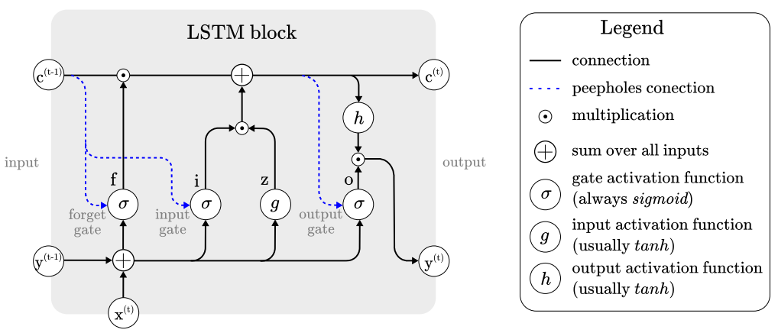

**Figure 3.** Architecture of typical vanilla LSTM block [13]

## **Performance Metrics**

Absolute-difference metrics:metrics all focus on measuring the average dispersion error, without attention to bias. The smaller the average error, the better the method. We turn first to absolute-difference metrics. They are good model selection criteria when (repeated) average performance is important [14].

* **Mean Absolute Error (MAE):** MAE measures the average of the sum of absolute differences between observation values and predicted values and corresponds to the expected loss for the L1 loss function. Equation 3 shows *Mean-Absolute Error.*

Where,  is the forecasted value and is the real one [14].

* **Mean Squared Error (MSE**): Mean Squared Error (MSE) is another common metric used to evaluate the accuracy of a model. Unlike MAE, which averages the absolute differences, MSE averages the squared differences between the observed and predicted values. This means that MSE gives more weight to larger errors, making it more sensitive to outliers.Equation 4 explains Mean-Squared Error [14].

(4)

* **Goodness of fit or Coefficient of Determination:** R2 measures the improvement of the regression line over a simple mean line, (Eq. 5a and b).

(5b)

is the sum of the squared error of the regression line and is the sum of the squared error of the mean line. The value of R2 lies between 0 and 1, a higher value of R2 indicates the model is better [14].

# **DATA PREPROCESSING AND ANALYSES**

Only SST as a feature and as a target was used. The same for the Sea level as well. The models used were deployed individually for each feature with different sperate results as we used Univariate Time Series Modelling. The Date is an index used in the machine learning models, however, other features can be used to reveal statistical descriptions and correlational values with SST and Sea Level for future work. Feature Engineering techniques make modeling the target easier to predict with more efficient results. Time Series plots and study during the work was done to find the best parameters in our case study. The use of those plots aligned with tuning the AR models and the LSTM models as well. In Python, we used the scatter plot library which offers the forecasts as points for a better understanding of the forecasting trends at specific days and un-usual trends as well.

## **Auto Regressive Model (AR)**

To find the best parameters for the ARMA (Auto Regressive Moving Average) model, we automated the tuning hyperparameter by setting a range of (p) values “p_params = range(0, 25, 8)” which is the lag value. The lag value mainly means the last how many data points mostly affect the value of SST or Sea Level and assigning this value to the model makes it focus o those 8 values as we used in our case so it can generalize and forecast well after training the model. (q) values “q_params = range(0, 3, 1)” which is the error lag value in the ARMA model and finding the possible values in a grid that can help us pick the appropriate parameters based on less mean absolute error value and less computational complexity, to merge the results as a grid using Python.

**Table 3.** Mean Absolute Error Parameter Grid

|  |  |  |  |  |
| --- | --- | --- | --- | --- |
| **Q / P** | **0** | **8** | **16** | **24** |
| **0** | 4.053 | **0.1593** | 0.1569 | 0.1545 |
| **1** | 2.0843 | 0.1624 | 0.1529 | 0.1545 |
| **2** | 1.1812 | 0.1539 | 0.1515 | 0.1509 |

As shown in Table 3 above, the lowest MAE value is at (p) value of 24 days and (q) value of 2 which represents the most computationally complex model. The model of (8, 2) provides 0.1539 MAE and is less complex than the first one so it was chosen to be used for this purpose. The AR model uses a p-value only which looks like (p, 0, 0). ARMA uses p and q but not d (p, 0, q), and ARIMA (Auto Regressive Integrated Moving Average) uses the three of them (p, d, q). After building the ARMA model with (8, 0, 2), the model couldn’t successfully forecast on the test set, and it skipped significant parts starting from 95 steps forward. For this reason, we applied a simpler model which is AR with the parameter shown in Table 3 above (8, 0, 0) having 0.1593 mean absolute error value.

## **Prophet Model**

Prophet model features used were the day of week, quarter, month, year, day of the year, day of the month, week of the year, weekday, season, and SST as the target. As a time-series model, those features helped the model understand the trend pattern of SST values at specific times of the data we trained the model on. Boxplot showing the SST by season for each year between 2004 and 2023 helps clarify the outliers and the trends in each quarter of the specific year.

Additional Hyperparameter tasks can be applied into the Prophet additive model which it’s equation explained previously in Equation 2, however, in our case we have used the default settings for the Prophet model to forecast future scenarios of SST and Sea Surface Height above Sea Level.

## **LSTM Model**

The LSTM model needs hyperparameter steps as well to be able to forecast the SST seasonal trends and S4ea Level. After our findings from the time series plots, there is a strong correlation between the SST and itself in previous days. Also similar for the Sea Level as described and shown in the ACF and PACF plots for SST and for Sea Level. We built an additional model for the LSTM model which is the value 1 year earlier. This was done by assigning the window size in the LSTM as 365. The other LSTM model window size was used as 8, which allows us to see the results of the AR model with a lag value of 8 and the LSTM model with a window size of 8 and compare the results. This way we can have two models built for short-term forecasts and two models for long-term SST and Sea Level forecasts using and picking the most powerful ones after testing the four models. Forecasting long-term dependency for more than a year will let the model use its predictions as an input for the next step which will make the results less efficient over time. This is the case for any machine learning model; however, we focused on building the most robust model possible so we can forecast a year or two effectively to be used in policy-making and climate change, and also predict short-term forecasts with the AR and LSTM in disaster management cases and military operations with high-quality forecasts.

Continuous collection of the data together with our key solution using Walk Forward Validation can provide significant impact for improving the forecasts by the latest real data available.

1. **SST Analysis**

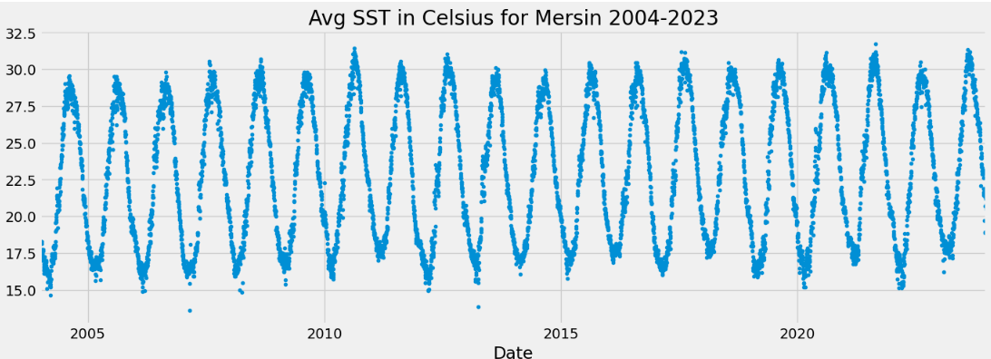

**Figure 4.** Daily AverageSST Analysis Plot in Mersin (2004-2023)

Figure 4 above shows the Daily Average Sea Surface Temperature in the specific coordinates in Mersin between the period of 2004 and 2023 in Celsius.

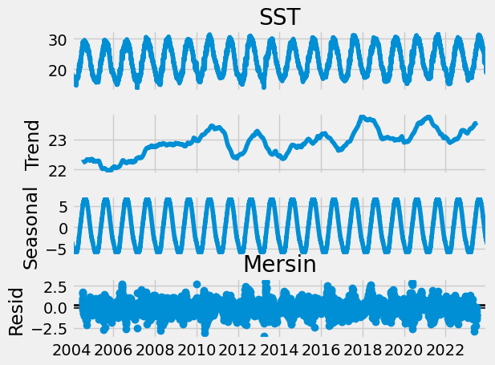

**Figure 5.** Seasonal Decomposition Analysis in Mersin (2004-2023)

The Seasonal Decomposition Plot above in Figure 5 shows increasing trend of SST values in the last years especially after the year of 2014.

The increase trend in Figure 5 above is noticeable by two main factors, the first is the increases in maximum SST values we reach (in summer), and the second is the minimum SST values we have in recent years which clears the increase of the minimum value (in winter) after the year of 2014. Since 2014 we never reached a similar or colder trend but much higher even between 2014 and the end of 2023.

Additionally, Figure 6 below shows the SST values in Mersin which are above 28 degrees Celsius.

This ensures the increase of the very high SST values over years especially recently in summer seasons.

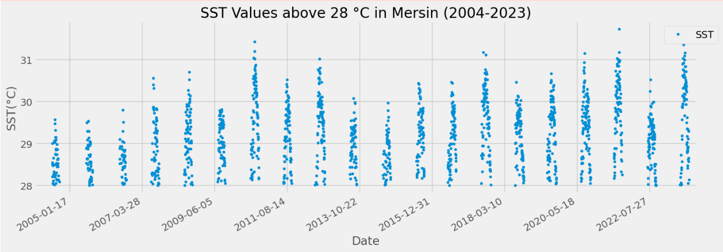

**Figure 6.** SST values above 28 degrees Celsius in Mersin (2004-2023)

Standard deviation represents 4.66 and the mean is 22.9. merging them which is 22.9 + 4.66 equals approximately 28 degrees Celsius.

Then the Values of 28 oC and more are represented in figure 6 above.

There is a clear increase in the max values over years which between 2004 till 2007 seems to be very few, and later on years there are higher values.

Climate change is causing the surface waters of the sea to warm. The warming of surface waters is causing changes in water density and the mixing of warmer, surface water with cooler, deeper water [1]. This explains the rise of SST values after 2014 more and more over the years.

**Figure 7.** Time Series Analysis Plot in Mersin (2004-2023) Daily Average SST.

Autocorrelation (ACF), and Partial Autocorrelation (PACF) in Time Series help us determine the relationship between SST and itself for the previous values. Autocorrelation can provide these values even with common or repeated value which the relation seems be strong between the SST value and itself for around 75 days in Figure 7 above. PACF stands for Partial Autocorrelation which provides the correlation with new relations only without repeating the relation as same as ACF plot.

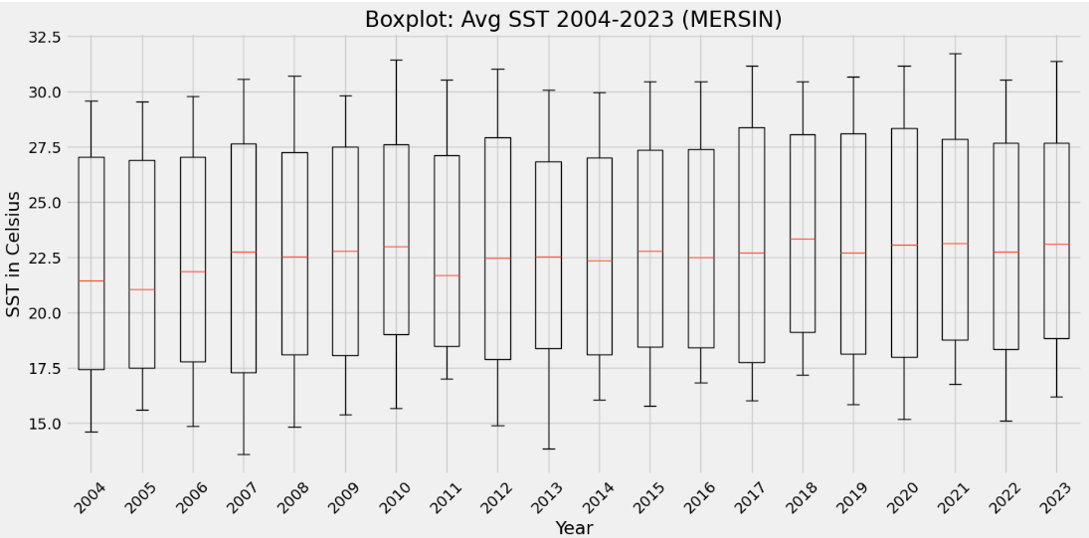

**Figure 8.** Yearly boxplots in Mersin (2004-2023)

The yearly box plots above in figure 8 generally did not have any outliers between 2004 and 2023.

Additionally, there are different skewness for each year in the SST value in Mersin as shown in Boxplots above in figure 8 which helps to understand the positive, negative, or gaussian skewness for each year.

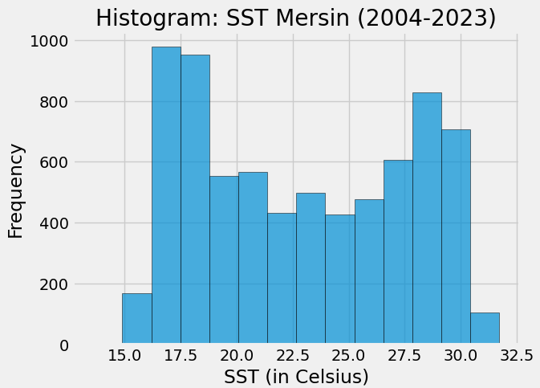**Figure 9.** Frequency Histogram in Mersin (2004-2023)

Figure 9 above shows bi-model distribution for the daily SST values in Mersin between 2004 and 2023.

This is due to the change and the main two periods that SST is changing in summer as the max hot values and in winter as the max cold values.

**Figure 10.** Frequency Distribution in Mersin with mean line (2004-2023)

Figure 10 above shows the Frequency Distribution again and shows the red line as the mean value which is near 22.5 degrees Celsius.

**Figure 11.** Boxplots by year and season in Mersin (2004-2023)

Some unusual outliers are shown in specific seasons of some years such as summer 2016 and winter 2016 as shown above in figure 11.

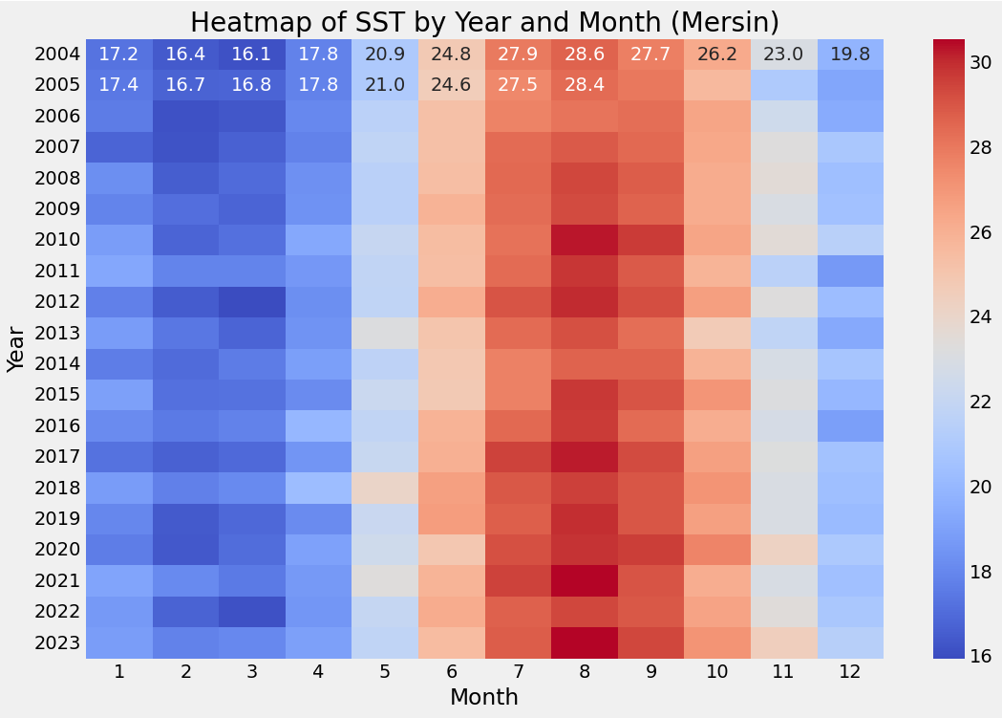

**Figure 12.** Heatmap for SST by year and month in Mersin (2004-2023)

Figure 12 above shows the changes for specific month for specific year between 2004 and 2023 in Mersin. August generally shows the highest SST values in the years especially in 2023, 2021, 2017, and 2010.

It is the same for the cold winter seasons in which both February and March sign the coldest SST values months in the year especially 2022, 2020, 2019, 2017, 2012, 2007, and 2006.

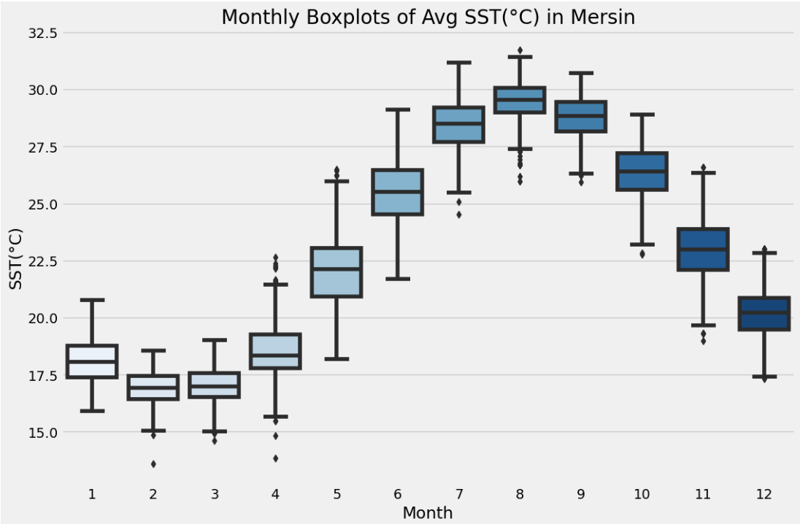

**Figure 13.** Monthly Boxplots for SST in Mersin (2004-2023)

As shown above in figure 13, the coldest month of SST is February, and the warmest month of SST is August. For specific details of each month of a specific year the heatmap of the figure 12 above can be useful to get specific insights.

**Results - SST**

**Figure 14.** SST Forecasts on Test set for Mersin using Prophet

It is noticeable in the light blue color extending over time which makes the model less reliable over time. Prophet generally could provide a general forecast of SST without very high-quality forecasts.

This ensures the big changes that happens for SST values over years which seems to be higher due to climate change affects and other features as well.

**Auto-Regressive (P = 8):**

**Figure 15.** SST Forecasts on Test set for Mersin using Auto-Regressive model.

Note: Walk-Forward Validation was applied on the test set

As shown in figure 15 above, The AR model forecasts are impressive on the test set. However, the Walk-Forward Validation was applied which had a continuous data collection one by one after each forecast. This way the model can be dependent on real data and not on forecasted ones.

**LSTM (Window=8):**

**Figure 16.** SST Forecasts on Test set for Mersin using LSTM with window size of 8.

LSTM with window size of 8 as shown in Figure 16 above provided pretty good results on the test set. The LSTM model was easier to deploy than the Auto-Regressive model as the AR model is computationally complex which LSTM is less complex than AR model.

Additionally, seems the forecasts for the max values of SST in the summer of 2021 and 2023 a bit far away from the real forecasts. There was not any continuous data collection such as we did in AR model. This can be due to unexpected and very high SST values we reached in the summers of 2021 and 2023.

For both models, AR and LSTM with low window size we always need continuous data collection to forecast future contexts. As the window size is smaller

**LSTM (Window=365):**

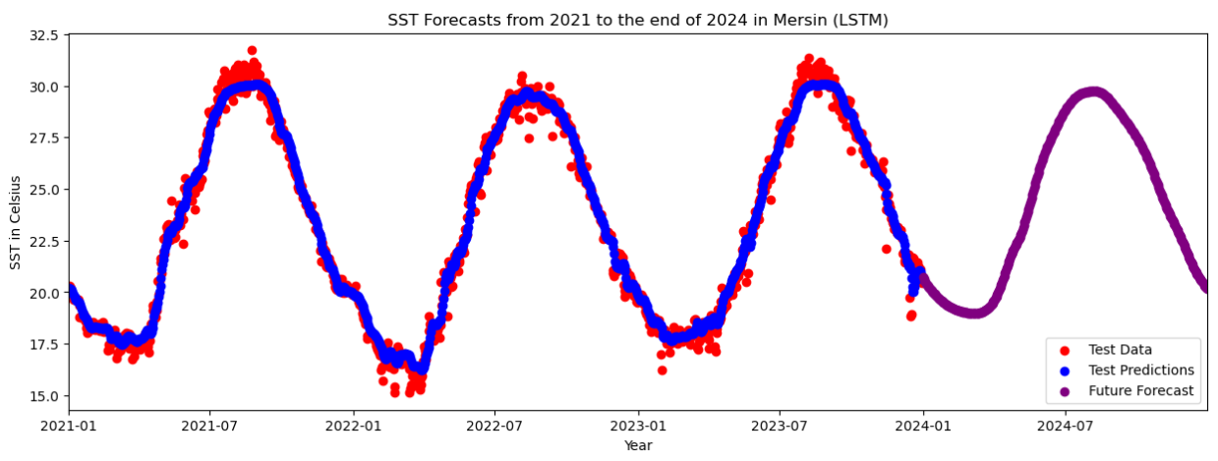

**Figure 17.** SST Forecasts on Test set and till end of 2024 for Mersin using LSTM with window size of 365.

LSTM with 365 window size made the model more complex and could be less specific. Generally, the results on test set are very similar to the previous LSTM model in Figure 17 above, however it is less specific forecasts for max and min values than figure 16 which is due to higher window size.

Additionally, the forecasts for future scenarios show an increase of the min values which is winter of 2024 but almost similar SST values for max values in summer 2024.

**Table 4.** Evaluation Metrics – Test Set (SST)

| Model name | Metrics | | |
| --- | --- | --- | --- |
| MAPE | MSE | R2 |
| Prophet | 2.86% | 0.79 | 97.08% |
| LSTM  window=8 | 1.60% | 0.26 | **98.79%** |
| LSTM window=365 | 1.83% | 0.30 | 98.57% |
| AR | 1.52% | 0.24 | **98.9%** |

*Evaluation Table*

1. **Sea Level Analysis**

On the same coordinates in Mersin city, Sea Surface Height above Sea Level was collected in meters.

Ther is a strong positive relation with SST as shown in the Correlation matrix heatmap in Figure 2.

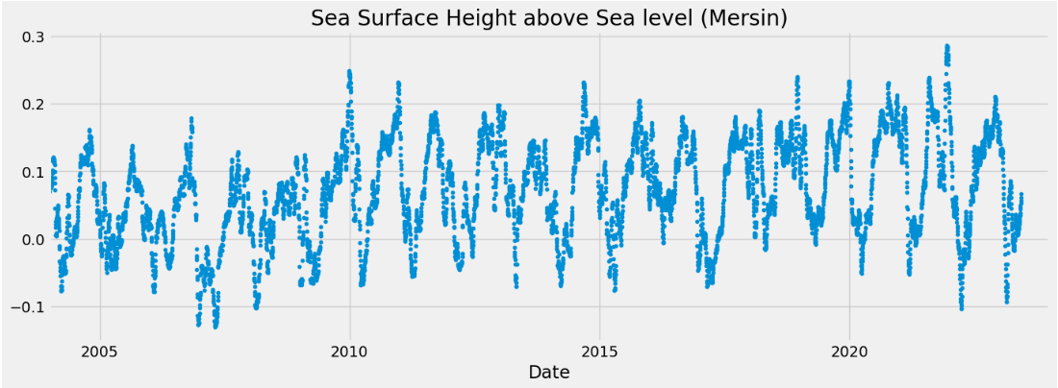

**Figure 18.** DailySea Surface Height above Sea Level for Mersin (2004-2023) in meters.

**Figure 19.** DailySeasonal Decomposition Analysis of Sea Level for Mersin (2004-2023) in meter

The increase trend of Sea Level in Mersin is high especially starting from 2009 and so on.

Time Series Analysis:

**Figure 20.** DailySeasonal Decomposition of Sea Level for Mersin (2004-2023) in meter

Figure 20 above shows the Autocorrelation (ACF) and the Partial Autocorrelation (PACF) for Sea Height above Sea Level in meter.

Till 22 days seems it has a relationship in the PACF plot with the value of the Sea Level.

However, in the ACF plot the relationship is till around 60 days which shows old relationships as well.

**Figure 21.** Yearly boxplots of Sea Level for Mersin (2004-2023) in meter

Figure 21 above shows increase trend for the Sea level in recent years starting from 2009 and so on.

There are noticeable outliers in minimum SST values (in winter) for the years 2008, and 2013.

Histogram:

**Figure 22.** Histogram of Sea Level for Mersin (2004-2023) in meter

The Histogram for the Sea Level in Figure 22 above shows a bi-modal distribution.

**Figure 23.** Distribution of Sea Level for Mersin with Mean Line (2004-2023) in meter

In addition to Bi-modal distribution in figure 23 and 22 above, the red line shows the mean value for Sea Level in the city of Mersin.

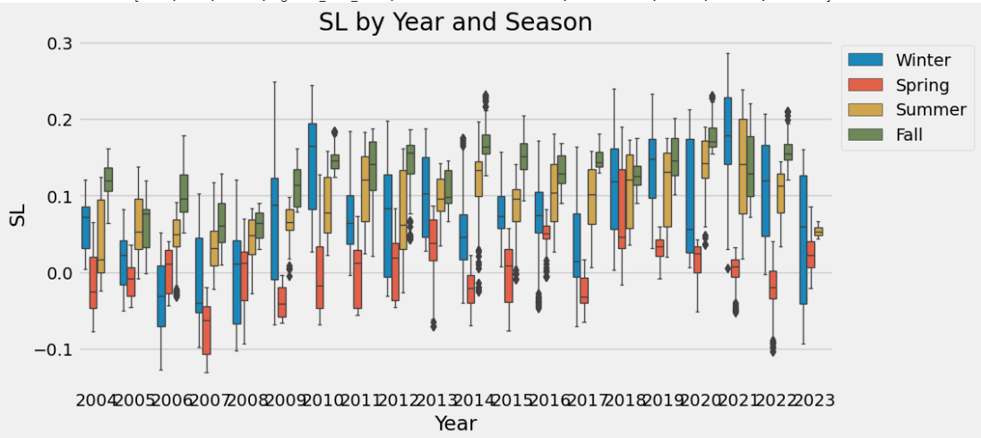

**Figure 24.** Boxplots for year and season for Sea Level in Mersin (2004-2023) in meter

**Figure 25.** Heatmap of Sea Level for Mersin (2004-2023) in meter

Figure 25 above shows very specific analysis as a heatmap for specific month of a specific year for the Sea Level values.

The results show that Sea level starting from September 2009 and so on for the months July, August, September, October, November, December, and January.

It is noticeable some very high values in December 2021 and very low in December 2006.

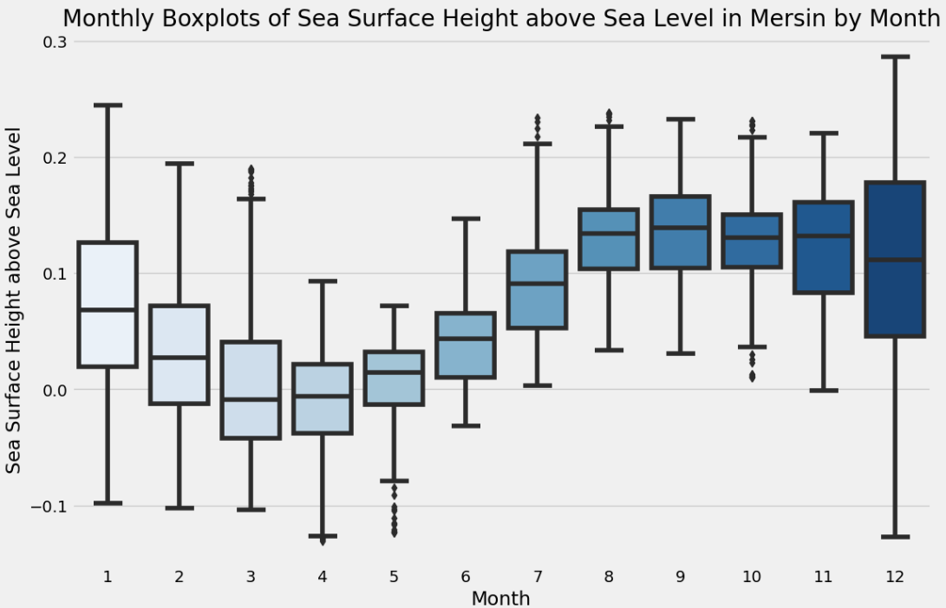

**Figure 26.** Monthly boxplot for Mersin (2004-2023) in meter

**Results – Sea Level**

**Figure 27.** Sea Level Forecasts on Test set for Mersin using Prophet.

Figure 27 above shows the sea level forecasts using Prophet as shown in blue color. The forecasts show increases in the future trend for future scenarios of Sea Level.

**Figure 28.** Sea Level Forecasts on Test set for Mersin using Auto-Regressive Model with P = 8.

Note: Walk-Forward Validation was applied on the test set.

Auto Regressive with P values of 8 provided impressive forecasts on test set. Walk-Forward Validation was applied on the test set so the model can have continuous data collection which makes the model relying on real data instead of forecasted ones.

Whenever the model relies on forecasted data it will make the forecasts less reliable over time and far away from real data forecasts. In case of any un-usual activity for our dataset which is not expected by our model however it happens on reality, this type of examples makes our model forecasts less reliable and in case those actions affect future forecasts as well then, the confusion continues to be exist with our model as shows the Autocorrelation (ACF) and Partial Auto Correlation (PACF) in figure 20 previously which shows a Partial Auto Correlation with around 22 days and Auto Correlation with 60 days.

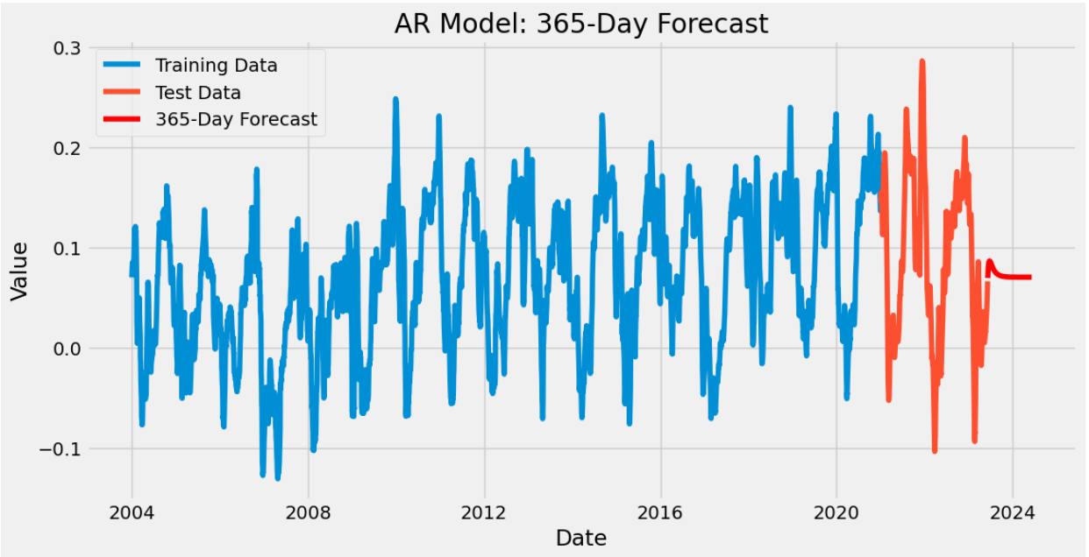

**Figure 29.** Sea Level Forecasts on future scenarios for Mersin using Auto-Regressive Model.

Note: Walk-Forward Validation was applied on the test set.

As shown in figure 29 above, the forecasts for future forecasts using Auto Regressive model can be useful for short term forecasts. As explained previously, the AR model relies on previous values especially the last 8 values as we use the P value or lag value as 8 which over time with future values the values to forecast long term scenarios need the previous ones which are missed also so the model will rely on the forecast values instead and the model be less reliable over time and fail for the long term forecasts.

**Figure 30.** Sea Level Forecasts on Test set for Mersin using LSTM model with window size of 8.

Similar to AR model, we used the window size as 8 for the LSTM model. This way we could compare the results of both models. However, both are for short-term high-quality forecasts.

The problem with AR models is the Complexity in term of computational tasks. In this matter, the LSTM was less complex than the Auto Regressive model during training.

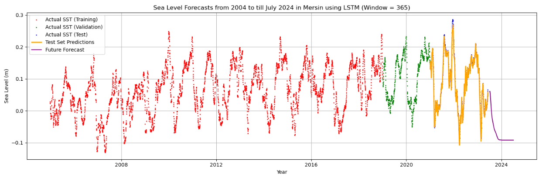

**Figure 31.** Sea Level Forecasts on Test set for Mersin using LSTM model with window size of 365.

LSTM with window size of 365 results are shown above in figure 31 for training, validation, testing, and future foreasts.

**Table 5.** Evaluation Metrics – Test Set (Sea Surface Height Above Sea Level)

| Model name | Metrics | | |
| --- | --- | --- | --- |
| MAPE | MSE | R2 |
| Prophet | 271.33% | 0.06 | 44.18% |
| LSTM  window=8 | 12.33% | 2.44 | **99.64%** |
| LSTM window=365 | 22.08% | 5.39 | 99.21% |
| AR | 10.51% | 0.0 | **99.81%** |

*Evaluation Table*

**CONCLUSIONS**

Climate change is causing SST to warm. Water’s functionality in global change aligns by decreasing the CO2 caused by humans on Earth. The “noise” that humans’ impact on the sea makes the SST increase. Using the latest machine learning techniques, we could successfully identify the SST and Sea Level trend over historical data and test the models for unseen future forecasts.

Robustly forecasting SST and Sea Level values helps in policymaking toward climate change and awareness for future forecasts. Both the AR model and the LSTM of 8 window size performed impressive forecasts with short-term dependencies, however, the AR model is a complex task from the computational side, and it had an advantage by using continuous real-data with the use of Walk-Forward-Validation which makes LSTM preferable for this matter. Additional work can be done by applying a hybrid model combining wavelet, LSTM, with AR statistical models to benefit from both solutions. The rising sea temperatures pose threats to ecosystems and marine life. As the sea warms, the window is likely to shift for many species, causing them to move to new locations.

Lastly, SST values and Sea Level are widely important for military operations and disaster management. Accurate predictions are crucial for disaster prevention and management such as Storm Surges. The Auto-Regressive (AR) statistical model and the LSTM model both effectively improve SST and Sea Level forecasting in high-quality results to avoid or better manage disaster and early detection including hazards or storm surges used in air traffic and military operations and responses.

The LSTM model with 365 applied best results for both forecasts of Sea Level and Sea Surface Temperature in case of long-terms forecasts.

For the short-terms forecasts, which need more specific results, especially for maximum and minimum values in seasons, we found that the Auto Regressive model with Walk Forward Validation could forecasts the best results for this task. LSTM with window size of 8 was very close to the AR model results for the short terms forecasts which sometimes can be preferred due to less complexity computationally than the Auto Regressive model.

In the end, the findings of this research contribute to enhancing sustainability in the water environment under climate change conditions. The findings offer valuable insights for policymakers, and environmental professionals engaged in future climate-change planning, especially with global warming effects on the environment. Continuous research and development are necessary to achieve optimal improvements in forecasting SST and Sea Level by studying additional atmospheric variables and other specific actions that increase or decrease the SST. The Mediterranean area is a critical region for studying the role of climate change. Time series analyses of daily SST and Sea Level are necessary for future scenarios in the Mediterranean region. Future studies will focus on hybrid models by considering wavelet details to increase the precision of model outputs.

# **ACKNOWLEDGEMENT**

This study is supported by The North Atlantic Treaty Organization (NATO) the Science for Peace and Security (SPS) Multi-Year Project number G5970 named Cube4EnvSec: “Big Earth Data-cube Analytics for Transnational Security and Environment Protection”. Thanks to [Abdallah DWIKAT](https://www.linkedin.com/in/abdallah-dwikat-04095927b), Under-Graduate Computer Engineering at Istanbul Aydin University, Faculty of Engineering.

# **REFERENCES**

[1] NIWA Taihoro Nukurangi, “Climate, Freshwater & Marine Science,” [Online]. Available: https://niwa.co.nz/climate-change-information-climate-solvers/climate-change-and-oceans. [Accessed: Aug. 05, 2024].

[2] National Oceanic and Atmospheric Administration, “Why do scientists measure sea surface temperature?” [Online]. Available: https://noaa.gov. [Accessed: Aug. 04, 2024].

[3] Sangwan and R. Bhardwaj, “Assessing River Flow Patterns in the Context of Climate Change: A Machine Learning Framework,” USBAS, GGSIPU, Delhi, India, [2024].

[4] Port Of Mersin, Wikipedia, [Online]. Available: https://en.m.wikipedia.org/wiki/Port_of_Mersin. [Accessed: Aug. 07, 2024].

[5] İ. Balık, “Antalya Limanı’nın Türkiye’de Elleçlenen Yük İçerisindeki Payı ve Yakın Çevresindeki Limanlar İle Karşılaştırmalı Yük Analizi! Load Analyses of Antalya Port and Near Vicinity of it,” Akademisi Dergisi, vol. 16, no. 3, pp. 1437-1456, 2023. [Online]. Available: https://doi.org/10.35674/kent.1272994. [Accessed: Aug. 11, 2024].

[6] CEAM, “Mediterranean SST Report,” [Online]. Available: https://www.ceam.es/news/mediterranean-sst-report-2/. [Accessed: Aug. 12, 2024].

[7] E. I. McBride, K. Sanchez Medina, and K. Sundmacher, “Hybrid semi‐parametric modeling in separation processes: a review,” Chemie Ingenieur Technik, vol. 92, no. 7, pp. 842-855, [2020].

[8] K. C. Onyelowe, D. R. Eidgahee, H. Jahangir, F. I. Aneke, and L. I. Nwobia, “Forecasting shear parameters, and sensitivity and error analyses of treated subgrade soil,” Transportation Infrastructure Geotechnology, vol. 10, no. 3, pp. 448-473, [2023].

[9] D. Zeebaree, Q. Abdulazeez, A. M. Abdullrhman, L. M. Hasan, and O. S. Kareem, “The prediction process based on deep recurrent neural networks: A Review,” Asian Journal of Research in Computer Science, vol. 11, no. 2, pp. 29-45, [2021].

[10] H. C. Kilinc, “Daily streamflow forecasting based on the hybrid particle swarm optimization and long short-term memory model in the Orontes Basin,” Water, vol. 14, no. 3, p. 490, [2022].

[11] R. J. Hyndman and G. Athanasopoulos, Forecasting: Principles and Practice, 2nd ed., Melbourne, Australia: OTexts, 2018, ch. 8. [Online]. Available: https://otexts.com/fpp2. [Accessed: Aug. 12, 2024].

[12] S. J. Taylor, B. Letham (2017). Forecasting at scale. PeerJ Preprints 5:e3190v2 [Online]. Available: https://doi.org/10.7287/peerj.preprints.3190v2, [Accessed: Aug. 12, 2024].

[13] V. Houdt, G. Mosquera, and G. Nápoles, “A review on the long short-term memory model,” Artif. Intell. Rev., vol. 53, pp. 5929–5955, 2020. [Online]. Available: https://doi.org/10.1007/s10462-020-09838-1. [Accessed: Aug. 12, 2024].

[14] M. M. Steurer, R. J. Hill, and N. Pfeifer, “Metrics for evaluating the performance of machine learning based automated valuation models,” Journal of Property Research, vol. 38, no. 2, pp. 99-129, 2021. [Online]. Available: https://doi.org/10.1080/09599916.2020.1858937. [Accessed: Aug. 12, 2024].

[15] Harnessing Machine Learning to Decode the Mediterranean’s Climate Canvas and Forecast Sea Level Changes Cristina Radin 1,* , Veronica Nieves 1,* , Marina Vicens-Miquel 2,3,4 and Jose Luis Alvarez-Morales 5 1 Image Processing Laboratory, University of Valencia, 46980 Valencia, Spain.

[16] Computer Science Department, Texas A&M University-Corpus Christi, Corpus Christi, TX 77843, USA; [mvicensmiquel@islander.tamucc.edu](mailto:mvicensmiquel@islander.tamucc.edu).

[17] Conrad Blucher Institute, Texas A&M University-Corpus Christi, Corpus Christi, TX 77843, USA 4 NSF AI Institute for Research on Trustworthy AI in Weather, Climate, and Coastal Oceanography, University of Oklahoma, Norman, OK 73019, USA 5 University of Valencia, 46980 Valencia, Spain * Correspondence: [cristina.radin@uv.es](mailto:cristina.radin@uv.es) (C.R.); [veronica.nieves@uv.es](mailto:veronica.nieves@uv.es) (V.N.).

[18]U. Şener, B. İ. Kılıç, A. Tokgözlü, Z. Aslan, (2023, June). Prediction of Wind Speed by Using Machine Learning. In *International Conference on Computational Science and Its Applications*, pp. 73-86. Cham: Springer Nature Switzerland.

For Codes: Live link GitHub directory at: <https://github.com/apodwikat/NATO-SPS-Programme/>