Visualization of market data BVC

Andrés Polanía, José Ramírez, Christian Rodríguez

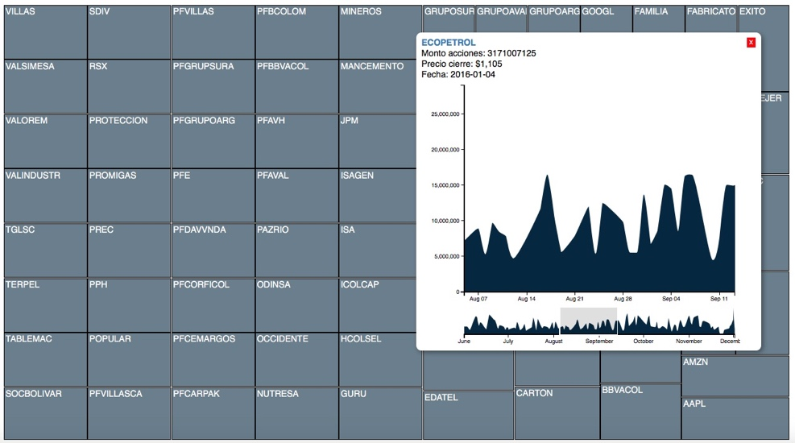

Fig. 1. Historical behavior embedded in stock market.

# **Abstract**– The Colombian Stock Exchange BVC is a private entity registered in the stock market, offers different platforms in which local market variations are recorded and reported.

# In the market for many years there is a great research and development of tools specialized in the financial area that allow to carry out analysis activities and that allow the decision making, but these tools mainly focus on users with intermediate and advanced knowledge in the stock market, the visualization developed focuses mainly on users who are not knowledgeable or basic in the stock market, then the tool allows exploration activities so that the user can identify and compare their own interests with respect to the information displayed.

**Index Terms**­– Stock market, Treemap, BVC

## Introduction

The Colombian Stock Exchange BVC is a private entity registered in the stock market and acts as manager of the stock markets, fixed income and standardized derivatives of Colombia. In addition, it offers different platforms in which local market variations are recorded and reported, for this reason, it is important to highlight the complex task of the BVC in the financial market and the need to focus the project of the course in a specific area . For this reason, from the meeting of understanding with the expert it was decided that the project will focus on the stock market. This stock market or variable income market has great relevance in the financial market since they are representative of the capital that a company owns and from the perspective of the BVC is "the gateway of the non-experts" (Castillo, 2016) On the subject of actions.

State of the art

There are a variety of proposals that seek to show the values of the market actions that are mainly focused on large exchanges.

Finviz

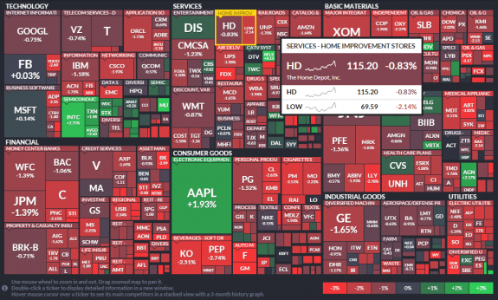

Fig. 2. <http://finviz.com/map.ashx?t=sec>

Stockmapper.

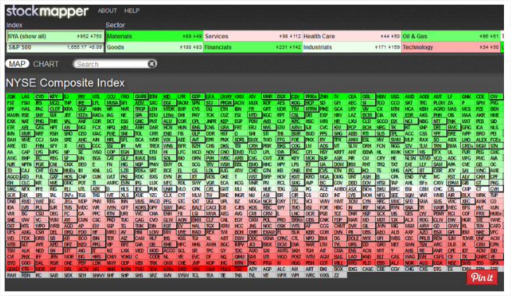Fig. 3. <http://www.stockmapper.com/>

Capital one

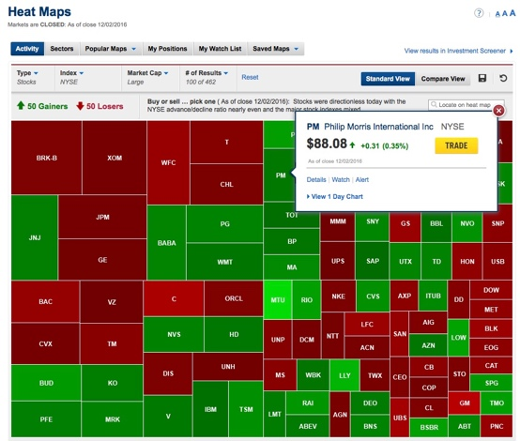

Fig 4. <https://research.capitaloneinvesting.com/Research/main/Stock-Market/Heatmap>

Proposed method

The method that was implemented was based on treemaps. That desition was taken buecause it can supply all client needs. In the example of Finviz that show an overview of all stocks. It permits take a visualization of the market. The user can use the information in orther to buy or sell a stock depending in his requirements.

The data processed corresponds to those of the Colombian stock market with quantitative data on the variation of the different shares listed on the stock exchange. The dataset consists of a table of data that contains the current information. The data are classified into four groups: VOLUME, QUANTITY PARTICIPATION, DAY VARIATION and CLOSURE PRICE.

There are 30 actions with the 4 value indicators. Which are:

Quantity: Number of shares in the market.

Closing price: The price of a stock at the time of closing of the stock exchange.

Volume: It is the multiplication of the quantity and the closing price. The value of the company.

Results and evaluation

The tasks that the visualization manages to fulfill are:

T1. Discover and summarize the global view of the behavior of the profitability of local market shares over time.

T2. Discover the distribution and measures of central tendency of an action to know moments of investment and reduce their risk.

T3. Compare stocks and their trend in the current market.

T4. Present the characteristics of the company that owns the action and emphasizing the industry of the company.

T5. From the COLCAP index, discover the behavior of the profitability of a stock in the market.

T6. Knowing an action locate the extreme points of profitability and their relationship correlation with market elements.

Discussion and conclusion

The visualization developed allows the user to present and discover the data independently of the level of knowledge of the operation of the stock market.

Additionally it is possible to perform exploration tasks with the help of embedded graphs for each action, from which you can navigate through its historical behavior by zooming on the data.

Because the navigation and the use of the visualization is interactive, the user can easily understand the state of the market with which he can get to make buying and selling decisions in the stock market.

References

1. BVC (2016) Bolsa de valores de Colombia. Recuperado el 3 de Octubre de 2016 de: http://www.bvc.com.co/pps/tibco/portalbvc
2. En.wikipedia.org. (2016). *Colombia Stock Exchange*. [online] Available at: https://en.wikipedia.org/wiki/Colombia_Stock_Exchange [Accessed 6 Dec. 2016].
3. Castillo, C. (2016, Septiembre 28). Entrevista realizada a Carlos Castillo en la reunión de entendimiento del tema BVC. [Entrevista personal].
4. Bloomberg (2016) Bloomberg For Enterprise. Recuperado el 2 de Octubre de 2016 de: https://www.bloomberg.com/enterprise/