

Master’s Degree Programme

Information Technology

**A solution for integration of Business information system in Recruitment Agency**

Proposal Submitted

By

Khaled Mosharraf 923524 (MIT)

A.K.M Bahalul Haque 926413(MIT)

Md Tanvir Rahman 927940 (MIE)

Submitted to:

**Prof. Dr. Stephan Schneider**

Date of Submission

**January 28th, 2016**

**Problem Statement:** In last few years around 300,000 new international students have entered Germany to study. Most of them are intended to work here after their studies. But as an international student without sober language proficiency and few other reasons it is very difficult for them to arrange an appropriate job. Being an international student we have figured out few reasons behind that. Most of the students don’t have proper knowledge about the job market here in Germany. Language barrier lists in the top among the problems students face, as most of the recruiter wants an employee with very good German language proficiency. Internet is a best medium to search jobs but most of the Job searching websites doesn’t contain exact filtering methods, so that the seeker couldn’t search the exact type of job they desire. Even they find a company the next steps become more difficult for them, starting from making the curriculum vita, cover letter and applying to the respective company. All the procedure may sometime differ from their home country.

Statistics has shown that in 2012 there are around 155,000 vacant positions for highly skilled positions like technicians, engineers and computer scientist. Nuremburg based institution for Employment Research estimates in 2010 that within 2025 Germany’s workforce will decline by 6.5 million. Demographic researchers predict that Germany will only be able to maintain its economic strength if there are 400,000 more immigrants than emerges annually. And International students can be a part of this workforce if proper guidance is provided. Most of the International master students coming here, have more or less work experience in relevant study field in their home country.

**Objectives of project:** Understanding the depth of the problem we have come up with a solution aiming International Students as well as German Graduates. Most of the company relies on their own website or online job portals; very few companies use print media, social media or employment agencies. As most of the international student has an obscure idea about their job fields and they couldn’t reach to Company’s own website. And in Job Portals due to lacking of specified filters they couldn’t search the job they want. Our plan is to march a job Portal and a recruitment agency in a single platform. Our idea not only includes typical Job portal like already existing one it will contain specific and on demand filters so that it can provide the exact information asked. We have introduced human interactive sessions like consultation to provide hand to hand service to our clients. Our service will not only work only for the job seekers but also for the employers. Companies have to spend extra money for their recruitment processes. They can also incorporate their recruitment procedure with our system.

The figures below provides an overview of how the whole system works. The different layers of the organization works in pretty much the above manner.



**Figure: Service Diagram**

The diagram below describes how a customer starts with registering and ends with getting a job or providing a job.

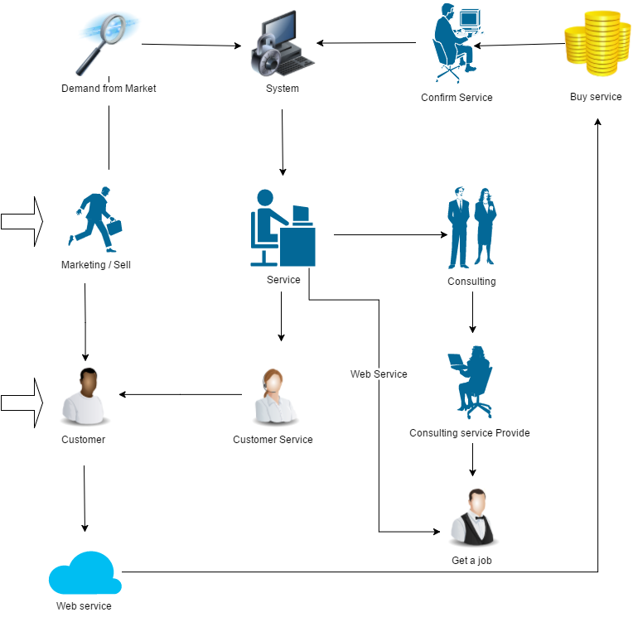

**Figure: Service Flow Diagram**

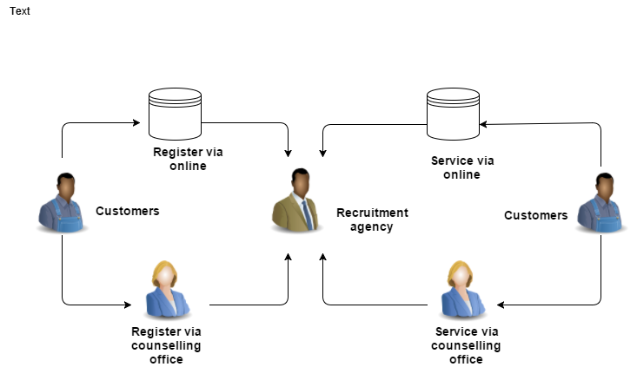These diagrams below describes about the overall work flow within the system.

**Figure: Basic Work Flow Diagram**

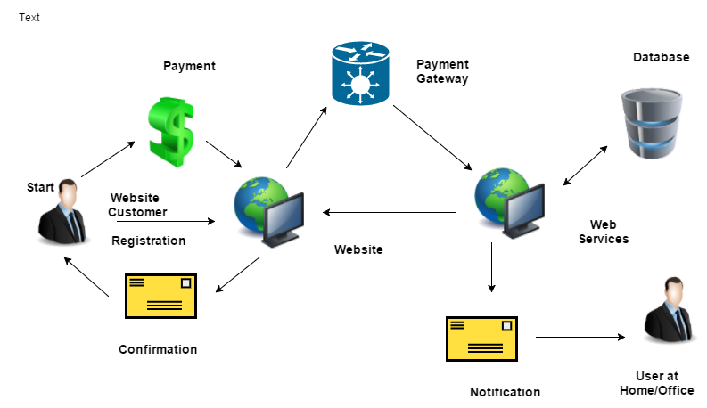

**Figure: Extended Work Flow Diagram**

**Proposed Use of Methodologies for the project**

* Requirement Engineering
* Agile Requirement Engineering
* Six Sigma
* BPMN 2.0
* Strategic IT Planning