# 6089-127 Rev A Step 1 Procedure

### Attach a serial number

1. Unpack a board.
2. Obtain and attach a serial number label to the large connector that mates with the SM.

Serial number label

### Check FPGA orientation

1. Visually verify that the FPGAs have been installed with the correct orientation. Each one has a dimple in one corner. That dimple should align with the “A1” mark on the board.

Pin “A1” dimple

2 places

### Check polarized capacitors on top side

1. Visually verify the orientation of the 14 120uf capacitors, in round aluminum cans, on the top side of the board. The blue mark indicates the negative terminal. Looking at the board with the large P1 connector pointing away from you, the 4 pairs of capacitors on the left side of the board should have the blue mark pointing to the right. The 3 pairs of capacitors on the right side of the board should have the blue marks pointing away from each other.

Blue marks opposite each other

6 places

Blue marks to the right

8 places

1. Visually verify the orientation of the 28 220 uf or 330 uf capacitors on the top side of the board. Four are adjacent to each of the 7 large LGA80D voltage regulators. The gray bars indicate the positive terminal. The bar should be near the “+” symbol on the silkscreen.

LGA80D regulator

7 places

Gray bars facing “+” sign

28 places

1. Visually verify the value of the 8 220uf capacitors connected to the LGA80D regulator in the middle of the row, U109. Look at 4 on the top side now (C455, C456, C488, and C489) and after the next step look at 4 on the bottom side of the board (C673, C674, C702, and C703). Use a magnifier or microscope to examine them. They should have “227” written on them. These are 220 uf 6.3 volts capacitors. If they have “337” written on them, then they are the wrong value for this location, because they are 330 uf 2.5 volt capacitors and the voltage rating is insufficient.

### Check polarized capacitors on bottom side

1. Flip the board over.
2. Visually verify the orientation of the 28 220 uf or 330 uf capacitors on the bottom side of the board. They are on the opposite side from the capacitors checked in the previous step. The gray bars indicate the positive terminal. The bar should be near the “+” symbol on the silkscreen.
3. Perform the examination of the 220 uF capacitors that are on the bottom side of the board. The details are in the previous step.

Gray bars facing “+” sign

28 places

### Attach bottom cover

1. Attach a bottom cover using six M2.3 x 4mm Flat-Head screws

M2.5 x 4 mm FH screw

6 places

### Set slide switches to 3.3V

1. There are 8 slide switches on the bottom side of the board. Set all of them to the “3.3V” position, which is to the left with the board oriented as shown (NOT the 3.8V position).

Slide switch in 3.3 V position (left)

8 places

### Connect the test board

1. Flip the board back over to the top-side up position.
2. Mate it with the test board.

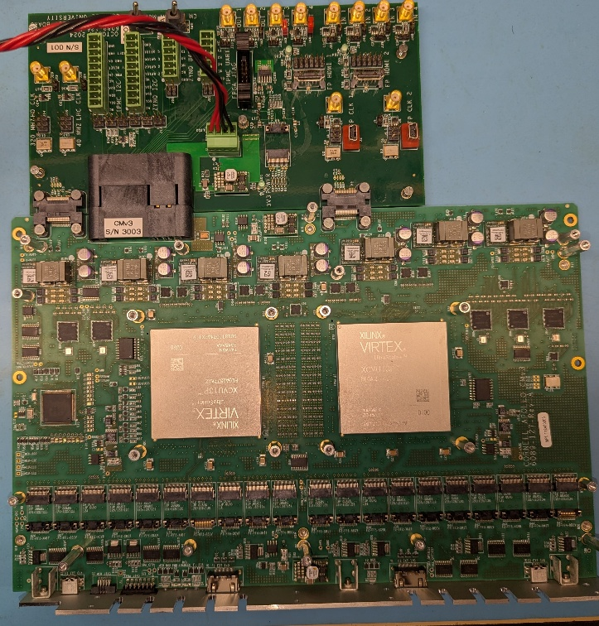

1. The power cable, JTAG programmer, and ZYNQ UART cable should all be connected.

### Connect MCU Segger JTAG programmer

1. Plug the cable for the Segger programmer into the front panel MCU JTAG connector. The polarization pin and the red stripe should be as shown below.

Red stripe

Polarization pin

### Prepare MCU programs (ONLY ONCE, UPDATE THESE COMMANDS AS APPROPRIATE)

1. Setup the compiler environment on LNX750 with the following commands:

cd /home/crs/apollo/mcu

source setup_mcu.sh

The file “setup_mcu.sh” contains:

export PATH=/home/wittich/Downloads/gcc-arm-none-eabi-9-2019-q4-major/bin:${PATH}

export FREERTOS_ROOT=/home/wittich/src/FreeRTOSv10.2.1/FreeRTOS/Source

1. Download the repo that contains both the bootloader and the application:

git clone [git@github.com:apollo-lhc/cm_mcu.git](mailto:git@github.com:apollo-lhc/cm_mcu.git)

1. Change to the “bootloader” project and compile the code with the “REV3=1” flag:

cd /home/crs/apollo/mcu/cm_mcu/projects/boot_loader

make -k REV3=1 DEBUG=1

1. Change to the “application” project and compile the code, again with the “REV3=1” flag:

cd /home/crs/apollo/mcu/cm_mcu/projects/cm_mcu

make -k REV3=1 DEBUG=1

### Check M3V3 management voltage

1. Connect a voltmeter to the “M3V3” and “GND” test points.
2. Set the variable voltage source that is powering the test board to its minimum voltage.
3. Turn on the power supply. Gradually increase the voltage. The voltmeter should jump to the 3.3 volt level when the power supply meter is around 6.5 volts. Note the voltage. Continue to increase the voltage to 12 volts and note the input current on the power supply. It should be around ??? amps.

GND and M3V3 test points for voltmeter connection

### Program the MCU

1. Verify that the 12V DC power is on.
2. Change to the “bootloader” project’s “gcc” directory and download the code to the board:

cd /home/crs/apollo/mcu/cm_mcu/projects/boot_loader/gcc

JLinkExe -commandfile /home/wittich/jlinkloadbl.cmd

1. Change to the “application” project’s “gcc” directory and download the code to the board:

cd /home/crs/apollo/mcu/cm_mcu/projects/cm_mcu/gcc

JLinkExe -commandfile /home/wittich/jlinkload.cmd

### Verify successful programming and proceed with software tests

1. After programming, the green MCU_ENABLED and PWR_OK LEDs should be lit. Note the current on the 12V power supply. It should be around ??? amps.