# 6089-127 Rev A Step 1 Procedure

### Attach a serial number

1. Unpack a board.
2. Obtain and attach a serial number label to the large connector that mates with the SM.

### Check FPGA orientation

1. Visually verify that the FPGAs have been installed with the correct orientation. Each one has a dimple in one corner. That dimple should align with the “A1” mark on the board.

### Check polarized capacitors on top side

1. Visually verify the orientation of the 14 120uf capacitors, in round aluminum cans, on the top side of the board. The blue mark indicates the negative terminal. Looking at the board with the large P1 connector pointing away from you, the 4 pairs of capacitors on the left side of the board should have the blue mark pointing to the right. The 3 pairs of capacitors on the right side of the board should have the blue marks pointing away from each other.



1. Visually verify the orientation of the 28 220 uf or 330 uf capacitors on the top side of the board. Four are adjacent to each of the 7 large LGA80D voltage regulators. The gray bars indicate the positive terminal. The bar should be near the “+” symbol on the silkscreen.



1. Visually verify the value of the 8 220uf capacitors connected to the LGA80D regulator in the middle of the row, U109. Look at 4 on the top side now (C455, C456, C488, and C489) and after the next step look at 4 on the bottom side of the board (C673, C674, C702, and C703). Use a magnifier or microscope to examine them. They should have “227” written on them. These are 220 uf 6.3 volts capacitors. If they have “337” written on them, then they are the wrong value for this location, because they are 330 uf 2.5 volt capacitors and the voltage rating is insufficient.

### Check polarized capacitors on bottom side

1. Flip the board over.
2. Visually verify the orientation of the 28 220 uf or 330 uf capacitors on the bottom side of the board. They are on the opposite side from the capacitors checked in the previous step. The gray bars indicate the positive terminal. The bar should be near the “+” symbol on the silkscreen.
3. Perform the examination of the 220 uF capacitors that are on the bottom side of the board. The details are in the previous step.

### 

### Remove Standoffs Blocking FireFly Cables

1. Remove and set aside 5 standoffs that are located between the FireFly sockets and the front of the board. Unscrew them from the bottom side of the board. They obstruct the installation of copper FireFly test cables.

### 

### Attach bottom cover

1. Attach a bottom cover using six M2.5 x 4mm Flat-Head screws into countersunk holes.

### Set slide switches to 3.3V

1. There are 8 slide switches on the bottom side of the board. Set all of them to the “3.3V” position, which is to the left with the board oriented as shown (NOT the 3.8V position).

### Connect the test board

1. Flip the board back over to the top-side up position.
2. Verify that the power supply is OFF.
3. Mate the CM with the test board.

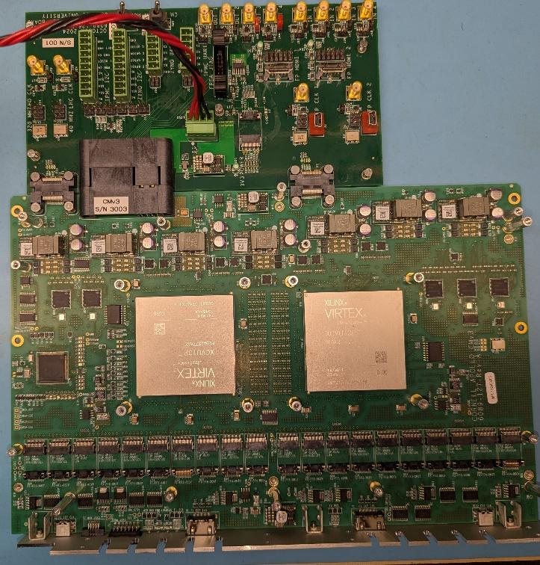

1. The power cable, JTAG programmer, and ZYNQ UART cable should all be connected.

### Connect MCU Segger JTAG programmer

1. Plug the cable for the Segger programmer into the front panel MCU JTAG connector. The polarization pin and the red stripe should be as shown below. The connector is fragile. Do not force it.

### Check M3V3 management voltage

1. Connect a voltmeter to the “M3V3” and “GND” test points. These are located close to where you just connected the MCU Segger JTAG programmer.
2. Set the variable voltage source that is powering the test board to its minimum voltage.
3. In the next step, STOP if the voltmeter exceeds 3.4 volts. This indicates a regulator problem, and further increases in the voltage may damage other parts.
4. Turn on the power supply. Gradually increase the voltage while observing the voltmeter. The voltmeter should jump to the 3.3 volt level when the power supply meter is around 6.5 volts. Note the voltage. STOP if the 3.3 volt level is not achieved by the time the power supply is at 7.5 volts. Continue to increase the voltage to 12 volts and note the input current on the power supply. It should be around 0.6 amps.

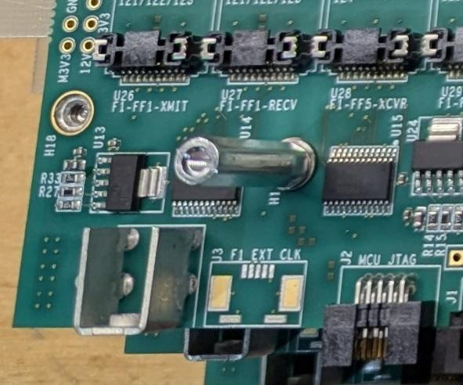

### Program MCU for production testing

1. Log onto the machine lnx231.classe.corrnell.edu and go to the directory /nfs/cms/tracktrigger/apollo/mcu_bit.
2. Program the boot loader:
   1. ` ./load_bl.sh`
3. Load the MCU testing program:
   1. `./load_prodtest.sh`
4. If there are any errors, log them and fail the board.

### Verify successful programming and proceed with software tests

1. After programming, the green MCU_ENABLED and PWR_OK LEDs should be lit. Note the current on the 12V power supply. It should be around 0.6 amps.

### MCU software tests

Run the production MCU test firmware testing suite. To connect to the MCU, on lnx231, run the command `screen /dev/ttyUSB0 115200`. (to exit screen, type “C-A k y”).

From the prompt, run the command `prodtest1` . If the output says ‘All tests successful’, record success. If not, record the information and fail the board.

**[ GO TO HEAT SINK INSTALLATION STEP]**

### Program MCU with main firmware

1. Log onto the machine lnx231.classe.corrnell.edu and go to the directory /nfs/cms/tracktrigger/apollo/mcu_bit.
2. Load the MCU testing program:
   1. `./load_main.sh`
3. If there are any errors, log them and fail the board.

**Load board ID into the internal EEPROM**

1. Open the MCU console via `screen /dev/ttyUSB1 115200`.
2. At the prompt, type `first_mcu <ID> 3 0 0 `. Replace <ID> with the CM serial number (just numbers) from the sticker you placed on the board. (The final three numbers are as follows: 3 is the board revision, and the other two are flags that can be used to debug fireflies or power supplies.)
3. Type “id” at the prompt and confirm that the entry took.

### Clock testing program

1. Program each FPGA using VIVADO with the following bit file:
   1. /nfs/cms/tracktrigger/apollo/clocktest/clock_test.bit
2. Run the following script to load the testing clock programs into the clocks. This script takes about XX minutes to complete.
   1. /nfs/cms/tracktrigger/apollo/clocktest/loadall_test1.sh
3. Compare test output to expectation by running the command `blah` at the MCU prompt.
4. If there are any errors, log them and fail the board.
5. NEED TO UPDATE TO OTHER CLOCK TESTING PROGRAMS
6. Load final clocking programs into EEPROMs
   1. Script needed
   2. This script takes about XX minutes to complete.

### Install copper cables

Connect medium length flyover copper cables as shown below. Adjacent TX and RX sites (labeled F*-FF1/2/3/4-XMIT and F*-FF1/2/3/4-RECV on the board) should be connected using the joined cables with the black lines on the cable facing upward on the RX side. The two-way F*-FF5-XCVR and F*-FF6-XCVR sites should be connected to each other using the copper cables that have the individual fibers separated. The connectors should slide easily into the slot, and can be secured in with the metal latch.

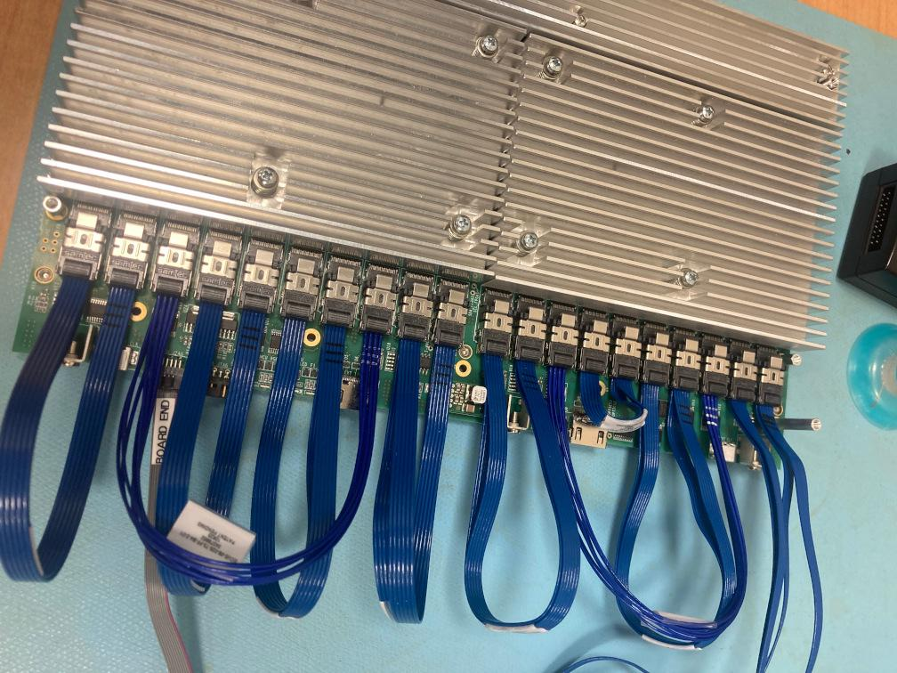

Switch to Link testing