FireFly Installation for TF on CMv3 (6089-127 Rev A)

Set FireFly transmitter voltage slide switches
- There are 8 slide switches on the bottom side of the board. Set all of them to the “3.3V” position (NOT the 3.8V position).
- Set only switch SW6 to the “3.8V” position. This set the transmitter voltage for the FireFly in site “U39”. (FPGA #2 quads 125/126/127)

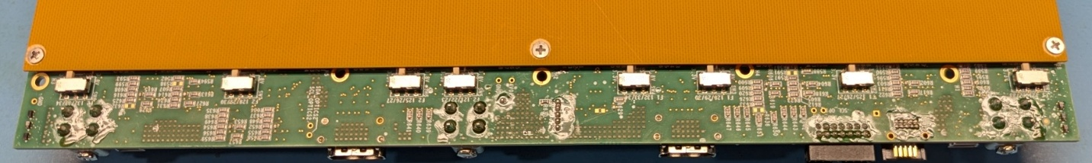

Selector switches in the “3.3V” (OFF) position.

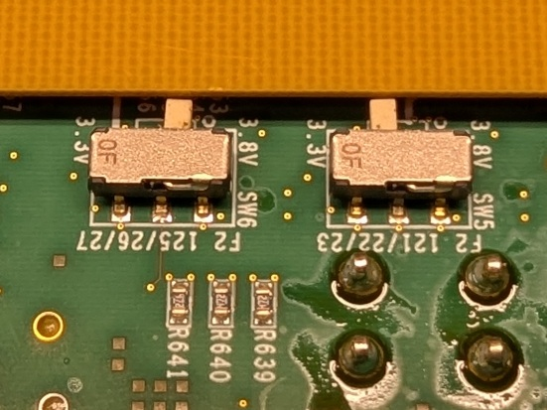
Selector switch SW6 in the “3.8V” (ON) position.
Selector switch SW6 location.

Reinstall standoffs and spacers
Several standoffs may have been removed to facilitate testing the board with copper FireFly cables. If so, they need to be replaced.

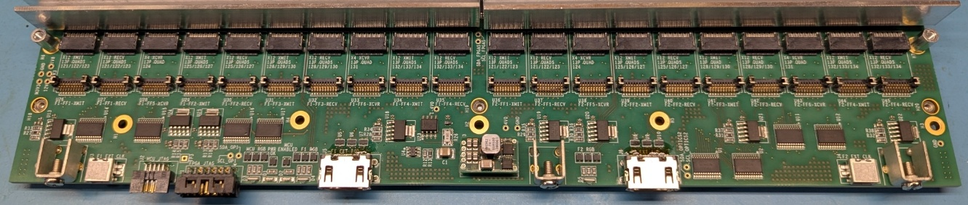

Missing FireFly heatsink standoffs
(2 places)
Missing top cover standoffs
(3 places)

- Remove the bottom cover.
- Install 3 21-mm long top cover standoffs
  - From the bottom side of the board, insert a Phillips-head M2.5 x 8 screw and an M2.5 lock-washer through one of the mounting holes H1, H2, or H3.
  - From the top side of the board add an M2.5 x 21 mm standoff.
  - Tighten the screw and standoff.
- Install 2 8-mm long FireFly heatsink standoffs
  - From the bottom side of the board, insert a Phillips-head M2.5 x 6 screw and an M2.5 lock-washer through one of the mounting holes H4 or H5. (NOTE: The M2.5 x 8 screws are too long for these standoffs)
  - From the top side of the board add an M2.5 x 8 mm standoff.
  - Tighten the screw and standoff.
- Reinstall the bottom cover.

Prepare and attach front panel
- Remove and discard the factory screws, if any, from the front panel mounting blocks.

Remove screws

- On a front panel that has already had the overlay applied, attach two 45-mm standoffs for the fiber optic connectors on the upper half. Insert Phillips-head M2.5x6 screws plus M2.5 lockwashers from the back side, and thread on the spacers from the front side. Finger tighten so as to not strip the plastic threads.
- Attach a fiber optic coupler block to the standoffs using Phillips-head M2.5 x 12-mm screws. Be sure the “key” faces in the direction shown in the photo.
- Print and attach a label that shows the CM serial number. The format is “CMxxxx” where “xxxx” is the 4-digit serial number that matched the one on the board.
- Attach the front panel to the board with three Phillips-head M3x6 screws.
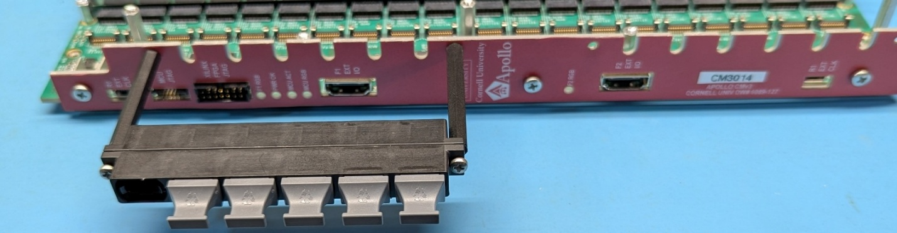
Coupler block
45-mm standoffs
Serial number label

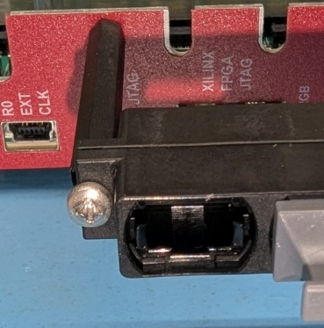
“Key” direction

Install FireFly modules
- Plug in all the required FireFly modules. For a TF board, the FireFly types and sites are:
  - F1-FF1-RECV (U27) Quads 121/122/123: 25Gx12 Receiver
  - F1-FF2-RECV (U30) Quads 125/126/127: 25Gx12 Receiver
  - F1-FF3-RECV (U32) Quads 128/129/130: 25Gx12 Receiver
  - F1-FF4-RECV (U35) Quads 132/133/134: 25Gx12 Receiver
  - F2-FF5-XCVR (U38) Quad 124: 25Gx4 Transceiver
  - F2-FF2-XMIT (U39) Quads 125/126/127: 25Gx12 Transmitter
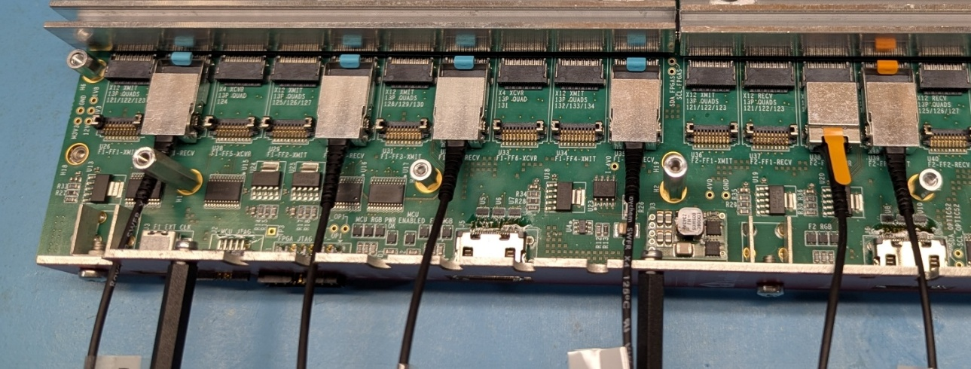

25Gx12 Receiver
25Gx4 Transceiver
25Gx12 Transmitter

- Cut five 11-mm wide by 15-mm long strips of pink 1.78 mm thick Laird Tflex HD300 (DigiKey P/N 926-1594). Apply them to the top of the FireFly receivers and transmitter. Cut one 11-mm square piece and apply it to the top of the FireFly transceiver. Be sure it does hot ovelap the latch on this device. If you have trouble cutting and centering them, cut larger pieces to start with.

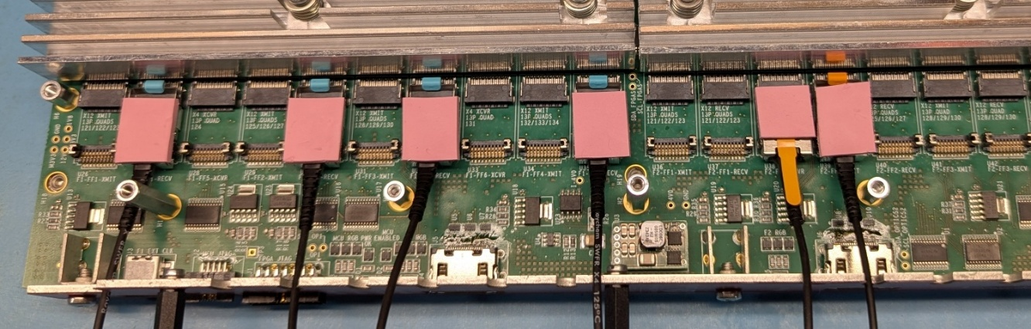

11-mm by 15-mm ( 5 places)
11-mm square (do not overlap latch)
- Mount the FireFly heatsink using 4 M2.5x12 screws, 4 M2.5 shoulder washers, and 4 S001YJ1D springs. The shoulder on the washer should be inside the spring. Tighten the screws just until the springs are fully compressed. Dress the cables that fit between the heatsink and the front panel.

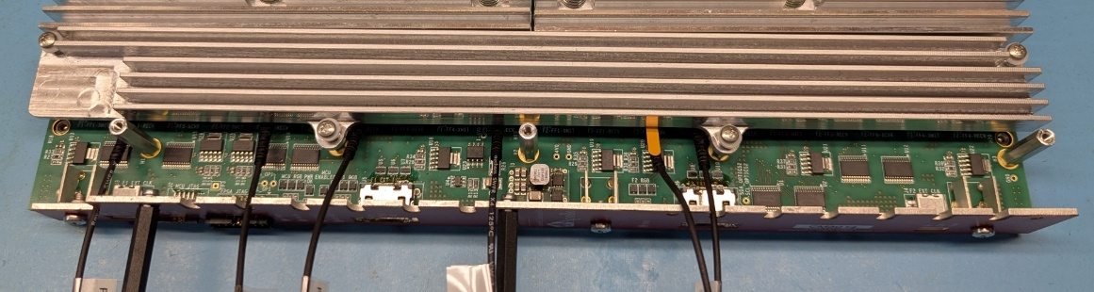

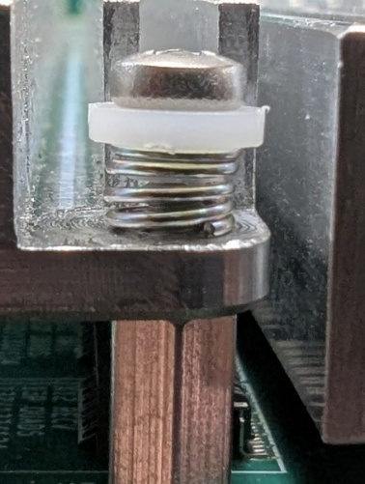
- One at a time, route the FireFly cables in the space between the front panel and the FireFly heatsink. Pass the cable through the slot in the front panel and plug the MTP connector into the front panel coupler block. Do them is the same order as they are installed on the board.

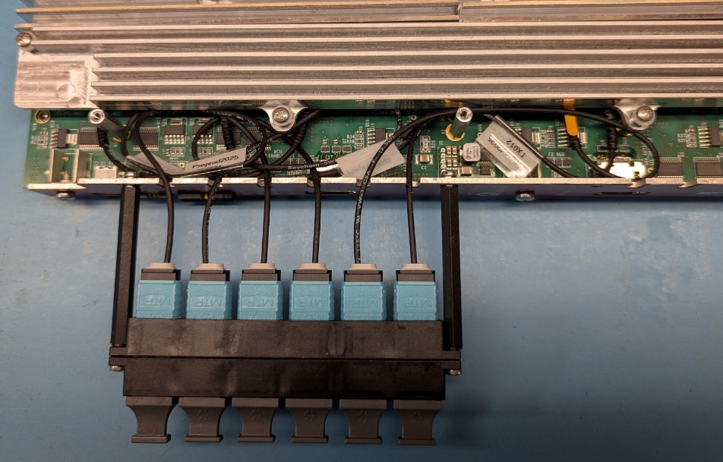

- Label both sides of the coupler block. Use the Epson LW-PX750 with a 9 mm black-on-white cartridge. For the TF, use the data format shown below. The “^” character is a “space”.

OT-DTC^^^^OT-DTC^^^^OT-DTC^^^^OT-DTC^^^^^^DTH^^^^^^^^L1T
^RECV^^^^^^RECV^^^^^^RECV^^^^^^RECV^^^^^^^XCVR^^^^^^^XMIT
^^#1^^^^^^^^^#2^^^^^^^^^#3^^^^^^^^^#4

- With scissors, trim the excess from both ends of the tape.

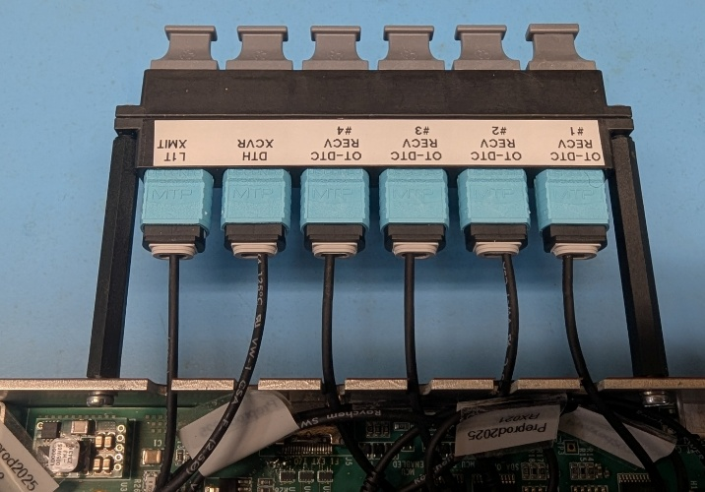
Viewed from top side of CM

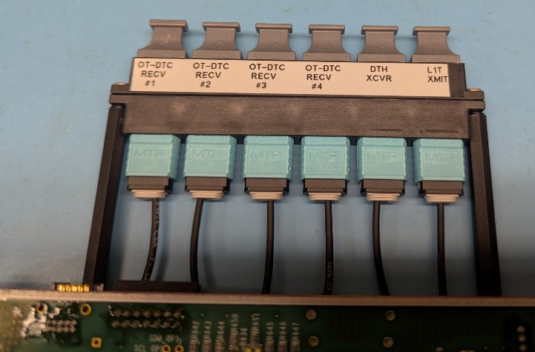
Viewed from bottom side of CM

Details about installing FireFly modules

- When installing a FireFly module with a retaining clip, the clip MUST be at its full height on both sides throughout the process.
  - If the clip is down by even a small amount, it will bend the receiver on the socket when the FireFly is pushed in.
  - Subsequently pressing down on the clip to lock it will be hard, and the receiver will be bent even more. The FireFly may be withdrawn slightly.
  - Examining the empty socket will reveal bent receivers.
  - A bent receiver can be VERY CAREFULLY straightened, but if you over-correct then the receiver can be broken off.

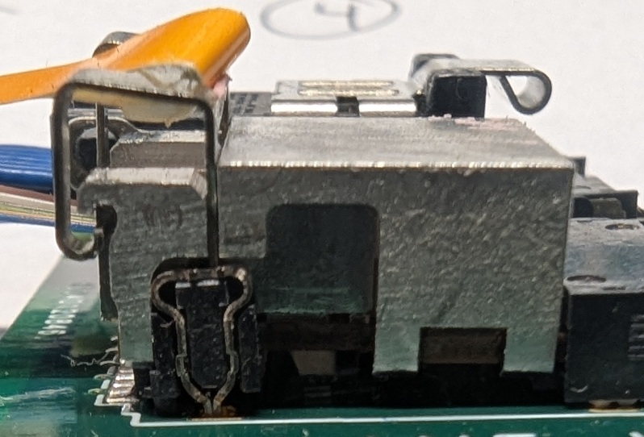
FireFly fully inserted
Clip aligned over receiver
Clip at full height during insertion
Figure 1 Correct alignment of the Retaining Clip for Insertion

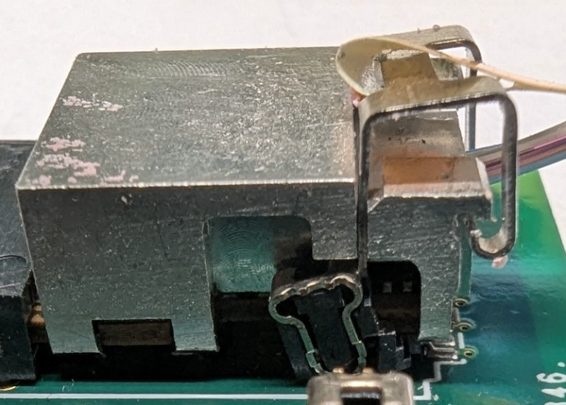
FireFly slightly withdrawn
Receiver bent forward when FireFly is pushed in
Clip slightly less than full height during insertion
Figure 2 Incorrect positioning of the Retaining Clip

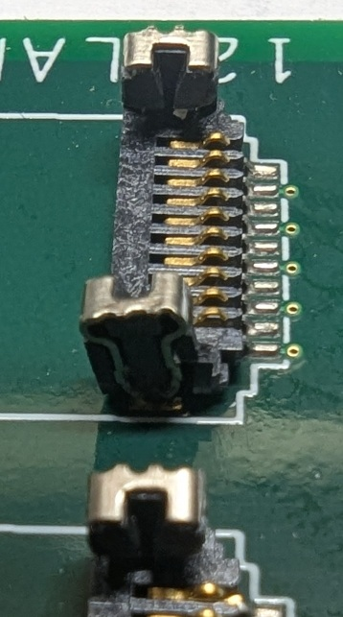
Bad (bent) receiver
Good (straight) receiver
Figure 3 Bent Retaining Clip Receiver

- When installing a FireFly module or cable, it is first placed over the low-speed connector.
  - If the module has a retaining clip, it must be at its full height. See instructions about retaining clips. Cable latches must be open.
  - As the module or cable is held level, it is slightly pushed into the high-speed connector while verifying that it is entering the center of the connector.
  - It is then fully slid into the high-speed connector. It should be flush against the connector.
  - Some incorrect alignment issues are shown below. They may be slightly exaggerated.
Module is level before gold fingers enter high-speed connector.
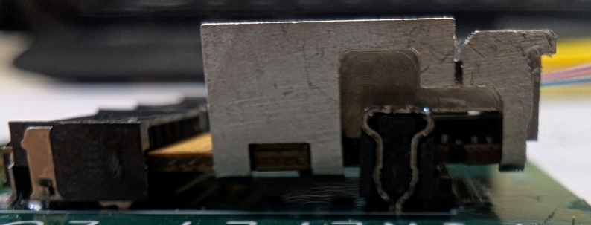
Module is then slid forward a slight bit while being checked for insertion into the center of the connector.

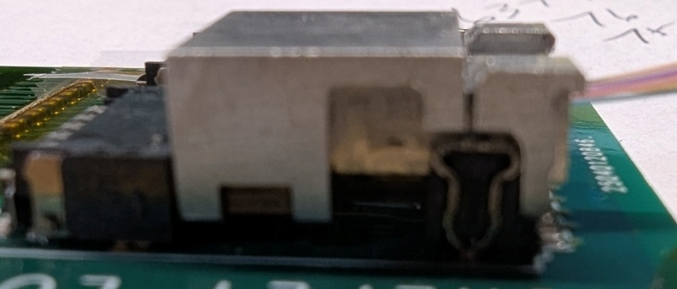
Module is slid fully into the connector. No gap, no visible gold.

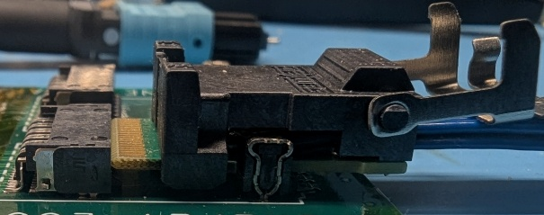

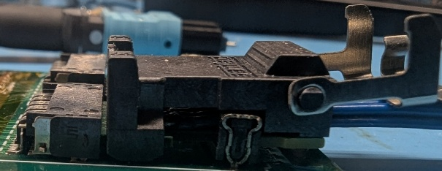

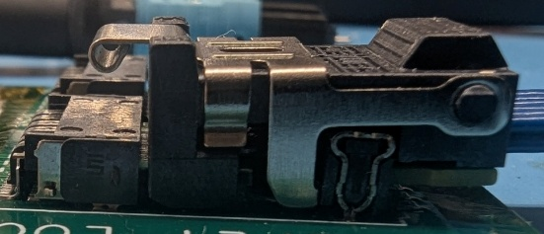
The closed latch on a cable must be behind, and not overlap, the side of the low-speed connector.

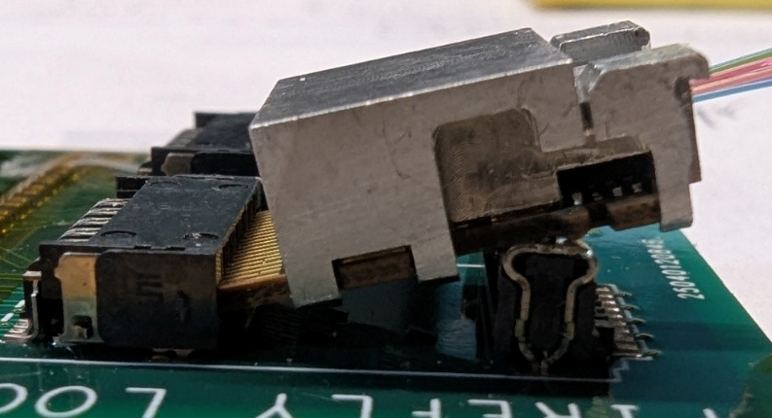
This module is tilted, and was started into the high-speed connector before being placed over the low-speed connector.

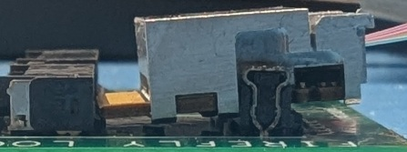
These fingers are not aligned with the center of the high-speed connector

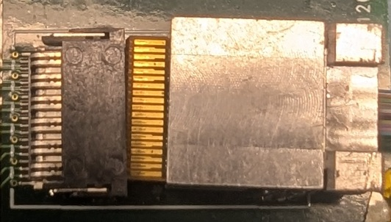
This module is not square to the connector

