SIMPLICREATIVE

Theme-Mapped Copy & Layout Recommendation
Ibar Special Needs Trust Advisors | Homepage Demonstration
Gold Standard | GS-TPL-003 | v1.0
Purpose: show how the approved Content & Page Outline can be mapped to an approved WordPress theme/template. The screenshots are layout references only. The AI selects an existing theme section whose structure fits the approved content job, then drafts copy sized for that structure. The client revision column is intentionally editable and blank.

Engineering boundary: the system does not invent a new page design. It uses the approved theme as a component library. If no existing theme section can responsibly support an approved content requirement, flag the mismatch for human review rather than forcing the content into an unsuitable layout.

How to Read This Output
Layout Reference  Screenshot from the approved theme/template. Reference the structure only. | Sample Copy  Initial draft messaging shaped to the approved content flow and approximate layout capacity. | Client Revised Copy  Space for edits, corrections, approvals, and preferred wording.

Open Client Clarifications
Name formatting: confirm whether the formal brand presentation should be Ibar, iBar, or another approved form throughout the new site.
Word-choice options shown in parentheses are deliberate review prompts. Final copy should use the client-approved selection.

Homepage Section 1 | Hero
Layout Reference | Sample Copy | Client Revised Copy
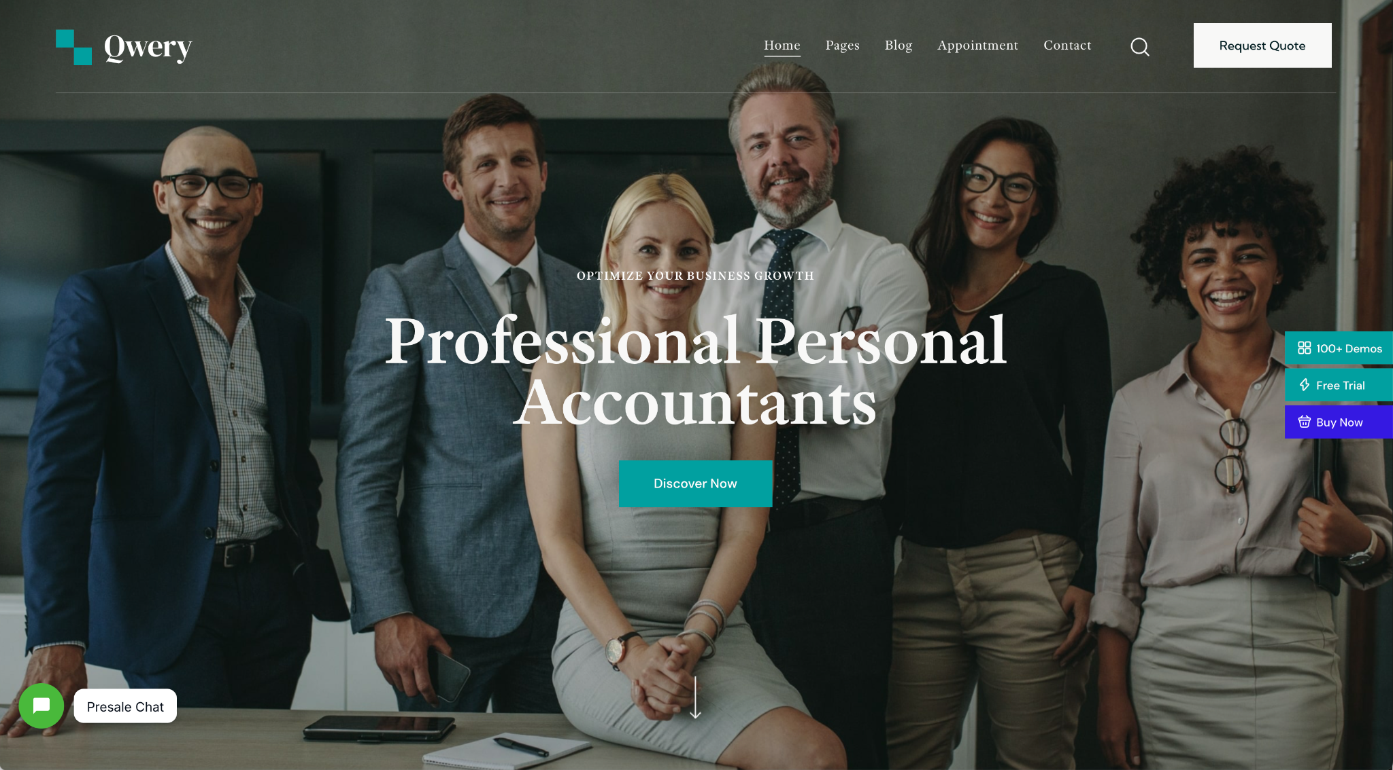  Theme/template screenshot. Layout reference only. Ignore original imagery, branding, colors, and copy. | SECTION KICKER  Special Needs Trust Administration  HEADLINE  A Lifetime Solution for Special Needs Trust Beneficiaries  Ibar helps families and beneficiaries navigate special needs trust administration with the personal support of a dedicated advisor and the continuity of an experienced corporate trustee relationship.  CTA  Request a Consultation → Contact

Mapping logic: use the theme hero because the approved content job requires one clear promise, a concise supporting statement, a single primary CTA, and a strong image area.

Homepage Section 2 | What We Do
Layout Reference | Sample Copy | Client Revised Copy
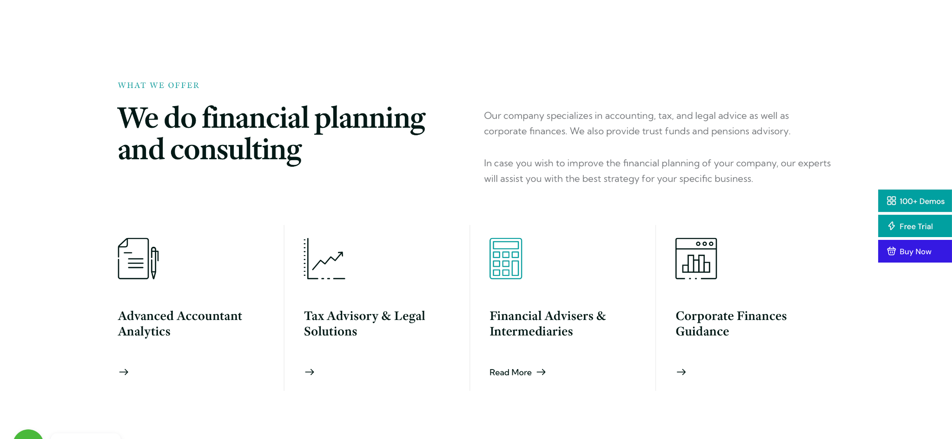  Theme/template screenshot. Layout reference only. Ignore original imagery, branding, colors, and copy. | SECTION KICKER  What We Do  HEADLINE  Special Needs Trust Expertise You Can Count On  For over 40 years, individuals and families across California have turned to Ibar Special Needs Trust Advisors for help protecting their loved ones and supporting their quality of life.  Our experienced team works closely with banks that serve as corporate trustees, providing hands-on support and a deep understanding of each beneficiary’s unique needs.  Ibar helps administer special needs trusts as part of:  • An estate plan, when parents and grandparents are planning ahead to protect a loved one’s future.  • A personal injury settlement, when settlement assets must be protected and managed without jeopardizing public benefits.  CTA  Learn more about what we do →

Mapping logic: the theme's text-plus-image section supports a short educational introduction and two clear service situations without creating custom UX.

Homepage Section 3 | Who We Help
Layout Reference | Sample Copy | Client Revised Copy
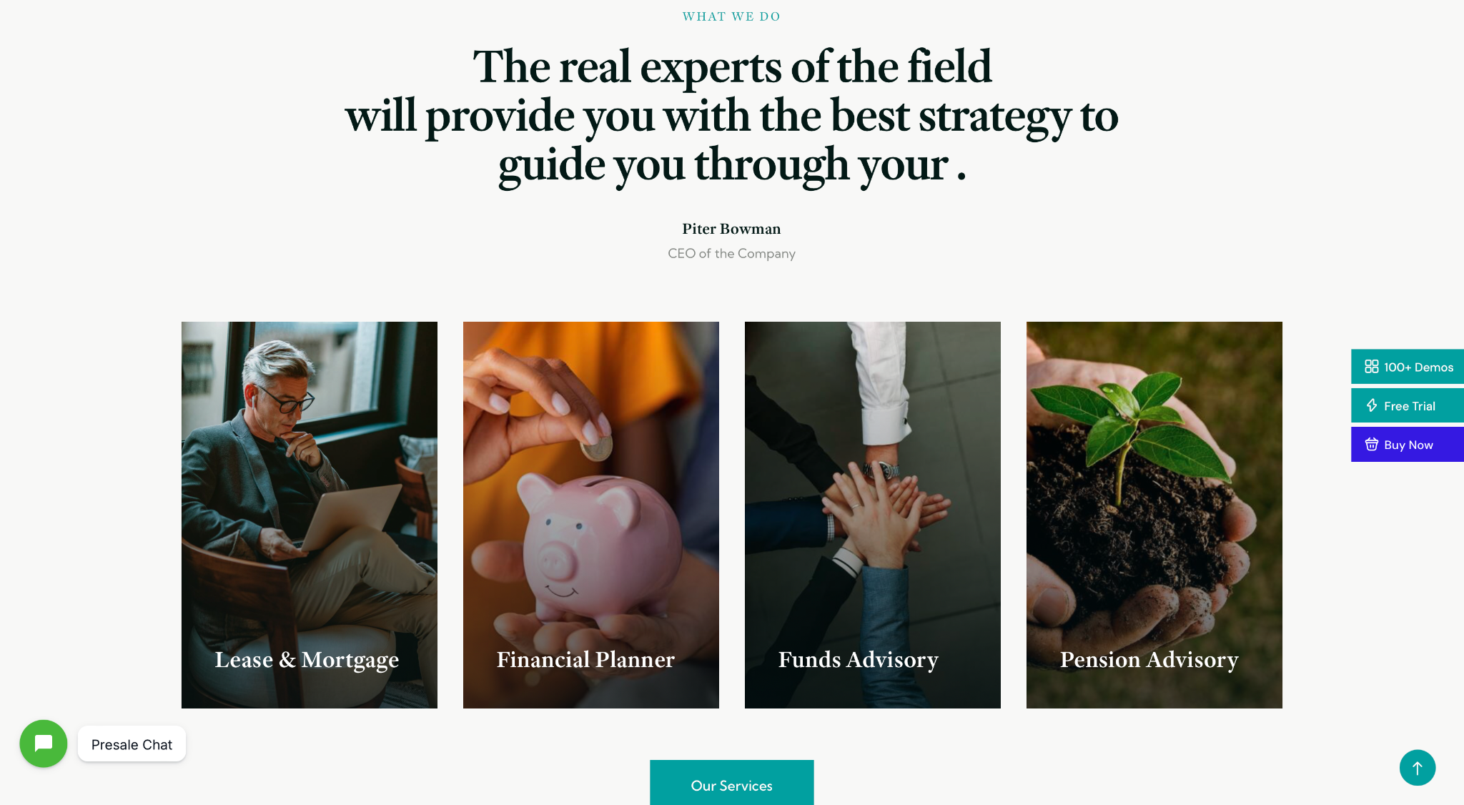  Theme/template screenshot. Layout reference only. Ignore original imagery, branding, colors, and copy. | SECTION KICKER  Who We Help  HEADLINE  Supporting Families, Beneficiaries & Trusted Advisors  Every special needs trust is unique, but our goal is always the same: protect beneficiaries while providing guidance and support for everyone involved.  • Families planning ahead for a loved one with special needs.  • Beneficiaries who rely on a trust to support their quality of life.  • Estate-planning and personal-injury attorneys who need an experienced, trustworthy SNT partner.  • Corporate trustees who need a dedicated advisor to help manage the day-to-day requirements of an SNT.

Mapping logic: use the theme's centered image + copy section because the approved content is an audience summary, not four separate custom journey cards.

Homepage Section 4 | The Ibar Difference
Layout Reference | Sample Copy | Client Revised Copy
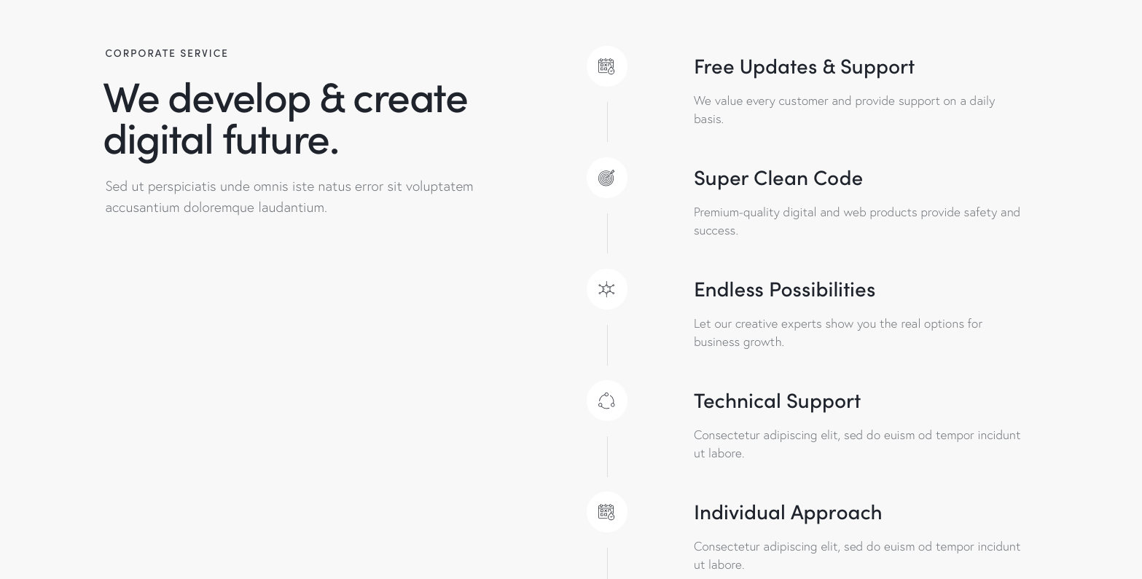  Theme/template screenshot. Layout reference only. Ignore original imagery, branding, colors, and copy. | SECTION KICKER  The Ibar Difference  HEADLINE  The Stability of a Corporate Trustee, Combined with the Personal Support of a Dedicated SNT Advisor  Choosing who will manage a loved one’s special needs trust is an important decision. With Ibar, families can pair the stability of a corporate trustee with the dedicated guidance of an advisor who knows the beneficiary and family.  Dedicated Advisor Support  Every beneficiary is assigned a dedicated Ibar Advisor who understands their needs and serves as a consistent point of contact.  Public Benefit Expertise  Ibar helps beneficiaries maintain SSI, Medi-Cal, and other public benefits through thoughtful trust administration.  Team-Based Support  An experienced team stands behind every dedicated advisor, helping provide continuity even when the primary advisor is unavailable.  40+ Years of Experience  Ibar brings decades of specialized experience helping families navigate special needs trust administration with confidence.

Mapping logic: the theme's stacked image/text feature supports differentiation through a headline plus several compact proof pillars. Benefits language remains client-review dependent.

Homepage Section 5 | Lifetime Support
Layout Reference | Sample Copy | Client Revised Copy
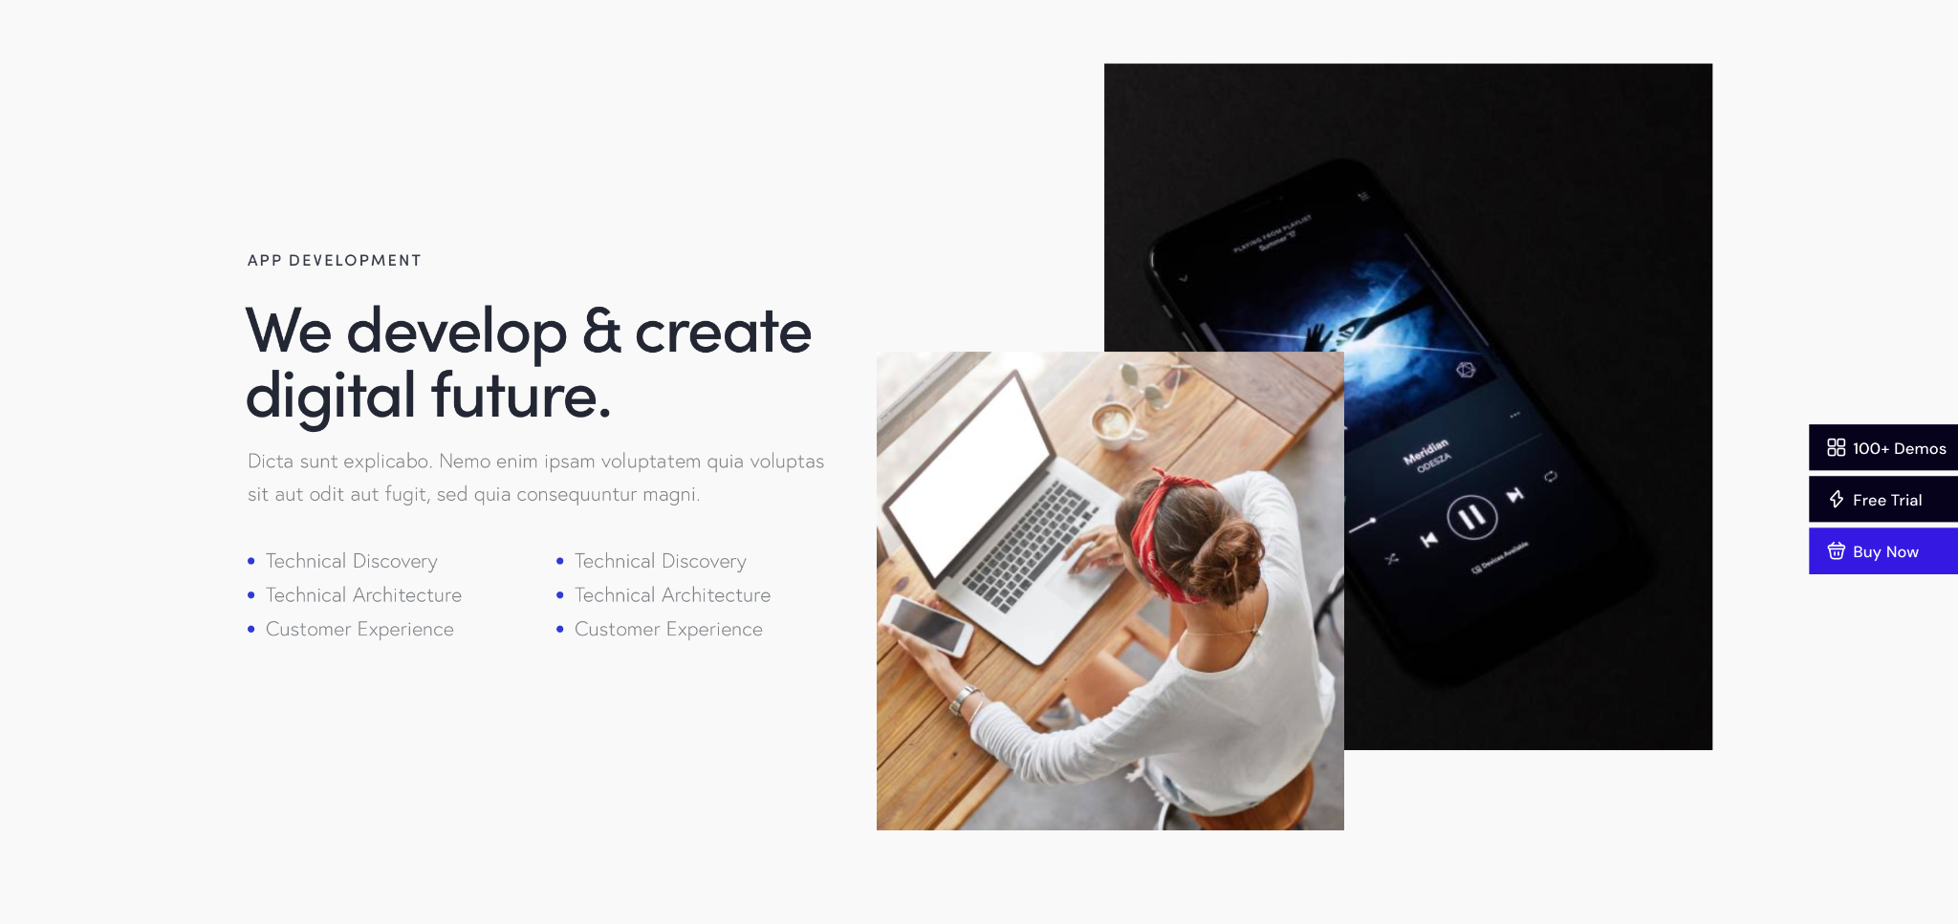  Theme/template screenshot. Layout reference only. Ignore original imagery, branding, colors, and copy. | SECTION KICKER  Lifetime Support  HEADLINE  Supporting Beneficiaries Through Every Stage of Life  A beneficiary’s needs can evolve throughout life. Ibar provides ongoing guidance to help families and trustees make informed decisions at every phase of the journey.  CTA  See how Ibar supports every stage → What We Do  Recommended visual: approved Sam lifetime-journey graphic or a simplified adaptation that fits the selected theme section.

Mapping logic: use a horizontally structured visual section to make the lifetime-support idea tangible without creating a custom interactive experience.

Homepage Section 6 | Testimonials
Layout Reference | Sample Copy | Client Revised Copy
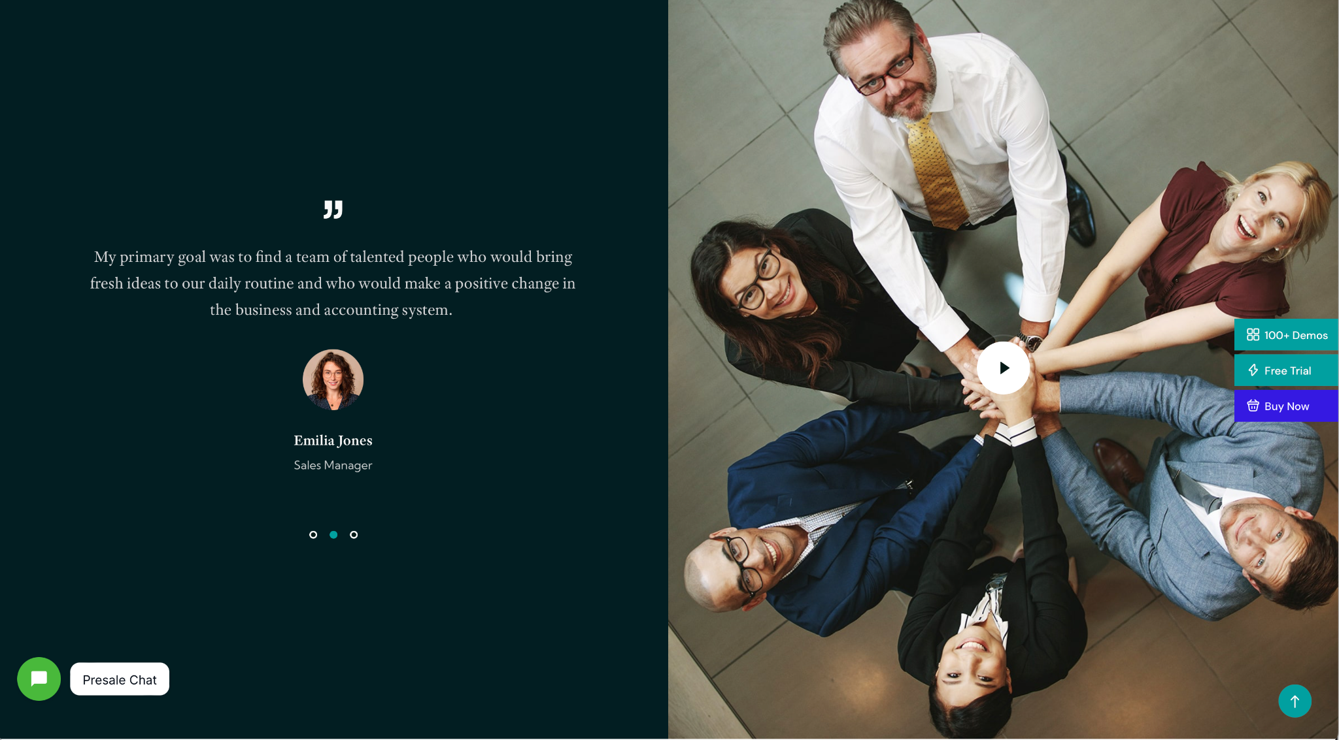  Theme/template screenshot. Layout reference only. Ignore original imagery, branding, colors, and copy. | SECTION KICKER  Testimonials  HEADLINE  What Families Say About Ibar’s Expertise and Support  Use approved testimonial excerpts from Ibar’s existing testimonial library. Prioritize quotes that reinforce responsiveness, advocacy, continuity, trust, and personal knowledge of the beneficiary.  Do not invent, paraphrase, or shorten testimonials without client approval. Preserve attribution and permissions.  CTA  Read more testimonials →

Mapping logic: use the theme's testimonial carousel/card component because the content job is social proof. Source only approved client testimonials.

Homepage Section 7 | Resources
Layout Reference | Sample Copy | Client Revised Copy
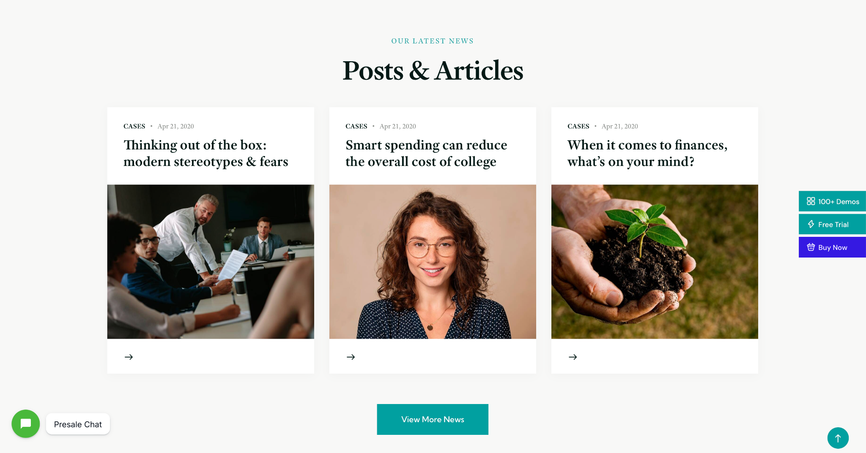  Theme/template screenshot. Layout reference only. Ignore original imagery, branding, colors, and copy. | SECTION KICKER  Resources  HEADLINE  Posts & Articles  Practical guidance for families and professionals navigating special needs trusts, trustee decisions, benefits-sensitive administration, and long-term planning.  Populate this section from approved blog posts. Use the theme's existing post-card structure and imagery rules.  CTA  View all resources →

Mapping logic: use the theme's existing post-card module so the homepage can surface recent or featured educational content without custom development.

Homepage Section 8 | Contact
Layout Reference | Sample Copy | Client Revised Copy
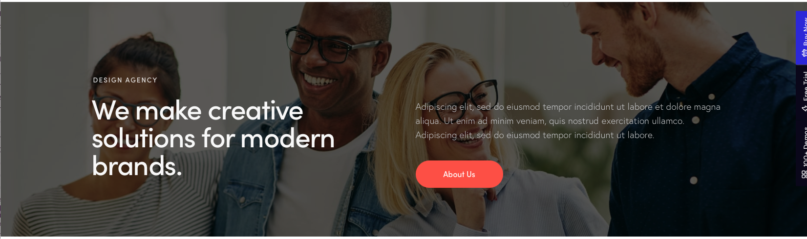  Theme/template screenshot. Layout reference only. Ignore original imagery, branding, colors, and copy. | SECTION KICKER  Contact Us  HEADLINE  Not sure where to start?  Exploring how Ibar can support you starts with a conversation. Tell us a little about your situation and we’ll review your information and get back to you as soon as we can.  CTA  Request a Consultation  Confirm final public contact details. Current discovery direction is to use the intake form as the primary contact path and avoid publishing email addresses.

Mapping logic: use the theme's final CTA section because the approved page journey ends with one clear action and minimal friction.

Engineering Interpretation of This Gold Standard
The production system should accept: approved Content & Page Outline + approved theme/template URL or approved screenshot set + current brand/content sources. It should return: theme-section mapping + layout reference capture + layout-aware sample copy + client revision area + source/constraint notes.

System Step | Required Behavior
Theme inspection | Open the approved theme URL and identify reusable sections/components, not just whole demo pages.
Component extraction | Capture section screenshots and basic structure such as image placement, heading count, text capacity, cards/columns, CTA location, and special interactions.
Content mapping | Match each approved page-outline section to the theme component that best performs that section's job.
Copy generation | Draft copy to the approved strategy and approximate structural capacity of the chosen component.
No template-copy reuse | Ignore the demo theme's original words, images, colors, and branding as content.
Mismatch handling | If no component responsibly supports the approved content, return THEME_LAYOUT_MISMATCH_REQUIRES_HUMAN_REVIEW.
Human approval | Client/human revisions become the approved copy source for implementation. AI draft is never treated as final approval.

Required Guardrails
APPROVED_CONTENT_FLOW → APPROVED_THEME → COMPONENT_MATCH → LAYOUT-AWARE_COPY → HUMAN/CLIENT_REVISION → APPROVED_IMPLEMENTATION_COPY
THEME_SCREENSHOT = LAYOUT_REFERENCE_ONLY
THEME_COPY != SOURCE_COPY
THEME_LAYOUT_MISMATCH_REQUIRES_HUMAN_REVIEW
AI_DRAFT != CLIENT_APPROVAL
MATERIAL_STRATEGIC_CHANGE != PRODUCTIZED_COPY_REVISION

