

FACILITATING AND LEARNING MATERIAL FOR

UNIT 13: PORTS, CABLES, AND CONNECTORS

NATIONAL CERTIFICATE I

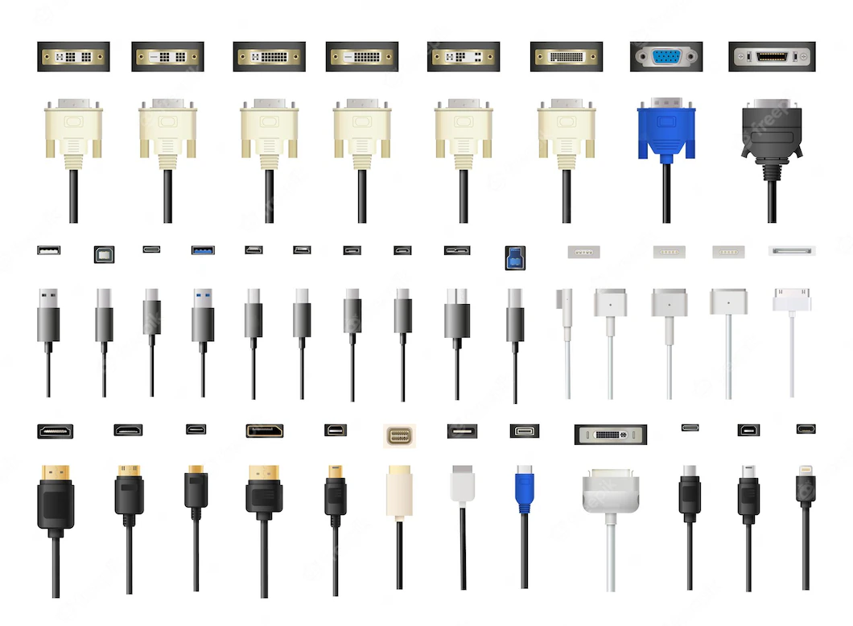
LEARNING OUTCOMES
1 | Demonstrate knowledge of ports, cables, and connectors
2 | Demonstrate skills in ports, cables, and connectors
3 | Demonstrate skills in installing and troubleshooting ports

Contents
1. LO 1 DEMONSTRATE KNOWLEDGE OF PORTS, CABLES AND CONNECTORS 6
PC (a) Describe ports, cables and connectors 6
PC (b) State types of ports, cables and connectors 8
PC (c) State features of ports 8
Features of USB Port 8
PC (d) Outline features of Cables 9
PC (e) State features of Connectors 9
Self-Assessment 1 10
2. LO 2 DEMONSTRATE SKILLS IN PORTS, CABLES AND CONNECTORS 11
PC (b) Select the appropriate cable by connectors 12
PC (c) Match cables to ports 13
PC (d) Identify alternative ports for same function 14
PC (e) Identify cables of alternative ports 14
Self-Assessment 2 15
Checklist 15
3. LO 3 Demonstrate skills in installing and troubleshooting ports 16
PC (c) Remove faulty ports 21
PC (d) Replace faulty ports on device board 22
PC (e) Replace faulty ports with adapter 22
PC (f) Follow safe work practices 23
Checklist 23
References 24

INTRODUCTION AND PRELIMINARY NOTES

On completion of this unit, the learner will be able to demonstrate knowledge of ports, cables, and connectors, demonstrate skills in ports, cable and connectors and demonstrate skills in installing and troubleshooting ports

This learning material should be used with the unit specification given as the unit specification will guide you to the standards stated with all the range statement. You should also be guided by the evidence requirements so that your learning is relevant to the required standards.

The way the learning material is written is to encourage learner autonomy and initiative (i.e., activities that require the learner to work independently of the facilitator and to make decisions concerning how he/she might approach a task) so that you as a learner can take ownership of your own learning. Follow the instructions and the steps indicated in the learning material and work as independently as possible.

ICONS AND THEIR MEANINGS
# | Icon | Meaning
1 |  | Learning Outcome
2. | 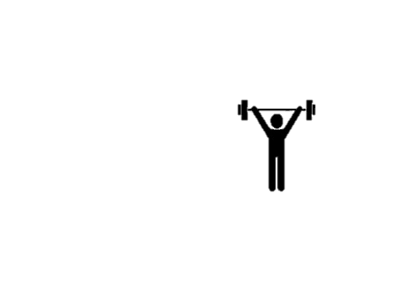 | Self- Assessment

Table 1: Icons and their meanings
The meaning of each icon is provided in Table 1. You should know what each icon represents. Carefully observe the icons and their meanings.



LO 1 Demonstrate Knowledge Of Ports, Cables, And Connectors
This LO is developed to help you acquire knowledge in ports, cables, and connectors.
To achieve this, we will go through PCs (a) – (e).

In this session you will describe ports, cable and connectors, state types of ports, cables and connectors, state features of ports, outline features of cables and state features of connectors.

PC (a) Describe ports, cables, and connectors
External devices are connected to a computer using cables, connectors, and ports. Ports are slots on the motherboard into which a cable of external device is plugged in. These cables have connectors terminating the cables. Examples of external devices attached via ports are the mouse, keyboard, monitor, microphone, and speakers.

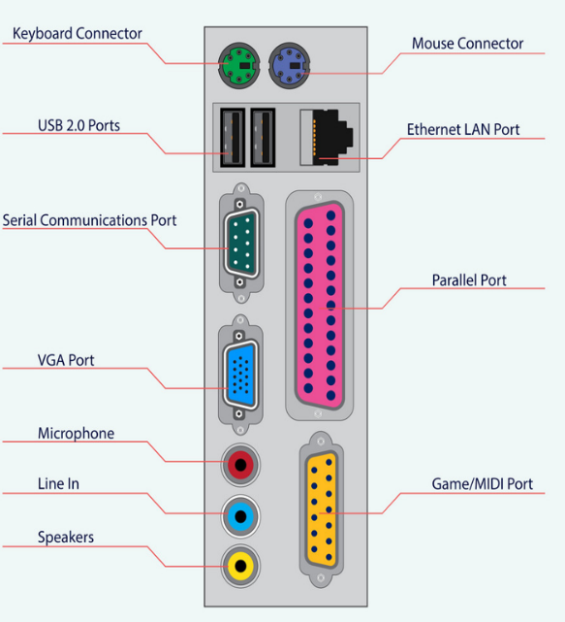
Port: A computer port, also known as a communication port, is a port that connects the computer to peripherals such as the keyboard, mouse, printer, display unit, monitor, flash drive, and speaker. The data from any peripheral is transmitted to the computer via the computer port. Figure 1.1a show some of the common ports on can find on a computer. In general, communication ports are divided into two types, which can be classified based on the protocol and type of communication utilized, such as Serial and Parallel Ports.1.1b
Figure 1:1 Computer Ports

Cable: A computer cable is used to connect monitors, keyboards, printers, hard drives, and other peripherals to computers. Figure 1.2 shows an image of cables used in a computer system.
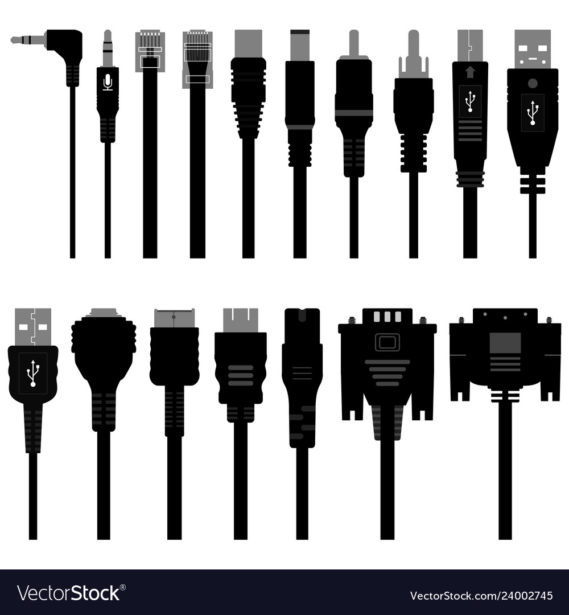
Figure 1:2 Computer Cables

Connectors: A computer cable connector is the part of a cable that plugs into a port or interface to connect a device to the motherboard or another device. Figure 1.3 displays some images of connectors.
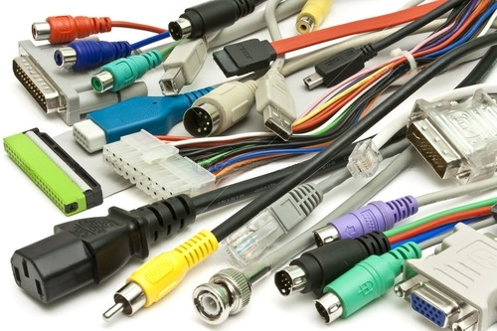
Figure 1:3 Computer Connectors

PC (b) State types of ports, cables, and connectors
There are various types of ports, cables, and connectors in a computer system. Below is a list of some of these ports, cables, and connectors.

Table 1:1 types of ports, cables, and connectors
Ports | Cables | Connectors
Serial | Serial | Serial (DB-9, DB-25)
Parallel | Parallel | Parallel (DB-25)
USB (Universal Serial Bus) | USB (Universal Serial Bus) | USB (Type-A, Type-B, Type-C, Mini-USB, Macro-USB)
PS/2 (Personal System/2) | PS/2 (Personal System/2) | PS/2 (Mini-DIN-6)
VGA (Video Graphic Array) | VGA (Video Graphic Array) | VGA (DE-15)
Ethernet | Ethernet | Ethernet (RJ-45 Connector)
HDMI (High-Definition Multimedia Interface) | HDMI (High-Definition Multimedia Interface) | HDMI (Type-A, Type-B, Type-C, Type-D)
Serial | Serial | Serial (DB-9, DB-25)

PC (c) State features of ports
There are various types of ports in the computer system as discussed previously. At this level you will know about the features of a USB port.

Features of USB Port
- USB device has a maximum speed up to 480 Mbps (for USB 2.0).
- USB acts as a “plug and play" device.
- USB can draw power by its own supply or from a computer. USB devices use power up to 5 voltages and deliver up to up to 500 mA.
- Low-power devices (such as mice) can draw their power directly from the bus.
- USB provides two-way communication between the PC and peripheral devices, making it ideal for many I/O applications.

PC (d) Outline features of Cables
There are various cables used in a computer system as discussed previously. However, in this session you will learn about the features of the USB cable.

- Individual USB cables can run as long as 5 meters.
- A USB cable has two mains, wires for power and a twisted pair of wires to carry the data.
- USB devices are hot-swappable, that means there is no need to shut down and restart the PC to attach or remove a peripheral.
- Length of individual USB cable can reach up to 5 meters without a hub and 40 meters with hub.

PC (e) State features of Connectors
There are many connectors in the computer system, but we shall consider at this level the USB as one of the most common connectors and consider its features
Polarization
The USB connector can only be nominally inserted in one way. It is possible to force a wrong connector, but this can cause damage to the device.

At least four contacts All USB connectors have at least four contacts (some USB models may have five, USB 3.0 connectors or more), which are used for power, ground and two data lines (D + and D -). The USB connector is designed to transmit 5V up to 500mA.

Shielding
The USB connector is shielded, so it provides a metal shell that does not belong to the circuit, which is very important to keep the signal intact in the environment with a lot of electrical "noise".

Powerful power connection
It is very important for the power pin to establish a connection before the data line to avoid trying to power the device through the data line, which is taken into account in the design of all mil spec USB connectors.

Mould strain relief
All USB cables are plastic-wrapped at the connector to prevent pressure on the cable and damage to the electrical connection.


Self-Assessment 1
Well done. You are almost finished with this lesson. To consolidate all that you have learnt in this lesson, here is an assessment for you to take

- A computer cable _____________ is the part of a cable that plugs into a port or interface to connect a device to the motherboard or another device.

- The RJ-45 is an example of a USB connector. True/False

- State two (2) Features associated with USB cable.

………………………………………………………………………………………………………………………………………………………………………………………………………………………………………………………………………………………………………………………………………………………………………………………………………………………………………………………

- Explain any 2 of the features of a USB connector

………………………………………………………………………………………………………………………………………………………………………………………………………………………………………………………………………………………………………………………………………………………………………………………………………………………………………………………


LO 2 Demonstrate Skills In Ports, Cables, And Connectors
This LO is developed to help you acquire skills in ports, cable, and connectors.
To achieve this, we will go through PCs (a) – (e). After completion of this Learning outcome, you will have the skill set to manage and on ports, cables, and connectors in a computing environment. Let’s go.

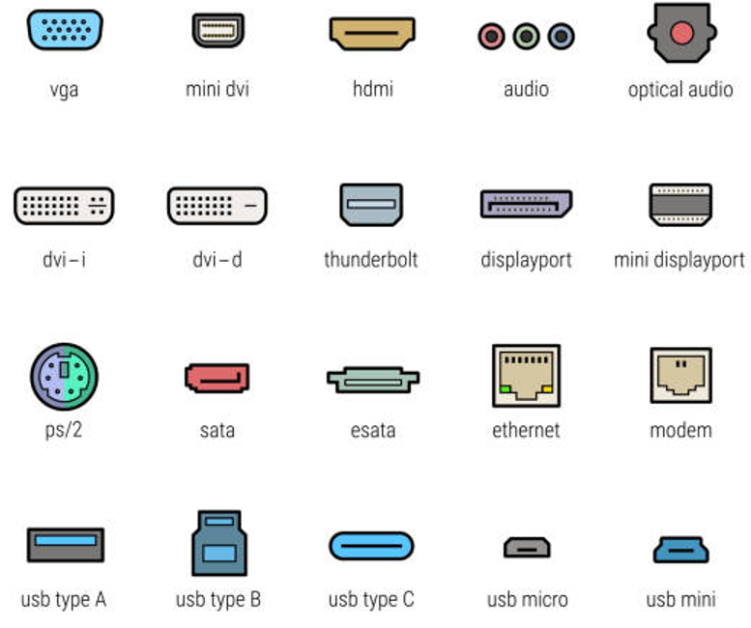
Figure 2:1 Ports

PC (a) Identify ports
There are several computer ports available, at this level you should be able to identify the following ports in the table below.
Figure 2:2 type of ports

PC (b) Select the appropriate cable by connectors

In computing systems, cables play critical role in connectivity. Cables are normally terminated with connectors. There are a variety of cables and connectors. Below are cables and their corresponding connector which will help you select appropriate cables and their connectors.

Table 2:1 Cable and its connectors
Name | Cable | Connectors
HDMI | 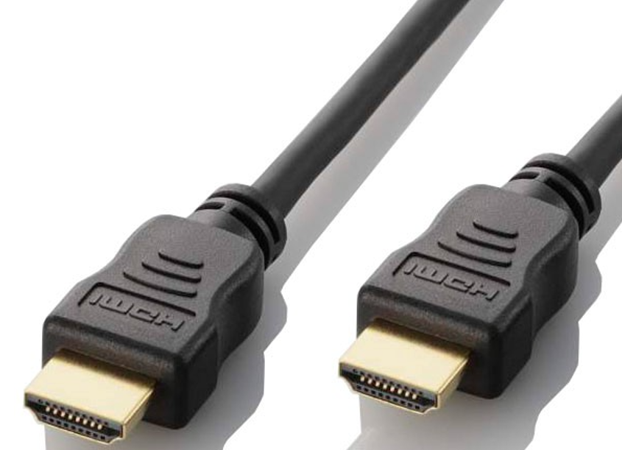 | 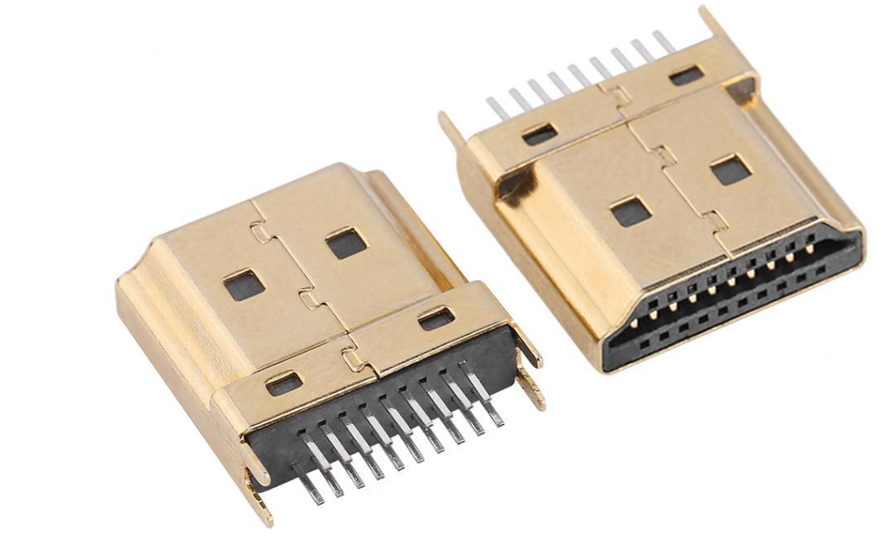
Serial | 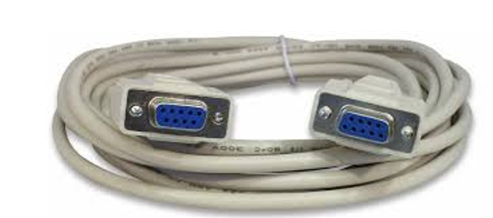 | 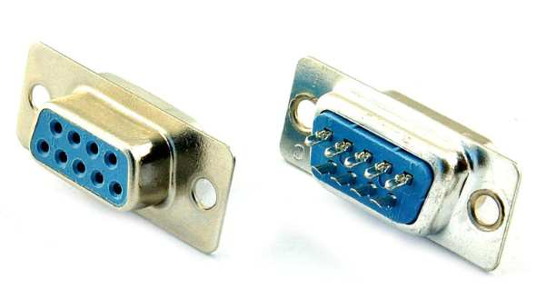
Ethernet | 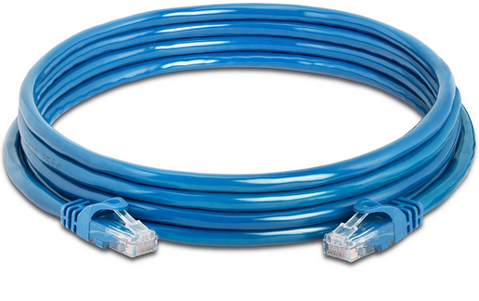 | 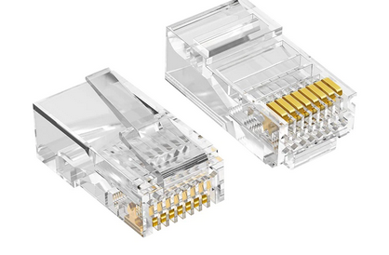
USB | 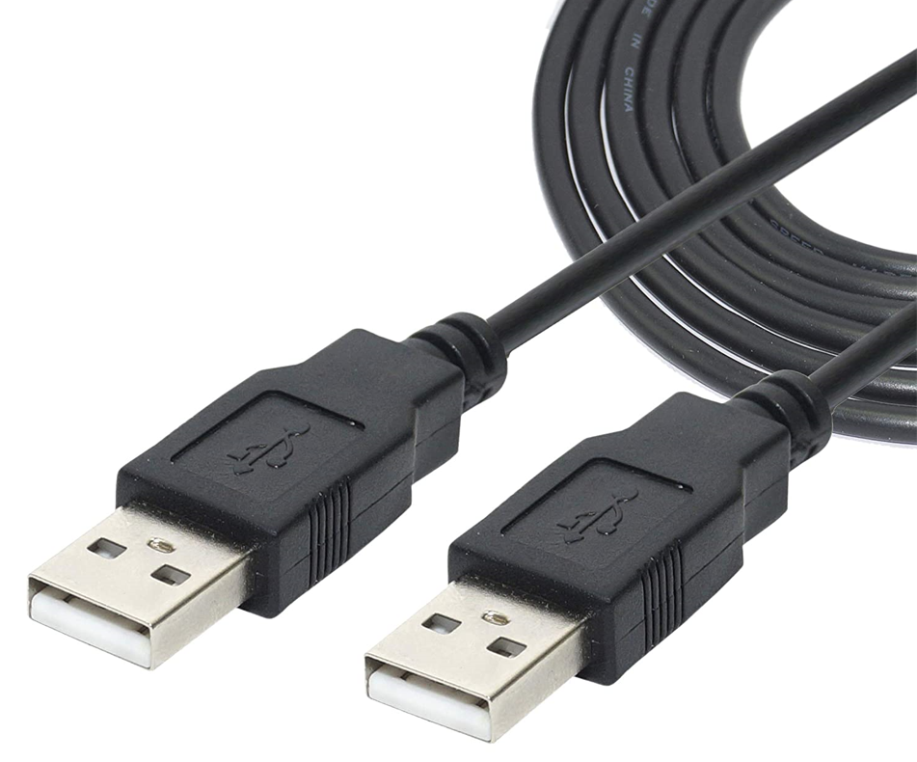 | 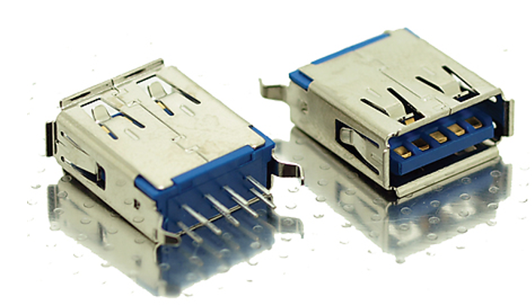
Parallel | 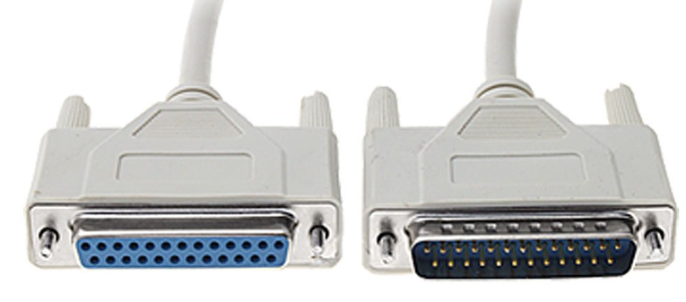 | 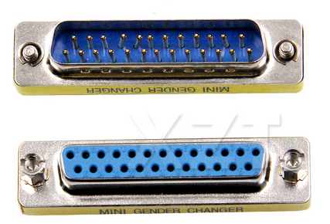

PC (c) Match cables to ports
External devices are connected to a computer using cables and ports. Cable of external device is plugged into Ports which are slots on the motherboard.
Below is a table of some computer cables matching their respective ports

Table 2:2 cables matching their respective ports
Name | Cable | Ports
HDMI |  | 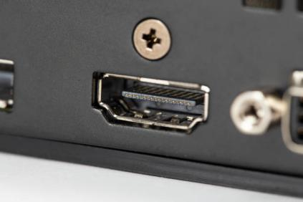
Serial |  | 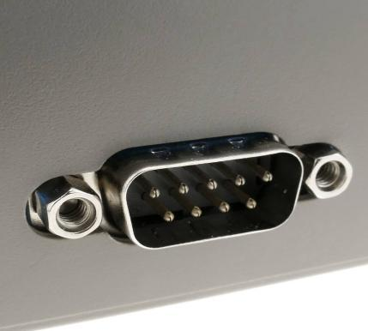
Ethernet |  | 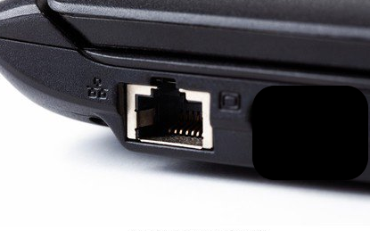
USB |  | 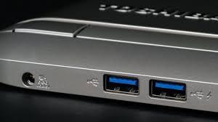
Parallel |  | 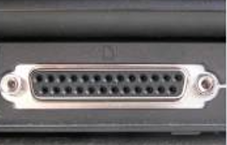

PC (d) Identify alternative ports for same function
In computing systems, there are various functions that can be performed with various ports. Below are functions and the ports that are associated with it.
Table 2:3 ports and their functions
Ports | Functions
PS/2, USB | Connecting to input devices
Parallel, USB | Connecting to output devices
HDMI, VGA | Connecting to screens.

PC (e) Identify cables of alternative ports
Table 2:4 Cables and their functions
Cables | Functions
PS/2, USB | Connects Mouse, Keyboard
Parallel, USB | Connects Printers
HDMI, VGA | Connects Projectors, Televisions


Self-Assessment 2
Well done. You are almost finished with this lesson. To consolidate all that you have learnt in this lesson, here is a practice activity for you. For this exercise identify appropriate ports, cables, and connectors.

Checklist
No | Activity | Yes | No
1 | Identify ports
2 | Select appropriate cable by connectors
3 | Match cables to ports
4 | Identify alternative ports for same function
5 | Identify cables of alternative ports


LO 3 Demonstrate skills in installing and troubleshooting ports
This LO is developed to help you acquire skills in installing and troubleshooting ports.
To achieve this, we will go through PCs (a) – (f). After completion of this Learning outcome, you will have the skill set to install and troubleshoot ports in a computing environment. Let’s go.

PC (a) Install device cable to appropriate port
You will go through the practical steps needed to install a MODEM to it appropriate port to access the internet. Let’s learn this with ease.
Below are the step-by-step processes to follow.

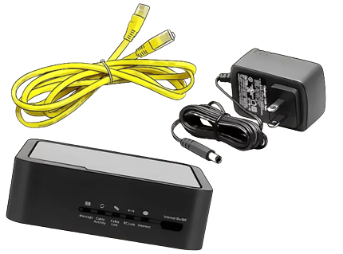
Make sure you have all necessary accessories should include the following:
- An ethernet cable for connecting the modem to your computer
- The cable modem's power adapter
- A coaxial cable for connecting the modem to the cable line

- Power up the modem
Connect the modem to a power source and turn it on
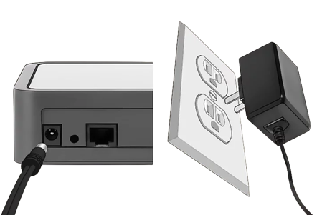

- Connect the coaxial cable to the modem
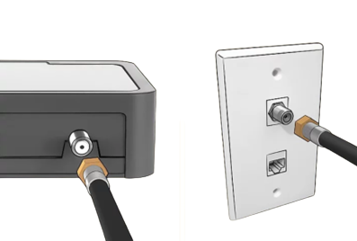
Take the coaxial cable coming from your wall and connect it to the port at the back of the modem

- Connect the computer to the modem with an ethernet cable
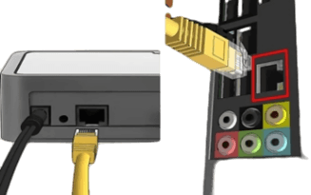

- Browse the web


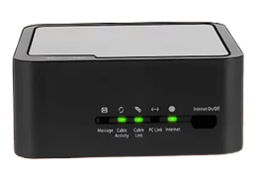

PC (b) Troubleshoot to test for connectivity
For problems connecting to a computer network, one will have to troubleshoot. With the steps below, you how to troubleshoot connectivity issues.

Check your Wi-Fi connection on your devices
You can find the Wi-Fi symbol in the following locations on the following devices.
- Windows: In the task bar in the lower-left corner.
- Mac: In the menu bar in the upper-right corner.
- Smartphones and Tablets: In the upper-right corner of the screen.
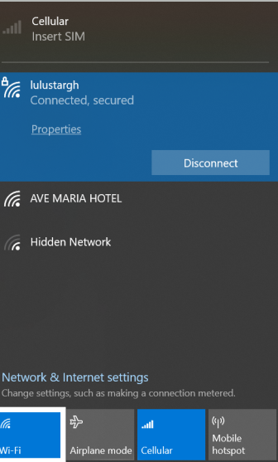
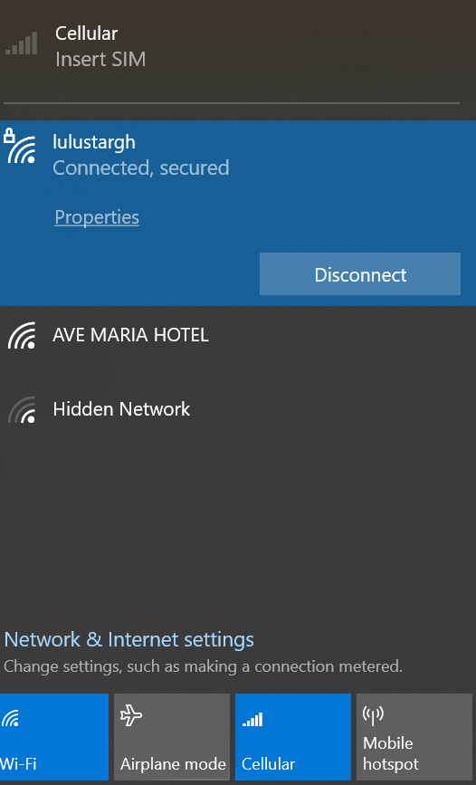

- Make sure Wi-Fi is turned on
Click or tap the Wi-Fi icon on your computer or smart device. Check to make sure Wi-Fi is turned on in the Wi-Fi menu.

- Check different internet services or websites
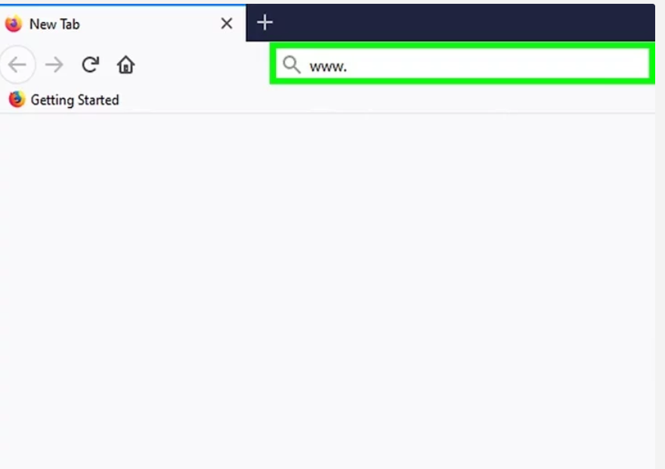

- Check the lights on your modem or router

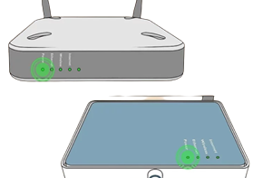

- Make sure your internet cable is firmly attached to your modem or router
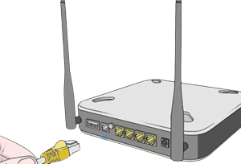
- Restart your modem or router
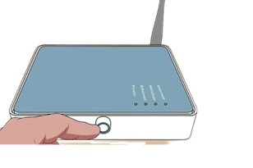
- Restart your internet-connected devices
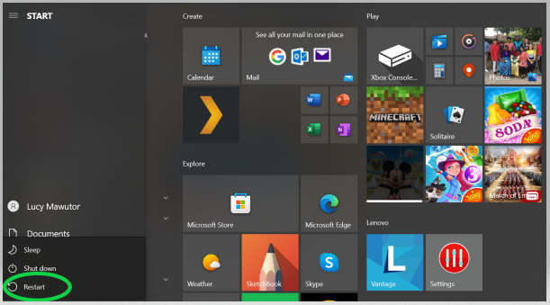

- Move your wireless devices closer to your modem or router
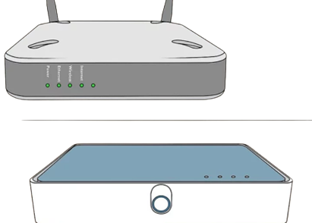

- Use a wired connection
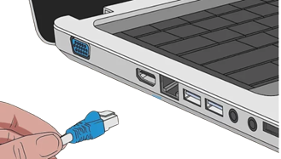

- Wait a couple of hours and try again.
Sometimes internet traffic can overwhelm your internet service resulting in slow internet speeds and poor connections.

- Call your internet service provider.
Sometimes problems with your internet connection are the problems with your internet service provider.


PC (c) Remove faulty ports
Once a port is faulty and needs to be replaced, the faulty port will have to be removed before a new one is replaced.
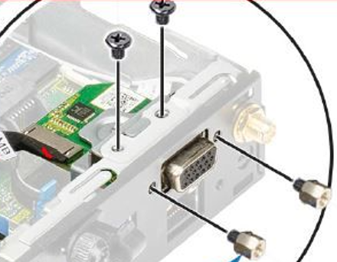

Below are the steps needed to remove a VGA port on a motherboard
Tools needed: Screwdriver
- Open the case
- Disconnect devices and cables connected to the system
- Lay down the case
- Remove the screws with a screwdriver
- Remove the VGA port by pulling it out

PC (d) Replace faulty ports on device board

You shall look at how to replace a faulty USB port in this session.
Follow the following procedures.
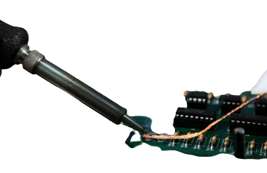
- Remove the system unit cover
- Unplug the system cables on the motherboard to avoid damage
- Unscrew the panel on which the USB is connected
- Remove the faulty USB
- Desolder the pins attaching the USB to the board using solder wick and heat gun
- Remove the faulty USB port
- Solder the new USB port
- Fix it back unto the board

PC (e) Replace faulty ports with adapter

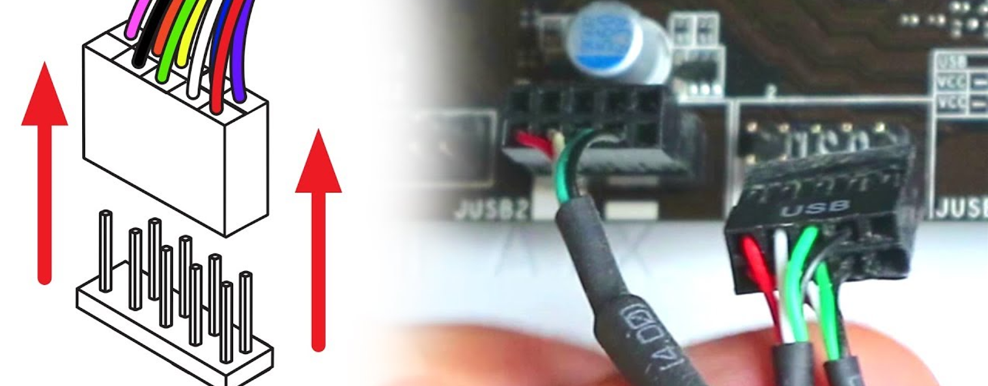

Whiles using the tap port on a computer, it can get faulty and there will be a need to replace these ports. You should look at how to replace a USB adapter in a computer system.

Below are the steps that needed to be followed to achieve this.

- Open your computer's case by removing the side panel.
- Use your screwdriver to remove any screws connected to the old USB card.
- Remove the PCI USB card with a strong, upward tug. If the card is in the front of the case, it should slide out easily.
- Place the new card where the old one was.
- Press straight downward firmly, holding the USB card at both ends, to lock it into the PCI slot.
- Screw it onto the case.
- Connect it to the motherboard either through USB or a port header connection

PC (f) Follow safe work practices

Checklist
No | Activity | Yes | No
1 | Install device cable to appropriate port
2 | Troubleshoot to test for connectivity
3 | Remove faulty ports
4 | Replace faulty ports on device board
5 | Replace faulty ports with adapter
6 | Follow safe work practice

References
- Elprocus. (n.d.). What is a Computer Port: Types and Their Characteristics. Retrieved from https://www.elprocus.com/what-is-a-computer-port-types-and-their-characteristics/
- educba. (n.d.). Types of Computer Cables. Retrieved from https://www.educba.com/types-of-computer-cables/
- GeeksforGeeks. (n.d.). Types of Computer Ports. Retrieved from https://www.geeksforgeeks.org/types-of-computer-ports/

