实验二 JavaFX基础

学号： 32001298 姓名： 杨晨露 班级： 计算机2001
【实验目的和要求】
- 了解 JavaFX 编程的基础知识。
- 使用JavaFX 来演示OOP。
【实验内容】
- 用JavaFX设计一个登录界面，实现用户名、密码和登录按钮的界面。

代码：（截图和源代码）

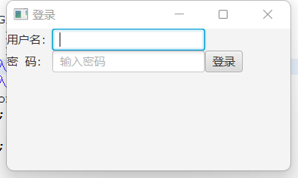
package grade;

import java.util.ArrayList;

import javafx.application.Application;
import javafx.stage.Stage;
import javafx.scene.Scene;
import javafx.scene.control.Button;
import javafx.scene.control.Label;
import javafx.scene.control.TextField;
import javafx.scene.control.PasswordField;
import javafx.scene.layout.GridPane;
public class Login extends Application
{
private TextField tf=new TextField();
private PasswordField pf=new PasswordField();

@Override
public void start(Stage Stage)
{
GridPane rootGP=new GridPane();
final Label lab1=new Label("用户名：");
final Label lab2=new Label("密 码：");
tf.setPromptText("输入用户名");
pf.setPromptText("输入密码");
Button bt = new Button("登录");
rootGP.add(lab1,1,0);
rootGP.add(tf,2,0);
rootGP.add(lab2,1,1);
rootGP.add(pf,2,1);
rootGP.add(bt,3,1);

Scene scene=new Scene(rootGP,300,150);
Stage.setTitle("登录");
Stage.setScene(scene);
Stage.show();
}

public static void main(String[] args) {
launch(args);
}

}
- 设计一个时钟界面，给出当前时间.

代码：（截图和源代码）

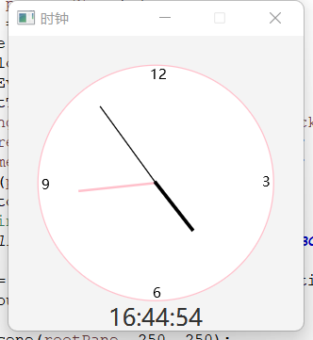
package grade;

import javafx.animation.KeyFrame;
import javafx.animation.Timeline;
import javafx.application.Application;
import javafx.event.ActionEvent;
import javafx.event.EventHandler;
import javafx.geometry.Pos;
import javafx.scene.Scene;
import javafx.scene.control.Label;
import javafx.scene.layout.BorderPane;
import javafx.scene.layout.Pane;
import javafx.stage.Stage;
import javafx.util.Duration;

public class Main extends Application {

@Override
public void start(Stage primaryStage) {
BorderPane rootPane = new BorderPane();
Pane pane = new Pane();
Clock clock = new Clock(pane);
EventHandler<ActionEvent> eventHandler = e -> {
clock.setCurrentTime();
String timeString = clock.getHour() + ":" + clock.getMinute() + ":" + clock.getSecond();
Label label_CurrentTime = new Label(timeString);
label_CurrentTime.setStyle("-fx-font-size: 20px; -fx-font-family: 'Microsoft YaHei UI'");
rootPane.setTop(pane);
rootPane.setBottom(label_CurrentTime);
// System.out.println(label_CurrentTime);
BorderPane.setAlignment(label_CurrentTime, Pos.BOTTOM_CENTER);
};
Timeline animation = new Timeline(new KeyFrame(Duration.millis(1000), eventHandler));
animation.setCycleCount(Timeline.INDEFINITE);
animation.play();
Scene scene = new Scene(rootPane, 250, 250);
primaryStage.setResizable(false);
primaryStage.setTitle("时钟");
primaryStage.setScene(scene);
primaryStage.show();
}

public static void main(String[] args) {
launch(args);
}

}

package grade;

import javafx.scene.layout.Pane;
import javafx.scene.paint.Color;
import javafx.scene.shape.Circle;
import javafx.scene.shape.Line;
import javafx.scene.text.Text;

import java.util.Calendar;
import java.util.GregorianCalendar;

public class Clock {
private int hour;
private int minute;
private int second;
Pane pane;

public Clock(Pane pane) {
this.pane = pane;
setCurrentTime();
}

public int getHour() {
return hour;
}

public int getMinute() {
return minute;
}

public int getSecond() {
return second;
}

public void setCurrentTime() {
Calendar calendar = new GregorianCalendar();
this.hour = calendar.get(Calendar.HOUR_OF_DAY);
this.minute = calendar.get(Calendar.MINUTE);
this.second = calendar.get(Calendar.SECOND);
paint();
}

protected void paint() {
double width = 250;
double height = 250;
double clockRadius = width * 0.8 * 0.5;
double centerX = width / 2;
double centerY = height / 2;
Circle circle = new Circle(centerX, centerY, clockRadius);
circle.setFill(Color.WHITE);
circle.setStroke(Color.PINK);
Text text1 = new Text(centerX - 5, centerY - clockRadius + 12, "12");
Text text2 = new Text(centerX - clockRadius + 3, centerY + 5, "9");
Text text3 = new Text(centerX + clockRadius - 10, centerY + 3, "3");
Text text4 = new Text(centerX - 3, centerY + clockRadius - 3, "6");

double sLength = clockRadius * 0.8;
double secondX = centerX + sLength * Math.sin(second * (2 * Math.PI / 60));
double secondY = centerX - sLength * Math.cos(second * (2 * Math.PI / 60));
Line sLine = new Line(centerX, centerY, secondX, secondY);
sLine.setStroke(Color.BLACK);
sLine.setStrokeWidth(1);

double mLength = clockRadius * 0.65;
double minuteX = centerX + mLength * Math.sin(minute * (2 * Math.PI / 60));
double minuteY = centerY - mLength * Math.cos(minute * (2 * Math.PI / 60));
Line mLine = new Line(centerX, centerY, minuteX, minuteY);
mLine.setStroke(Color.PINK);
mLine.setStrokeWidth(2);

double hLength = clockRadius * 0.5;
double hourX = centerX + hLength * Math.sin((hour % 12 + minute / 60.0) * (2 * Math.PI / 12));
double hourY = centerY - hLength * Math.cos((hour % 12 + minute / 60.0) * (2 * Math.PI / 12));
Line hLine = new Line(centerX, centerY, hourX, hourY);
hLine.setStroke(Color.BLACK);
hLine.setStrokeWidth(3);

pane.getChildren().clear();
pane.getChildren().addAll(circle, text1, text2, text3, text4, sLine, mLine, hLine);
}

}

