实验六 二进制I/O

学号： 32001298 姓名： 杨晨露 班级： 计算机2001
【实验目的和要求】
- 能操作处理文本I/O。
- 能使用二进制I/O类 FileInputStream和FileOutputStream。
- 能使用二进制I/O类 FilterInputStream和FilterOutputStream。
- 能使用二进制I/O类 DataInputStream和DataOutputStream。
- 能使用二进制I/O类 BufferedInputStream和BufferedOutputStream。
- 能使用对象I/O类实现序列化。
【实验内容】
1、（创建文本文件）编写程序，如果文件 高级程序设计.txt不存在，则创建该文件。如果存在，则向该文件追加新数据。使用文本I/O将100个随机生成的整数写入这个文件，整数间用空格隔开。

代码：（截图和源代码）

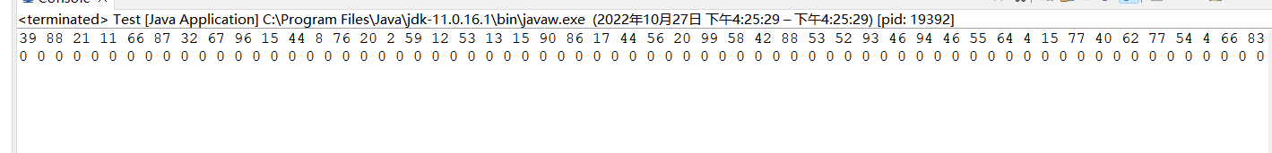

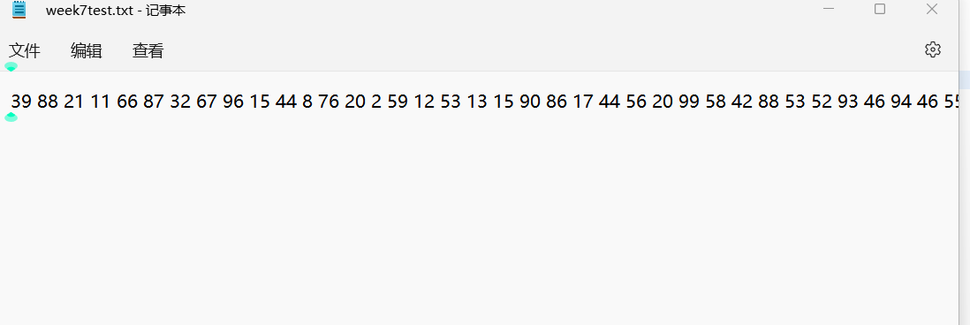
package week7;

import java.io.*;
import java.util.Arrays;
//import java.io.BufferedReader;
//import java.io.File;
//import java.io.FileInputStream;
//import java.io.FileWriter;
//import java.io.IOException;
//import java.io.InputStreamReader;

public class Test {
public static void main(String[] args) {
String filename="week7test.txt";
File file=new File(filename);// 创建指向文件的File对象
if(!file.exists()) { //判断文件是否存在
try {
file.createNewFile();// 再创建
} catch (IOException e) {
// TODO: handle exception
e.printStackTrace();
}
}
try {
FileWriter filew=new FileWriter(filename); // 向文件写入内容
String s="";
for(int i=0;i<100;i++) {
s+=(int)(Math.random()*100)+" ";
}
filew.write(s);
filew.close();
} catch (IOException e) {
// TODO: handle exception
e.printStackTrace();
}
try {
BufferedReader br=new BufferedReader(new FileReader(filename));//读取数据
String[] array=new String[100];
String s="";
String tamp="";

try {
while ((s=br.readLine())!=null) {
tamp+=s;
tamp+=" ";
}
array=tamp.split(" ");//设置分隔符
System.out.println(tamp);
int[] t=new int[100];
for (int i = 0; i<0;i++) {
t[i]=Integer.parseInt(array[i]);
}
Arrays.sort(t);//数组t排序
for(int i:t) {
System.out.print(i+" ");
}
} catch (IOException e) {
// TODO: handle exception
}
} catch (FileNotFoundException e) {
// TODO: handle exception
}
}
}

2、（存储Loan对象）编写程序清单如10-2所示，重写Loan类实现Serializable。编写程序创建5个Loan对象并利用ObjectOutputStream将它们存储在一个文件LoanInfo.dat文件中。

代码：（截图和源代码）

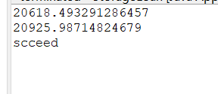

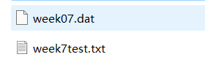
package week7;

import java.io.*;

public class StorageLoan {
public static void main(String[] args) throws
ClassNotFoundException, IOException
{
try (ObjectOutputStream output = new ObjectOutputStream(
new FileOutputStream("week07.dat")))
{
Loan[] loans = new Loan[2];
loans[0] = new Loan(1.5, 4, 20000);
loans[1] = new Loan(1.5, 6, 20000);
output.writeObject(loans);
}
try (ObjectInputStream input = new ObjectInputStream(
new FileInputStream("week07.dat")))
{
while (true) {
Loan[] newLoans = (Loan[]) (input.readObject());
for (int i = 0; i < newLoans.length; i++) {
System.out.println(newLoans[i].getTotalPayment());
}
}
} catch (EOFException ex) {
System.out.println("scceed");
}
}
}

package week7;

import java.io.*;

public class Loan implements Serializable {
private double annualInterestRate;
private int numberOfYears;
private double loanAmount;
private java.util.Date loanDate;

/** Default constructor */
public Loan() {
this(2.5, 1, 1000);
}

/** Construct a loan with specified annual interest rate,
number of years and loan amount
*/
public Loan(double annualInterestRate, int numberOfYears,
double loanAmount) {
this.annualInterestRate = annualInterestRate;
this.numberOfYears = numberOfYears;
this.loanAmount = loanAmount;
loanDate = new java.util.Date();
}

/** Return annualInterestRate */
public double getAnnualInterestRate() {
return annualInterestRate;
}

/** Set a new annualInterestRate */
public void setAnnualInterestRate(double annualInterestRate) {
this.annualInterestRate = annualInterestRate;
}

/** Return numberOfYears */
public int getNumberOfYears() {
return numberOfYears;
}

/** Set a new numberOfYears */
public void setNumberOfYears(int numberOfYears) {
this.numberOfYears = numberOfYears;
}

/** Return loanAmount */
public double getLoanAmount() {
return loanAmount;
}

/** Set a newloanAmount */
public void setLoanAmount(double loanAmount) {
this.loanAmount = loanAmount;
}

/** Find monthly payment */
public double getMonthlyPayment() {
double monthlyInterestRate = annualInterestRate / 1200;
double monthlyPayment = loanAmount * monthlyInterestRate / (1 -
(Math.pow(1 / (1 + monthlyInterestRate), numberOfYears * 12)));
return monthlyPayment;
}

/** Find total payment */
public double getTotalPayment() {
double totalPayment = getMonthlyPayment() * numberOfYears * 12;
return totalPayment;
}

/** Return loan date */
public java.util.Date getLoanDate() {
return loanDate;
}
}

3、（从文件中恢复对象）利用前面一题存储的文件LoanInfo.dat文件，编写程序从上述文件中读取内容到Loan对象中，并计算贷款总额并打印到控制台上。

代码：（截图和源代码）

4、（字符频率）编写程序，提示用户输入一个ASCII文本文件名，然后显示文件中每个字符出现的频率。

代码：（截图和源代码）

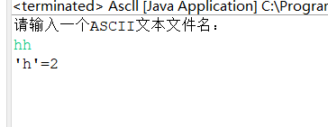
package week7;

import java.util.Scanner;

public class Ascll {
public static void main(String[] args) {
System.out.println("请输入一个ASCII文本文件名：");
Scanner in=new Scanner(System.in);
String str=in.nextLine();
int[] num=new int[128];
for (int i=0;i<str.length();i++)
{
char c = str.charAt(i);
num[c]++;
}

String result=new String();
for(int i=0;i<128;i++) {
if(num[i]>0) {
result+="'"+(char)i+"'"+"="+num[i]+" ";
}
}
System.out.print(result);
}
}

